LEARNER GUIDE

COMPUTERS, DEVICES AND COMPUTING SYSTEMS

Module Code | 252901001-KM-07
NQF Level | 4
Credits | 6
Curriculum Code | 252901001
Qualification Title | Occupational Certificate: Cybersecurity Analyst
SAQA QUAL ID | 118986

Name
Contact Address
Telephone (H)
Telephone (W)
Facsimile
Cellular
E-mail

Note to the learner
This Learner Guide provides a comprehensive overview of the module. It is designed to improve the skills and knowledge of learners, and thus enabling them to effectively and efficiently complete specific tasks.
Entry Requirements

- NQF 4
Provider Accreditation Requirements for the Knowledge Module

Physical Requirements
- The provider must have lesson plans and structured learning material or provide learners with access to structured learning material that addresses all the topics in all the knowledge modules as well as the applied knowledge in the practical skills.
- QCTO/ MICT SETA requirements

Human Resource Requirements:
- Lecturer/learner ratio of 1:20 (Maximum)
- Qualification of lecturer (SME):
    - NQF 6 in industry recognised qualifications with 1 years’ experience in the IT industry
    - CYBERSECURITY vendor certification
- Assessors and moderators: accredited by the MICT SETA
Legal Requirements
- Legal (product) licences to use the software for learning and training
- OHS compliance certificate
- Ethical clearance (where necessary)
Module Purpose
The main focus of the learning in this knowledge module is to build an understanding of what computers can do, and the processes that make them function in terms of the four major parts: the input, output, CPU (central processing unit), and memory. It gives an overview of networks and connectivity

Topic elements to be covered include
The learning will enable learners to demonstrate an understanding of:
- KM-07-KT01: Problem solving skills for IT Professionals
- KM-07-KT02: Techniques for safety
- KM-07-KT03: System components
- KM-07-KT04: Motherboards
- KM-07-KT05: Processors
- KM-07-KT06: Memory
- KM-07-KT07: BIOS and CMOS
- KM-07-KT08: Hard drives and storage devices
- KM-07-KT09: Power supplies and voltage
- KM-07-KT10: Ports, cables, and connectors
- KM-07-KT11: Input and output devices
- KM-07-KT12: Installing and managing printers
- KM-07-KT13: Mobile devices, multimedia, and laptop computers
- KM-07-KT14: Preventative maintenance
- KM-07-KT15: Troubleshooting procedures
- KM-07-KT16: Operating systems
- KM-07-KT17: Managing files
- KM-07-KT18: Applications utility, troubleshooting, and optimization
- KM-07-KT19: Configuring device drivers
- KM-07-KT20: Networking and wireless connections
- KM-07-KT21: Recovery
- KM-07-KT22: Cloud computing
- KM-07-KT23: Security fundamentals
- KM-07-KT24: Introduction to applications

Venue, Date and Time:
Consult your facilitator should there be any changes to the venue, date and/or time.
Refer to your timetable
Assessments

The only way to establish whether you are competent and have accomplished the learning outcomes is through continuous assessments. This assessment process involves interpreting evidence about your ability to perform certain tasks. You will be required to perform certain procedures and tasks during the training programmer and will be assessed on them to certify your competence.

This module includes assessments in the form of self-evaluations/activities and exercises. The exercises, activities and self-assessments will be done in pairs, groups or on your own. These exercises/activities or self-assessments (Learner workbook) must be handed to the facilitator. It will be added to your portfolio of evidence, which will be proof signed by your facilitator that you have successfully performed these tasks.

Listen carefully to the instructions of the facilitator and do the given activities in the time given to you.

KM-07-KT01: Problem solving skills for IT Professionals
Learning Outcome
Topic elements to be covered include:
- KT0101 Identification of the problem
- KT0102 Establishing a probable cause
- KT0103 Testing to determine the cause
- KT0104 Establishing a plan to resolve the problem
- KT0105 Implementing your solution
- KT0106 Verifying functionality
- KT0107 Implementing preventative measures
- KT0108 Documenting results

KT0101 Identification of the problem
CHALLENGES FACING IT PROFESSIONALS

- Workload
- Cybersecurity
- Skills gaps
- Digital transformation
- Cloud computing
- Hiring
- Budget
- Leadership support
- Analytics and data management
- Automation
- Project management
- Career growth
1. WORKLOAD
Both IT staff and decision-makers are overwhelmed with work demands. It’s sort of a chicken and egg scenario—decision-makers are using increasing workloads as an excuse not to authorize training, and staff are struggling to complete assignments because they lack the proper skills. Either way, time that was previously designated toward skills development is now being used to catch up on an increasing backlog of work.
Workload concerns are the highest they’ve been in the history of our IT Skills and Salary Report. It’s the number one training inhibitor, as IT professionals believe mounting workloads limit the amount of time they can spend out of office or in a training course.
Better manager oversight and strategy is required to address this issue. Automation may also be a solution as a means to reduce time-consuming tasks that are not high priority.
2. CYBERSECURITY
The cybersecurity challenge is two-fold:
- Cyberattacks are growing in size and sophistication
- Millions of cybersecurity jobs remain unfilled
Organizations cannot take IT security lightly. An analysis of worldwide identity and access management by the International Data Corporation (IDC) revealed that 55% of consumers would switch platforms or providers due to the threat of a data breach, and 78% would switch if a breach impacted them directly.¹ Customers aren’t willing to put their data at risk.
The problem is there aren’t enough IT professionals with cybersecurity expertise. Forty percent of IT decision-makers say they have cybersecurity skills gaps on their teams. It’s also identified as the most challenging hiring area in IT.
There isn’t an immediate solution to this problem, but a long-term fix is to build your cyber workforce from the inside. Invest in cybersecurity training and upskill your current staff. Hiring and outsourcing isn’t always a viable (or cheap) solution. Current IT professionals who know the industry are more apt to transition into successful cybersecurity professionals.
3. SKILLS GAPS
Over 80% of North American IT departments have skills gaps. Globally, IT skills gaps have increased by 155% in three years. They can no longer be ignored, especially as a lack of necessary skills can be credited for increased employee stress, development and deployment delays, and increased operating costs.
According to IT decision-makers, skills gaps will cost employers up to 416 hours and over R22,000 per employee, per year. You would think those numbers would motivate organizations to increase skill development opportunities for employees, but that isn’t always the case. Less than 60% of decision-makers say their organizations offer formal training for technical employees, down one percent from the previous year. This tells us that organizations aren’t serious enough about skill development.
The time to act is now—skills gaps will only grow and further debilitate IT departments unless actions are taken. Strategic and continual training is the antidote. That’s the good news. The uphill battle is conveying the value to management and securing budget to ensure employees receive continual training. IT professionals need better support. If organizations do not invest in their employees’ skills now, they will pay for it down the road.
4. DIGITAL TRANSFORMATION
Digital transformation is latest disrupter. It has led to technology no longer providing a sustained competitive advantage. It now plays a supporting role to people with the right skills. Expertise is needed now more than ever to manage and implement all of the new technologies.
But it’s not that simple. As discussed above, IT departments are suffering from gaps in critical skills areas such as cybersecurity, cloud computing and DevOps. Even IT professionals who are offered professional development opportunities are struggling to keep up. The rate of technological change is outpacing training.
IT professionals and departments are falling behind—they are failing to meet business objectives and seize market opportunities. While continual training is part of the equation, prioritizing skill needs is even more of a priority. That’s why we created the Skills Development Index™ to help IT professionals rank their most critical skill needs and determine which type of training to pursue. Informal training has its merits, especially when on-the-fly knowledge must be acquired, but when a high-value project is on the line, more formal learning is the better option.
5. CLOUD COMPUTING
Cloud is the top investment area worldwide for IT departments. Organizations require an infusion of cloud skills to match their monetary investment in cloud platforms. Much like cybersecurity, cloud professionals are in high demand and short supply. According to IT decision-makers, cloud computing is the second most challenging hiring area in the world.
The opportunities of cloud computing are impossible to ignore. Cloud is the ultimate enabler, opening new channels of revenue by leveraging technologies like artificial intelligence (AI) and the Internet of Things (IoT). But professionals are needed to capitalize on this technology, and currently, there aren’t enough of them.
Despite the worker shortage, organizations are all-in on cloud solutions. In fact, more than 50% of organizations use more than one cloud provider.² It’s not unique for an organization to require cloud skills in AWS, Microsoft Azure and Google Cloud. And generic cloud computing expertise isn’t enough, especially if you’re an engineer or architect. It’s imperative that cloud professionals have current skill sets and train on the platforms they engage with regularly.
6. HIRING
Talent recruitment and retention is a major challenge for IT leaders—50% are currently struggling in the area. Only seven percent of IT decision-makers say that hiring has been easy.
Managers hoping to hire their way out of a skills gap problem have been dealt a dose of reality, as key positions like cloud computing and cybersecurity are the most difficult to fill.
One potential solution to this quandary is degree deflation, which is a conscientious effort to focus on skills rather than a college degree during the hiring process. A bachelor’s degree is not necessarily an indicator of abilities, especially in tech. Recent training and certifications better illustrate what a professional is capable of right now.
7. BUDGET
A lack of budget and resources is another major concern for both IT staff and decision-makers. The open-field sections of our IT Skills and Salary Survey are littered with criticisms about budget constraints. IT professionals want to train but their requests aren’t always approved by management.
Budget is often the major roadblock impeding professional development and hiring. IT departments need to ensure they are communicating the right messages to organizational leadership to help them understand the value of ongoing training. Here’s a place to start: revenue growth, low employee turnover and new product development are signs of a skilled workforce.
There are a number of ways to maximize a constrained budget. Prepayments and special offers are options to save on training. Lock in a discounted rate for a full year, or save a certain percentage on individual courses. Also, make sure you are aware of any training credits your company may have. They are typically issued by tech providers as a way to help drive value for a particular investment. Global Knowledge accepts training credits and vouchers as payment for courses. Know your balance and know when they expire.
8. LEADERSHIP SUPPORT IN PRIORITIZING NEW SKILLS DEVELOPMENT
Some IT decision-makers do not authorize training even when it’s built into their budget—41% had formal training available but decided to forgo it. Nearly 20% of IT professionals say management does not see a tangible benefit from training. That’s a huge disconnect, especially since IT pros have a strong desire to learn and grow their careers. It’s difficult to accomplish that without support from leadership.
Often, IT management, fairly or unfairly, is blamed for poor employee morale and unclear job roles and responsibilities. Communication is one of the biggest gripes—IT professionals believe leadership isn’t always transparent, especially when it comes to decisions about resources and budgets.
And IT professionals will not wait out a poor work situation. Ninety-one percent of unsatisfied employees are likely to pursue alternative employment. Many respondents in our IT Skills and Salary report changed employers in the last year and sited of poor culture or toxic management as primary reasons.
9. ANALYTICS AND DATA MANAGEMENT
Aside from cybersecurity and cloud computing, this is the biggest skill gap area for IT departments. Organizations are struggling to manage a wealth of new data. By 2025, IDC estimates the world will create and replicate 163 zettabytes (ZB) of data, 10 times the number that was created in 2016.³ New data is constantly accumulating, creating a host of storage and security risks that must be addressed. IT professionals are desperately needed to manage this data growth, but the problem has exacerbated because qualified individuals are difficult to come by.
It’s not enough to accumulate this data. Organizations need analysts and critical thinkers to create a culture of information, enabling data-driven decisions to inform almost all business activities.
The good news is most cloud platforms, such as AWS and GCP, allow you to capture, process, store and analyse data all in one place. The key now is to upskill and certify professionals on the technologies and services associated with these platforms.
10. AUTOMATION
Since workload is the biggest challenge for IT professionals, finding ways to automate more mundane and time-consuming tasks such as email sends and social media posting is crucial.
But companies are now looking to automate larger and more business-critical tasks, such as cyberattack response, log monitoring and ERP integration.
Automation’s role in cybersecurity is certainly growing. It’s a tool that should be used to predict cyber threats and implement responses more quickly than can be accomplished manually.
Hackers are using automation to execute their attacks, so it’s time to bring the fight back to them. Automation allows attackers to move quickly, so organizations demand a faster detection and response time.
Automation is also useful in cloud migration. For organizations moving to the cloud, many of the migration tasks, such as manual configuration, can be automated, which reduces migration time from days to minutes.
11. PROJECT MANAGEMENT
Companies with certified project managers are more likely to have projects that are completed on time and within budget. It takes experience and strategic thinking to align projects with departmental and organizational goals. A strong project manager keeps projects on track so deadlines are met, resources are available and leadership is in the loop. Without someone to steer the ship, projects lack direction and risk increases. A business that fails to recognize these risks probably doesn’t value project management highly.
Rising skills gaps have made the jobs of project managers even more difficult, as critical expertise is lacking. It’s the project manager’s job to communicate skills needs with management and help guide realistic expectations. IDC believes that by 2020, 90% of all organizations will have adjusted project plans, delayed product/service releases, incurred costs or lost revenue because of a lack of IT skills, with losses worldwide totalling 390 billion annually. A successful project manager keeps their focus on the big picture even as disrupters, such as skills gaps, create risks for the business.
PMI®’s Project Management Professional (PMP®) certification is an essential certification for project managers. PMP provides a verified level of assurance that a project manager has the experience and skills to effectively define, plan and deliver their projects. If you’re a prospective project or program manager, the PMP certification should be in your immediate plans.
12. CAREER GROWTH
Share this: Two-thirds of IT professionals who changed employers last year did so in pursuit of better growth and development opportunities. In fact, growth outweighs a higher salary in terms of the top factor for changing employers.
As IT decision-makers struggle to fill open positions, it’s important that they invest in the areas their employees deem valuable. If growth opportunities are not available, IT professionals have proven that they will not sit idly by. More than half of the professionals we surveyed said they expected to at least casually look for new jobs in 2020.
KT0102 Establishing a probable cause
Establish a Theory of Probable Cause
Such as theory and probable indicate a guess on your part, even if it is a guess backed by data. The way this step is written acknowledges that the root cause (step one) may not have been accurately identified. However, the cause is specific enough to begin troubleshooting.
This stage may require significant research on your part. Vendor documentation, your organization’s own documentation and a good old-fashioned Google search may all be required to provide the basis for your theory.
Specific steps here may include:
- Questioning the obvious
- Considering multiple approaches, including top-to-bottom or bottom-to-top for layered technologies (such as networks)
One of the main issues that I’ve observed with newer trouble shooters is failing to question the obvious. In my classes, I rephrase this as “start simple and work toward the complex.” Yes, I am aware that operating systems, networks and cloud deployments are all very complex. However, that does not mean that your issue is complex.
I have found over the years that careful note-taking is important at this point. Your notes can include data copied from websites, web URLs, suggestions from your team members, etc.

KT0103 Testing to determine the cause
The pressure to bring high-quality products into the market means the product must undergo several rounds of testing to ensure issues are identified and rectified in time. But the process of developing test cases and carrying out manual or automated testing is not as easy as it appears; testers often come across many challenges along the testing lifecycle that makes the entire process rather taxing.
Here are key challenges developers face when it comes to software testing:
1. Undefined Quality Standards
Software products tend to comply with quality requirements when the standards are clearly defined. Unfortunately, perfectly defined quality standards is not always the case which makes testing a real challenge. Undefined or poorly defined quality standards means there is no clarity on testing requirements, specifications, guidelines, or characteristics. In the absence of the right standards, it becomes extremely difficult for testers to a) satisfy customer needs, b) meet quality requirements, and c) comply with regulations.
Before embarking on the testing journey, it is thus critical for teams to define these quality standards upfront as they help in developing expectations around the quality of the product under development. They not only make the testing process more efficient; they also help reduce redundancy, minimize errors, reduce time to market, as well as lower costs. Make sure the standards you define are realistic, reliable, and measurable. Rope in the required people to define standards and ensure they are clearly communicated to the team.
2. Test Environment Duplication
When testing a software product, most teams limit efforts to a handful of test cases. This, however, is not a true representation of the challenges the product might face in a real-world environment. Not using a realistic test environment means testers will only find issues that are reflected under very specific circumstances – thus reducing the chance of discovering real-world or hard to find bugs.
Using a real-life environment is important to test the product across all possible parameters. It ensures the product is tested across all possible configuration combinations and that any issue that could potentially impact end user experience is identified and rectified in time. A test environment that is as production-like as possible also reduces the likelihood of introducing a new feature that is not compatible with the production environment.
3. Lack of Communication
Testers often tend to work in complete isolation, and very rarely indulge in communicating with other team members. Such communication often leads to testers spending more in back-and-forth emails, attending meetings, taking phone calls, and providing status updates. It also impacts shared understanding across the entire team and leads to poor insight into risks and issues that can act as impediments to the project.
Open and constant communication is the foundation of great software testing. Make sure to invest in modern collaboration tools that help teams stay in touch with one another and stay updated with project updates. Ensuring great communication across the team and associated stakeholders means testers have access to all the information they need to start testing quickly and efficiently. It also helps in communicating potential bugs in issues and implement all the improvements needed to build a winning product.
4. Unstable Environment
Another major challenge with respect to software testing is the presence of unstable test environments. Unstable environments tend to potentially disrupt the overall release process. Since they are poorly managed, they result in conflicts and schedule delays; in the long run, they can impact quality, availability and efficiency of test environments while affecting time-to-market deadlines and costs.
To overcome issues with unstable environments, you need to get into the practice of formalizing test environment requirements early in the testing lifecycle. Using a formal template can help capture requirements in time, allocate suitable resources with matching skill sets, and build new environments by procuring the required infrastructure.
5. Insufficient Requirements Gathering
Testers also often find themselves challenged by user requirements which tends to wreck the testing process. Inadequate or insufficient requirements analysis has several consequences on the quality of the software under development: it can lead to inadequate functionality or even new requirements being discovered late in the development lifecycle. Too many missed requirements exert immense pressure on project schedules and compel testers to skip test cases to save time.
Since requirements gathering can play a big role in ensuring business and customer expectations are met, it is important to invest time for gathering requirements. Proper gathering ensures teams know what features the product is supposed to offer, the level of functionality expected as well as in unearthing the right defects and issues.
In the software development lifecycle, testing plays an equally important role as development – if not more. But given how complex today’s products have become, testers often find themselves struggling with a melee of testing challenges: right from undefined quality standards to test environment duplication, lack of communication, unstable environment, and insufficient requirements gathering. To make testing a streamlined and challenge-free process, it is vital for teams to engage with partners who can put practices in place that help in overcoming challenges and meeting required quality and cost requirements with ease.

KT0104 Establishing a plan to resolve the problem
Establish a Plan of Action and Implement the Solution
If you believe you know the root cause of the troubleshooting issue, you can now plan how to address it. Here are some reasons to plan ahead before blindly jumping into a course of action:
- Some fixes require reboots or other more significant forms of downtime
- You may need to download software, patches, drivers or entire operating system files before proceeding
- Your change management procedures may require you to test modifications to a system’s configuration in a staging environment before implementing the fix in production
- You may need to document a series of complex steps, commands and scripts
- You may need to back up data that might be put at risk during the recovery
- You may need approval from other IT staff members before making changes
Once you’ve completed this stage, you’re now ready to do whatever it is you believe you need to do to solve the problem. These steps may include:
- Run your scripts
- Update your systems or software
- Edit configuration files
- Change firewall settings
Make sure that you have a rollback plan in place in case the fix you’re attempting does not address the issue. You must be able to reverse your settings to at least get back to where you began.
In some cases, implementing the proposed fix may be quicker than the research phases that preceded it. Those research phases are essential, however, to make sure you’re addressing the real issue and to minimize downtime.

KT0105 Implementing your solution
Technology Solutions Every Business Owner Needs to Know

Technology has become an indispensable part of the business realm. Online marketing has become far more popular when compared to the traditional commercial system. The world is constantly going through a technological revolution. It is an extremely difficult task to keep up with the exponential advances in science and technology, but this is what separates the rapidly growing businesses from the stagnant businesses which have refused to acknowledge the importance of upgrading their technical infrastructure. Business owners must constantly relearn how new technologies affect their marketing, advertising, and servicing strategies so they can transform their company into a technology managed services provider. Here are some key technological solutions that every business owner should know and consider investing in:
1. Building Websites that Adapt to any Screen Size or Resolution
This is commonly referred to as “responsive web development”. It aims to design websites that can be viewed uniquely and comfortably on any device with any screen size. Essentially, the text and buttons (hyperlinks) on a website should adapt to the device being used to view the site. This is done by simplifying and prioritizing content on the website and changing certain essential elements of the design. Having to scroll left and right or zoom in constantly to read text can turn off customers who do not have the patience to navigate poorly designed websites. As browsing is far more common on smartphones and tablets, investing in this simple yet effective technology can greatly amplify a company’s growth rate.
2. Migrating to a Cloud-Based Service
Cloud-based technology can save money that would have been otherwise spent employing an IT department or investing in IT infrastructure. Cloud services are relatively inexpensive, and allow companies to function in a more open, adaptive, and responsive manner. Files and documents can be accessed remotely without the need for a centralized server. This allows employees to work more efficiently as they have better access to data. Departments within the company can communicate with each other effectively as well to boost productivity.
3. Switching to VoIP Business Phone Systems
VoIP (Voice over Internet Protocol) is a potent means of communication. It provides toll-free voice calling and call forwarding features for customers. You can even have a list of different numbers where you can be reached before a voicemail is suggested. VoIP can be integrated with Cloud services to monitor incoming and outgoing calls as well as data usage. It can even be used as an automated help desk, allowing an organization to project themselves as a progressive technology managed services provider instead of an obsolete business. VoIP is certainly a very important investment for both small scale and large scale businesses in order to maintain open communication channels with customers.
4. Investing in E-mail Marketing
While social media holds an important place in advertising, nothing makes more of an impact than a well-framed e-mail. Investing in good e-mail marketing will help you navigate through spam filters and get your point across to potential customers. Access to extensive mailing lists can be bought from mailing list brokers or trade groups. Composing short and relevant e-mails is essential. Subscribers do not want their inboxes to be filled with your e-mails all the time! Spacing out the delivery of these emails and giving customers a reason to open them is of paramount importance—catchy subjects lines go a long way here.
5. Adapting Better Security Infrastructure
From small retail stores to multinational companies, security is crucial. Glitches in the security structure of a company can cause huge losses. With new and more open technology being used, unfamiliar threats in the form of hackers arise every day. Business owners must invest in good online security software and network security staff to keep the company safe from data or budget leaks that could damage the company’s reputation. In case of retail stores or supermarkets, owners should consider investing in 360 degree sweeper cameras that provide constant updates and recognize threats via smart image processing.
6. Using SEO to Your Advantage
If you own a company that does most of its business online, investing in SEO (Search Engine Optimization) experts can positively influence your business. SEO involves using specific keywords and search algorithms to make it easy to find your websites via search engines. Efficient application of SEO techniques can even push your website to the first or second page of results put on search engines (such as Google) when a particular keyword related to your website is requested.
Technology has no doubt changed the way business is conducted. It will continue to evolve and business owners who adapt to these changes will make huge profits. Most of the above listed technological solutions apart from extensive security are not particularly expensive and can be implemented fairly easily. It is tempting to allot funds for technological solutions but it is also important to differentiate out the extravagant ones from the functional ones. Investing in the right IT solutions will go a long way in establishing a well-regarded, customer-oriented business.
KT0106 Verifying functionality
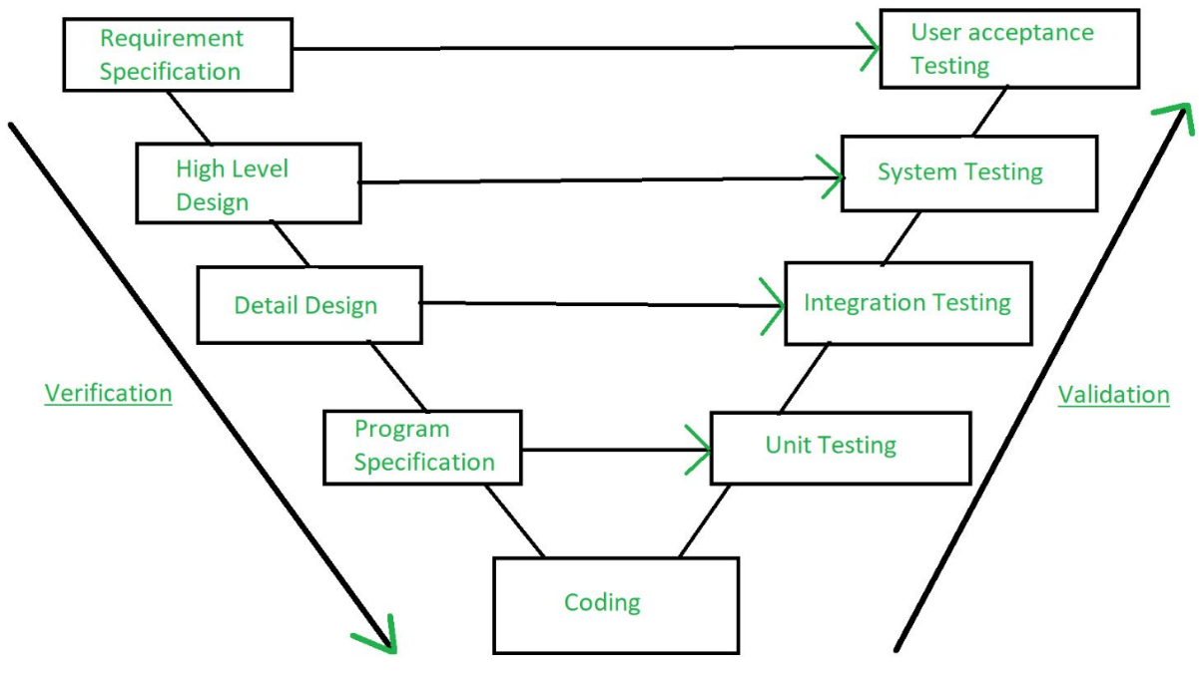
Verification and Validation is the process of investigating that a software system satisfies specifications and standards and it fulfils the required purpose. Barry Boehm described verification and validation as the following:
Verification: Are we building the product, right?
Validation: Are we building the right product?
Verification:
Verification is the process of checking that a software achieves its goal without any bugs. It is the process to ensure whether the product that is developed is right or not. It verifies whether the developed product fulfils the requirements that we have.
Verification is Static Testing.
Activities involved in verification:
- Inspections
- Reviews
- Walkthroughs
- Desk-checking
Validation:
Validation is the process of checking whether the software product is up to the mark or in other words product has high level requirements. It is the process of checking the validation of product i.e., it checks what we are developing is the right product. it is validation of actual and expected product.
Validation is the Dynamic Testing.
Activities involved in validation:
- Black box testing
- White box testing
- Unit testing
- Integration testing

KT0107 Implementing preventative measures
Steps to Protect Your Computer from Cyber Threats
Backup, Boot Disk, Computer, Cyber Threats, Extension, Filename, Firewall, Internet, Safety, Security, Software, Update, Virus, Web, Web Browser
Many people depend on their home computer to conduct essential business for both their professional and personal life. For example, more employees are now working remotely from home. Many consumers use their computing devices to shop, bank, and pay bills online. All of these are highly personal activities, as well as highly lucrative targets for hackers and identity thieves. You would never want your private data to fall into the wrong hands. That’s why you must protect yourself from malicious online attacks. Here are the critical steps that you must follow to keep your computer(s) safe from cyber threats.
1. Install Internet Security Software



Strong cybersecurity starts with installing the strongest antivirus software on all of your computing devices. Internet security software should also protect your devices from dangerous malware as well – which is often used in identity theft crimes. Furthermore, you must keep your antivirus software up-to-date. You should also scan your computer for viruses and malware each night before turning it off.
2. Install a Firewall



The best way to protect your PC from hackers is to prevent them from accessing it to begin with. You can do that by installing a firewall. A firewall will block outside attempts to gain access to your computer. It can also protect your computer from some viruses, malware, and Trojans too. All Windows-based computers/laptops/tablets come with the Windows Firewall already preinstalled. However, most internet security software programs include the option to install a firewall as well.
3. Create a Boot Disk



Even with the best internet security precautions, your computer could still be compromised by a malicious cyber-attack. Oftentimes, malicious software is so destructive that it can corrupt your computer’s operating system – which means you can no longer use it. Your only option to salvage your computing device is to restore it to the original (factory) settings. Therefore, you should create an emergency boot disk if one didn’t come with your device. Most people create a boot disk on a USB flash drive. You can learn how to create a boot disk by researching it further online.

4. Backup Everything

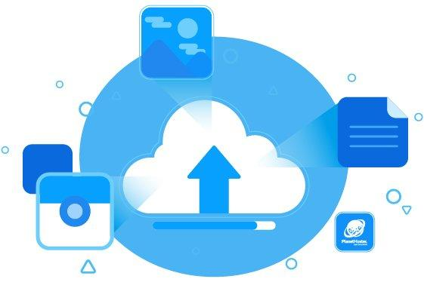

In addition to an emergency boot disk, you need to regularly backup your computer’s files to ensure that you never lose them. A growing number of home computer users are being targeted by ransom attacks. Hackers essentially lock their computer which prevents access to their files. You can backup your computer files on a USB flash drive, or by using some type of cloud storage system – like Google Drive.
5. Install Software Updates



Hackers are often able to exploit security holes that they find in software that runs operating systems and computer programs. Therefore, you want to make sure that all of the software you use is kept up-to-date. If you have a Windows-based device, you can configure your settings to automatically download and install all Windows updates. Google and Apple offer automatic updates for their devices as well. Most of the computer programs that you use will alert you when a new update is available.
6. Configure Strict Web Browser and Email Security Settings



You can enhance your cybersecurity by configuring strict security settings for your web browser and email application. For example, you should strongly consider disabling JavaScript since it’s used a lot by hackers. Furthermore, you can disable the cookies in your web browser, so that your internet browsing habits aren’t tracked by any websites.
7. Don’t Install/Run Unknown Programs



Hackers will often hide a Trojan horse (or other malicious software) inside of a program that otherwise looks completely legit and harmless. While hackers can hide malicious software in any kind of program, they usually do it in games and screensavers – since they are so popular with users. Therefore, you should never download/install/run programs unless you are completely sure that they are safe and legit. In fact, you should never download a program before scanning it with your internet security software.
8. Don’t Open Unknown Email Attachments/Links



In addition to being a very popular communication medium, email is also a very popular way to spread malicious software. Email is especially popular for phishing scams – where a user is tricked into sharing personal data with identity thieves. You should have your internet security software configured to scan every email that you receive. Furthermore, you should never open an email attachment nor click on any links from an unknown email address. Even if the sender looks legit, you should scan all attachments with your internet security software before opening them.
9. Disable Hidden Filename Extensions



Windows-based devices have a security flaw that makes them vulnerable to cyber threats. By default, the Windows operating system hides file extensions for all known file types. Unfortunately, that gives hackers a sneaky way to hide the file extensions of their malicious software programs. Therefore, you will want to disable that option in Windows. That way you will be more likely to notice suspicious file extensions that don’t belong on your computer.
10. Turn Off Computer and Disconnect from the Internet



Last but not least, you don’t have to be actively browsing the Internet for your computer to succumb to a cyber attack. If you leave your computer on and connected to the Internet, it’s still at risk of cybersecurity threats. Therefore, when you are done using your computing device, you need to completely turn it off. Furthermore, you should go ahead and disconnect it from the Internet to make sure that there is absolutely no way that a cybercriminal could access it.

In short, protecting your computer from cyber threats starts with installing antivirus software and a firewall. However, just in case your device succumbs to a cybersecurity threat, you should create a boot disk, as well as conduct regular data backups. Always install available software updates – especially security updates for your operating system. Make sure that you configure strict browser and email security settings too. Don’t download or run unknown programs – and don’t open unknown attachments and links in emails. For added online security, disable the hidden filenames feature if you have a Windows-based device. Always turn off your computer and disconnect it from the Internet when you aren’t using it.
KT0108 Documenting results
A lot of software providers forget about the importance of documenting their processes. A software test document is one of those important tracking tools overlooked by many. It’s especially true when the project has no dedicated QA specialist. Yet, the benefit of a test document in place is immense for a project.
The article is useful for both customers and providers of software development services. Still, QA specialists are the target audience. So, be ready to dive deep into the details and technicalities of writing a test document. Besides, the blog post will have a part two, so stay tuned.
The first part of the ultimate guide has six chapters:
- Checklists
- The Reasons for Creating Test Cases
- How to Create a Test Case
- The Lifecycle of a Test Cases
- Test Suits
- Typical Errors When Creating a Test Document
1. Checklists for writing a software test document
Starting a more or less complex task requires a checklist. You need one when you shop, plan a BBQ, and when you test your software.
In a nutshell, a checklist is a set of ideas for testing, developing, planning and managing a project. You can pitch ANY idea as long as it’s sane and falsifiable. Your checklist should additionally conform to 3 principles to work:
- Logic
- Coherence and structure
- Fullness and non-redundancy
As simple as that! The checklist is the most basic and most overlooked element of a test document. Yet, it lays the foundation for the success of your software development project.
2. The reasons for creating test cases
When you’re ready with your checklist you can assign a test case to every bullet point on your checklist. If you missed something, don’t worry. You can add and delete your test cases when you need to. Still, try not to mess the coherence and structure of your checklist. Anyways, let’s define what test case is.
A test case is a case for bug checking a software solution. Test cases always include testing steps and expected results.
The benefits of making test cases for your own project are undeniable. To be short, you have 7 reasons to create a test document for your project:
  - You structure and systematize your testing approach. It’s very important for medium and large projects.
  - You increase your test coverage metrics by measuring them and taking action.
  - You follow your plan by tracking your current situation and compare it with the plan.
  - You foster communication between developers, clients, and QA specialists. In case something goes off the rails, you’ll be able to prove you’ve done everything by the book.
  - You store data for legacy use and knowledge transfer between co-workers and teams. This way, you’ll be able to bring a new co-worker up to speed with your project asap.
  - You’re able to perform regression and repeated testing. It’s very useful to be able to compare your current test case with a legacy one of the same feature.
  - You increase the quality of your test requirements. Especially when your test case may show you that your expected results were off the target.

3. How to create a test case
Now, you see creating a test document is definitely not a waste of time. You furthermore don’t spend that much time at all since test cases are quite simple. Below, you may see an excel file showing the structure of your typical test case.

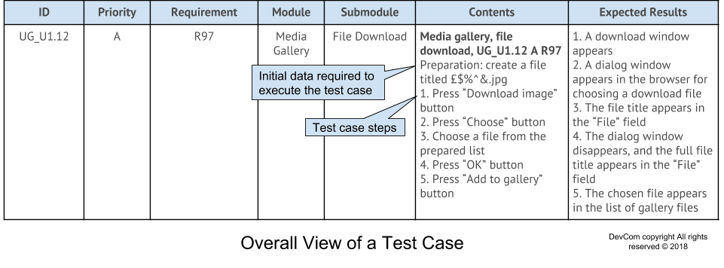
The structure of a test case goes as follows:
  - Identifier. The field holds a unique value allowing to distinguish one test case from another.
  - Priority. The field shows the importance of a test case. To highlight the importance, you can use A-Z, 1-9, words like “high”, medium, and low or any other useful grading.
  - Requirements. It allows you to locate the main requirement you’re testing. In the example above, “R97” refers to the requirement description #97.
  - Module and sub-module. The field describes elements of the software solution you should test.
  - Contents. It provides you with a gist of the test case. A tester should be laconic and to the point here. In the contents, you can find the initial data required to execute the test case. Moreover, the field contains the actions necessary to perform the test case.
  - Expected Results. The QA specialist describes the consequence of every action described in the contents.
You can change the document as you and your team want. The test document should serve the software testing efforts and not be the burden. Moreover, each test case is not set in stone. You have a dynamic test document on your hand with test cases failing and succeeding.
4. The life-cycle of a test case
The short but interesting life of a test case goes through different testing phases.

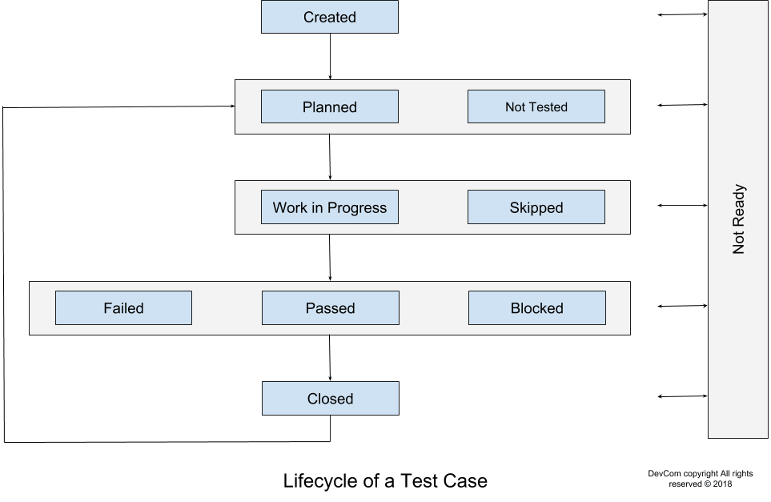

Firstly, you assign ‘Created’ to all the new test cases. Then, you can move your test case to either the ‘Planned’ phase or ‘Not Tested’. ‘Planned’ describes a test case included in the upcoming testing iteration. ‘Not tested’ is almost the same phase but you don’t include the test case into the testing iteration.
Afterward, your test case goes in one of two states either ‘Work in progress’ or ‘Skipped’. ‘Work in progress’ describes complicated test cases taking a lot of time. But, testers usually skip this phase because the typical test case doesn’t take much time to perform. As for ‘Skipped’, testers use it to skip a test case due to either lack of time or a change in the testing logic.
Next, you have three separate test case phases: ‘Failed’, ‘Passed’ and ‘Blocked’. The first one, ‘Failed’, means you’ve stumbled upon a bug, and you have some work for your developers. The second one, ‘Passed’, means you have found no bugs during the test. The final one, ‘Blocked’, means you can’t perform your test due to another, separate bug.
Finally, there are two odd phases ‘Closed’ and ‘Not Ready’. You can use the ‘Closed’ phase in those rare situations when you closed the test case and the result is not important. Otherwise, I recommend you use one of the previous states like ‘Failed’, ‘Passed’ or ‘Blocked’. As for ‘Not Ready’, you can use it for test cases with errors, inadequate requirements, or other issues.
5. Test suits
We went through everything important about test cases. Yet, testers usually don’t work with isolated test cases but rather with a test document as a whole. So, you always have some kind of test suite determining the order of your testing.
First, you have the option of preparing for each test separately or for the whole test suite combined. Second, you can execute test cases either gradually or freely. Obviously, you can have a mix of these different test suites. Whatever makes your project succeed. Still, you’ll end up with 4 distinct types of test suits. Choose wisely!

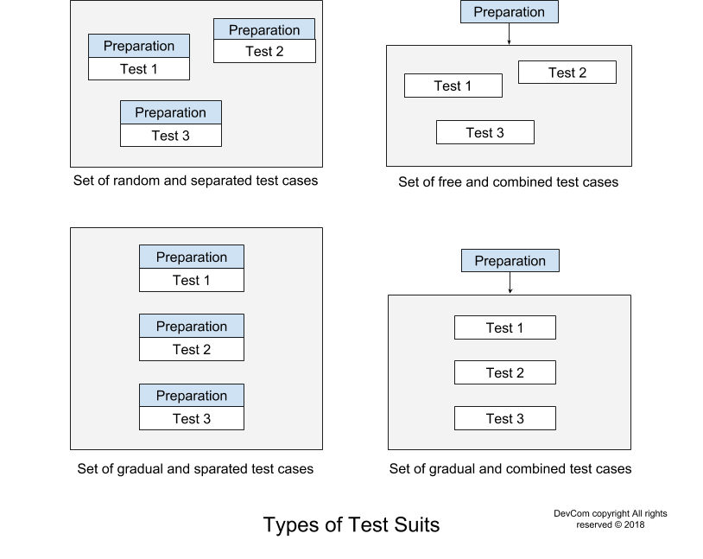
6. Typical errors
Software testers distinguish between two types of errors when creating a test document. The first type of error is formatting and descriptive ones. These mistakes are inaccuracies leading to misinterpretations and the consequent test fails. The second type of error includes logical mistakes. The source of this type of testing mistakes is a fundamental misunderstanding of a test case. So, if you don’t understand a test case, I recommend you to address your co-workers for clarification. And don’t take “no” for an answer!
List of formatting and descriptive mistakes:
  - A test case has a deficient title or no title at all. A tester should make the title as concise as possible because co-workers never read the full description. Even, at the gunpoint.
  - Test case steps have no enumeration and no list of expected results. This error can lead to a test case performed all wrong and even submitted as well performed
  - Writing the same test case information twice or more. Obviously, the same information in different places is a misleading practice.
  - Using imperative verbs. Use “should”, “must”, “ought to”, “will” instead. The reason is people are often irritated by imperative verbs.
  - Writing in either a past or a future tense. The use of incorrect tenses may distract people from a test case they are performing right now.
  - Using words like “check” and “test”. These words don’t specify what exactly should a tester do. So, the tester can perform an action different from the one needed.
  - Describing standard interface elements in your own words instead of using conventional terminology. This practice makes a tester look unprofessional and makes the test document complicated.
  - Grammar mistakes. I hope I don’t have to explain this one?
The list of logical mistakes:
1. Linking for information to other test cases. This is a misleading practice. A tester should be wise enough to copy-paste the required info into the current test case.
2. Describing features irrelevant to your testing. In other words, you should be laconic, and write to the point.
3. Defining expected results and action descriptions badly and ambiguously. Again, this can lead to misinterpretations and test fails.
4. Inventing an app feature necessary for the project. Sometimes, testers think a certain feature is a must for an application without even bothering to look into the technical documentation.
5. Misunderstanding the app functionality and thus the test case. This error is severe and can lead to inadequate results for the whole testing project.
6. Considering an incorrect app behaviour to be the expected result. In other words, if you get 404 pages, you don’t describe it as a result. You describe it as a failure.
7. Distributing data suits into equivalence classes incorrectly.

Internal Assessment Criteria and Weight
- IAC0101 Problem-solving steps and the application thereof are explained

(Weight 5%)

KM-07-KT02 : Techniques for safety 5%
Learning Outcome

Topic elements to be covered include:
• KT0201 Personal protective equipment
• KT0202 Chemicals
• KT0203 Cables
• KT0204 Hazards (Tripping, electrical, fire, jewellery, etc.)
• KT0205 Environmental risks
• KT0206 Ergonomics and lifting techniques

• KT0201 Personal protective equipment
Personal protective equipment – what do you need?


Personal protective equipment (PPE) is essential for hazardous workplaces. What do your workers need to keep them safe? Here’s a list of items you might need to supply:
1. Head protection
To avoid head injuries from falling objects, knocking heads when working in small spaces and electric shock during electrical work, safety helmets and hard hats should be provided. A set of spares should also be available for any visitors and to replace any damaged helmets.
2. Eye protection
Protecting workers’ eyes from airborne dust and debris, when working with chemicals or from sparks when welding, safety goggles are essential. Over glasses should be available for employees who wear spectacles.
3. Hand protection
A variety of gloves made from different substances are available to enable workers to perform tasks without the risk of injury to their hands. They protect from chemical hazards, heat and burns, cuts and scrapes and injury from machinery. They range from thin latex which still allows for delicate work to thick gloves made from heavy materials which would be suitable for work which doesn’t require much dexterity.
4. Foot protection
Work boots, steel capped boots, anti-slip footwear and gum boots can all prevent injury to feet from heavy or sharp objects, corrosive or irritating substances, electric shock during electrical work and falls.
5. Hearing protection
Loud noises can damage hearing, especially when exposure is sustained. Protective devices include ear plugs and ear muffs. Ear Muffs is very easy to fit, but they tend to offer less protection than ear plugs as they sit over the ears rather than directly in the ear canal thereby blocking less sound. Ear muffs can also be hot and uncomfortable meaning workers remove them.
6. Face protection
When working with chemicals, molten metal and potential impact hazards, facial protection with a brow guard or visor is advisable.
7. Respiratory protection
Airborne dust and debris is not only a danger to eyes but can damage the lungs when inhaled as well. Airborne solvents and chemical fumes are also hazardous. To prevent respiratory issues, disposable respirators, half and full-face masks and respiratory helmets are available.

Each industry has specific PPE requirements around their environment. Safety Works has done their homework and categorized products by specific “industry solutions” for all-round wearer protection. These industry solutions allow you to purchase an entire head-to-toe PPE outfit to ensure your employees’ safety in the workplace.

• KT0202 Chemicals
Tips for working safely around chemicals
You need to protect any employee who is exposed to hazardous chemicals by following the Occupational Safety and Health Administration (OSHA)’s Hazard Communication Standard (HCS). These tips can help you to meet the standard and protect employees.

1 Learn the hazard communication standard
The HCS uses the United Nations’ Globally Harmonized System of Classification and Labeling of Chemicals (GHS). This system puts chemicals into health and physical hazards categories. This helps employees quickly understand a chemical’s dangers.
2 Train employees about chemical hazards
Employers must train employees about any chemical hazards that might be in their work areas before employees start work and whenever there is a new hazard. They must also train employees in a way and in a language they can understand. Employers must tell employees about:
- how to spot hazardous chemicals,
- the personal protections in place,
- who to contact with a problem
- what information is on labels and safety data sheets (SDSs), and
- how to get access to the sheets.
3 Provide safety data sheets (SDSs)
The sheets should be in a standard 16-section format. They should give details about each hazardous chemical in the workplace. Employees should have easy access to SDSs, either in their work area or electronically.
4 Label all containers of hazardous chemicals
Employers must make sure all containers are clearly labeled with at least a product identifier and general information about a chemical’s hazards. Makers and importers of chemicals have to provide a label showing a signal word, pictogram, and statement for each hazard class and category. Employees must have access to complete information about a chemical's hazards.
5 Create a written hazard communication program
A written hazard communication program will state how you will handle hazard communication in your workplace. It will also list all the hazards in each work area. OSHA recommends using the product identifier to make it easier to track the status of SDSs and labels for hazardous chemicals.

• KT0203 Cables
SAFETY TIPS FOR WORKING WITH ELECTRICAL WIRES

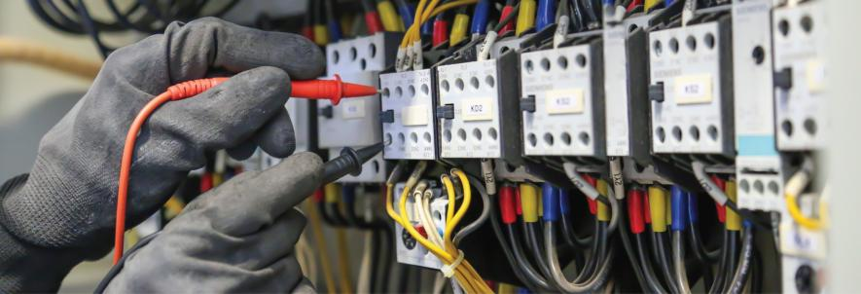
International Enviroguard

Living in the modern age means that we rely heavily on electricity. Electric power is vital for everything from computers and servers to lights and printers. Job sites rely on electricity to run heavy machinery and power various operational systems. However, while electricity is so valuable, it's also dangerous. When workers are exposed to hazardous electric sources, they can get seriously injured and even die.
Because of the dangers involved, it's imperative to understand how to keep employees safe at all times. So, we're going to look at the top safety tips for working with electrical wires and what you can do to maintain a safe and healthy workplace.
A Primer on Electrical Wire Injuries and Incidents
To help illustrate why electrical wires are so hazardous, let's look at some numbers. The Electrical Safety Foundation International helps monitor and track injuries and deaths caused by electrical hazards on the job.
- In 2019, 166 workers died from electrical incidents. That number was the highest in eight years, with a previous high of 174 workers in 2011. The lowest death count in the intervening years was 134 in 2015. The rise and fall of workplace deaths illustrate the need for constant vigilance and protection. When employers and employees get complacent, bad things can happen.
- The most dangerous industry for electrical deaths is construction, which accounted for 43 percent of fatalities in 2019. In second place is the utility industry.
- Oddly enough, while 2019 was the deadliest year for electrical accidents, it also had a relatively low number of injuries (1,900) compared to previous years. Ironically, 2015 saw the highest injury count with over 2,400 - the most within the same eight-year span.
- In 2019, there were over 110,000 structural fires in non-residential buildings. Of those, around eight percent of them were caused by electrical malfunction (8,095 total).
As you can see, electrical hazards can cause significant losses, both in lives and property damage.
What OSHA Says About Electrical Wire Safety
The Occupational Health and Safety Administration is responsible for setting safety guidelines for workers handling electrical wires. There are a few specific codes that address the issue, so let's break them down.
OSHA Electrical Safety Standard 1910.137(b)(2)
Code 1910.137(b)(2) refers to the type of personal protective equipment that employees should wear at all times. Employers are responsible for providing this PPE and training all workers on how to use it properly. Failure to do so can result in steep fines, not to mention injuries and potential deaths on the job.
As a rule, OSHA requires:
- Rubber gloves
- Face shields
- Safety shoes or boots
- Insulating sleeves
- Flame-resistant clothing
Depending on the type of work being done, employees may need additional PPE for extra protection. For example, if a worker is handling hazardous chemicals, they may need a respirator or breathing apparatus to ensure that they don't inhale toxic fumes. Regardless of the job, employers still have to provide sufficient PPE for all employees.
In addition to PPE, OSHA provides guidelines for insulating protective equipment (IPE). Workers will use IPE to help facilitate their tasks, but IPE is not worn like PPE. Some examples of IPE include
- Insulating line hoses and hoods
- Insulating barriers
- Live-line tools like shotgun sticks or hot sticks
Employers must test both PPE and IPE regularly to ensure that they can protect workers sufficiently. If items are used regularly, OSHA recommends testing gear about once a month. Employers must also provide formal examinations in between onsite testing. Gloves should be examined every six months and insulating sleeves every year.
OSHA Electrical Safety Standard 1926.431
This standard relates to equipment upkeep and maintenance. If employers don't inspect, repair, and upgrade their machinery, that can lead to failure and electrical injury or death. This specific standard refers to the construction industry, but the recommendations work well for all job sites. Some elements of standard 1926.431 include:
- Explosion-Proofing- Employers must maintain equipment so that there is little to no risk of an explosion due to electrical malfunction.
- Dust Proofing- Dust can get into machinery and cause various problems, both mechanical and electrical. Employers must protect all gear from dust-related incidents that could lead to an explosion or electrical arc.
- General Maintenance and Upkeep- Employers and employees must monitor equipment and machinery to watch out for loose screws, gaskets, and other pieces that may interfere with dust and explosion prevention.
- Reporting and Repair- If a worker spots any issues with machinery, they have to report to a supervisor immediately. Once a report is filed, the employer must stop using the circuit until the problem is fixed.
OSHA Electrical Safety Standard 1926.416(a)(3)
As we'll discuss in the next section regarding electrical safety precautions, workers need to know where circuits are at all times and how to shut them off. Typically, the best way to avoid electrical injuries or fatalities is to stop the flow of power from the source. This outlines various requirements for employers, such as labelling circuits with easy-to-spot signage, warning employees before they start work in an area with a live circuit, and locating and inspecting circuits regularly.
8 General Safety Tips for Working with Electrical Wires
Before your employees start working with or around electrical wires, they should be trained in proper safety techniques and precautions. Here are some generalized tips that can help prevent a disaster.
1. Make a Plan
The best way to avoid harm is to draft a project plan beforehand. During the planning phase, workers can assess the equipment and environment to spot any potential hazards. Planning can ensure that workers will use the proper PPE and IPE during the job and that they'll know where the correct circuit is for shutting off power.
2. Wear the Right Clothing and Gear
As we mentioned, OSHA requirements say that workers should have rubber gloves, insulating sleeves, and safety glasses on at all times. Fire-resistant clothing can also help prevent injury because the fibers are not very conductive or are treated with a flame-retardant. During the planning stage, employers and employees can determine whether additional PPE is necessary. Workers should also avoid wearing any metal, such as watches or jewellery.
3. Use the Buddy System
Should the worst happen, your workers shouldn't be by themselves on the job. A buddy system helps ensure that someone can always call for help if necessary or perform CPR. Both individuals should be trained in electrical safety and CPR before starting work.
4. Use the Lock Out Tag Out (LOTO) System
There are six steps to the LOTO system, and they can help ensure that all circuits are shut off and de-energized before working. De-energizing a circuit simply means making sure that there is no residual power left in the wires or machinery.
- Step One: Inspect the System- Before starting work, employees should be able to assess hazards on the fly, even if they didn't come up during the planning phase.
- Step Two: Shut Down the Circuit- Workers should know how to power down the circuit entirely so that there is no low-level residual energy.
- Step Three: Isolate the Equipment- Shut off any valves, unplug any cords, and separate the machinery from all electrical sources.
- Step Four: Lock and Tag- Any switches or buttons that can turn the equipment on should be locked in the off position. Doing this ensures that no one can accidentally activate the system. Each lock should have a corresponding tag with the worker's name and contact information.
- Step Five: Check for Stored Energy- Depending on the equipment, workers should be able to test for any residual electricity within the system. If they detect anything, they should also be able to discharge any stored energy.
- Step Six: Verify Everything- Employees should double-check and walk through all previous steps again to ensure that they didn't miss anything.
5. Avoid Working in Wet Areas
Since water is such a potent electrical conductor, it can pose significant safety risks on a job site. Even damp areas can be a problem, so workers must be able to address it. For example, if there is standing water on the ground, employees can either dry it off or cover it with non-conductive material (i.e., a wooden board).
6. Use a Ground Fault Circuit Interrupter (GFCI)
GFCIs are portable devices that workers can plug into an outlet or circuit. If there is a power surge because someone is getting electrocuted, the GFCI will detect it and kill the power automatically. Using these devices can act as a final failsafe just in case something else goes wrong.
7. Stay Away from Overhead Power Lines
OSHA recommends a minimum safe distance of 10 feet from any overhead electrical wires. Many injuries and accidents happen because of overhead lines, so workers should be hyper-aware of them.
8. Inspect Power Cords and Outlets for Damage
Finally, workers should check all electrical wires and elements, including plugs and outlets. Any damaged components should get replaced immediately. For example, if a three-pronged plug is missing the grounding prong, employees should swap it out with a new plug. They should look for signs of burning or charring, as that can indicate exposed wiring and potential electrical sparks.

• KT0204 Hazards (Tripping, electrical, fire, jewellery, etc.)
Electrical Safety
Electricity travels in closed circuits. Shock occurs when the body becomes a part of an electric circuit. Electric shock can cause direct injuries such as electrical burns, arc burns, and thermal contact burns. It can also cause injuries of an indirect or secondary nature in which involuntary muscle reaction from the electric shock can cause bruises, bone fractures, and even death resulting from collisions or falls. Shock occurs when person in contact with ground comes in contact with any of the following:
- Both wires of the electric circuit
- One wire of the energized circuit and the ground
- A metallic part that has become energized by being in contact with an energized wire.
The severity of the shock received when a person becomes a part of an electric circuit is affected by three primary factors:
- The amount of current flowing through the body.
- The path of the current through the body.
- The length of time the body is in the circuit.
Other factors that may affect the severity of shock are the frequency of the current, the phase of the heart cycle when shock occurs, and the general health of the person prior to shock. The effects of an electrical shock can range from a barely perceptible tingle to immediate cardiac arrest. Although there are no absolute limits or even known values that show the exact injury from any given amperage, the table below shows the general relationship between the degree of injury and the amount of amperage for a 60-cycle hand-to-foot path of one second's duration of shock.
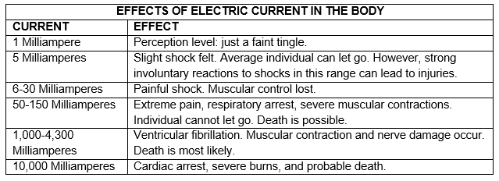
As this table illustrates, a difference of less than 100 milliamperes exists between a current that is barely perceptible and one that can kill. Muscular contraction caused by stimulation may not allow the victim to free himself/herself from the circuit, and the increased duration of exposure increases the dangers to the shock victim. For example, a current of 100 milliamperes for 3 seconds is equivalent to a current of 900 milliamperes applied for 0.03 seconds in causing fibrillation. The so-called low voltages can be extremely dangerous because, all other factors being equal, the degree of injury is proportional to the length of time the body is in the circuit. Simply put, low voltage does not mean low hazard.
In the event of an accident involving electricity, if the individual is down or unconscious, or not breathing: CALL 911 immediately. If an individual must be physically removed from an electrical source, it is always best to eliminate the power source first (i.e., switch off the circuit breaker). However, if time or circumstance do not allow this option, be sure to use a nonconductive item such as a dry board. Failure to think and react properly could make you an additional victim. If the individual is not breathing and you have been trained in CPR, have someone call 911 and begin CPR IMMEDIATELY!
COMMON ELECTRICAL HAZARDS AND PREVENTIVE STEPS
Many common electrical hazards can be easily identified before a serious problem exists. Read and follow all equipment operating instructions for proper use. Ask yourself, "Do I have the skills, knowledge, tools, and experience to do this work safely?"
Do not attempt electrical repairs unless you are a qualified electrical technician assigned to perform electrical work by your supervisor. Qualified individuals must receive training in safety related work practices and procedures, be able to recognize specific hazards associated with electrical energy, and be trained to understand the relationship between electrical hazards and possible injury. Fixed wiring may only be repaired or modified by Facilities Services.
All electrical devices fabricated for experimental purposes must meet state and University construction and grounding requirements. Extension cords, power strips, and other purchased electrical equipment must be Underwriters Laboratories (UL) listed.
Remove all jewellery before working with electricity. This includes rings, watches, bracelets, and necklaces.
Determine appropriate personal protective equipment (PPE) based on potential hazards present. Before use, inspect safety glasses and gloves for signs of wear and tear, and other damage.
Use insulated tools and testing equipment to work on electrical equipment. Use power tools that are double-insulated or that have Ground Fault Circuit Interrupters protecting the circuit. Do not use aluminium ladders while working with electricity; choose either wood or fiberglass.
Do not work on energized circuits. The accidental or unexpected starting of electrical equipment can cause severe injury or death. Before any inspections or repairs are made, the current must be turned off at the switch box and the switch padlocked or tagged out in the off position. At the same time, the switch or controls of the machine or the other equipment being locked out of service should be securely tagged to show which equipment or circuits are being worked on. Test the equipment to make sure there is no residual energy before attempting to work on the circuit. Employees must follow lock-out/tag-out procedures.
Cords and Power Strips
- If you need additional power supply, the best solution is to have additional outlets installed by Facilities Services. Do not use extension cords or power strips ("power taps") as a substitute for permanent wiring.
- Extension cords and power strips may be used for experimental or developmental purposes on a temporary basis only. Extension cords can only be used for portable tools or equipment and must be unplugged after use. Do not use extension cords for fixed equipment such as computers, refrigerators/freezers, etc.; use a power strip in these cases. In general, the use of power strips is preferred over use of extension cords.
- Power strips must have a built-in overload protection (circuit breaker) and must not be connected to another power strip or extension cord (commonly referred to as daisy chained or piggy-backed). As mentioned above though, extension cords and power strips are not a substitute for permanent wiring.
- Ensure any power strips or extension cords are listed by a third-party testing laboratory, such as Underwriters Laboratory (UL). Make sure the extension cord thickness is at least as big as the electrical cord for the tool.
- Inspect all electrical and extension cords for wear and tear. Pay particular attention near the plug and where the cord connects to the piece of equipment. If you discover a frayed electrical cord, contact your Building Coordinator for assistance. Do not use equipment having worn or damaged power cords, plugs, switches, receptacles, or cracked casings. Running electrical cords under doors or rugs, through windows, or through holes in walls is a common cause of frayed or damaged cords and plugs.
- Do not use 2-prong ungrounded electrical devices. All department-purchased electrical equipment must be 3-prong grounded with very limited exceptions.
Never store flammable liquids near electrical equipment, even temporarily.
Keep work areas clean and dry. Cluttered work areas and benches invite accidents and injuries. Good housekeeping and a well-planned layout of temporary wiring will reduce the dangers of fire, shock, and tripping hazards.
Common signs of an electrical problem include: flickering lights, warm switches or receptacles, burning odors, sparking sounds when cords are moved, loose connections, frayed, cracked, or broken wires. If you notice any of these problems, have a qualified electrician address the issue immediately.
To protect against electrical hazards and to respond to electrical emergencies it is important to identify the electrical panels that serve each room. Access to these panels must be unobstructed; a minimum of 3’ of clearance is required in front of every electrical panel. Each panel must have all the circuit breakers labelled as to what they control. Contact your Building Coordinator for assistance.
When performing laboratory inspections, it is a good idea to verify the location of the power panel and to open the door to ensure any breakers that are missing have breaker caps in its place. If no breaker is present and no breaker cap is covering the hole, contact your Building Coordinator for assistance.
Avoid operating or working with electrical equipment in a wet or damp environment. If you must work in a wet or damp environment, be sure your outlets or circuit breakers are Ground Fault Circuit Interrupter (GFCI) protected. Temporary GFCI plug adapters can also be used, but are not a substitute for GFCI outlets or circuit breakers.
Fuses, circuit breakers, and Ground-Fault Circuit Interrupters are three well-known examples of circuit protection devices
Fuses and circuit breakers are devices that are placed in circuits to automatically break the circuit when the amount of the current flow becomes excessive and therefore unsafe. Fuses are designed to melt when too much current flows through them. Circuit breakers, on the other hand, are designed to open the circuit by electro-mechanical means.
Fuses and circuit breakers are intended primarily for the protection of conductors and equipment. They prevent overheating of wires and components that might otherwise create hazards for operators.
The Ground Fault Circuit Interrupter (GFCI) is designed to shut off electric power within as little as 1/40 of a second, thereby protecting the person, not just the equipment. It works by comparing the amount of current going to an electric device against the amount of current returning from the device along the circuit conductors. A fixed or portable GFCI should be used in high-risk areas such as wet locations and construction sites.
Entrances to rooms and other guarded locations containing exposed live parts must be marked with conspicuous warning signs forbidding unqualified persons to enter. Live parts of electric equipment operating at 50 volts or more must be guarded against accidental contact. Guarding of live parts may be accomplished by:
- Location in a room, vault, or similar enclosure accessible only to qualified persons.
- Use of permanent, substantial partitions or screens to exclude unqualified persons.
- Location on a suitable balcony, gallery, or platform elevated and arranged to exclude unqualified persons, or
- Elevation of 8 feet or more above the floor.
SAFE USE OF ELECTROPHORESIS EQUIPMENT
Electrophoresis is a commonly used laboratory technique that uses electrical energy to separate molecules such as proteins or nucleic acids by their size, structure, and electrical charge. Electrophoresis units present several possible hazards including electrical, chemical, and radiological hazards. Each of these hazards need to be addressed before using the units.
Chemical Hazards
Hazardous chemicals commonly used in conjunction with electrophoresis work include:
- Ethidium bromide – mutagen, irritant
- Acrylamide – carcinogen, neurotoxin, irritant
- Phenol – corrosive, toxic
- Chloroform – suspect carcinogen, toxic
Always review the Material Safety Data Sheet prior to working with any hazardous material. See the Chemical Hygiene Plan for more information on working with hazardous chemicals.
Electrical Hazards
Typical electrophoresis units operating at 100 volts can provide a lethal shock of 25 milliamps. Take the following precautions when working with electrophoresis equipment:
- Ensure all switches and indicators are in proper working condition and that power cords and leads are undamaged and properly insulated.
- Label equipment with the warning: “Danger: Electrical Hazard.”
- Connect equipment to outlets with ground fault circuit interrupters (GFCIs)
- Use 3-prong plugs.
- If available, use power supplies with safety features that detect issues with the electrical circuit (e.g., no load, overload, sudden load changes, short circuits, etc.)
- Turn off main power supply before connecting or disconnecting electrical leads.
- With dry gloved hands, connect one lead at a time using one hand only.
- Be sure that leads/banana plugs are fully seated.
- Switch off all power supplies and unplug the leads before opening the gel chamber lid or reaching inside the gel chamber. Do not rely on safety interlocks.
Laboratory personnel may be exposed to thermal hazards when heating agarose solutions. Exercise caution when using a microwave to melt agarose solutions – don’t use sealed containers, and beware of superheated liquids that may suddenly and unexpectedly boil. Let hot agarose solutions cool to 50°-60°C before adding ethidium bromide or pouring into trays. Wear insulated gloves and point the flask opening away from you.
Ultraviolet (UV) light boxes and handheld lamps are often used in visualizing ethidium bromide gels and pose potential exposures to UV radiation.
Work Practices:
- Read and follow manufacturer’s instructions for electrophoresis equipment.
- Consult with PI prior to initial use of electrophoresis equipment. Discussion should include special hazards and safety precautions.
- Consider using ethidium bromide substitutes.
Personal Protective Equipment
- Wear a long-sleeved lab coat, safety goggles, nitrile gloves (latex is not effective), long pants, and closed-toe shoes.
- Wear appropriate skin and eye protection when working with UV radiation.
Emergency procedures
- Hazardous Waste Management: Dispose of chemicals and gels as hazardous waste. Collect in a non-leaking container labelled with a hazardous waste tag. Request pickup of hazardous waste using the EHS online system.
- Non-Hazardous Waste Management: Some gels may be considered non-hazardous and may be treated as such. For example, ethidium bromide <0.4 wt% in non-polyacrylamide gel is considered non-hazardous waste and can be placed into a closed bag, then into trash.

• KT0205 Environmental risks
Environmental Factors That Can Impact Your Health
A number of specific environmental issues can impede human health and wellness. These issues include chemical pollution, air pollution, climate change, disease-causing microbes, lack of access to health care, poor infrastructure, and poor water quality.
1. Chemical Safety
Different chemicals can impact human health in different ways, and often, exposure to dangerous or foreign substances creates health vulnerabilities. The chemical safety field is concerned with minimizing the effects of both natural and synthetic chemicals. More specifically, chemical safety seeks to safeguard human and environmental health from exposure to potential toxins; it focuses on chemicals that exist in the ambient world, as well as synthetic chemicals that are used in industrial processes or are the by-products of manufacturing activity.
Public health officials who work in chemical safety often focus on toxicology, which is the study of substances that have a toxic effect on the human body, whether when ingested or when absorbed through natural surroundings. Another important aspect of public health is chemical risk assessment, which involves scientists and clinicians working to determine a substance’s full biological effects.
This is a critical field of public health: According to the World Health Organization (WHO), more than 1.6 million deaths in 2016 were due to exposure to selected chemicals. Some examples of dangerous chemicals in the environment are heavy metals and toxins that find their way into the water supply and harmful pesticides that make their way into the food supply chain.
2. Air Pollution
Studies have shown that air pollution effects on humans are a significant public health concern, not only because of their role in climate change, but also because exposure to air pollution can increase morbidity and mortality.
When environmental scientists talk about air pollution, they’re describing any solid or liquid particles, as well as gases, that are suspended in the air and have harmful or poisonous effects. When we think about air pollution, we tend to think in terms of human-caused pollutants, and rightly so: Some of the most dangerous and ubiquitous examples of air pollution include car and truck exhaust, as well as polluting by-products of industrial processes. However, many natural air pollutants can cause health concerns; for example, pollen and mold spores are often linked with asthma and allergies.
According to the WHO, air pollution effects on humans are significant. For example, air pollution causes:
- 29% of all global deaths from lung disease
- 24% of all global deaths from stroke
- 17 % of all global deaths and disease from acute lower respiratory infection

3. Climate Change and Natural Disasters
Another environmental issue with serious ramifications for human health is climate change, along with the increase in natural disasters that has accompanied the shift in Earth’s climate. The National Environmental Health Association lists climate change as the single biggest human health threat of the 21st century.
Climate change disrupts the natural world in a number of ways that can impede health and increase vulnerability to disease; these include increases in the planet’s temperature and more frequent heavy rains and runoff. The various impacts may result in greater vulnerability to nervous and respiratory diseases, diarrhoea, and more.
Additionally, climate change increases the frequency of natural disasters, often having a ravenous effect on homes and communities and sometimes resulting in loss of life. Wildfires, hurricanes, cyclones, and droughts are just a few examples.
4. Diseases Caused by Microbes
Diseases caused by microbes — also known as microorganisms — present another area of public health concern. Trillions of microbes exist within the human body, and they also live in water, soil, and air. Most of them have no negative health effects, and many microbes perform important biological functions, such as supporting digestive and immune health, according to the National Human Genome Research Institute. Bacteria, viruses, and fungi are types of microbes.
Harmful microbes, which are more commonly called pathogens or germs, can infect humans and cause illness. Eating is one of the primary ways in which humans can contract diseases caused by microbes. One example is food poisoning from E. coli, a type of bacteria that can be found in the environment and in foods, and which can cause respiratory illness, urinary tract infections, and other adverse health effects.
There are also a number of harmful microbes that live in the soil. Humans can come into contact with them by ingesting them (through contaminated food) or through inhaling them (through soil particles in the air). Tetanus and botulism are examples of diseases caused by soil-borne microbes.
5. Lack of Access to Health Care
Another environmental factor that contributes to disease and overall poor health outcomes is living in an area with a lack of access to health care services.
According to Healthy People, “Many people face barriers that prevent or limit access to needed health care services, which may increase the risk of poor health outcomes and health disparities.” Some factors that contribute to lack of access to health care are economic instability, unreliable transportation to clinical facilities, and simple lack of education about the importance of preventive care.
Individuals who don’t have access to health care services (including pharmaceuticals as well as dental care) are at a higher risk for chronic conditions, which may include asthma, cancer, diabetes, or heart disease.
6. Infrastructure Issues
Infrastructure issues can also have a major impact on community health. Examples include the following:
- Poorly maintained roads (increasing risk of car accidents)
- Lack of access to clean drinking water
- Lack of local health care infrastructure, such as clinics capable of giving vaccinations
Overcoming poor infrastructure requires the right allocation of resources from local, state, and federal governments, as well as a qualified workforce to keep infrastructure properly maintained.
7. Poor Water Quality
Very well Health reports that across the world, more than 780 million people don’t have access to clean drinking water; shockingly, about a third of the world’s population lacks access to proper sanitation services (e.g., clean bathrooms). The health implications are sobering: Each day, more than 2,200 children die due to diseases caused by poor water quality.
A number of factors can contribute to poor water quality, including industrial waste and pollution, lack of access to proper water treatment and sanitation services, and outdated plumbing infrastructure.
8. Global Environmental Issues
Global environmental issues account for more than 12.6 million deaths each year, according to WHO data. Along with the issues mentioned here, these can include soil pollution, ultraviolet radiation, and biodiversity loss. According to the data, more than 100 illnesses and injuries can be directly linked to environmental health concerns. Often, these issues have the greatest impact on communities that are poor and already have significant health care vulnerabilities.

• KT0206 Ergonomics and lifting techniques
Ergonomics
Safe Lifting
Today, forklifts, hoists, dollies and other types of lifting equipment are used to lift heavy objects. However, sometimes it is necessary to load or unload moderate to heavy objects by hand. When that is the case, knowing the proper ways to lift can save you a great deal of pain and misery from a sprained back.
Assess the situation
Before lifting or carrying a heavy object, ask yourself the following questions:
- Can you lift this load safely, or is it a two-person lift?
- How far will you have to carry the load? * Is the path clear of clutter, cords, slippery areas, overhangs, stairs, curbs or uneven surfaces?
- Will you encounter closed doors that need to be opened?
- Once the load is lifted, will it block your view?
- Can the load be broken down into smaller parts?
- Should you wear gloves to get a better grip and protect your hands?
Size up the load
- Test the weight by lifting one of the corners. If it is too heavy or an awkward shape, stop.
- If there is any doubt, ask for help from fellow workers.
- Try to use a mechanical lift or a hand truck.
- Try to break the load down into smaller parts.
Use good lifting techniques
- Get close to the load. Centre yourself over the load and stand with your feet shoulder width apart.
- Tighten your stomach muscles. Tight abdominal muscles increase intra-abdominal pressure and help to support the back.
- Get a good handhold and pull the load close to you. The farther the load is from your body, the heavier it will feel.
- Bend your knees. Bending your knees is the single most important thing you can do when you lift moderate to heavy objects. Squat down like a weightlifter, bend your knees, keep your back in its natural arch, and let your legs do the lifting. Your leg muscles are much more powerful than the smaller muscles in your back.
- Do not jerk. Use a smooth motion and lift straight up.
- Do not twist or turn your body while lifting. Keep your head up, and look straight ahead. Hold the load close and keep it steady.
Carrying the load
Change direction by turning your feet, not your back. Your nose and your toes should always be pointing in the same direction. Any sudden twisting can result in taking out your back.
Rest if you fatigue. Set the load down and rest for a few minutes.
Setting the load down
- Bend your knees. Squat down and let your legs do the work.
- Keep your back curves. Remember not to twist your body while setting down a load, and keep your head up.
- Keep the load close
- Plan your release. Once the load is where you want it, release your grip. Never release your grip until the load is secure.
Using hand trucks and pushcarts
- Push rather than pull. It is easier and safer to push than to pull. You can use your body weight to assist when pushing.
- Keep close and lock your arms. Stay close to the load, try not to lean over and keep your back in its natural arches.
- Use both hands. Carts are easier to push and control using both hands.
- Use tie-downs, if necessary, to secure the load.
Forklifts
- Use a forklift to lift and transport very heavy objects.
- Obtain training and authorization before using a forklift.

Proper Lifting Technique

Follow these tips to avoid compressing the spinal discs or straining your lower back when you are lifting:
- Keep a wide base of support. Your feet should be shoulder-width apart, with one foot slightly ahead of the other (karate stance).
- Squat down, bending at the hips and knees only. If needed, put one knee to the floor and your other knee in front of you, bent at a right angle (half kneeling).
- Keep good posture. Look straight ahead, and keep your back straight, your chest out, and your shoulders back. This helps keep your upper back straight while having a slight arch in your lower back.
- Slowly lift by straightening your hips and knees (not your back). Keep your back straight, and don't twist as you lift.
- Hold the load as close to your body as possible, at the level of your belly button.
- Use your feet to change direction, taking small steps.
- Lead with your hips as you change direction. Keep your shoulders in line with your hips as you move.
- Set down your load carefully, squatting with the knees and hips only.
Keep in mind:
- Do not attempt to lift by bending forward. Bend your hips and knees to squat down to your load, keep it close to your body, and straighten your legs to lift.
- Never lift a heavy object above shoulder level.
- Avoid turning or twisting your body while lifting or holding a heavy object.

Internal Assessment Criteria and Weight
• IAC0201 Proper techniques for handling computer components for the safety and the longevity of the hardware are identified and described
(Weight 5%)

KM-07-KT03 : System components 5%
Learning Outcome

Topic elements to be covered include:

• KT0301 Storage devices such as hard drives, magnetic tapes, flash drives
• KT0302 Solid-state drives such as IDE, SATA, and SCSI
• KT0303 Processors and CPUs, processing speeds, operating systems, and controls

KT0301 Storage devices such as hard drives, magnetic tapes, flash drives
Types of storage devices
Explore the many devices designed to boost your digital storage capacity and discover how they work.
Share this

Storage capacity is no longer dependent on the physical capacity of your computer. Many options exist to hold your files while saving storage space on your computer, phone, or tablet. If your devices are slow and running out of space, you can offload files onto a physical storage device. Or better yet, use the best storage technology and save your files to the cloud.
Cloud storage
While not exactly a device per se, cloud storage is the newest and most versatile type of storage for computers. “The cloud” is not one place or object, but rather a huge collection of servers housed in data centres around the world. When you save a document to the cloud, you’re storing it on these servers.
Because cloud storage stores everything online, it doesn’t use any of your computer’s secondary storage, allowing you to save space.
Cloud storage offers significantly higher storage capacities than USB flash drives and other physical options. This saves you from having to sift through each device to find the right file.
While external HDDs and SSDs were once favoured for their portability, they, too, fall short compared to cloud storage. There aren’t many pocket-friendly external hard drives. While they’re smaller and lighter than a computer’s internal storage drive, they are still tangible devices. The cloud, on the other hand, can go with you anywhere without taking up any physical space, and without the physical vulnerabilities of an external drive.
External storage devices were also popular as a quick solution for transferring files, but they’re only useful if you can access each physical device. Cloud computing is thriving as many businesses now operate remotely. It's likely that you wouldn’t mail a USB drive overseas to send a large file to a colleague. Cloud storage acts as a bridge between remote workers, making collaboration from afar a breeze.
If you forget to bring a hard drive containing important documents to a meeting, there’s not much you can do other than go back and grab it. If you break or lose a hard drive altogether, it’s unlikely you’ll ever get that data back. These risks don’t exist for cloud storage—your data is backed up and accessible whenever and wherever you are so long as you have access to the internet.
With Dropbox, you can access any file in your account from your desktop. It’s just like storing your files locally only they don’t use up any of your disk space. Keeping all your files saved in Dropbox means they’re always one click away. You can access them from any device with internet connection, and share in an instant.
External storage devices
In addition to storage media contained within a computer, there are also digital storage devices that are external from computers. These are commonly used to expand storage capacity on a computer that runs low on space, allow more portability, or provide easy file transfers from one device to another.
And if you want to transfer files from external drives to the cloud, you can use external drive backup and access your files from anywhere.
External HDDs and SSDs
You can get both HDD and SSD devices as external drives. These generally offer the largest storage capacity among external options, with external HDDs offering up to 20 TB of storage and (reasonably-priced) external SSDs offering up to 8 TB of storage.
External HDDs and SSDs work in the exact same way that their internal counterparts do. Most external drives can connect to any computer; they’re not tied to one device, so they’re a decent solution for transferring files across devices.
Flash memory devices
We mentioned flash memory earlier when discussing SSDs. A flash memory device contains trillions of interconnected flash memory cells that store data. These cells hold millions of transistors that when switched on or off represent 1s and 0s in binary code, allowing a computer to read and write information.
One of the most recognizable types of flash memory device is the USB flash drive. Also known as a thumb drive or a memory stick, these small, portable storage devices have long been a popular choice for extra computer storage. Before it was quick and easy to share files online, USB-flash drives were essential for easily moving files from one device to another. However, they can only be used on devices with a USB port. Most older computers have a USB port, but newer ones may require an adapter.
These days, a USB flash drive can hold up to 2 TB of storage. They’re more expensive per gigabyte than an external hard drive, but they have prevailed as a simple, convenient solution for storing and transferring smaller files.
Aside from USB drives, flash memory devices also include SD and memory cards, which you’ll recognize as the storage medium used in digital cameras.
Optical Storage Devices
CDs, DVDs, and Blu-Ray discs are used for a lot more than playing music and videos—they also act as storage devices. Collectively they’re known as optical storage devices or optical media.
Binary code is stored on these disks in the form of minuscule bumps along a track that spirals outwards from the centre of the disk. When the disk is in operation it spins at a constant speed, while a laser contained within the disk drive scans the bumps on the disk. The way the laser reflects or bounces off a bump determines whether it represents a 0 or 1 in binary.
A DVD has a tighter spiral track than a CD, allowing it to store more data despite being the same size, and a finer red laser is used in DVD drives than CD drives. DVDs also allow dual layering to increase their capacity further. Blu-Ray took things to another level, storing data on multiple layers with even smaller bumps that require an even finer blue laser to read them.
- CD-ROM, DVD-ROM, and BD-ROM refer to read-only optical storage disks. The data written on them is permanent and cannot be removed or overwritten. This is why they can't be used as a personal storage. Instead, they are typically used for software installation programs.
- CD-R, DVD-R, and BD-R format disks are recordable, but cannot be overwritten. Whatever data you save on a blank recordable disk will then be permanently stored on that disk. So, they can store data, but they’re not quite as flexible as other storage devices.
- CD-RW, DVD-RW, and BD-RE are re-writable. This allows you can to write new data on them and erase unwanted data from them as much as you want. They’ve been overtaken by newer technology like flash memory, but CD-RWs were once the top choice for external storage. Most desktop computers and many laptops have a CD or DVD drive.
CD can store up to 700 MB of data, DVD-DL can store up to 8.5 GB, and Blu-Ray can store between 25 and 128 GB of data.
Floppy Disks
While they may be obsolete at this point, we can’t discuss storage devices without at least mentioning the humble floppy disk, aka diskette. Floppy disks were the first widely-available portable, removable storage devices. This is why most "Save" icons look the way they do; they're modelled after the floppy disk. They work in the same way as hard disk drives, although at a much smaller scale.
The storage capacity of floppy disks never exceeded 200 MB before CD-RW and flash drives became the favoured storage media. The iMac was the first personal computer released without a floppy disk drive in 1998. From here, the over 30-year reign of the floppy disk very quickly declined.
Storage in computer systems
A storage device is a piece of hardware that is primarily used for storing data. Every desktop computer, laptop, tablet, and smartphone will have some kind of storage device within it. There are also standalone, external storage drives that can you can use across devices.
Storage is not only necessary for saving files, but also for running tasks and applications. Any file you create or save on your computer saves to your computer’s storage device. This storage device also stores any applications and your computer operating system.
As technology has advanced over time, data storage devices have also evolved in a major way. Nowadays, storage devices come in many shapes and sizes, and there are a few different types of storage device that cater to different devices and functions.
A storage device is also known as a storage medium or storage media. Digital storage is measured in megabytes (MB), gigabytes (GB), and, these days, terabytes (TB).
Some computer storage devices are able to hold information permanently while others can only hold information temporarily. Every computer has both primary and secondary storage, with primary storage acting as a computer’s short-term memory, and secondary as a computer’s long-term memory.
Primary Storage: Random Access Memory (RAM)
Random Access Memory, or RAM, is the primary storage of a computer.
When you’re working on a file on your computer, it will temporarily store data in your RAM. RAM allows you to perform everyday tasks like opening applications, loading webpages, editing a document or playing games. It also allows you to jump from one task to another without losing your progress. In essence, the larger the RAM of your computer, the smoother and quicker it is for you to multitask.
RAM is a volatile memory, meaning it cannot hold onto information once the system turns off. For example, if you copy a block of text, restart your computer, and then attempt to paste that block of text into a document, you’ll find that your computer has forgotten the copied text. This is because it was only stored temporarily in your RAM.
RAM makes it possible for a computer to access data in a random order, and thus reads and writes much faster than a computer’s secondary storage.
Secondary Storage: Hard Disk Drives (HDD) & Solid-State Drives (SSD)
In addition to RAM, every computer also has another storage drive that’s used for storing information on a long-term basis. This is secondary storage. Any file you create or download saves to the computer’s secondary storage. There are two types of storage device used as secondary storage in computers: HDD and SSD. While HDDs are the more traditional of the two, SSDs are fast overtaking HDD as the preferred tech for secondary storage.
Secondary storage devices are often removable, so you can replace or upgrade your computer’s storage, or move your storage drive to a different computer. There are notable exceptions, like MacBooks, which don’t offer removable storage.
Hard Disk Drives (HDD)
The hard disk drive (HDD) is the original hard drive. These are magnetic storage devices that have been around since the 1950s, though they’ve evolved over time.
A hard disk drive is comprised of a stack of spinning metal disks known as platters. Each spinning disk has trillions of tiny fragments that can be magnetized in order to represent bits (1s and 0s in binary code). An actuator arm with a read/write head scans the spinning platters and magnetizes fragments in order to write digital information onto the HDD, or detects magnetic charges to read information from it.
HDDs are used for TV recorders, servers, and laptop and PC storage.
Solid-State Drives (SSD)
Solid-state drives emerged far more recently, in the ‘90s. SSDs don’t rely on magnets and disks, instead they use a type of flash memory called NAND. In an SSD, semiconductors store information by changing the electrical current of circuits contained within the drive. This means that unlike HDDs, SSDs don’t require moving parts to operate.
Because of this, SSDs not only work faster and smoother than HDDs (HDDs take longer to gather information due to the mechanical nature of their platters and heads), they also generally last longer than HDDs (with so many intricate moving parts, HDDs are vulnerable to damage and wear).
Outside of newer PCs and high-end laptops, you can find SSDs in smartphones, tablets, and sometimes video cameras.
The best way to store large amounts of data
If you're running out of space on your devices, it's time to look into an alternative storage device. Even external storage devices such as flash drives can run out of space, break, or get lost. That's why the best way to store all your files is in the cloud. It's safer, faster, and easier to access.

KT0302 Solid-state drives such as IDE, SATA, and SCSI
Types of Hard Drives – SATA, PATA, SCSI, and SSD
A hard drive is a non-volatile hardware component on a computer that acts as the storage for all digital content. It holds program files, documents, pictures, videos, music, and more.
The non-volatile nature of hard drives means they don’t lose data, even if power is lost. Due to this, they help computers store files and other data for a long time – as long as they don’t get damaged or corrupted.
Since the first release of hard drives by IBM in 1956, hard drives have evolved from being the size of a refrigerator and having a storage capacity of just 5MB to ones that are pocket-sized and have up to 4 TB of storage capacity.
In this article, I will cover the different types of hard drives so you can choose the best for your computer.
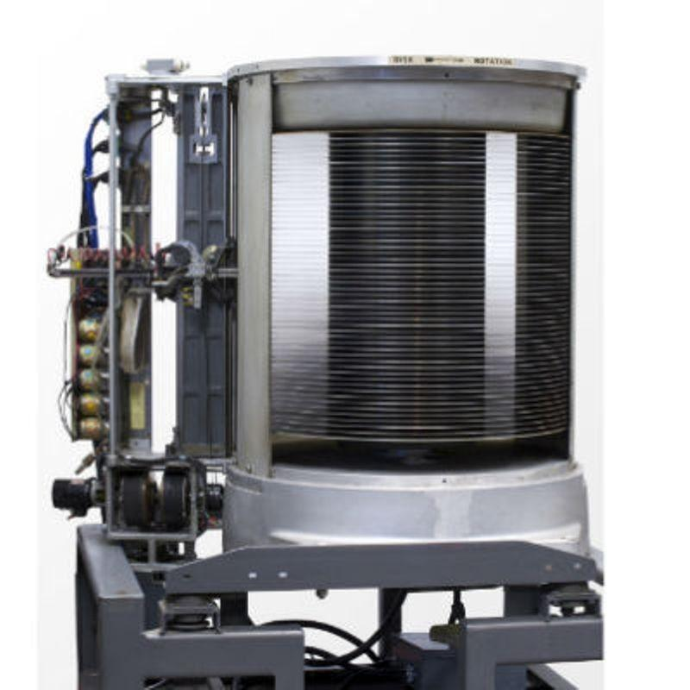
The first hard drive
Types of Hard Drives
Currently, hard drives are divided into 4 major types:
- Parallel Advanced Technology Attachment (PATA)
- Serial Advanced Technology Attachment (SATA)
- Small Computer System Interface (SCSI)
- Solid State Drive (SSD)
These names come from the way they connect to the computer. In this article, I’m now going to elaborate on each of these types of hard drives as concisely as possible.
Parallel Advanced Technology Attachment (PATA)
The PATA hard drives were first introduced to the market by Compaq and Western Digital in 1986. They can have up to 80GB capacity and transfer data as fast as 133 MB/S.
They were named Parallel Advanced Technology Attachment because they use a parallel ATA interface to connect to the computer. Apart from PATA, they are also called Integrated Drive Electronics (IDE) and Enhanced Integrated Drive Electronics (EIDE).
PATA hard drives are made of mechanical moving parts and are based on parallel signalling technology – meaning they transmit multiple bits of data simultaneously.
Serial Advanced Technology Attachment (SATA)
In recent times, a lot of desktop and laptop computers have gotten SATA hard drives because they have superseded PATA hard drives in size, power consumption, and even better pricing.
The mode of connection to a computer remains the same as PATA, but instead of parallel signalling technology for data transmission, they use serial signalling technology. This means that they transfer data one bit at a time.
A notable advantage SATA hard drives have over PATA hard drives is the transmission of data at a rate of 150 – 300 MB/S. In addition, they have thinner cables and a cable limit of 1 meter.
Small Computer System Interface (SCSI)
SCSI hard drives are upgrades over SATA and PATA drives for many reasons such as round-the-clock operations, speed, storage, and several others.
For connection, SCSI hard drives use a small computer system interface – which is a standard for connecting peripheral devices such as printers, scanners, and others.
Best of all, they allow the connection of peripheral devices such as printers, scanners, and other hard drives. In addition, they transmit data at 320 MB/S and you can connect them internally or externally.
Connections through SCSI on personal computers have now been replaced by the Universal Serial BUS (USB). This means that SCSI is no longer used as consumer hardware.
Solid State Drive (SSD)
SSD hard drives are one of the latest hard drive technologies at the time of writing this article.
Unlike the hard drive technologies before SSD drives, they don’t consist of moving parts and they don’t use magnetism for storing data.
Instead, they use integrated circuits (ICs) just like third-generation computers. This makes them more durable, faster, and less prone to damage and corruption.
SSD hard drives have a notable advantage of transferring data at speed of 550 MB/S and allow faster boot times than the types of hard drives before them.

KT0303 Processors and CPUs, processing speeds, operating systems, and controlsnternal Assessment Criteria and Weight
What are Different Types of Processors: Applications and Characteristics

What is a Processor?
Definition: The processor is a chip or a logical circuit that responds and processes the basic instructions to drive a particular computer. The main functions of the processor are fetching, decoding, executing, and write back the operations of an instruction. The processor is also called the brain of any system which incorporates computers, laptops, smartphones, embedded systems, etc. The ALU (Arithmetic Logic Unit) and CU (Control Unit) are the two parts of the processors. The Arithmetic Logic Unit performs all mathematical operations such as additions, multiplications, subtractions, divisions, etc and the control unit works like traffic police, it manages the command or the operation of the instructions. The processor communicates with the other components also they are input/output devices and memory/storage devices.
Types of Processors
There are different types of processors in the embedded system which include the following.
General Purpose Processor
There are five types of general-purpose processors they are, Microcontroller, Microprocessor, Embedded Processor, DSP and Media Processor.
Microprocessor
The general-purpose processors are represented by the microprocessor in embedded systems. There are different varieties of microprocessors available in the market from different companies. The microprocessor is also a general-purpose processor that consists of a control unit, ALU, a bunch of registers also called scratchpad registers, control registers and status registers.
There may be an on-chip memory and some interfaces for communicating with the external world like interrupt lines, other lines for the memory and ports for communicating with the external world. The ports often called the programmable ports that means, we can program these ports either to be acting as an input or as an output. The general-purpose processors are shown in the below table.
S.NO | Processor | Clock Speed | Bus Width | MIPS | Power | Price
1 | Intel Pentium 111 | The clock speed of Intel Pentium 111 processor is 1GHz | The bus width of Intel Pentium 111 processor is 32 | A million instructions per second of Intel Pentium 111 processor is ~900 | The power of this processor is 97 W | $900
2 | IBM PowerPC 750X | The clock speed of the IBM PowerPC 750X processor is 550 MHz | The bus width of the IBM PowerPC 750X processor is 32/64 | A million instructions per second of IBM PowerPC 750X processor is ~1300 | The power of this processor is 5 W | #900
3 | MIPS R5000 | The clock speed of the MIPS R5000 processor is 250 MHz | The bus width of the MIPS R5000 processor is 32/64 | NA | NA | NA
4 | StrongARM  SA-110 | The clock speed of StrongARM  SA-110 processor is 233 MHz | The bus width of StrongARM  SA-110processor is 32 | The million instructions per second of StrongARM  SA-110processor is 268 | The power of this processor is 1 W | NA
Microcontroller
The microcontroller is basically a computer that comes in various packages and sizes. The reading input and responding to output is the basic function of the microcontroller. Generally, it is known as General Purpose Input Output (GPIO). Some of the microcontrollers are Microchip Atmega328-AU, Microchip P1C16F877A-I/P, Microchip P1C16F1503-I/P, Microchip P1C16F671-I/SN, Microchip P1C18F45K22-I/P, etc.
Embedded Processor
An embedded processor is one type of processor which is designed to control mechanical functions and electrical functions. It consists of several blocks they are the processor, timer, an interrupt controller, program memory and data memory, power supply, reset and clock oscillator circuits, system application-specific circuits, ports and interfacing circuits.
Digital Signal Processor
The digital signal processor is one type of processor used for measuring, filtering and/or compress digital or analog signals. The signal processing means analysis and manipulation of signal. This processing can be done via computer or Application Specific Integrated Circuits (ASIC), Field Programmable Gate Array (FPGA) or Digital Signal Processor (DSP) to obtain the clear signal. The DSP processors are used in an oscilloscope, barcode scanners, mobile phones, printers, etc. These processors are fast and use for real-time applications. The typical DSP system is shown in the below figure.
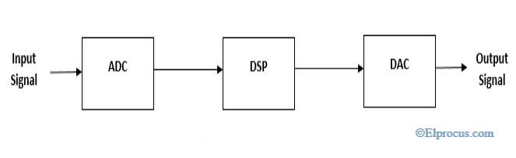
Typical-system-for-digital-signal-processors
The digital signal processors are shown in the below table
S.NO | Processor | Clock Speed | Bus Width | MIPS | Price
1 | T1 C5416  Processor | The clock speed of the T1 C5416 processor is 160 MHz | The bus width of T1 C5416  Processor is 32 | The million instructions per second for T1 C5416  The processor is ~600 | The price of the T1 C5416  The processor is R34
2 | DSP 32C  Processor | The clock speed of the DSP 32C Processor  is 80 MHz | The bus width of DSP 32C  Processor is 32 | The million instructions per second for DSP 32C  Processor is 40 | The price of the DSP 32C  Processor R75
Applications of DSP
The applications of the digital signal processor are
- Speech processing
- Image processing
- Medical processing
- Biometric Processing
- Seismology
- Radar
Media Processor
The image/video processor is the media processor that is designed or created to deal with the data in real-time. The voice user interface and professional audio are the applications of the audio processor. Some of the media processors are TN2302AP IP, IN2602 AP IP, DM3730, DM3725, DM37385, DM388, TMS320DM6467, TMS320DM6431, etc
Application-Specific System Processors (ASSPs)
The application-specific system processor is a semiconductor integrated circuit product used to implements a specific function. The performance, characteristics and die size of the application-specific system processor is the same as the ASIC. The ASSP’s are used in various types of industries to perform video encoding or decoding and audio encoding or decoding. In place of embedded software, the application-specific system processor is used to run the application and it provides the solution faster. Example: IIM7100, W3100A
Application-Specific Instruction Set Processors (ASIPs)
The application-specific instruction-set processors are designed for specific applications. These processors have low power consumption, high computational speed, and good flexibility. Due to programmability, the data path utilization is high in ASIPs, and the performance of this instruction set processor is good.
ASIC Processors
The application-specific integrated circuits are built for specific applications. These chips are small in size and consume low power. The design cost of ASIC is high and this is the main disadvantage. The application-specific integrated circuit chips are used in satellites, modems, computers, etc. Some of the top ASICs manufacturer companies are Ams AG. Listed Company, Bitfury. Private Company, XMOS Semiconductor Private Company, Analogix Semiconductor Private Company, EDAptive Computing Private Company, Lumen Radio Private Company, Integrated Device Technology, Hookit. Private Company, etc.
MultiProcessor
The multiprocessor is a computer with more than one CPU, each shares main memory, a computer bus, and peripherals to simultaneously process the programs and these systems are also known as tightly coupled systems. The advantages of multiprocessors are increased throughput, increased reliability and economy of scale. These processors are used when very high speed is required to process a large volume of data.
Characteristics of Multiprocessors
The Characteristics of Multiprocessor are
- The multiprocessors consist of more than two processors or two processors which are similar
- Memory and input/output facilities shared by the processors
- The access time of the memory is the same for each processor because the processors are connected by bus
- Access to the input/output devices are shared by the processors
- The same function performed by all the processors
FAQs
1). What is a microcontroller?
The microcontroller is an IC (Integrated Circuit) which is designed to perform specific functions in an embedded system.
2). What are the types of microprocessors?
There are five types of microprocessors they are DSP (Digital Signal Processor), ASIC (Application Specific Integrated Circuit), RISC (Reduced Instruction Set Computing), CISC (Complex Instruction Set Computing) and Super Scalar Processor.
3). What is the need of the DSP processor?
The digital signal processors need to filter and compress the signals which are analog and used to detect the errors.
4). What is the core?
The core is the brain of the Central Processing Unit. There are different types of cores they are octa-core, dual-core, quad-core, etc.
5). What is the main memory of the computer?
The Random Access Memory is the main memory in a computer, which is used to store the OS (Operating System) software and the other data files or data for the unit.

• IAC0301 Various types of system components are identified and described
(Weight 5%)

KM-07-KT04 : Motherboards 5%
Learning Outcome
Topic elements to be covered include:
• KT0401 Function of motherboard
• KT0402 Location of primary components
• KT0403 Motherboard chipsets, audio connections, drive activity light, the power light, on/off buttons, and USB connections
KT0401 Function of motherboard
What is the Function of the Computer Motherboard?
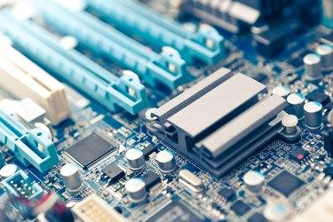
In the world of modern technology, our conception of what a computer is capable of achieving continues to expand at an unprecedented rate of speed. As powerful hardware becomes more lightweight, portable and affordable than ever before, our computing devices are evolving rapidly. Although our expectations of what a computer is capable of may be changing, the central hardware powering these complex operations is not. A computer motherboard is one of the most integral elements of the modern computer, and it has served as the focal point of operations since the days of the first desktop computers. Understanding the motherboard function can help you gain a better idea of how computers work and how all the various technology "under the hood" works together.
The Function of Motherboard Hardware
The motherboard, also referred to as the main circuit board, is considered the home base of many important computer hardware elements, including the central processing unit (CPU), memory, sound cards and other peripheral items. During use, the motherboard establishes vital electronic connections between these various hardware units to ensure that tasks undertaken by the user are completed successfully and efficiently. The process of managing all these connections in real time is demanding on the motherboard. Because of this, cooling fans are often attached to motherboards to help control the temperature and ensure that all hardware remains protected from heat damage.
Exploring Modern Motherboards
One of the most important hardware items attached to the motherboard is the CPU. Typically, motherboards feature a small socket connector somewhere centrally located on the hardware. This socket is intended solely for the computer's CPU. Although much of the additional hardware connected to the motherboard is critical for a computer to function properly, the lack of a CPU renders the computer unable to function at all.
An often overshadowed element of the motherboard that plays a huge role in maintaining successful functionality is the power connector. The power connector on the motherboard usually features 20 or 24 pins and directly connects to the connector on the computer's primary power supply. Once an electrical connection is established between the power supply and the motherboard, the motherboard distributes additional power to all the peripheral hardware connected to it. With that in mind, it can be argued that the motherboard is not only the central hub of information distribution within the computer but also of electrical distribution.

KT0402 Location of primary components
Components of a Computer System
Given below are the 5 components of a computer along with their purpose and functions.
- Input Unit
A computer will only respond when a command is given to the device. These commands can be given using the input unit or the input devices.
For example: Using a keyboard we can type things on a Notepad and the computer processes the entered data and then displays the output of the same of the screen.
The data entered can be in the form of numbers, alphabet, images, etc. We enter the information using an input device, the processing units convert it into computer understandable languages and then the final output is received by a human-understandable language.
- Output Unit
When we command a computer to perform a task, it reverts for the action performed and gives us a result. This result is called output. There are various output devices connected to the computer. The most basic of which is a monitor. Whatever we write using a keyboard or click using a mouse, is all displayed on the monitor.
Thus, the output unit gives us the final result once the entire processing is done within the mechanism of a device.
For example: when we visit an ATM, we enter our details like language, pin, amount to be withdrawn, etc. and then the final money which the cash dispenser releases is our outcome. In this case, the cash dispenser acts as an output unit.
To get a list of computer input and output devices and the function of the various I/O devices, visit the linked article.
For better understanding and more interactive analysis of the components of the computer, candidates can check the video given below and get detailed information reading the five major components responsible for the functioning of a computer device.
- Memory Unit
When we enter the data into the computer using an input device, the entered information immediately gets saved in the memory unit of the Central Processing Unit (CPU). Because of the presence of some existing programming, the Memory Unit transmits the data further to the other parts of the CPU.
Similarly, when the output of our command is processed by the computer, it is saved in the memory unit before giving the output to the user.
- Control Unit
This is the core unit which manages the entire functioning of the computer device. It is one of the most essential components of the computer system.
The Control Unit collects the data entered using the input unit, leads it on for processing and once that is done, receives the output and presents it to the user. It can be said to the centre of all processing actions taking place inside a computer device.
Basically, the instructions taken, interpretation of entered data, issuing signals to execute the data and then finally retrieving the data is all done in the Control Unit.
- Arithmetic & Logical Unit
As the name suggests, all the mathematical calculations or arithmetic operations are performed in the Arithmetic and Logical Unit of the CPU.
It can also perform actions like a comparison of data and decision-making actions. The ALU comprises circuits using which addition, subtraction, multiplication, division and other numerical based calculations can be performed.
Central Processing Unit (CPU)
The Central Processing Unit is the core of any computer devices. It comprises three major components of the computer which have been discussed above:
- Memory Unit
- Control Unit
- Arithmetic and Logical Unit
All these three units are elements of CPU and together help in the efficient working and processing of data. It is also known as the “Brain of Computer” and no action can be conducted by a device without the execution and permission of the Central Processing Unit.
The device is a close-knit circuit comparison microprocessor which helps in fetching the data and proving suitable results to the user. Thus, CPU is the main processing unit of the computer

KT0403 Motherboard chipsets, audio connections, drive activity light, the power light, on/off buttons, and USB connections

Components of Motherboard
In the below section, some of the important components of the motherboard are defined below:
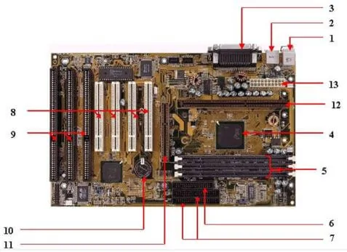
1. Keyboard and mouse
There are mainly 2 types of mouse and keyboard connectors. The first connector is known as PS/2 & the second connector is known as USB.
2. Universal Serial Bus (USB)
The USB port is used for connecting the computer system. In the computer system, there is various type of devices that are connected with the USB port like keyboard, mouse, camera, scanner, printers, and another device. The main use of a USB port is to connect the peripheral devices and computer motherboards. The peripheral device connected to the computer system can be inserted or remove without system restarts that can be the main advantage of a USB port.
3. Parallel port
The old printers that are used in past use the parallel port to connect with the computer system. In the parallel port, multiple wires are used to send or receive multiple bits of the data in a single instance. On the other hand, serial ports use only one wire at a time. In the parallel port, 25 pins female DB type connector is used.
4. CPU chip
The central processing unit is the processor that controls all the functions of the computer system. The overall flow of task and functions are controlled by the central processing unit. For the computer system, the central processing unit is called the brain of the computer system.
5. RAM slots
The RAM slots are used for connecting the RAM (memory) in the computer system. In the general computer system, there are mainly two RAM slots but sometimes there can be four-plus slots in the motherboard to increase the memory of the computer system.
6. Floppy Controller
The older motherboard chip contains a 34-pin type ribbon cable for connecting the computer system with a floppy drive. In this ribbon cable, one end is directly connected with the computer system and one end is connected with the motherboard.
7. IDE controller
The integrated drive electronics are also known as ATA or Parallel ATA. The IDE is the type of component that issued for hard drive control. In today’s computer system, the IDE controller supports is not supported.
8. PCI slot
The full form of PCI is a peripheral component interface. The PCI slot is mainly used to insert the expansion cards on the computer. The other PCI devices can also be connected like a sound card, network card, video, card, modems, and other device3s. In today’s computer system support for PCI expansion slots are not there.
9. ISA slot
Industry-standard architecture (ISA) is defined as standard architecture for expansion bus. The ISA slot issued for connecting input devices and modems.
10. CMOS Battery
The CMOS battery is used for storing the BIOS settings on the motherboard. The CMOS battery is also capable of storing the time and data in it.
11. AGP slot
AGP (Accelerated Graphics slot) is a type of computer slot that is used for attaching the video card to the system. This slot is a high-speed slot so that data transfer can be done at high speed.
12. CPU slot
The CPU slot is a type of port that is used to connect the central processing unit to the motherboard of the computer system.
13. Power supply slot
The power supply slot is used for providing the electric supply to the computer system so that it can start and perform its functions. The total power supply given to the system is around 110 ac power. In the power supply type connector, there are a total of 20-pins that are used to maintain the power supply to the computer system.
Factors of Motherboard
The main form factor for the motherboard is size and shape. The other factors are physical layout, mounting holes, and board organization.
In the below section, some of the form factors are mentioned below:
1. ATX
In this type, the standard locations were defined for mouse, keyboard, input/output devices, video connectors, and other devices. In the year 1990, the ATX form factor was developed. The expansion slot given new location as in this form factor expansion slot were given separate space so that they can be connected with the motherboard.
2. Micro-ATX
The benefit obtained from the Micro-ATX is the same as from the ATX form factor. The main difference is an improvement in system design so that the overall cost of the component can be reduced as the size of the motherboard is reduced in this form factor. The size is reduced by reducing the I/O slots number on the motherboard.
Uses of Motherboard
The motherboard is the main component in the computer system that is used for connecting all the components of the computer system so that they can perform several tasks and functions in the system. The motherboard is considered as the spine of the system as all components are connected to a single circuit board for performing their functions. The motherboard is a costly device and once it gets damaged the user needs to spend a lot of money to buy a new motherboard for a computer system. The motherboard is a central device where all devices are get connected and maintain the flow in the computer system.

Internal Assessment Criteria and Weight

• IAC0401 Understanding of motherboards, primary components and related aspects is demonstrated

(Weight 5%)

KM-07-KT05 : Processors 5%
Learning Outcome

Topic elements to be covered include:
• KT0501 Processors
• KT0502 Terminology
• KT0503 Processor speeds in megahertz and gigahertz
• KT0504 Architecture, including registers, cache memory, virtualization, graphics processing units, throttling, and overclocking
KT0501 Processors
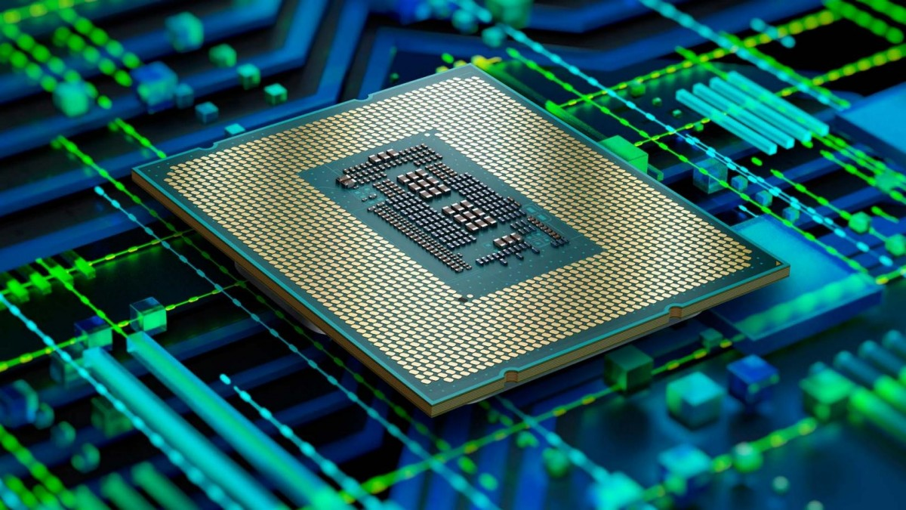
The processor is defined as a logic circuit or simple chip which reacts to fundamental instructions and input processes to operate the computer. The important purposes of a processor are getting, decoding, processing, executing and writing back as feedback to the instructions of the chip. The processor is termed as the brain of any electronic systems that incorporate into a laptop, computers, smartphones, and embedded systems. The control unit and arithmetic logic unit are the two significant components of the processors.
The logic functions can be addition, multiplication, subtraction and division whereas the control unit manages the traffic flow which follows the operation or command according to the input instruction. This processor interacts with the neighbouring component which can be their output, input, storage and memory components.
Different Types of Processors
The different types of processors are microprocessor, microcontroller, embedded processor, digital signal processor and the processors can be varied according to the devices. The important elements of the CPU are labelled as heart elements of the processor and system. The control unit activates, fetches, and execute the input instructions. The processor can be embedded in a microprocessor and comprise of unit IC chip. But some devices are based on multi-core processors. It comprises one or more CPU. It is a typical tiny component with pins embedded on the motherboard. It can also be linked to motherboard with fan and heat sink to disperse the produced heat.
1. Microprocessor
The fundamental process of the system is denoted by a microprocessor incorporated in the embedded systems. There are various types of microprocessors in the market implemented by different enterprises. The microprocessor is a standard processor which comprises of ALU, control unit and club of registers known as control registers, status registers, and scratchpad registers.
It can be on-chip memory and few interfaces can be interacting to the outer world via interrupting lines, and the other can be ports and memory registers to interact with the external world. These ports are often termed as programmable and make them act as output or input. These programs can be fed and modified according to the behaviour of the devices.
A one or two microprocessor can be merged together to form a multiprocessor. The input and output operations and memory are shared by the processors. The access time in the memory register is similar for every processor and every processor are associated by bus. The working and access and their input and output functions are mutually shared by the processor to perform the same function.
2. Microcontroller
The microcontroller is standard which is available in different size and packages. The input reading and reacting to its corresponding output is the fundamental function of the basic microcontroller and so it is called as general-purpose input and output processors (GPIO). Few of the microcontrollers are Microchip P1C16F877A, Microchip Atmega328, Microchip P1C18F45K22, Microchip P1C16F671, and Microchip P1C16F1503.
3. Embedded Processor
The embedded processor is structured to control the electrical and mechanical functions. It comprises of numerous blocks like timer, program memory, data memory, reset, power supply, data memory, interrupt controller, clock oscillator systems, interfacing circuits, specific circuits and system application ports and circuits.
4. Digital Signal Processor
The digital signal processor is used for filtering, measuring, compressing analogue and digital signals. The processing of signal means that manipulation and analysis of digital signals. This process can be made using application specified integration circuits, digital signal processor, field-programmable gate array or it can be a computer to achieve a distinct signal. The processors in DSP are used for barcode scanners, oscilloscope, printers, mobile phones. These processors are used for rapid and implied for real-time applications.
Components of Processor
- The fundamental parts of the processor are control units, arithmetic logic unit, registers, floating points, L1 and L2 cache memory.
- The arithmetic logic unit is comprised of logical and arithmetic functions on the operands in instructions.
- The unit of floating-point is called as numeric coprocessor or math coprocessor. It is a specialized operator which manipulates the numbers in rapid when compared to the operation of basic microprocessor circuits.
- The registers are used to save the instructions and other data to feed the operands to ALU and store the operation result. The L2 and L1 cache memory saves the time of CPU to fetch the data from RAM.
- The primary functions are fetching, decode, write back and execute. The fetch is the function which gets the instruction from memory and feeds to RAM.
- The decode is a process where the instructions can be edited to understand from the other elements of CPU is required to persist in the operation which is done by the instruction decoder. In the execute process, the CPU is required to trigger and carry out the functions.
- Many processors in the market are multi-cored which comprises of multiple IC to enhance the performance of the processor, power consumption is limited, and gives a simultaneous process to perform parallel processing or multiple tasks.
- The installation of multiple cores has separate processors as they are plugged into the one socket and gives a common established connection to make it faster.
- In some computers, it has two or more cores and can be increased to twelve cores. If the CPU can process only with a set of finite commands at one time, and it is called a single-core processor. If the CPU obeys the two instructions at a time then it is called a dual-core processor.
- If it obeys four sets of commands then its called as quad-core processors. If there are more cores, the computer can obey multiple commands simultaneously.
Types of Processors
Few processors are multi-threading that uses the core of the virtualized processor. These processors are also called as vCPU’s. It is not powerful like physical core and is implied to increase the performance in virtual machines. It can add the unnecessary vCPU to affect the consolidate ratio which can be built from four-six built-in one physical core.

KT0502 Terminology
Basic Computer Terminologies
1. CPU
CPU means ‘Central Processing Unit’. This is the place of computer data handling. Moreover, it does all the data manipulation, calculations and formatting data for output. Hence, whenever someone buys a computer, he/she becomes more conscious about the CPU and its capabilities.

The execution of the instructions within the computer system is very fast. It measures it in cycles of time and refers it to as megahertz. That’s why the ‘Mhz’ of a computer’s processor is sometimes referred to as the clock speed. Think about CPUs (and aligned circuitry) beating like a heart, this pulsing/beating is expressed as “MHz” e.g. 2000Mhz.
2. RAM
Specifically, RAM stands for “Random Access Memory” or “Ready Access Memory”. It is a temporary notepad where your computer sends information to disk, or to the storage place of instructions from other input devices. The term “random access” indicates that memory locations in RAM are accessible in any order unlike sequential access of a data cassette tape.
3. Hard-disk Drive
Your computers hard disk drive is like an audio CD that you possess at home – except your computer can read and write to it. In other words, your computer can take data from your hard drive (to process it in the CPU or place it in RAM to work with).
Also, it can record the results of the work it does back to the disk, which is “writing to disk”. The abbreviation HDD stands for “hard disk drive”.
If you open your HDD, you would find a pancake stack on double-sided disks.
4. Floppy Disk
You can also read and write data in a floppy disk. Simply, it is smaller than HDD and portable – you can take it to another computer and read from it there also. Floppy disks are sometimes called “secondary storage devices”. They were known as ‘floppy’ originally because they were 5¼ inches in width and floppy. They could carry almost 720kb of data. Today, however floppy disks are smaller, rigid, and can carry more data like 1.44Mb.
5. Hardware
Hardware is the term referring to all the physical parts in a computer system. It includes the monitor, the keyboard, the mouse, the main case which stores the RAM, CPU and the motherboard.
6. Software
‘Software’ is the term which refers to the instructions needed to make a computer work. It is intangible in nature. The software is also known as a “program”. Also, it is a set of computer files which are used to perform various actions on the computer. You can have a program for ‘word processing’. The software can be transferred to a compact disk and floppy disks, but usually, sit on the computer’s hard drive waiting to be “run”.
KT0503 Processor speeds in megahertz and gigahertz
What Does a Processor Do?
The Processor, also called CPU, is an essential piece of hardware of computer that enables your computer to interact with all of the applications and programs installed on your computer. The processor is able to interpret the program’s instructions and create the output that you interface with when you are using a computer.
The processor provides information and is able to complete tasks that you request when you open an application or make changes to a file because it is made of hardware that works together.
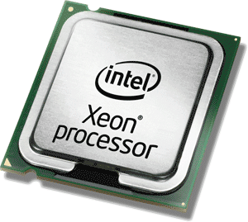
The processor would affect your computer experience since it may perform quickly or slowly. At the same time, computer performance may be decided by the processor cores and clock speed.

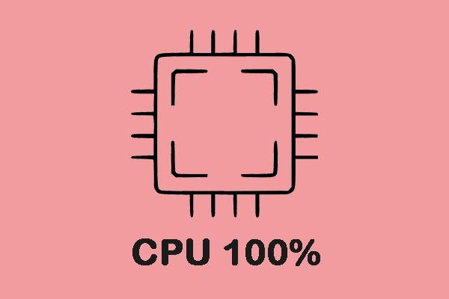
Sometimes your CPU is running at 100% and the speed of your computer becomes slow. This post will provide 8 solutions for you to fix this issue.
What Is Processor Speed?
The computer performance may be influenced by a lot of factors. Computer processor speed would be one of them. The processor is often regarded as the brain of the computer, so ensuring its working properly is very important to the longevity and functionality of your computer.
So, you should know what makes a good processor speed. Usually, the processor cores and clock speed may make a good speed for processor. Therefore, we will show you some information about the CPU cores and clock speeds.
What Are Processor Core and Clock Speed?
Processor Cores and Clock Speed are two different components of the CPU, but they depend on each other and work toward the same goal to improve the computer processor speed so as to improve computer performance.
Processor core is a single processing unit within the computer’s central processing unit. It receives instructions from a single computing task, working with the clock speed to quickly process this information and temporarily store it in the RAM and the permanent information is saved to the hard drive.
In general, most computers have multiple cores so that helps you to complete several tasks at the same time.
The clock speed of a CPU decides how quickly the central processing unit can retrieve and interpret instructions, which helps the computer to complete more tasks by getting them down faster. Clock speed is measured in GHz. If the value is larger, the clock speed is faster.
However, it is difficult to increase the clock speed, so more processor cores are increased to improve computer performance.

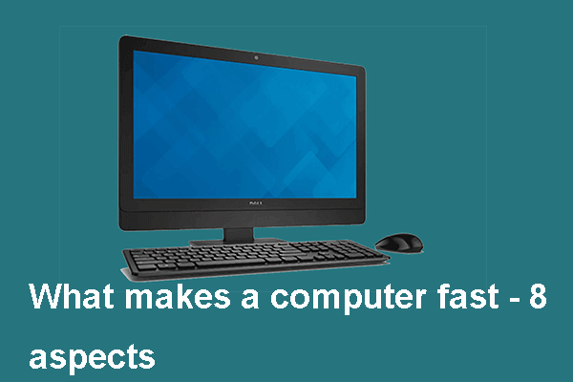
What Makes a Computer Fast? Here Are Main 8 Aspects
What makes a computer fast or do not know how to make computer faster? This post is what you need as it shows the fast computer specs.

What Is a Good Processor Speed for a Laptop or Desktop PC?
After knowing what makes computer processor speed, what is a good processor speed? Read on to know more detailed instructions.
As for most laptops on the market, they have dual-core processors, which is able to meet the needs of most everyday users. Meanwhile, some users use quad-core processors which can improve computer performance.
What is a good speed for processor? If you are a professional or a student, the quad-core processor with up to 4.00 GHz is required. If you are a hardcore gamer, you may need a 6 or 8 core processor. A good processor speed is between 3.50 to 4.2 GHz, but it is more important to have a single-thread performance. In short, 3.5 to 4.2 GHz is a good speed for processor.
KT0504 Architecture, including registers, cache memory, virtualization, graphics processing units, throttling, and overclocking
What is a CPU?
At the heart of the computer there is a unit called the central processing unit (CPU).
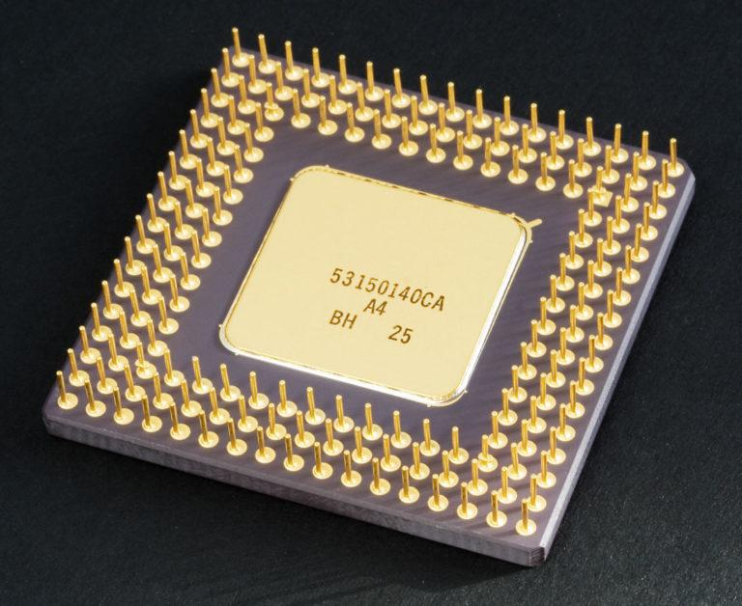
You’ve probably heard of CPUs before. They’re made by companies like Intel, AMD, Fujitsu, Zhaoxin, and Qualcomm, and have technical data associated with them such as Quad Core, 3.2 GHz with 6Mb of cache.

The CPU can be further divided into three main parts: the arithmetic logic unit (ALU), the control unit (CU), and what are known as registers. You will look at these first.
CPU Main Parts
1. Registers
Registers are parts of the CPU that can store data. They operate a little like RAM, but rather than use capacitor-based memory cells, the memory cells are only composed of logic gates. Registers can’t hold as much data as RAM can, but they operate considerably faster.
There are five different types of register within the CPU. The table below gives you some basic details, and you will see how these registers operate in the next section.
Accumulator | AC | Stores the results of calculations
Instruction Register | IR | Stores the address in RAM of the instruction to be processed
Memory Address Register | MAR | Stores the address in RAM of the data to be processed
Memory Data Register | MDR | Stores the data that is being processed
Program Counter | PC | Stores the address in RAM of the next instruction
2. The Arithmetic Logic Unit
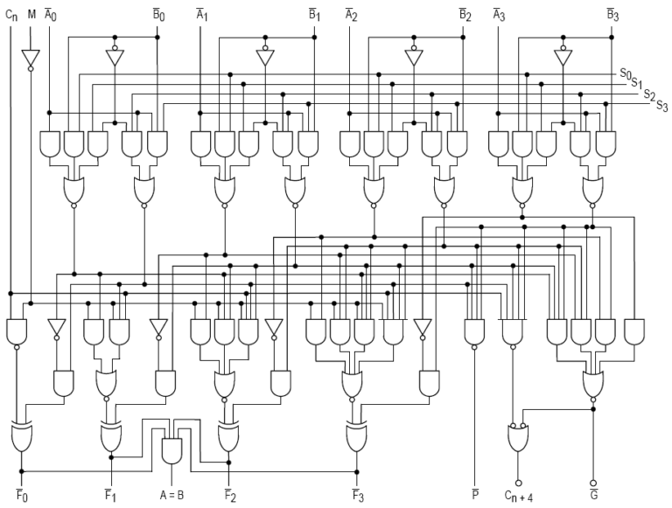
CC BY-SA 3.0, Link
The ALU is the core of the CPU. It is made up of all those logic circuits that you have been learning about for the past three weeks.
The ALU uses these logic circuits to perform a variety of operations. It can perform addition of binary numbers. It can also perform a variety of other arithmetic operations, such as subtraction and incrementation. The ALU can also perform logical operations, such as comparing two binary numbers to see if they are the same or not.
3. The Control Unit
The control unit decodes what each instruction means, and can then controls how the other components operate. So when the control unit receives an instruction, which is just a binary number, it will then signal what the ALU and memory is supposed to do. It might be that the instruction is to add two numbers together, or it might be that the instruction is to store a number in RAM.
The control unit also contains a clock. This is a tiny oscillating crystal, which controls the rate at which calculations are performed by the CPU.
Memory
The RAM stores both the instructions that the computer needs to perform, and the data on which to perform it. The idea of storing both data and instructions in the same memory is the basis of what is known as the stored-program computer. When reading from or writing to RAM, two registers are needed: one to store the address in RAM that is being read from or written to, and another register to store the data itself.
Buses
All of these components are connected together by bundles of wires that are collectively known as buses. So there is a bus to carry data, another for addresses, and another for instructions.
Input and Output
Additionally, a computer would usually have some input and output devices that can receive external data and then output the results of the calculation. This could be something as simple as a data connection, or something more complicated such as a keyboard and monitor.
This method of putting together a computer is known as the Von Neumann Architecture. It was devised by John von Neumann in about 1945, well before any of the components that would be needed to produce it had actually been invented.

Internal Assessment Criteria and Weight
• IAC0501 Understanding of processers and related aspects is demonstrated
(Weight 5%)

KM-07-KT06 : Memory 5%
Learning Outcome

Topic elements to be covered include:
• KT0601 Types of memory: RAM and ROM including DRAM, SRAM, CMOS RAM, and VRAM
• KT0602 Purpose of memory

KT0601 Types of memory: RAM and ROM including DRAM, SRAM, CMOS RAM, and VRAM
Types of RAM
As you've probably noticed, RAM is a sort of universal name for memory. Beyond that, each new name refers more to the mode of operation than an actual type of memory. The "D" in DRAM refers to the dynamic access. The "S" in SRAM and SDRAM refers to synchronizing the chip to the motherboard. EDO RAM refers to the extended data output whereby the column address isn't turned off after a read.
Dynamic RAM (DRAM)
First, dynamic means moving or always changing. In dynamic RAM, electricity always has to be moving through the chip to keep refreshing the memory. DRAM is the basic type of memory chip, and everything that came later was mainly a way to get address information faster. Dynamic also means that data can be moved into or out of memory, over and over again, for as long as power is available.
Data in a DRAM chip is stored in very compact form, with each bit using only its own capacitor and accompanying transistor. Once again, if the capacitor has a charge, the computer reads that as a 1. If it does not have a charge, it's a 0. Capacitors have a tendency to leak their charge fairly quickly. For that reason, they often have to be refreshed. The controller refreshes the DRAM sequentially during any given operation.
Synchronous RAM (SRAM)
SRAM introduced a clock that was actually built onto the memory module. This allows the module to be synchronized to the motherboard clock, introducing the term synchronous, or synchronized memory. Another feature of SRAM chips was that they weren't as dense as DRAM. The chips used a matrix of 6-transistors and no capacitors. Transistors don't require power to prevent leakage, so SRAM didn't have to be refreshed on a regular basis. By staying charged, the data changed only when a register changed, making the chips a lot faster than DRAM.
Because of the extra space in the matrix, SRAM uses more chips than DRAM for the same amount of storage space. Manufacturing costs are higher, so although DRAM was slower, the higher density and lower cost still made them popular in many machines. However, combining the best of both technologies quickly led to the development of SDRAM chips.
CAUTION
L-2 memory caches are usually on SRAM, which is extremely fast (as fast as 7–9 ns and 2–5 ns for ultra-fast SRAM). Level 2 cache is usually installed in sizes of 256KB or 512KB.
SRAM is also used for CMOS configuration setups and requires a small amount of electricity, provided by a backup battery on the system board, to keep its data. It comes on credit-card-sized memory cards, is available in 128KB, 256KB, 512KB, 1MB, 2MB, and 4MB sizes, and has a battery life of 10 or more years.
Synchronous DRAM (SDRAM)
When the concept of synchronizing a memory chip to the motherboard proved successful, the idea was retrofitted to DRAM chips. Synchronous DRAM synchronizes the interrupt requests to the motherboard and works just like SRAM, only with the higher density (and lower cost) of the DRAM chip. Most SDRAM controllers are built into the North bridge of the motherboard chip set.
SDRAM uses the synchronization feature to eliminate the waiting problems between the CPU and the memory controller. When the CPU is ready to access data from memory, it goes to a specified clock point. The CPU knows when operations are going to be completed and when data is going to be available. No wait states means better performance (approximately 20 percent better than EDO memory, in most cases).
As we've seen, DRAM, fast page mode, and extended data output mode all measured memory speeds in nanoseconds (billionths of a second). A 70 ns part would be a "7," a 60 ns part a "6," and so on. The lower the number, the faster the memory. With the introduction of SDRAM, this measurement became less accurate. At such short intervals, per-second time began to lose any real value. Instead, the transfer speed of the front side bus began to make more sense as a measure of speed. For this reason, SDRAM modules began to be rated as 66MHz, 100MHz, 133MHz, 800MHz, and so on.
Rambus DRAM (RDRAM)
RDRAM comes out of technology developed originally by Rambus, Inc., for the Nintendo 64 gaming system. It's not that new, but it seems new because Intel started to use it with its Pentium 4 processors and 800-series chipset. Rambus memory is integrated onto Rambus Inline Memory Modules (RIMMs). The modules use Rambus DRAM (RDRAM) chips. We discuss the Rambus modules later in this chapter.
RDRAM chips are synchronized to the processor's memory bus (not the motherboard clock). Therefore, the processor won't request something at mid tick (the reverse of an interrupt). In DRAM, the CPU is synchronized to the motherboard (which is fairly slow), but the memory chip is not. In SRAM and SDRAM, both the CPU and the memory are synched to the motherboard. In RDRAM, the synchronization is no longer tied to a slow motherboard, but is synchronized to the memory bus. The memory bus clock is derived from the processor, but it still uses a multiplier of the motherboard clock.
Video RAM (VRAM)
VRAM and WRAM have been supplanted by DDR memory chips, but you may find a question about VRAM (pronounced "vee-ram") on the exam. Video RAM was designed to provide two access paths to the same memory address. It's as if VRAM were a café that has two doors, one in the front and one in the back. Information came in one "entrance" at the same time that other information flowed out the other "exit." When the video controller read the memory for information, it accessed an address with one of the paths. When the CPU wrote data to that memory, it accessed the address via the other path. Because of these two access paths, we say that VRAM was dual-ported.
Manipulating graphics is processing-intensive, and so this ability to push data in and out of the chip at the same time helps a moving image appear continuous. VRAM chips were about 20 percent larger than DRAM chips, due to extra circuitry requirements. Modern computers usually have modest graphics processing integrated right onto the motherboard, with the AGP as a convenient way to add an extra video card.
VRAM, WRAM, and AGP
The AGP acronym stands for Accelerated Graphics Port. Most computers include this accelerated port, which is an integrated part of the I/O system. An AGP is not the same thing as VRAM or a video accelerator card, nor is it the same thing as today's integrated graphics. Although some video cards still use the expansion bus, most connect with the port.
To say that a computer has "AGP memory," or "comes with AGP," can be confusing at best. At worst, it can demonstrate a faulty knowledge of the distinction between video memory and I/O subsystems. AGP is discussed in Chapter 7.
WRAM is short for Windows RAM, and has no connection with Microsoft, even though the acronym includes the word "Windows." WRAM, like VRAM, was dual-ported, but used large block addressing to achieve higher bandwidth. Additional features provided better performance than video RAM at lower manufacturing costs. With the advent of AGP and DDR RAM, both video and Windows RAM have faded from the marketplace. That's not to say that add-on graphics accelerator cards have vanished.

KT0602 Purpose of memory
What Are the Functions of Computer Memory?
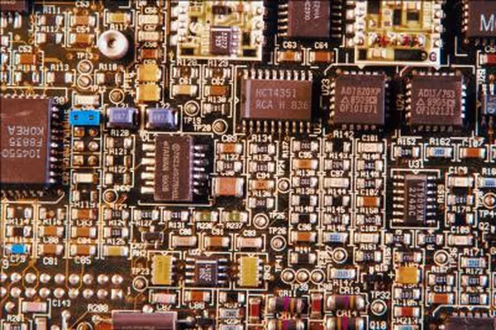
The basic function of computer memory is essentially to store data. Depending on the type of data it stores and the role it plays in computer operation, however, memory performs several different functions. Although all of these functions involve data storage, RAM, ROM, flash memory and hard drives each perform a different and necessary function to keep a computer and its peripherals working.
RAM
Random access memory (RAM) provides temporary application data storage. Instead of having to go back and find information on the hard drive every time a computer needs a piece of data, the computer temporarily stores frequently used files on RAM, making them easier to find. When the computer shuts down, all the data in RAM is erased or transferred to the hard drive, making room for new data when the computer begins operating again.
Hard Drive
A hard drive is core of a computer's data storage. It provides memory space for system and user files -- everything from your operating system to documents and images. In mechanical terms, a hard drive is a rotating disk treated with a magnetic coating, similar to the magnetic ribbons that store data on cassettes. A moving arm reads and copies data to and from the rotating disk, allowing you to open files from the hard disk or save new data.
Flash Memory
Flash memory, the common term for electronically erasable programmable read-only memory (EEPROM), is used in computer video game cards and to store some vital system information. Unlike other memory types that copy or erase data byte-by-byte, EEPROM can edit data in groups of bytes, making it a popular choice for devices like memory sticks and cameras where the data stored is constantly changing. Unlike hard drives, EEPROM does not require a fragile moving arm, prompting some computer manufacturers to move toward replacing hard disks with flash architecture, although the technology remains more expensive than hard disks.
ROM
Read-only memory (ROM) is used to store data that controls the most basic computer functionality, such as starting up, detecting peripherals and operating the computer fan. As the name suggests, the data cannot be edited by the system or users and, unlike RAM, the data stays recorded even when the computer is off. Like hard drives and flash memory, ROM is an example of non-volatile memory -- meaning that it remains in place when the power is off -- while RAM is considered volatile memory.

Internal Assessment Criteria and Weight
• IAC0601 Purpose of memory and how it relates to computer components is described
(Weight 5%)

KM-07-KT07 : BIOS and CMOS 5%
Learning Outcome

Topic elements to be covered include:

• KT0701 BIOS: Basic Input-Output System that runs a computer
• KT0702 Upgrade BIOS
• KT0703 Potential issues
• KT0704 CMOS: Complementary Metal Oxide Semiconductor
• KT0705 CMOS setup, settings, and access
KT0701 BIOS: Basic Input-Output System that runs a computer
What is BIOS?
As your PC’s most important start-up program, BIOS, or Basic Input/Output System, is the built-in core processor software responsible for booting up your system.
Typically embedded into your computer as a motherboard chip, the BIOS functions as a catalyst for PC functionality action.
Programmed on an erasable, programmable, read-only memory (EPROM) chip, BIOS is stored on this memory chip which retains data when the power source is switched off. When the PC is powered back on, BIOS retrieves that same stored data.
The BIOS system is also responsible for managing data flow between your computer’s operating system and any attached devices including a hard drive, keyboard, video adapter, printer, or mouse.
Each time you power your PC on, BIOS runs through a process called Power-On Self-Test, or POST, that determines whether your attached devices are operating correctly and are in their proper place.
Once all attachments are allocated and given the OK, your computer start-up continues as usual and takes you to your load screen in a matter of seconds.
If BIOS detects any problems, an error screen will appear or a series of beep codes will sound, effectively indicating to you that something has gone wrong.
New developments in BIOS technology
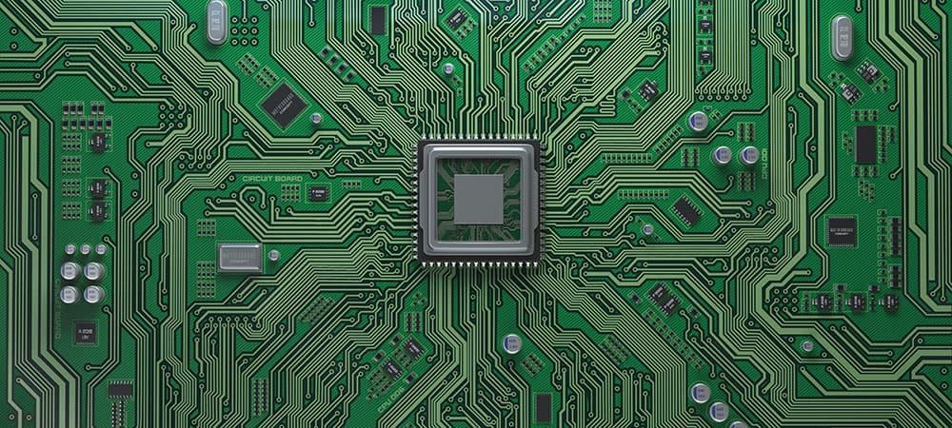
BIOS software has existed within computers since the 1980s and has made plenty of leaps and strides when it comes to efficiency and improvement. However, with the rapid speed of technological evolution, BIOS has become outdated and presents a number of roadblocks for today’s tech.
Newer PCs capable of handling several terabytes of storage prove to be too complex for weaker BIOS software. Limited to 16-bit processor modes and booting drives of 2.1TB or less, newer computers are usually equipped with 3TB drives or more.
Thus, the UEFI was born out of necessity for higher-powered booting. The new standard of BIOS accommodates the limitations the old BIOS system couldn’t work around. UEFI, or Unified Extended Firmware Interface Forum, can run in 32-bit or 64-bit modes and theoretically handle drives up to 9.4 zettabytes.
Not only is UEFI a BIOS replacement, but it also functions as a mini operating system that runs on top of your PC’s integrated firmware.
In essence, whether your computer is powered on by BIOS or UEFI, it is this software that you count on for fast boot times and proper processing functionality. Being able to access your PC’s BIOS allows you to perform regular maintenance for healthy computer upkeep.
What are the basic functions of BIOS?
Now that you understand what BIOS is, let’s dive into what it really does for your desktops, laptops, and tablets. BIOS’s functionality can be broken down into four key responsibilities.
1. POST
As we mentioned before, POST is an acronym for the Power-On Self Test that your PC runs through the moment you turn it on. POST tests the hardware of your PC and ensures that there is nothing out of order and no errors present with your operating system.
POST goes through everything from your keyboard and disk drive to your RAM speed in a computer and integrated ports. Should everything be in order, POST will continue as usual and allow your PC to boot normally.
If there is a detected error, BIOS will issue an error message that may come in the form of displayed text or a series of error-indicating beeps.
These beeps are always signals to certain messages, so if you happen to get this result, you will need to check out what it means for your computer’s hardware [1].
2. CMOS setup
Your PC stores all low-level settings like system time and hardware configuration within its CMOS.
This means that every change you make to your BIOS structure is saved on this special memory chip called the Complementary Metal-Oxide Semiconductor, or CMOS. The CMOS setup is responsible for setting your password, time, and date.
3. Bootstrap loader
The program that lives within your computer’s EPROM or ROM, the bootstrap loader is tasked with reading your PC’s hard drive boot sector to move along the complete operating system load.

When you restart your PC, the bootstrap loader activates the POST, then loads Windows 10 into memory. Newer PCs have replaced the bootstrap loader with an EFI, or Extensible Firmware Interface.
4. BIOS drivers
BIOS drivers are the many programs stored in your computer’s many memory chips. These low-level drivers are used to boot your system and prompt basic operational controls on your PC.

KT0702 Upgrade BIOS
How to Update Your Computer's BIOS
In general, your computer's basic input/output system shouldn't need to be updated that often, but sometimes you have to view or even edit your computer's BIOS.

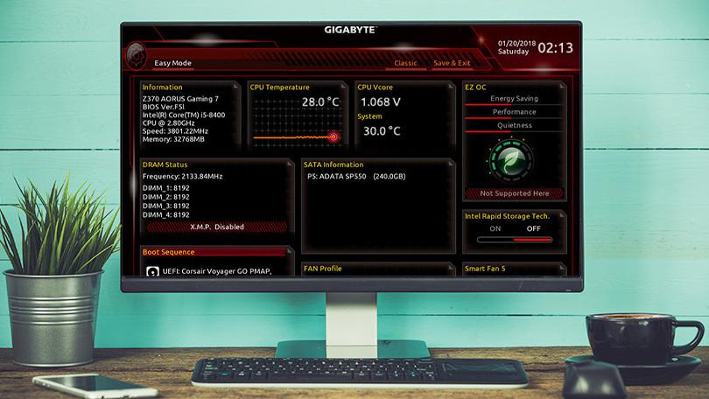
Your computer's basic input/output system—or BIOS—lives in a small chip on your motherboard, and manages the most basic instructions that allow your computer to boot into an operating system. From time to time, your PC's manufacturer may offer updates to the BIOS with certain improvements. Here's how to install them.
In general, you shouldn't need to update your BIOS that often. Installing (or "flashing") a new BIOS is more dangerous than updating a simple Windows program, and if something goes wrong during the process, you could end up bricking your computer. I don't mean to be all doom-and-gloom about it. I've never had a problem updating my BIOS, and I've done it plenty of times, but it's important to be careful.
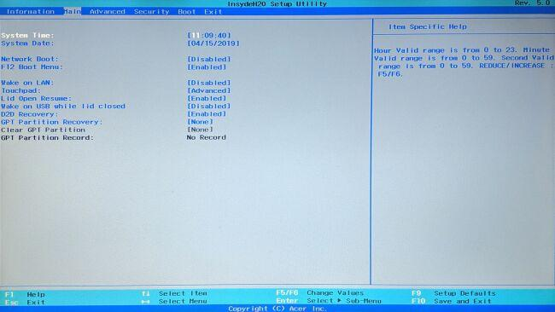
Since BIOS updates don't usually introduce new features or huge speed boosts, you probably won't see a huge benefit anyway. Unless the latest BIOS comes with security patches, support for new hardware you plan to use, or fixes a bug that's been plaguing your daily usage, you're best off leaving it alone altogether. If you fall into one of those categories and need to update your BIOS, though, here's how to do it.

KT0703 Potential issues
When you purchase a PC from SilentPC.com, you can rest assured that we not only choose the most reliable components, but we thoroughly test every part in our PCs. When our customers add products or change BIOS settings independently of us, errors can occur. SilentPC.com cannot be held responsible for parts added to systems by customers, or custom BIOS work done by customers or technicians other than ourselves.
However, if you run into BIOS problems, the following are the most common reasons for BIOS errors and computer instability that we have run into, and how to update your BIOS in order to fix the following problems.
1 | BIOS Error - Failed to Overclock
The Failed to Overclock error screen shows up whenever your BIOS settings have been cleared, and usually has nothing to do with actually overclocking your system, unless you just tried to overclock your system. Some common occurrences which cause this error to arise are:
- Your system has been physically moved
- Your CMOS battery is failing
- Your system is having power issues
- Overclocking your RAM or CPU (we do not overclock our parts)
- Adding a new device which is defective
We do not recommend overclocking any part in your Quiet PC. Overclocking the RAM or CPU is not something we support, because you are basically telling your PC to send more power to the CPU or RAM than the component was designed for in order to increase speed and performance. Overclocking diminishes the life expectancy of your PC, and can damage PC components (when done incorrectly). When using a silent PC, generally speaking, you are already dealing with higher temperatures than you would with a standard build. Overclocking exponentially increases those heat levels in your PC, putting more wear and tear on your components.

2 | BIOS Error - Failed Device
Failed Device is the second most common instance of a bios error screen (besides overclocking your PC). This happens when a new flash drive, USB device, or hard drive is connected to your PC. Most of the time adding a new flash drive or hard drive to your PC should not be an issue, since all of the ports in our PCs are tested thoroughly. Yet, we cannot test every component or piece of equipment customers choose to add to their machine, later on down the road.
Failed USB drives and USB devices, or bad hard drives commonly cause this type of error screen. If you encounter this BIOS error immediately after connecting a new device to your PC, simply disconnect the device and reboot to see if the error continues. If everything works well after the new device is removed, then you can assume that the new device was defective or unstable.
If you’ve added a new piece of equipment, first disconnect and reboot it, to see if the error continues to reoccur. If the error is not present when the new device is removed, then there could be an incompatibility issue between the new device and your system, or the new device may be defective. Connecting the device to another computer will help you know if the device is defective or not.
If you have purchased a PC from us and you run into this type of bios error screen without adding a new device to your PC, please feel free to contact us at support@silentpc.com since there could potentially be a bigger problem behind the BIOS error screen.
How To Restore BIOS to Factory (SilentPC.com) Settings
If your BIOS settings have been reset, or if you’ve attempted to overclock your PC and your PC failed, you may need to set the BIOS back to its optimized default settings. Setting your BIOS back to original settings is also referred to as restoring your BIOS settings. SilentPC.com (Cool Tech PC) saves all of our BIOS settings under the BIOS profiles tab, which most modern motherboards support. Simply load any of the pre-saved profiles under the profiles tab (unless you have altered one of those profiles) to reset everything back to the way it was when we sent the PC out.
Load BIOS defaults
Below is a quick guide on how to load your bios profiles:
- Login into the BIOS by hitting the Delete or F2 key (depending on your motherboard) during your computer's boot process (when you see the BIOS screen pop up).
- Navigate to the Tools Tab.
- You should see an item called Profile. Simply use one of the profiles to load the settings your machine initially had when you first received it.
- Hit the F10 key or select the "Save and Reset" option. Your Bios Settings should now revert back to how it was originally setup by us.

3 | BIOS Error - CPU Fan Error
Many customers run into an error that tells them that the CPU fan has an error. This is usually just because our silent fans spin slower than normal fans. We’ve designed our machines to be as quiet as possible, and some of our designs have no moving parts in them at all.
This error most often occurs when the settings in the BIOS have been reset, often due to an improper shut down or a power outage. By default, we disable the CPU fan speed sensors because the motherboard will think that the fans are dying (even though we are just using slower fans than a standard build). We recommend checking in the BIOS under the Hardware Monitor section to verify that the CPU fan is actually spinning if you receive this error. Yet, we still recommend turning the fan sensor off in the BIOS because all of our quiet CPU coolers.
Because there are so many different types of BIOS versions, we cannot provide step-by-step instructions on how to do this. Almost all of the fan settings in the BIOS are going to be located in the hardware/monitor section of the BIOS. Please consult your motherboard manual for detailed instructions on how to navigate your BIOS. If you have purchased your PC from us, and are not sure how to proceed when you receive this error, please contact us at support@silentpc.com, so we can further assist you.
BIOS Solutions | CPU Fan Error Solution
Seeing this CPU Fan Error should prompt you to push the F1 key which in turn will load the BIOS screen. You should make sure that all of the fan’s sensors are turned off in the hardware monitor section by manually turning the fan speed sensors off. The easiest way to reset everything is to load from one of the profiles which we’ve preset in the BIOS. This should set everything back to where we originally had it. Please note: this feature is only available on motherboards that support UEFI, and that you should still consult a technician if the problem persists or if you need help.

4 | BIOS Error - Boot Device Error
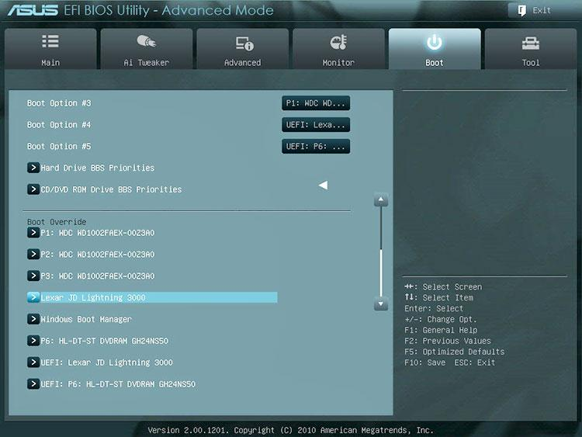
A Boot Device Error is a common occurrence among modern motherboards (which support UEFI). The DVD drive or hard drive may be set to boot as a UEFI (Unified Extensible Firmware Interface) and may not always work. UEFI utilizes the GPT partition scheme (globally unique identifiers partition table), and is far superior to that of the older MBR (master boot record). UEFI is almost always the default on modern motherboards, but this setting has been known to change when new devices are connected to the PC. Bottom line: booting off a DVD or hard drive may not always work when set to UEFI, and it is suggested to make sure that the primary boot device is either the DVD or hard drive, and not the UEFI DVD variant if you are having issues.
BIOS Solutions | Boot Device Error Solution
There are quite a few more options in the boot menu of a modern motherboard, than that of an old generation motherboard. Scrolling down on the boot page will list the primary DVD and hard drive boot options. Scrolling down even further will list the DVD boot options and the hard drive boot options. Simply select the DVD boot option, if you’re trying to boot off of the DVD drive, and make sure that UEFI is not at the top of the list. The same setting should be applied to the hard drive boot options. Once these setting are saved, you should be able to boot off of the DVD drive or hard drive, with no issues. You can almost always use the Quick Boot option (Typically the F8 key) which will allow you to quickly choose which device you would like to boot off of.

KT0704 CMOS: Complementary Metal Oxide Semiconductor
CMOS (complementary metal-oxide semiconductor) is the semiconductor technology used in the transistors that are manufactured into most of today's computer microchips. Semiconductors are made of silicon and germanium, materials which "sort of" conduct electricity, but not enthusiastically. Areas of these materials that are "doped" by adding impurities become full-scale conductors of either extra electrons with a negative charge (N-type transistors) or of positive charge carriers (P-type transistors). In CMOS technology, both kinds of transistors are used in a complementary way to form a current gate that forms an effective means of electrical control. CMOS transistors use almost no power when not needed. As the current direction changes more rapidly, however, the transistors become hot. This characteristic tends to limit the speed at which microprocessors can operate.

KT0705 CMOS setup, settings, and access
How to Access the CMOS Setup Program

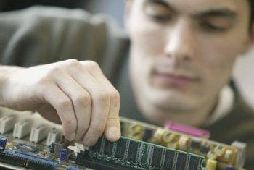
The CMOS and BIOS setups are both specified in the system BIOS. Some computer manufacturers refer to this setup menu as the BIOS setup, while others refer to it as the CMOS setup. The difference between the BIOS and CMOS lies in the function of each component on the motherboard. CMOS is the component that remembers your system settings when you power the computer down, while BIOS contains the settings for the boot-up process. You configure both groups of settings through the same setup menu.

- Press “Windows-C” to display the Charms menu.
- Click the “Settings” icon to open the Settings menu.
- Click the “Change PC Settings” link at the bottom of the menu.
- Click the “General” option in the left navigation panel, and then click the “Restart Now” button in the right panel. The computer boots up and displays the Windows 8 boot screen.
- Click the “Troubleshoot” option, and then click “Advanced Options” in the Troubleshooting menu.
- Click the “UEFI Firmware Settings” option.
- Click “Restart” to restart the computer and enter the BIOS.
- Navigate through the menu to the desired settings page using the directional arrows and the Page Down and Page Up keys. Select items by highlighting the desired option, and then pressing the "Enter" key. Set the BIOS and CMOS options to your liking.
- Press the “Esc” key to open the Exit dialog box. Navigate to “Save Settings and Exit” or a similar option, and then press the “Enter” key to save your BIOS/CMOS settings.
- Reboot the computer to implement the modified settings.

Internal Assessment Criteria and Weight
• IAC0701 Understanding of BIOS and CMOS operations is demonstrated
(Weight 5%)

KM-07-KT08 : Hard drives and storage devices 5%
Learning Outcome

Topic elements to be covered include:

• KT0801 Hard drives and storage devices
• KT0802 Installing discs, formatting discs, partitioning discs, troubleshooting disks, as well as IDE, SCSI, and SATA
• KT0803 Parts of a hard disk, such as platters, tracks, sectors, clusters, and cylinders
• KT0804 Installing IDE devices

KT0801 Hard drives and storage devices
What Does Hard Disk Drive (HDD) Mean?
A hard disk drive (HDD) is a non-volatile computer storage device containing magnetic disks or platters rotating at high speeds. It is a secondary storage device used to store data permanently, random access memory (RAM) being the primary memory device. Non-volatile means data is retained when the computer is turned off. A hard disk drive is also known as a hard drive.
Hard Disk Drive (HDD)
A hard drive fits inside a computer case and is firmly attached with the use of braces and screws to prevent it from being jarred as it spins. Typically, it spins at 5,400 to 15,000 RPM. The disk moves at an accelerated rate, allowing data to be accessed immediately. Most hard drives operate on high-speed interfaces using serial ATA (SATA) or serial attached technology. When the platters rotate, an arm with a read/write head extends across the platters. The arm writes new data to the platters and reads new data from them. Most hard drives use enhanced integrated drive electronics (EIDE) including cables and connectors to the motherboard. All data is stored magnetically, allowing information to be saved when power is shut off.
Hard drives need a read only memory (ROM) controller board to instruct the read/write heads how, when and where to move across the platters. Hard drives have disks stacked together and spin in unison. The read/write heads are controlled by an actuator, which magnetically reads from and writes to the platters. The read/write heads float on a film of air above the platters. Both sides of the platters are used to store data. Each side or surface of one disk is called a head, with each one divided into sectors and tracks. All tracks are the same distance from the centre of the disk. Collectively they comprise one cylinder. Data is written to a disk starting at the furthest track. The read/write heads move inward to the next cylinder once the first cylinder is filled.
A hard drive is divided into one of more partitions, which can be further divided into logical drives or volumes. Usually a master boot record (MBR) is found at the beginning of the hard drive and contains a table of partition information. Each logical drive contains a boot record, a file allocation table (FAT) and a root directory for the FAT file system.

KT0802 Installing discs, formatting discs, partitioning discs, troubleshooting disks, as well as IDE, SCSI, and SATA
Preparing a Hard Disk for Use
Preparing a hard disk for use in your PC is the process by which you set up the drive so that it can hold your data (everything from Windows to programs and documents files). Usually, you’ll only need to go through this process when installing a new drive. Occasionally, however, you might decide it’s time to give your PC a fresh start, by erasing everything on your drives, re-preparing them, and installing fresh copies of your software. (If you ever decide to do this, be very sure that you’ve backed up any essential data to another storage medium.)
If you have a PC made by one of the big PC producers, such as HP/Compaq, Dell, IBM, and so on, you probably received a restore CD or two (or sometimes instructions on how to make them using files stored in a hidden partition on your hard disk). A restore CD or restore partition can work in one of two ways:
- Most restore CDs restore the computer's original software, wiping out your data and other personal information in the process.
- Some restore CDs can also repair Windows and applications without wiping out your data.
If you have serious enough problems to justify using a restore CD, make sure you know how yours works or else watch your data vanish!
In most PCs, the system BIOS handles configuration duties for ATA/IDE hard disk drives (the standard type of hard drive found in most systems). Many recent systems also support SATA hard disk drives through the system BIOS.
Preparing either of these types of hard disks requires the use of your operating system’s disk preparation utilities (Disk Management in Windows XP or Windows 2000; FDISK and FORMAT in Windows 9x/Me). These programs process the disk according to what the system or SCSI BIOS report. If the system BIOS is not configured properly, an ATA/IDE drive will not be recognized at its full capacity.
Most systems are set to auto-detect the capacity of ATA/IDE or SATA hard disks when you install them and turn on the computer; this type of hard disk configuration is the most common type. You can determine if your version of Windows can view the entire capacity of the drive during the disk preparation process.
Preparing an Additional Hard Disk with Windows XP
The process of installing a hard disk varies according to whether the drive is being added to your computer or is being installed as a replacement. The process described in this section assumes that you are adding an additional hard disk to your existing computer.

What Does Disk Formatting Mean?
Disk formatting is the configuring process of a data storage media such as a hard disk drive, floppy disk or flash drive for initial usage. Any existing files on the drive would be erased with disk formatting. Disk formatting is usually done before initial installation or before installation of a new operating system. Disk formatting is also done if there is a requirement for additional storage in the computer.
Disk Formatting
Disk formatting can be performed on both magnetic platter hard drives and solid-state drives. The formatting comprises low-level formatting, partitioning and high-level formatting. Low-level formatting aids in preparing the physical structure on the storage media. The partitioning process involves the division of the hard drive into logical volumes for data storage. High-level formatting helps in creating the file system format within the logical volume or within the disk partition. Disk formatting is usually done with the help of a disk formatting utility.
While preparing the hard drive for initial use, disk formatting checks for errors in the drive. It can scan and repair bad sectors. Another benefit associated with disk formatting is its capability to erase bad applications and remove sophisticated viruses.
Disk formatting is an action which must be done with caution. As it deletes data and removes programs installed, backup of the necessary data or applications are required. Disk formatting takes time. Frequent disk formatting can gradually decrease the life of a hard drive.

KT0803 Parts of a hard disk, such as platters, tracks, sectors, clusters, and cylinders
Hard Disk Drive Basics
A hard disk is a sealed unit containing a number of platters in a stack. Hard disks may be mounted in a horizontal or a vertical position. In this description, the hard drive is mounted horizontally. Electromagnetic read/write heads are positioned above and below each platter. As the platters spin, the drive heads move in toward the centre surface and out toward the edge. In this way, the drive heads can reach the entire surface of each platter.
Each disk consists of platters, rings on each side of each platter called tracks, and sections within each track called sectors. A sector is the smallest physical storage unit on a disk, almost always 512 bytes in size.
Figure below illustrates a hard disk with two platters. The remainder of this section describes the terms used on the figure.
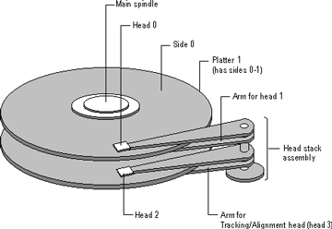
Two plated hard disk
The cylinder/head/sector notation scheme described in this section is slowly being eliminated. All new disks use some kind of translation factor to make their actual hardware layout appear as something else, mostly to work with MS-DOS and Windows 95.
Tracks and Cylinders
On hard disks, the data are stored on the disk in thin, concentric bands called tracks. There can be more than a thousand tracks on a 3½ inch hard disk. Tracks are a logical rather than physical structure, and are established when the disk is low-level formatted. Track numbers start at 0, and track 0 is the outermost track of the disk. The highest numbered track is next to the spindle. If the disk geometry is being translated, the highest numbered track would typically be 1023. Next figure shows track 0, a track in the middle of the disk, and track 1023.
A cylinder consists of the set of tracks that are at the same head position on the disk. In a figure below, cylinder 0 is the four tracks at the outermost edge of the sides of the platters. If the disk has 1024 cylinders (which would be numbered 0-1023), cylinder 1023 consists of all of the tracks at the innermost edge of each side.
Most disks used in personal computers today rotate at a constant angular velocity. The tracks near the outside of the disk are less densely populated with data than the tracks near the centre of the disk. Thus, a fixed amount of data can be read in a constant period of time, even though the speed of the disk surface is faster on the tracks located further away from the centre of the disk.
Modern disks reserve one side of one platter for track positioning information, which is written to the disk at the factory during disk assembly. It is not available to the operating system. The disk controller uses this information to fine tune the head locations when the heads move to another location on the disk. When a side contains the track position information, that side cannot be used for data. Thus, a disk assembly containing two platters has three sides that are available for data.
Sectors and Clusters
Each track is divided into sections called sectors. A sector is the smallest physical storage unit on the disk. The data size of a sector is always a power of two, and is almost always 512 bytes.
Each track has the same number of sectors, which means that the sectors are packed much closer together on tracks near the centre of the disk. Next figure shows sectors on a track. You can see that sectors closer to the spindle are closer together than those on the outside edge of the disk. The disk controller uses the sector identification information stored in the area immediately before the data in the sector to determine where the sector itself begins.
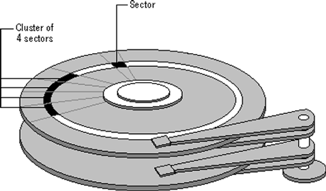
Clusters and sectors
As a file is written to the disk, the file system allocates the appropriate number of clusters to store the file's data. For example, if each cluster is 512 bytes and the file is 800 bytes, two clusters are allocated for the file. Later, if you update the file to, for example, twice its size (1600 bytes), another two clusters are allocated.
If contiguous clusters (clusters that are next to each other on the disk) are not available, the data are written elsewhere on the disk, and the file is considered to be fragmented. Fragmentation is a problem when the file system must search several different locations to find all the pieces of the file you want to read. The search causes a delay before the file is retrieved. A larger cluster size reduces the potential for fragmentation, but increases the likelihood that clusters will have unused space.
Using clusters larger than one sector reduces fragmentation, and reduces the amount of disk space needed to store the information about the used and unused areas on the disk.
The stack of platters rotates at a constant speed. The drive head, while positioned close to the centre of the disk reads from a surface that is passing by more slowly than the surface at the outer edges of the disk. To compensate for this physical difference, tracks near the outside of the disk are less-densely populated with data than the tracks near the centre of the disk. The result of the different data density is that the same amount of data can be read over the same period of time, from any drive head position.
The disk space is filled with data according to a standard plan. One side of one platter contains space reserved for hardware track-positioning information and is not available to the operating system. Thus, a disk assembly containing two platters has three sides available for data. Track-positioning data is written to the disk during assembly at the factory. The system disk controller reads this data to place the drive heads in the correct sector position.

KT0804 Installing IDE devices
How to Install IDE Hard Drive and Troubleshoot IDE Hard Drive Problems?
This guide is for installing an IDE drive. If you're opening up something an OEM machine you could be voiding your warranty, so check first.
When you try to install a really big hard drive into a lot of older systems, you'll find that the BIOS is only capable of seeing 137 GB. On even older mainboards you'll find a 32 GB limit. To get around this you'll want to use that install disk that came with the hard drive or if you're a relatively advanced user a BIOS update should be available. The install disk comes on a floppy so if you don't have one then you'd better be able to do a BIOS update.
Directly jump to the process you're most interested to get ready to install IDE hard drive:

Internal Assessment Criteria and Weight
• IAC0801 An understanding of hard drives and storage devices and components is demonstrated
• IAC0802 Installing procedures are explained
(Weight 5%)

KM-07-KT09 : Power supplies and voltage 5%
Learning Outcome

Topic elements to be covered include:

• KT0901 Power supply units, uninterruptible power supplies
• KT0902 Identifying power supplies
• KT0903 Amps, ohms, volts, and watts
• KT0904 Affecting system hardware and components

KT0901 Power supply units, uninterruptible power supplies
Redundant Power Supply vs Uninterruptible Power Supply (RPS vs UPS)

Have you ever seen redundant power supplies (RPS) in the servers or some switches, such as Cisco switches, HPE servers, etc.? What is the difference between RPS and ordinary power supply?
Maybe you know the meaning and application of RPS, but do you know UPS, the Unplugged power supply?
In this article, let’s discuss the difference between RPS and UPS.
Redundant power supply
The redundant power supply (RPS) is a kind of power supply used in the server. It is composed of two identical power supplies. The chip control power supply performs load balancing. When one power supply fails, the other power supply can take over its work immediately. Replace the power supply. Later, two power supplies work together. The redundant power supply is to achieve high availability of the server system. In addition to servers, disk array systems are also widely used.
The RPS power supply (Redundant Power System) is used as an external DC power supply for some switches.
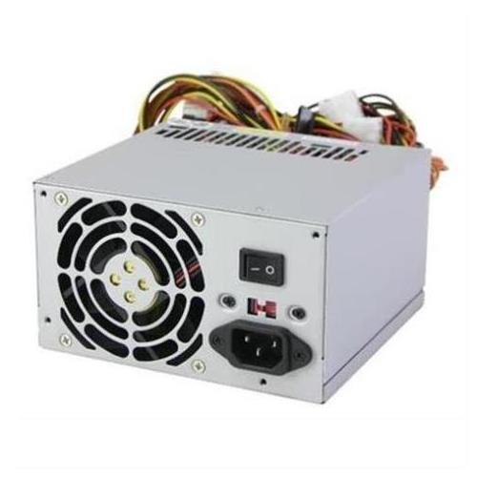
RPS can be used as a redundant power supply for switches or routers:
If the RPS and the power receiving equipment use the same AC power supply system, when the internal power supply of the power receiving equipment is abnormal, the RPS can continue to supply DC power to the failed equipment to ensure the continuous normal operation of the equipment;
If the RPS and the powered device use different AC power supply systems, DC power supply can continue to be provided when the external AC power supply of the powered device fails, ensuring continuous normal operation of the device.
Uninterruptible Power Supply
UPS, that is, uninterruptible power supply, is a system device that connects the battery (mostly lead-acid maintenance-free battery) to the host, and converts the DC power into commercial power through the module circuit of the host inverter. It is mainly used to provide a stable and uninterrupted power supply to a single computer, computer network system or other power electronic equipment such as solenoid valves and pressure transmitters.

When the mains power input is normal, the UPS supplies the mains power to the load after it is stabilized. At this time, the UPS is an AC power stabilizer, and it also charges the battery in the machine; when the mains power is interrupted (accident power outage), the UPS immediately supplies the DC power of the battery to the load through the inverter switching method to continue to supply 220V AC power to the load to maintain normal work and protect the load software and hardware from damage. UPS equipment usually provides protection against too high or too low voltage.
UPS is the third generation developed with brand-new digital technology to meet the reliability requirements of power supply for network monitoring, network systems, medical systems, etc., to overcome the increasingly poor power grid environment caused by the centralized power supply of medium and large computer network systems. Industrial frequency pure online intelligent UPS. A DC power supply is a device that maintains a constant current in the circuit. Such as dry batteries, accumulators, DC generators, etc.
UPS and DC power supply are important power supply equipment for enterprises. The traditional maintenance management includes:
① daily inspection appearance, regular replacement of wearing parts such as batteries, filter capacitors, fans, etc., and battery activation during overhaul;
② modification or use of replacement equipment, Use advanced tools to test battery performance. This kind of management method has high investment costs, heavy maintenance staff workload, it is not easy to grasp the equipment operating status and key data in real time, and the equipment accident prevention ability is low. Implementing online maintenance management can avoid the shortcomings of traditional methods and obtain good benefits.
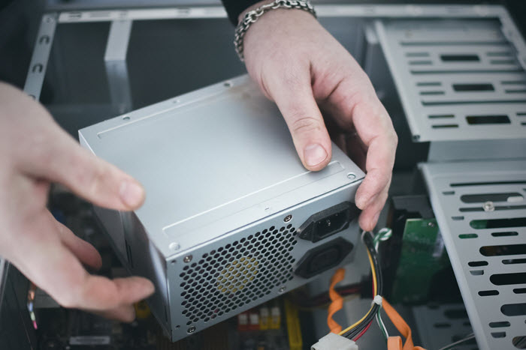
The difference between Redundant power supply and UPS power supply
Power redundancy can be adopted in capacity redundancy, redundant cold backup, parallel current sharing N 1 backup, redundant hot backup and other methods. Capacity redundancy means that the maximum load capacity of the power supply is greater than the load, which is of little significance for improving reliability.
Redundant cold backup means that the power supply is composed of modules with multiple functions, which are normally powered by one of them. When it fails, the backup module immediately starts to work. The disadvantage of this method is that there is a time interval for power switching, which causes a voltage gap.
N 1 backup mode with parallel current sharing means that the power supply is composed of multiple units, and each unit is connected in parallel through an OR gate diode, and each unit supplies power to the equipment. This scheme will not affect the power supply of the load when a power supply fails, but will affect the unit when the load end is short-circuited. Redundant hot backup means that the power supply is composed of multiple units and works, but only one of them supplies power to the equipment, and the other is no-load. When the main power fails, the backup power can be immediately turned on, and the output voltage fluctuation is very small.
For a long-term uninterrupted operation, highly reliable systems, such as base station communication equipment, servers, etc., often highly reliable power supply. Redundant power supply design is a key part of it and plays an important role in high systems. The redundant power supply is configured with 2 power supplies. When one power supply fails, other power supplies can be turned on immediately without interrupting the normal operation of the equipment. This is similar to the working principle of the UPS power supply: when the mains power is cut off, the battery replaces the power supply.
The difference between a redundant power supply and a UPS is mainly powered by different power supplies, while the UPS is powered by one power supply and the other is backed up at any time, sometimes automatically switched.
KT0902 Identifying power supplies
How to find the size of a computer power supply

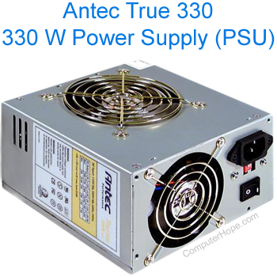
Unfortunately, your power supply does not interact with your motherboard in any way that would communicate its model information. Consequently, you can only determine the total output of a power supply by physically examining it. All power supplies, like the one shown to the right, have a sticker that gives all important specifications. For example, this power supply lists the total output as 330W (watts).
What if my power supply is already installed?
If you have a computer that is already assembled, you can determine how big the power supply is by opening the computer case and examining the unit.
- How to open a computer case.
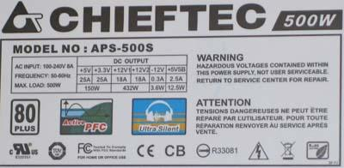
As shown in the image above, this Chief Tec power supply is rated at 500 Watts. Many power supply manufacturers also use the wattage of the power supply in the model number. For example, this power supply's model number is APS-500S, which indicates 500W of total output.
What if I can't see the power supply sticker?
All power supplies are required by UL (formerly known as Underwriters Laboratories) to include a sticker with power ratings on it. If you're unable to locate a sticker on your power supply, the identification may be on the side that is not visible. If this is the case, you need to remove the power supply before being able to identify it. The steps in doing so are listed in the additional information links listed in the next section of this page.
After removing the power supply, if you are still unable to find a sticker with the power ratings, we recommend purchasing a new power supply. A power supply without a sticker on it is dangerous to use. It could be a very low-quality unit and cause damage to your computer
KT0903 Amps, ohms, volts, and watts
What Are Amps, Watts, Volts and Ohms?

Some pylons near a power transform station at sunrise. More voltage in an electrical system makes more current flow. DOWELL/GETTY IMAGES
So much of our daily lives runs on electricity, yet most of us don't know the difference between a 60-watt and 75-watt light bulb, or how voltage from the wall socket supplies enough juice to run both a small desk lamp and a powerful microwave.
The three most basic units in electricity are voltage (V), current (I, uppercase "i") and resistance (R). Voltage is measured in volts, current is measured in amps and resistance is measured in ohms.
A neat analogy to help understand these terms is a system of plumbing pipes. The voltage is equivalent to the water pressure, the current is equivalent to the flow rate, and the resistance is like the pipe size.
There is a basic equation in electrical engineering that states how the three terms relate. It says that the current is equal to the voltage divided by the resistance or I = V/R. This is known as Ohm's law.
Let's see how this relation applies to the plumbing system. Let's say you have a tank of pressurized water connected to a hose that you are using to water the garden.
What happens if you increase the pressure in the tank? You probably can guess that this makes more water come out of the hose. The same is true of an electrical system: Increasing the voltage will make more current flow.
Let's say you increase the diameter of the hose and all of the fittings to the tank. You probably guessed that this also makes more water come out of the hose. This is like decreasing the resistance in an electrical system, which increases the current flow.
Electrical power is measured in watts. In an electrical system power (P) is equal to the voltage multiplied by the current.
The water analogy still applies. Take a hose and point it at a waterwheel like the ones that were used to turn grinding stones in watermills. You can increase the power generated by the waterwheel in two ways. If you increase the pressure of the water coming out of the hose, it hits the waterwheel with a lot more force and the wheel turns faster, generating more power. If you increase the flow rate, the waterwheel turns faster because of the weight of the extra water hitting it.
On the next page, we'll talk more about electrical efficiency.
Electrical Efficiency

Electrical systems are more efficient when a higher voltage is used to reduce current.
In an electrical system, increasing either the current or the voltage will result in higher power. Let's say you have a system with a 6-volt light bulb hooked up to a 6-volt battery. The power output of the light bulb is 100 watts. Using the equation, I = P/V, we can calculate how much current in amps would be required to get 100 watts out of this 6-volt bulb.
You know that P = 100 W, and V = 6 V. So, you can rearrange the equation to solve for I and substitute in the numbers.
Advertisement
I = 100 W/6 V = 16.67 amps
What would happen if you use a 12-volt battery and a 12-volt light bulb to get 100 watts of power?
I = 100 W/12 V = 8.33 amps
So, this latter system produces the same power, but with half the current. There is an advantage that comes from using less current to make the same amount of power. The resistance in electrical wires consumes power, and the power consumed increases as the current going through the wires increases. You can see how this happens by doing a little rearranging of the two equations. What you need is an equation for power in terms of resistance and current. Let's rearrange the first equation:
I = V/R can be restated as V = I*R
Now you can substitute the equation for V into the other equation:
P = V*I substituting for V we get P = I*R*I, or P = I²*R
What this equation tells you is that the power consumed by the wires increases if the resistance of the wires increases (for instance, if the wires get smaller or are made of a less conductive material). But it increases dramatically if the current going through the wires increases. So, using a higher voltage to reduce the current can make electrical systems more efficient. The efficiency of electric motors also improves at higher voltages.
This improvement in efficiency is what drove the automobile industry to consider switching from 12-volt electrical systems to 42-volt systems in the 1990s. As more cars shipped with electric-powered amenities — video displays, seat heaters, "smart" climate control — they required thick bundles of wiring to supply enough current. Switching to a higher-voltage system would provide more power with thinner-gauge wiring.
The switch never happened, because carmakers were able to boost efficiencies with digital technology and more efficient electric pumps at 12 volts. But some new models employ hybrid systems with a separate 48-volt generator to power advanced features like idle shut-off while increasing overall system efficiency.
KT0904 Affecting system hardware and components
Whatever you use your PC for, from playing mini roulette to browsing for the latest bargains, there will always come the point when it behaves unexpectedly. When it’s slow, often people feel powerless to do anything about it. Most of this stems from ignorance about the workings of their PC. This article will help you understand computer speed and what affects it. After reading this article, you’ll know what to look for when you want to increase computer speed and have a machine that runs as smoothly as possible.

NUMBER OF CORES (PROCESSORS)
The CPU is where you’ll find the processing units, each one known as a core. Every core will contain a control unit, ALU, and registers. Usually, a PC will have either two or four cores, and the more you have, the more programs you can run at the same time.
However, if you think that you can double your computer speed by doubling the number of cores, then think again! As they have to communicate with each other, this takes some of the speed away, but in general, increasing the number of cores is a great idea and will boost performance.

MULTIPLE APPLICATIONS AFFECTING COMPUTER SPEED
Any kind of computer speed test will indicate a decrease in performance with an increase in the number of tasks running. Multitasking slows down your PC because applications have less memory to themselves. The more apps running at the same time, the slower your PC will be. It’s something to keep in mind when optimizing performance on your machine.

GRAPHICS CARD TYPE
When it comes to visuals, the user interface, pictures, videos, and more, a powerful graphics card is imperative to good performance. If you are using your PC to process a lot of graphics, you may want to know how to speed up computer performance by optimizing your graphics card in the BIOS, or you could purchase a more up-to-date one and swap the old one out. Graphics cards can be used to perform nonvisual computations, too, so don’t forget that they are important for general performance.

DATA BUS WIDTH
Between the processor and main memory, you have a series of connectors or wires known as the data bus. This is what helps transport data between these two components. When you increase your bus from 32 to 64 bit, you will be able to transfer at least twice as much at any given time. If you want to improve performance, think about increasing the size of your data bus.

MEMORY CACHE
Computers often reuse actions, so in light of this, the cache is a type of memory that holds temporary instructions so that they needn’t be computed unnecessarily. The CPU automatically makes checks in the cache for any instructions before requesting data from the RAM. By doing this, performance is increased because it saves using data unnecessarily. These transfers take a lot less time than a transfer to and from the RAM. The larger the cache, the more data can be stored close to the CPU.

CLOCK SPEED
The clock rate, or clock speed, shows how fast the central processing unit can run. You will find this measured in gigahertz or megahertz, depending on the computer you have. The measurement is an indication of how many instruction cycles the CPU deals with every second. As an example, a 2 GHz CPU can perform 2 billion calculations every second. The larger this number is, the faster the CPU is, and the more heat is produced.
Maximum clock settings are hardcoded by default in PCs. However, you can tweak these by manipulating the computer’s BIOS. If you manipulate to increase your clock speed faster than what is advertised, this is known as overclocking. We would not recommend doing this because there are genuine limits to how fast your CPU can run. There is no guarantee that its circuitry will be able to meet the demands of overclocked speeds. If the speed is too fast, you run the risk of not completing a computation before the next one is carried out. Data can therefore become corrupted if the CPU is not able to keep up with the pace of its clock, and damage can come from overheating the machine.

MALWARE
One of the best ways to speed up computer performance is actually to eliminate malware. Malware, spyware, and viruses can monitor your activity, take control of your computer, and create all sorts of complications that reduce performance.
Anything unwanted and malicious is going to seriously affect performance, so make sure that you invest in a good antivirus to prevent such attacks on your computer. It will seriously help in the long run, and make sure that you scan your computer at least once every week to keep your antivirus updated and remove any unwanted junk from affecting the performance of your computer.

DEFRAGMENTING
Sometimes memory isn’t stored efficiently. When you run a defragmenter, fragmented data is rearranged so that your drives and disks can work more productively. With more space on them, this will also improve performance. Most defragmenters run on a schedule, so if you haven’t configured defragmentation to run regularly on your computer, then do so today.

Internal Assessment Criteria and Weight
• IAC0901 Power supply and the effect on system hardware and components are explained
(Weight 5%)

KM-07-KT10 : Ports, cables, and connectors 2%
Learning Outcome

Topic elements to be covered include:

• KT1001 Ports, cables, and connectors
• KT1002 Power supply units, uninterruptible power supplies, and identifying power supplies
• KT1003 Conversion of voltage, overcurrent protection, input supply voltage, DC voltage regulation, input under-voltage, and Energy Star designation
KT1001 Ports, cables, and connectors
Characteristics of Ports
A port has the following characteristics −
- External devices are connected to a computer using cables and ports.
- Ports are slots on the motherboard into which a cable of external device is plugged in.
- Examples of external devices attached via ports are the mouse, keyboard, monitor, microphone, speakers, etc.
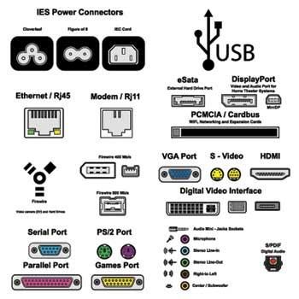
Let us now discuss a few important types of ports −
Serial Port
- Used for external modems and older computer mouse
- Two versions: 9 pin, 25 pin model
- Data travels at 115 kilobits per second
Parallel Port
- Used for scanners and printers
- Also called printer port
- 25 pin model
- IEEE 1284-compliant Centronics port
PS/2 Port
- Used for old computer keyboard and mouse
- Also called mouse port
- Most of the old computers provide two PS/2 port, each for the mouse and keyboard
- IEEE 1284-compliant Centronics port
Universal Serial Bus (or USB) Port
- It can connect all kinds of external USB devices such as external hard disk, printer, scanner, mouse, keyboard, etc.
- It was introduced in 1997.
- Most of the computers provide two USB ports as minimum.
- Data travels at 12 megabits per seconds.
- USB compliant devices can get power from a USB port.
VGA Port
- Connects monitor to a computer's video card.
- It has 15 holes.
- Similar to the serial port connector. However, serial port connector has pins, VGA port has holes.
Power Connector
- Three-pronged plug.
- Connects to the computer's power cable that plugs into a power bar or wall socket.
Firewire Port
- Transfers large amount of data at very fast speed.
- Connects camcorders and video equipment to the computer.
- Data travels at 400 to 800 megabits per seconds.
- Invented by Apple.
- It has three variants: 4-Pin FireWire 400 connector, 6-Pin FireWire 400 connector, and 9-Pin FireWire 800 connector.
Modem Port
- Connects a PC's modem to the telephone network.
Ethernet Port
- Connects to a network and high-speed Internet.
- Connects the network cable to a computer.
- This port resides on an Ethernet Card.
- Data travels at 10 megabits to 1000 megabits per seconds depending upon the network bandwidth.
Game Port
- Connect a joystick to a PC
- Now replaced by USB
Digital Video Interface, DVI port
- Connects Flat panel LCD monitor to the computer's high-end video graphic cards.
- Very popular among video card manufacturers.
Sockets
- Sockets connect the microphone and speakers to the sound card of the computer.

KT1002 Power supply units, uninterruptible power supplies, and identifying power supplies

Unregulated
An unregulated power supply is the most rudimentary type, consisting of a transformer, rectifier, and low-pass filter. These power supplies typically exhibit a lot of ripple voltage (i.e. rapidly varying instability) and other AC “noise” superimposed on the DC power. If the input voltage varies, the output voltage will vary by a proportional amount. The advantage of an unregulated supply is that it’s cheap, simple, and efficient.

Linear regulated
A linear regulated supply is simply a “brute force” (unregulated) power supply followed by a transistor circuit operating in its “active,” or “linear” mode, hence the name linear regulator. (Obvious in retrospect, isn’t it?) A typical linear regulator is designed to output a fixed voltage for a wide range of input voltages, and it simply drops any excess input voltage to allow a maximum output voltage to the load. This excess voltage drop results in significant power dissipation in the form of heat. If the input voltage gets too low, the transistor circuit will lose regulation, meaning that it will fail to keep the voltage steady. It can only drop excess voltage, not make up for a deficiency in voltage from the brute force section of the circuit. Therefore, you have to keep the input voltage at least 1 to 3 volts higher than the desired output, depending on the regulator type. This means the power equivalent of at least 1 to 3 volts multiplied by the full load current will be dissipated by the regulator circuit, generating a lot of heat. This makes linear regulated power supplies rather inefficient. Also, to get rid of all that heat they have to use large heat sinks which make them large, heavy, and expensive.
Switching
A switching regulated power supply (“switcher”) is an effort to realize the advantages of both brute force and linear regulated designs (small, efficient, and cheap, but also “clean,” stable output voltage). Switching power supplies work on the principle of rectifying the incoming AC power line voltage into DC, re-converting it into high-frequency square-wave AC through transistors operated as on/off switches, stepping that AC voltage up or down by using a lightweight transformer, then rectifying the transformer’s AC output into DC and filtering for final output. Voltage regulation is achieved by altering the “duty cycle” of the DC-to-AC inversion on the transformer’s primary side. In addition to lighter weight because of a smaller transformer core, switchers have another tremendous advantage over the prior two designs: this type of power supply can be made so totally independent of the input voltage that it can work on any electric power system in the world; these are called “universal” power supplies. The downside of switchers is that they are more complex, and due to their operation, they tend to generate a lot of high-frequency AC “noise” on the power line. Most switchers also have significant ripple voltage on their outputs. With the cheaper types, this noise and ripple can be as bad as for unregulated power supply; such low-end switchers aren’t worthless, because they still provide a stable average output voltage, and there’s the “universal” input capability. Expensive switchers are ripple-free and have noise nearly as low as for some a linear type; these switchers tend to be as expensive as linear supplies. The reason to use an expensive switcher instead of a good linear is if you need universal power system compatibility or high efficiency. High efficiency, light weight, and small size are the reasons switching power supplies are almost universally used for powering digital computer circuitry.

Ripple regulated
A ripple-regulated power supply is an alternative to the linear regulated design scheme: a “brute force” power supply (transformer, rectifier, filter) constitutes the “front end” of the circuit, but a transistor operated strictly in it’s on/off (saturation/cutoff) modes transfers DC power to a large capacitor as needed to maintain the output voltage between a high and a low setpoint. As in switchers, the transistor in a ripple regulator never passes current while in its “active,” or “linear,” mode for any substantial length of time, meaning that very little energy will be wasted in the form of heat. However, the biggest drawback to this regulatory scheme is the necessary presence of some ripple voltage on the output, as the DC voltage varies between the two-voltage control setpoints. Also, this ripple voltage varies in frequency depending on load current, which makes the final filtering of the DC power more difficult. Ripple regulator circuits tend to be quite a bit simpler than switcher circuitry, and they need not handle the high-power line voltages that switcher transistors must handle, making them safer to work on.
All power supplies are required by UL (formerly known as Underwriters Laboratories) to include a sticker with power ratings on it. If you're unable to locate a sticker on your power supply, the identification may be on the side that is not visible

KT1003 Conversion of voltage, overcurrent protection, input supply voltage, DC voltage regulation, input under-voltage, and Energy Star designation
What are AC-DC Converters
Electric power is transported on wires either as a direct current (DC) flowing in one direction at a non-oscillating constant voltage, or as an alternating current (AC) flowing backwards and forwards due to an oscillating voltage. AC is the dominant method of transporting power because it offers several advantages over DC, including lower distribution costs and simple way of converting between voltage levels thanks to the invention of the transformer.
AC power that is sent at high voltage over long distances and then converted down to a lower voltage is a more efficient and safer source of power in homes. Depending on the location, high voltage can range from 4kV (kilo-volts) up to 765kV. As a reminder, AC mains in homes range from 110V to 250V, depending on which part of the world you live it. In the U.S., the typical AC main line is 120V.
AC-DC Converters steer an alternating current, as its voltage also alternates, into reactive impedance elements, such as inductors (L) and capacitors (C), where it is stored and integrated. This process separates the power associated with the positive and negative potentials.
Filters are used to smooth out the energy stored, resulting in creation of a DC source for other circuits. This circuit can take many forms but always comprises of the same essential elements, and may have one or more stages of conversion.
The AC-DC converters depicted in figure 1 is called a ‘forward converter”, which is a higher efficiency than a slightly simpler architecture; a ‘flyback converter’.
Although not discuss in detail, a flyback converter differs from a forward converter in that its operation depends upon energy stored in the airgap of the transformer in the circuit. Apart from this difference, they can utilize the same essential blocks.
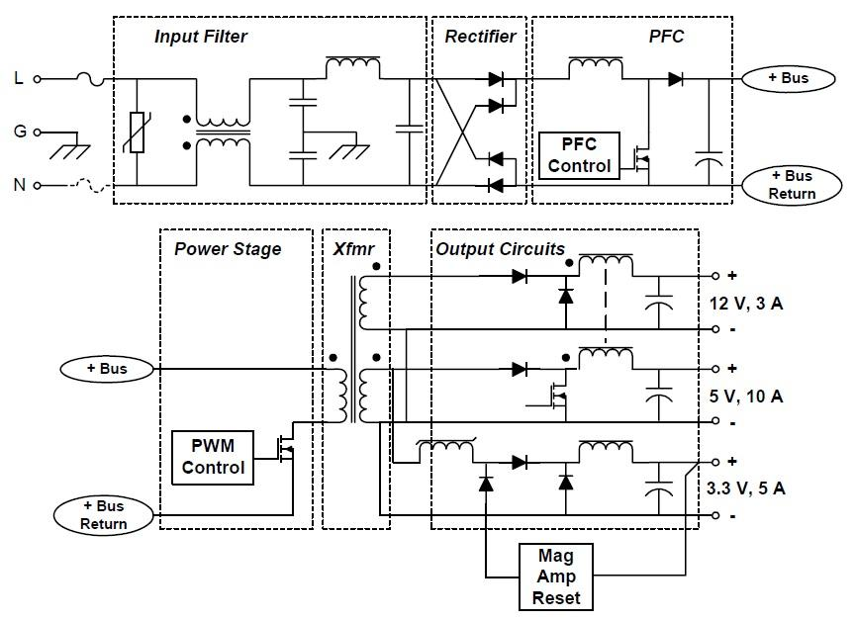
Figure 1: Functional Block Diagram of a Forward Converter AC/DC Power Supply
Input Filtering Block
An input filter is important as it prevents noise produced in the power supply switching elements from getting back onto the mains power supply. It also prevents noise that may be on the mains power supply getting into subsequent circuits. The filter passes through 50/60Hz mains frequency, and attenuates higher frequency noise and harmonics that might be present.
As with other parts of AC-DC converters, reactive elements like capacitors and inductors perform the important role of frequency – selective suppression. Capacitors do not pass DC, and can be used in series (as DC blocking ‘high pass filter’ elements), or parallel (to shunt high frequencies to ground preventing them from getting through to the converter).
The input filtering block will also typically include a voltage dependent resistor, or varistor to prevent high voltage spikes on the electrical power grid from damaging the power supply. This is the rectangular box with the diagonal line through it on the input in Figure 1. The most common type of varistor is a metal-oxide varistor (MOV). Any voltage over the devices ‘clamping voltage’ causes the MOV to become conductive, shunting the high voltage spike and suppressing the surge.
Rectification
The simplest AC-DC converters comprise of a transformer following the input filtering, which then passes onto a rectifier to produce DC. In this case, rectification occurs after the transformer because transformers do not pass DC. However, many AC/DC converters use more sophisticated, multi-stage conversion topologies as depicted in figure 1 due to advantages of smaller transformer requirements and lower noise referred back to the mains power supply.
Rectifiers are implemented using semiconductor devices that conditionally conduct current in one direction only, like diodes. More sophisticated semiconductor rectifiers include thyristors. Silicon controlled rectifiers (SCR) and triode for alternating current (TRIAC) are analogous to a relay in that a small amount of voltage can control the flow of a larger voltage and current.
The way these work is they only conduct when a controlling ‘gate’ is triggered by an input signal. By switching the device on or off at the right time as the AC waveform flows – current is steered to create a DC separation. There are many circuits for doing this, with signals tapped off the AC waveform used as control signals that set the phase quadrants thyristors are on or off. This is commutation, and can be either natural (in the case of a simple diode) or forced, as in the case of devices that are more sophisticated.
High efficiency power supplies can use active devices like MOSFETs as switches in such circuits. The reason for using topologies that are more complex is usually for efficiency improvement, to lower noise or to act as a power control.
Diodes have an intrinsic voltage drop across them when they conduct. This causes power to be dissipated in them, but other active elements may have much lower drop and therefore lower power loss. SCR and TRIAC circuits are particularly common in low-cost power control circuits like the light dimmer example below – used to directly steer and control current delivered to the load as the input mains alternates.
Note that these implementations are not galvanic when they do not have a transformer in the circuit – only useful in circuits that are appropriate like direct mains connected light control. They are also used in high power industrial and military power supplies where simplicity and robustness is essential
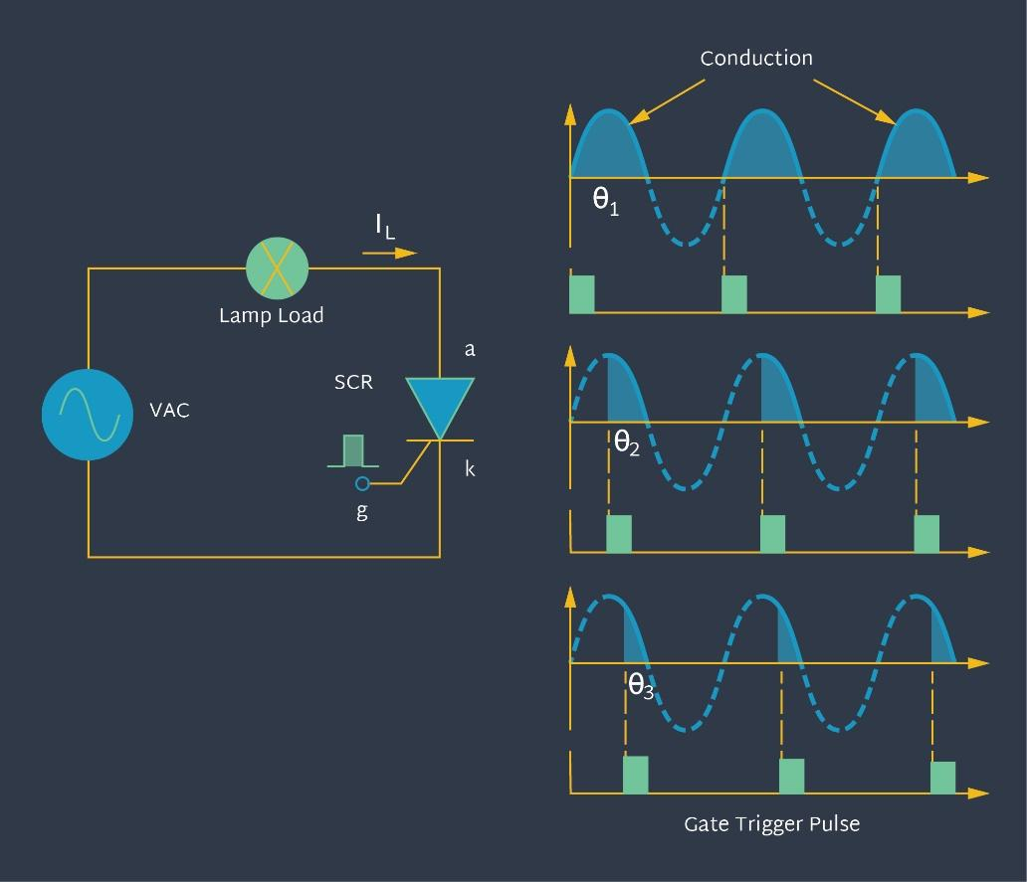
Figure 2: SCR Based Conversion
Power Factor Correction (PFC)
This is the most complicated aspect of a converter to understand. PFC is an essential element in improving the efficiency of a converter by correcting the relative phase of current being drawn to voltage waveform to maintain the optimum power factor. It reduces the ‘reactive load’ characteristics that the converter may otherwise present to the mains power supply.
This is essential for maintaining high quality, efficient electrical networks and electrical supply companies can even impose special reactive current tariffs on customers that have poor power factors. Passive or active PFC refers to whether active elements or passive elements being used to correct the phase relationships.
Semiconductor PFC can refer to special purpose ICs with integrated controllers tailored to actively monitor and adjust the PFC circuit, reducing the component count and simplifying the overall design while obtaining higher performance. They can incorporate other functions like over/under voltage protection, over current protection, soft start, and fault detection/response.
The converter depicted in figure 1 is a single stage PFC converter. The capacitor in this section is used to store the unbalanced energy between the pulsating input power and relatively constant output power of the stage. See the “Reactive Energy Storage” section for more details on this. Two stage PFC converters are commonly used as they don’t have to handle as wide a voltage range across the storage capacitor you get in universal power supplies, which has a detrimental effect on conversion efficiency. They can also offer better trade-offs in the capacitor size, and this can help reduce cost.
An AC-DC Converters Power Stage
The power stage controls the power delivered from the primary to the secondary side through the transformer. It comprises of an active switching device that switches at a high frequency that can be in the hundreds of kHz. The switch ON/OFF state is controlled by a pulse width modulation (PWM) input that changes depending upon the amount of power that needs to be dynamically delivered to the load.
This information is obtained by a feedback path from the secondary side that may be communicated by a number of techniques that accommodate for the converter’s isolation requirements. The higher frequency switching results in a smaller transformer requirement, reducing size and cost.
Transformer
A transformer is comprised of wires wound on a common core that couple into each other by electromagnetic induction. This is important when connecting to high voltage (mains) sources – referred to as ‘off-line’ conversion as the inductive coupling disconnects the mains from the subsequent circuit, a much safer scenario than direct connection.
Coupling by an electromagnetic field, rather than a direct copper circuit, called ‘galvanic isolation’ restricts the maximum energy that can cause electric shock or dangerous sparking discharge to the stored energy in the transformers magnetic field flux lines. The ability (related to size and materials) of the transformer to store energy is an important consideration in converter design as it dictates how well the transformer can provide the energy to maintain the desired voltage potential under changing load conditions.
Figure 1 has a block called ‘Mag Amp Reset’ associated with demagnetizing the transformer due to a magnetization current inherent in the architecture. Without this, the remanence of the core material would saturate it in a few cycles of the power stage PWM. Although too complex to cover in this tutorial, this additional circuit can be very confusing when reviewing converter circuit diagrams, and it is useful to know why it is required.
There are a number of techniques to perform demagnetization, the simplest being when the power stage switch is off a demagnetizing current is fed back diode through a separate auxiliary winding. This circuit restricts the maximum PWM duty cycle to 50%, but more complex methods can be used to enable higher duty cycles.
Transformers or other galvanic isolation methods (like optocouplers) are frequently used to communicate information signals between primary and secondary sides. This is needed to facilitate more intricate control of the conversion process – enabling a primary side situated control circuit to respond to the state of the secondary side load and dynamically change how it steers current to get lower noise and higher efficiency.
AC-DC Converters Output Circuit
As mentioned in the filtering section, electric fields in passive reactive (storage) elements like capacitors and inductors store energy. When used after the charge steering rectification, they act as a reservoir of energy during the alternating input power cycle. This is a vital element in a convertor as this energy storage acts as a source – enabling a constant output voltage under varying load conditions.
Active elements sense the voltage presented to the load and/or the current flowing into the load, and in a negative feedback control loop, use this information to adjust the energy pumped into these storage elements to maintain a constant output voltage level. This pumping process uses active elements to switch on and off the current flowing into the storage elements, referred to under the broad concept of regulation.
Regulation
We need a constant voltage presented to a load circuit, irrespective of the dynamic impedance of the load. Without this, over or under voltage conditions may occur, leading to spurious circuit behaviour or even circuit damage. This is particular true with low voltage digital electronics where supply voltages must be tightly constrained within a window of a few percent of a nominal value. Reactive elements do not have any in-built control of this. The way an AC/DC converter achieves a tightly controlled window of output voltage is by conditionally controlling the energy stored in the low impedance reactive store source.
The voltage output will change over time as power drains from these elements and may also have variance caused by the non-ideal characteristics of the devices – like series resistance or parasitic capacitance. Some kind of dynamic control to recharge this source is required. This is called regulation. Loads like microprocessors change the power they demand as they perform different operations, and this exacerbates the need to have an active dynamic regulation.
Regulation control is a feedback circuit that controls the switching elements. In this case the switching element is on the primary side of the converter. For a switch to be efficient it has to be either hard ON (lowest impedance possible) or hard OFF (highest impedance possible) – as in between states lead to power traveling through the switch being dissipated and wasted. Semiconductor switches like MOSFETS are non-ideal and exhibit some impedance, they dissipate energy and this lowers conversion efficiency.
There are only really two ways to control a switch, by varying the duty cycle a switch is on or off, called Pulse Width Modulation (PWM) or controlling the frequency of being ON or OFF. Non-Resonant Mode converters employ hard switching techniques, but Resonant Mode convertors employs a more intelligent soft-switching technique.
Soft switching means switching on or off the alternating current waveforms at zero voltage or zero current points, eliminating switching losses and leading to very high efficiency architectures. Techniques like synchronous rectification replace the rectification diodes with active switching elements like MOSFETS. Controlling the switching synchronized to the input AC waveform enables the MOSFET to conduct with a very low ON resistance and less voltage drop at the right time – leading to higher efficiency when compared to diode rectification.
How does the regulation circuit know when to switch? There are two principal methods of control mode: voltage control and current control. Regulators utilize one or a combination of both methods to regulate the voltage presented to the load circuit.
Voltage Control Mode
The regulation circuit senses output voltage, compares it to a reference voltage to create an error function. The error signal modifies the switching ratio to bring the output closer to the desired level. This is the simplest method of control.
Current Control Mode
Both output voltage and inductor current sensed and the combination used to control the duty cycle. This inner ‘current sensing loop’ enables faster response time to load change, but is more complex than voltage control mode.
Further complicating the regulation element, over and above the method of control, the way a converter acts as a commutation cycle is called a continuous or discontinuous mode of operation. A continuous mode of operation is one where the inductor current never falls to zero (if the converter topology has one).
This is a lower output ripple and therefore lower noise mode of operation, but as the inductor is always conducting, it is always dissipating some energy in its non-ideal series conduction losses. In discontinuous mode, the inductor current is allowed to go to zero, causing the load to obtain energy from the storage capacitors. This is a higher efficiency mode of operation but does potentially have more ripple and poorer regulation control.
Types of AC-DC Converters
As touched on briefly, there are several converter types relating to their topology, including flyback and buck- flyback architectures. These are common topologies as they incorporate transformers, have low component count and can be low cost relative to other options.
Flyback converters are typically a buck-boost AC-DC converters (step-up/step down) with the inductor replaced with a transformer. The stored energy inside the transformer is used to commutate the secondary through an active or passive rectification circuit. The most common type of flyback converter utilizes discontinuous mode (DCM) – with current flowing in the transformer getting to zero – as this typically has the simplest control loop and lowest cost. Continuous current mode (CCM) flyback convertors are required for higher power levels but result in higher transformer winding losses due to continuous conducting.
Many power supplies switch between modes depending upon the load level. Quasi resonant (QR) and valley switching/variable frequency variations on the flyback topology are more complex circuits that optimize when and how switching occurs to improve efficiency. QR flyback achieve this by recycling energy of non-ideal leakage inductances, and valley switching reduces spikes caused by overshoot. They are typically used in low power applications.

Internal Assessment Criteria and Weight
• IAC1001 An understanding of ports, cables, and connectors and the effect of voltage are demonstrated
(Weight 2%)

KM-07-KT11: Input and output devices
Learning Outcome

Topic elements to be covered include:

• KT1301 Input devices and function
• KT1302 Output devices and function
• KT1303 Keyboards, mouses, and touchscreens
KT1301 Input devices and function
List of Input Devices
Given below is the list of the most common input devices along with brief information about each of them.
- Keyboard
- A simple device comprising keys and each key denotes either an alphabet, number or number commands which can be given to a computer for various actions to be performed
- It has a modified version of typewriter keys
- The keyboard is an essential input device and computer and laptops both use keyboards to give commands to the computer
- Mouse
- It is also known as a pointing device
- Using mouse, we can directly click on the various icons present on the system and open up various files and programs
- A mouse comprises 3 buttons on the top and one trackball at the bottom which helps in selecting and moving the mouse around, respectively
- In case of laptops, the touchpad is given as a replacement of the mouse which helps in the movement of the mouse pointer
- Joy Stick
- It is a device which comprises a stick which is attached at an angle to the base so that it can be moved and controlled
- Mostly used to control the movement in video games
- Apart from a computer system, a joystick is also used in the cockpit of an aeroplane, wheelchairs, cranes, trucks, etc. to operate them well
- Light Pen
- It is a wand-like looking device which can directly be moved over the device’s screen
- It is light-sensitive
- Used in conjunction with computer’s cathode ray tube
- Microphone
- Using a microphone, sound can be stored in a device in its digital form
- It converts sound into an electrical signal
- To record or reproduce a sound created using a microphone, it needs to be connected with an amplifier
- Scanner
- This device can scan images or text and convert it into a digital signal
- When we place any piece of a document on a scanner, it converts it into a digital signal and displays it on the computer screen
- Barcode Reader
- It is a kind of an optical scanner
- It can read bar codes
- A source of light is passed through a bar code, and its aspects and details are displayed on the screen
All the devices mentioned above are the most commonly used input devices. Several other such types of equipment are used in different fields which can be counted as an input device.
For the reference of candidates and to help them with the common computer-related terms, given below are links to difference between articles which will make these terms easily understandable:

KT1302 Output devices and function
What Are the Functions of Output Devices on a Computer?

Input devices are the hardware that give computers instructions. Output devices relay the response from the computer in the form of a visual response (monitor), sound (speakers) or media devices (CD or DVD drives). The purpose of these devices is to translate the machine's response to a usable form for the computer user.

Video Card and Monitor
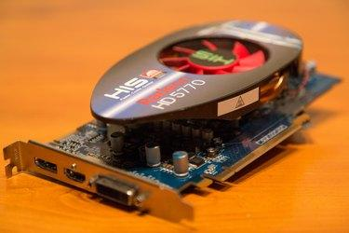
The video card and monitor work in conjunction to display visual output for the user. These two hardware devices help the user return instructions to the computer as well. The video card processes the images seen on the monitor. Monitor and video card quality determine how detailed images are returned. For users who only use a computer for data entry or office work, the images aren't as detailed. Gamers use the output of a video card and monitor to display detailed, 3D images, so the output instructions are more advanced.
Sound Card and Speakers

Although a monitor and video card are required components for a computer, a sound card and speakers are optional. However, these two output devices give a better user experience for the computer. Just like a monitor and video card, the quality of the hardware output devices for sound also determines the detail. Speakers and sound card can provide surround sound just like a television setup. This type of sound setup is used by gamers and multimedia creators. There are also headsets available for speakers, so the output can be heard by the computer users without disturbing others in the home.
CD and DVD Media
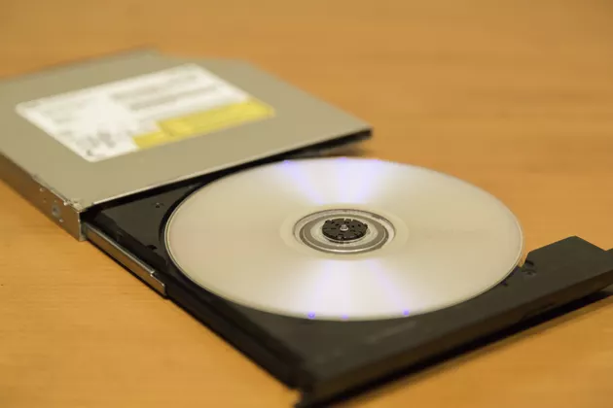
Writable CDs and DVDs have become a standard output device for computers. A hard drive stores information, and it's a required component. However, a CD or DVD is optional. The advantage of these hardware devices is storing data for a long period of time. CDs and DVDs are also used to share information with others. Users write data to a CD or DVD and store it in a location in case of a hard drive crash, of if an important document is accidentally deleted. CDs can be used in cars or portable devices to listen to music downloaded from software such as iTunes.

KT1303 Keyboards, mouses, and touchscreens
Types of Input Devices

What is Computer Keyboard?
The keyboard is the most popular data input device in any computer system. It converts the key data to electronic signals i.e. binary digital form.
The layout of the keyboard is like that of a standard typewriter of type QWERTY. It consists of a group of typewriter-like keys that enable the entry of data into the PC.
Keyboards are of two sizes 84 keys or 101/102 keys, but now keyboards with 104 keys or 108 keys also are available for Windows and Internet. Although there are some additional keys provided for performing additional functions.

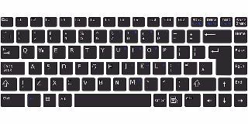
keyboard
Types of keys in a Keyboard
- Alphanumeric Keys: These keys include the letter keys (A-Z) and number keys (0/9).
3. Function Keys: The twelve function keys are present on the keyboard on the top. Each function key features a unique meaning and is employed for a few specific purposes.
4. Control keys: These keys provide cursor and screen control. e.g. Home, End, Insert, Delete, Page Up, Page Down, Control (Ctrl), Alternate (Alt), Escape (Esc), etc.
5. Special Purpose Keys: Keyboard also contains some special purpose keys like entering, Shift, Caps Lock, Number Lock, Space bar, Tab, and Print Screen, etc.

Types of keyboards
A keyboard may be a portable, wired, or wireless device that contains all the alphabets, numeric, symbols, and special characters, which is employed for entering input files into a laptop/personal computer system.
Keyboards are classified supported by the dimensions and their mode of usage. Those types are discussed below:
Multimedia Keyboard
The keyboard that has all multimedia buttons is named a multimedia keyboard. The buttons include play, pause, previous, next, volume up, volume down, mute and special buttons to launch media. Also, a button to launch a browser, my computer, calculator is out there.
Mechanical Keyboard
The primitive keyboard which uses physical buttons for every key’s called a mechanical keyboard. It makes noise when each key’s pressed. A button is pushed down and an electrical signal is shipped to the pc device which then shows the characters.
Wireless Keyboard
Bluetooth, IR technology, or Radio-frequency is employed to attach the keyboard to the pc device. These keyboards are lightweight and battery-powered. These keyboards should have a transmitter and trans-receiver.
Transmitter sends the strokes from the keyboard as radio waves which are received by trans-receiver kept near parent device (Computer).
Virtual Keyboard
The keyboard utilized in smartphones is named a virtual keyboard. This keyboard appears when needed and disappears when typing is completed. this will be automatically set as per need.

Mouse
The mouse is again the most popular data input device which controls the cursor or pointer while working on a computer screen/monitor.
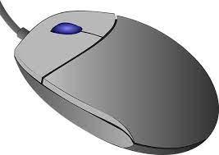
Mouse: Input Devices
Generally, the mouse contains a right button, a left button, and a wheel present between the buttons. Mouse performs various functions like opening a file or program, select menus move icons, size windows, start programs, and close windows, etc.
Types of mouse
Mechanical Mouse
A mechanical mouse features a rubber or metal ball on its underside which will appear in all directions.
Once we move the mouse then the mouse’s ball roll and sensors that are embedded inside identify the motion and move the cursor on the screen accordingly. These days, the mechanical mouse has been replaced with the Optical mouse.
It is a little palm-size box with laser light at its base, which senses the movement of the mouse and sends corresponding signals to the CPU. It allows us to regulate the pointer during a graphical user interface (GUI).
Optical Mouse
The optical mouse is a data input device, that uses laser light to detect mouse movement. It uses advanced technology like LED (light-emitting diode), optical sensor, and other DSP (digital signal processing) rather than the rubber ball mechanical mouse.
Optical mice haven’t any mechanical moving parts and no mousepads are required. Using process is when the mouse is moved, laser rays hit the surface and supply the direction to the pointer on the screen.
Other types of Mouse present in the Market:
- Infrared Frequency Cordless Mouse, Trace ball Mouse, Stylus Mouse, 3D Mouse, Laser Mouse, Track Point Mouse, Gaming mice

Joystick
The joystick is additionally a pointing or a data input device, which looks like a special remote having a spherical ball at both lower and upper ends. The lower spherical ball moves during a socket in any direction.
Functions are almost like that of a mouse. it’s mainly utilized in Computer-Aided Designing (CAD) and playing computer games.

Light Pen
The Light Pen (which looks like a pen) is a pointing device that can be used to pick a menu item or draw on the computer screen.
A photocell and an optical device are enclosed in a narrow tube. When the tip of the pen is passed over the display screen and the button is pressed, the photocell sensing element detects the screen position and sends the appropriate signals to the CPU.
Track Ball
A trackball is a data input device that’s mostly utilized in a notebook or laptop pc, rather than a mouse. it’s a ball that’s half inserted and by moving fingers on the ball, the pointer is often moved.
Since all parts of the device aren’t moved, it requires less space than a mouse. A trackball comes in various shapes sort of a ball, a button, or a square.

Scanner
The scanner is a data input device, which inputs images or text printed on paper into a computer-readable format by digitizing a picture/text. it’s used when some information is out there on paper and it’s to be transferred to the hard disc of the pc for further editing or manipulation.
In short, it converts Hard Copy documents or images into softcopy (digital format)
Microphone
The microphone is a data input device to input sound/voice which is then stored in a digital form.
The microphone is employed for various applications like adding sound to a multimedia presentation or for mixing music. Sometimes it’s abbreviated as mike. The information recorded by the microphone is stored within the computer and played back later.

Microphone: A sound input device
Magnetic Ink Card Reader (MICR)
MICR is a data input device that’s generally utilized in banks as there is an outsized number of cheques to be processed a day. The bank’s code number and cheque number are printed on the cheques
It uses a special sort of ink that contains characters. When it passes through the MICR reader, the particles of magnetic material are readable by a machine and produce the desired output.
Touch Screen
A touch screen is a computer screen that often serves as an input device. A user communicates with the device by pressing pictures or words on the screen, which are responsive to pressure.
When you touch your phone, an electric circuit is completed at the point where your finger makes contact, and the electrical charge at that position is changed.
A touchscreen is a system that combines an input (‘touch panel’) and output (‘display’) device.
Instead of using a mouse, touchpad, or other such items, the touchscreen allows the user to communicate directly with what is displayed.
Optical Character Reader (OCR)
OCR is an input device (or scanner) that can read a printed text, special characters (such as alphanumeric keys and numeric characters) printed paper, and feed it to the pc data. it’s used as a lightweight source to read characters printed on paper.
OCR scans the text optically, character by character, converts them into a machine-readable code, and stores the text on the system memory.

Bar Code Readers
Bar Code Reader is one sort of data input device used for reading bar-coded data (data within the sort of light and dark lines). Barcoded data is usually utilized in labelling goods, numbering the books, etc.
Bar Code Reader is a handheld scanner, which scans a Universal Product Code image, converts it into an alphanumeric value, which is then fed to the PC for further use.
Optical Mark Reader (OMR)
OMR may be a special sort of optical scanner device used to read pencil marks on multiple choice question answer sheets or other documents in a similar form. It is specially used for checking the solution sheets of examinations having multiple-choice questions.
Tests and surveys completed on these forms are read in by the scanner, checked, and the result is saved to a file.
Digital Camera
A digital camera is a sort of data input device that takes pictures. It’s utilized in film industries, TV, photo snap, making marriage video, etc.
Once taken a photograph, it is transformed into a computing system in a digital way and manipulated by the graphics program and hence, produces a printed picture.

Internal Assessment Criteria and Weight
• IAC1301 Input and output devices are identified and the respective functions are explained
(Weight 3%)

KM-07-KT12: Installing and managing printers
Learning Outcome

Topic elements to be covered include:

• KT1201 Types of printers
• KT1202 Installing and managing printers
• KT1203 Drivers, paper feed, networking, and user error
KT1401 Types of printers
- Inkjet printers. Inkjet printers are the de-facto standard for consumer/home-use printers.
- Laser printers.
- All-in-one printers.
- Super tank printers.
- Dye-sublimation printers.
- Dot matrix printers.
- 3D printers.

KT1402 Installing and managing printers
Steps for Deploying and Operating Print Management
- Step 1: Install Print Management. ...
- Step 2: Open Print Management. ...
- Step 3: Add and remove print servers. ...
- Step 4: View Printers. ...
- Step 5: Saving a custom view. ...
- Step 6: Manage Printers. ...
- Step 7: Troubleshoot Printers. ...
- Step 8: Troubleshoot Print Management.

• KT1403 Drivers, paper feed, networking, and user error
Few things lead to frustration quicker than when you need to print something in a pinch, and your printer doesn’t want to cooperate (and it won’t tell you why either!) While streaky lines across your images or faded text is one hassle, dealing with a printer that won’t even acknowledge you exist is another. Whether you’re getting an error message that doesn’t sync up with reality or your printer is giving you the silent treatment, knowing where to start when your printer won’t print can relieve some of that frustration.
Specific troubleshooting solutions will vary depending on your printer model, but once you understand some common issues, you can quickly search and find fixes specific to your unit. Manufacturers offer online resources to help you work through your most troubling printer issues and we’ve got some basic tips covered right here!
- Paper Jams and Ghost Jams
- Printer Driver Problems
- How to Add a Printer in Windows 10
- How to Print a Self-Test Page
- Loaded Paper Queue
- Wi-fi Connection Problems
- Unable to Print From a Mobile Device
- Printhead Clogging
- “Non-Genuine” Cartridge Message
- Replace the Cartridge / Low Ink Message
- Printer Hardware Problems
- Slow Printer Speed
- Printer Won’t Print

Paper Jams and Ghost Jams
If your printer says you have a paper jam, there are a couple of potential culprits. First, make sure the paper is properly aligned in the paper tray. If your paper is askew even a little bit, it can quickly turn into a jam. Usually, removing the paper from the unit and lining it up better to the feeding elements will clear up the problem. Paper trays are designed to hold a specific paper capacity. For some, it could be just 100 sheets, while others can hold an entire ream. Check your printer’s user guide for the recommended paper capacity – an overstuffed paper tray can instantly flag the paper jam warning in your machine. You should also make sure the paper or media type setting on the printer menu matches your current print job. Printers include settings for many different paper types like card stock, photo paper or presentation paper. Thicker paper can cause a paper jam if the settings are off and a quick change of the paper type can resolve your paper jam message right away.
Pick up rollers are the rollers that pick up the paper from the tray and feed it to the printer. These parts have also been known to cause a jams after repeated use and eventually may need to be replaced.
When your printer says that there’s a paper jam, and there isn’t, chances are it’s because there’s a mechanical problem afoot. Don’t immediately smash your printer in a field though! In searching for a solution for a ghost-jammed HP® printer, Neal Poole discovered that often real paper jams could leave residue behind that interferes with printer operation long after the jam is gone.
Small amounts of shredded paper junk lodged between gears that move your rear duplexer may leave your printer thinking there’s something lodged in the duplexer, not the gear. Examine the mechanical parts surrounding your ghost jam and make sure they operate cleanly (some models give you a more precise idea where the jam is located, especially for more complex office units).
Remove the rear duplexer and grip any of the four rollers. Do they move freely? If no, your next step is to . . .
- Touch two of the brass contact points with a paper clip. Bridging this contact makes the printer think the duplexer is still installed, and you’ll want to maintain this contact all the way through the final step.
- Press OK on the control panel.
- Take a look at the white plastic gears on the left-hand side. Do they move freely, or do they stall, skip, freeze, or jam? If it’s the second scenario, you have paper shards, which you will need to clear from the gears.
- Grip the furthest rubber roller and rotate. Check for shards of paper in the gear teeth.
- Once the rollers and gears spin freely, you’ve cleared the ghost jam, and you can remove the paper clip and reassemble.
Unplug your printer to reset the sensors if you are still getting a paper jam notice after cleaning.

Printer Driver Problems
Hardware isn’t always to blame. Your printer driver acts as the translator between your computer and your printer. Like other software, drivers can also go out of date, or lose compatibility with your operating system after an update. If your printer isn’t responding to basic commands or is constantly crashing, a driver update may fix the issue right away. You could also have the wrong driver downloaded on your computer to work with your printer. Uninstalling the driver you have on your desktop, then replacing it with an up-to-date version, often will get your printer and desktop chatting again. To find an updated version of your printer driver, visit the support page of your printer manufacturer and type in your printer model number. Then follow the steps on the page to download the most up to date version. We’ve included links to the most popular printer brand support pages below!
- HP Printer Drivers & Support
- Epson Printer Drivers & Support
- Brother Printer Drivers & Support
- Canon Printer Drivers & Support
- Lexmark Printer Drivers & Support
- Xerox Printer Drivers & Support

How to Add a Printer in Windows 10
If you are trying to connect to a new printer on Windows 10 and plan to print over Wi-Fi, you may be able to print right away without downloading the printer software. Windows 10 is compatible with most new printers right out of the gate. To add a new printer, go to Settings > Devices > Printers & Scanners> Add Printer and select the printer you want to add. If you plan to use this printer regularly you can set it as your default printer and also print a test page to test for print quality before printing out your document!

How to Print a Self-Test Page
If you are having trouble diagnosing your printer issue, printing a test page or printer status report can help narrow down what the problem is. If the test page prints successfully then your issue is likely the printer driver, printer software or cable connection. If it doesn’t print properly then there is likely an issue with the printer itself and may require repairs.
How to Print a Test Page in Windows 10
To print a test page in Windows 10, go to Settings > Devices > Printers & Scanners. Then select your printer and select Manage>Print a Test Page.
How to Print a Test Page in Windows 8
To print a test page in Windows 8, press the Windows key on your keyboard, then search “printer” on the start page. Select Settings > View Devices and Printers, then right click the printer icon and open up “Printer Properties” and select “Print Test Page”
How to Print a Test Page in Windows 7
To print a test page in Windows 7, click the “Start” button > Control panel > Devices and Printers. Then right click the printer icon and open up “Printer Properties” and select “Print Test Page”
Loaded Queue
When your print job finishes, your queue is supposed to clear itself automatically. That doesn’t always work out as planned, especially when some print runs are put on hold, postponed, or stopped due to data connection issues. If your queue gets all blocked up, it can cause your driver to grind to a halt. Often, in an attempt to print something, you’ll end up selecting print several times over, further overloading your queue.
Sometimes your printer isn’t the reason your jobs aren’t printing. A stuck print job can logjam your queue, which prevents jobs from being received by your printer. It also won’t go away when you click delete most of the time. So, what can you do to clear your queue and get your printer, well, printing again? Here’s how to get started:
A side note: this is explicitly for the HP printers paired with Windows, but the general principles apply across printer models and brands.
- Turn your printer off completely and unplug it from your power source.
- Be sure to save the document you are planning on printing; in the form you want it printed. When you clear your queue, all print jobs that haven’t saved will be erased—it will disappear as well.
- Open Windows Services by searching “Services” in your search toolbar or clicking the Window button on your keyboard.
- Halfway down your list of Services, you’ll see one called the “Print Spooler.” Right click on the Print Spooler option and look at your options. “STOP” will halt any stuck print you have bogging down your queue.
- Once you’ve halted all print jobs using the spooler, use the Windows Explorer browser to search: C:\Windows\System32\Spool\PRINTERS
- Delete all existing files in your queue and shut down your computer unit from Windows.
- Turn on your printer using the power button, then turn on your computer again.
- Restart the print spooler service.
- Print your document. If it works, you’re done!
If your print queue gets bogged down and freezes again, you have a couple of other options. HP offers a free software called HP Print and Scan Doctor which you can download for free. Running this program will automatically troubleshoot common issues with your printer and resolve them. If you are still having trouble with your queue jamming, uninstall and update your printer driver. Sometimes, an older driver may not be compatible or can corrupt, which will prevent your prints from processing.
Wi-fi Connection
Wireless connectivity is a double-edged blade. On the one hand, you can connect your printer to devices anywhere in your home. On the other, your connection is something that you can’t see. If your printer has dropped its Wi-fi signal, often you won’t be able to tell unless you troubleshoot the connectivity. If your printer’s Wi-fi is down, unplug it and reconnect it to your modem. It’s a bit of a trope these days, but powering down electronics can do wonders for fixing problems. If your device isn’t connecting to your printer, check to see that your Wi-fi and Bluetooth capabilities are up and operational.
A weak (or non-existent!) connection between your computer and printer will prevent you from getting the documents you need. And because the issues lie between the two, often it can be tough to diagnose. If your printer was connecting wirelessly to your printer and then stopped, try restarting your computer and printer to see if they will reconnect. If no, here are some common questions you should ask when you suspect your Wi-Fi connection may be to blame for your issues.

Internal Assessment Criteria and Weight
• IAC1401 An understanding of types of printers, installing printers and dealing with problems is demonstrated
(Weight 2%)

KM-07-KT13: Mobile devices, multimedia, and laptop computers
Learning Outcome

Topic elements to be covered include:

• KT1501 Mobile devices
• KT1502 Multimedia
• KT1503 Laptop computers
• KT1504 Troubleshooting common problems: battery or power supply issues, verifying connections, checking the wireless switch, and verifying software configuration

KT1501 Mobile devices
What is a Mobile Device?
Before the invention and widespread adoption of small electronics, people used computers and machines that were tethered to the physical infrastructure. Radios, televisions, and computers needed to be connected to a power source for electricity. They also needed cords to connect them to content and programming. As technology developed, improvements were made that allowed storage of electricity and information. As batteries and storage drives became smaller and less expensive, the development of mobile devices flourished. Modern society is intertwined with mobile devices for communication, entertainment, and access to information. Mobile device definition: a portable handheld computer, small enough to be carried easily, which can function without being physically connected to a network and power source.
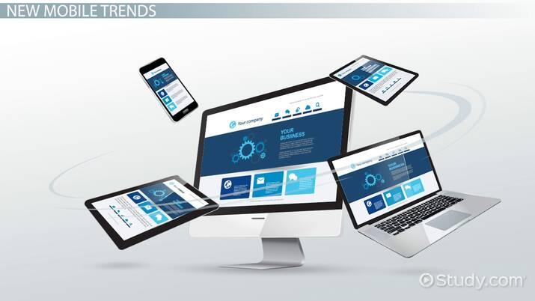
Characteristics of Mobile Devices
There is a great variety of mobile devices. Phones, tablets, e-readers, and other mobile devices share some common characteristics, including:
- Small enough to be carried easily
- Operates without a physical connection to electricity; uses a battery to store power
- Able to send and receive information wirelessly, using cellular data, Bluetooth, or Wi-Fi
- Features a user interface, such as a touchscreen or keyboard
- Includes internal data storage
- Often includes communication functions for voice or video calling
- May include sensors to record and store information, such as a camera, compass, or activity monitor
Small devices that are designed to store but not send and receive information, such as external hard drives, are not considered mobile devices.

KT1502 Multimedia
Definition of Multimedia
By definition Multimedia is a representation of information in an attractive and interactive manner with the use of a combination of text, audio, video, graphics and animation. In other words we can say that Multimedia is a computerized method of presenting information combining textual data, audio, visuals (video), graphics and animations. For examples: E-Mail, Yahoo Messenger, Video Conferencing, and Multimedia Message Service (MMS).
Multimedia as name suggests is the combination of Multi and Media that is many types of media (hardware/software) used for communication of information.
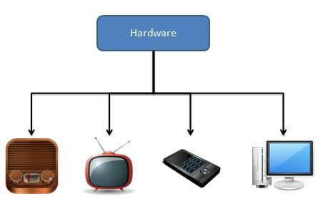
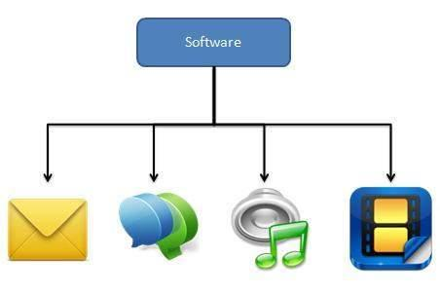
Components of Multimedia
Following are the common components of multimedia:
- Text- All multimedia productions contain some amount of text. The text can have various types of fonts and sizes to suit the profession presentation of the multimedia software.
- Graphics- Graphics make the multimedia application attractive. In many cases people do not like reading large amount of textual matter on the screen. Therefore, graphics are used more often than text to explain a concept, present background information etc. There are two types of Graphics:
  - Bitmap images- Bitmap images are real images that can be captured from devices such as digital cameras or scanners. Generally, bitmap images are not editable. Bitmap images require a large amount of memory.
  - Vector Graphics- Vector graphics are drawn on the computer and only require a small amount of memory. These graphics are editable.
- Audio- A multimedia application may require the use of speech, music and sound effects. These are called audio or sound element of multimedia. Speech is also a perfect way for teaching. Audio are of analogy and digital types. Analog audio or sound refers to the original sound signal. Computer stores the sound in digital form. Therefore, the sound used in multimedia application is digital audio.
- Video- The term video refers to the moving picture, accompanied by sound such as a picture in television. Video element of multimedia application gives a lot of information in small duration of time. Digital video is useful in multimedia application for showing real life objects. Video have highest performance demand on the computer memory and on the bandwidth if placed on the internet. Digital video files can be stored like any other files in the computer and the quality of the video can still be maintained. The digital video files can be transferred within a computer network. The digital video clips can be edited easily.
- Animation- Animation is a process of making a static image look like it is moving. An animation is just a continuous series of still images that are displayed in a sequence. The animation can be used effectively for attracting attention. Animation also makes a presentation light and attractive. Animation is very popular in multimedia application
Applications of Multimedia
Following are the common areas of applications of multimedia.
- Multimedia in Business- Multimedia can be used in many applications in a business. The multimedia technology along with communication technology has opened the door for information of global wok groups. Today the team members may be working anywhere and can work for various companies. Thus the workplace will become global. The multimedia network should support the following facilities:
  - Voice Mail
  - Electronic Mail
  - Multimedia based FAX
  - Office Needs
  - Employee Training
  - Sales and Other types of Group Presentation
  - Records Management
- Multimedia in Marketing and Advertising- By using multimedia marketing of new products can be greatly enhanced. Multimedia boost communication on an affordable cost opened the way for the marketing and advertising personnel. Presentation that has flying banners, video transitions, animations, and sound effects are some of the elements used in composing a multimedia-based advertisement to appeal to the consumer in a way never used before and promote the sale of the products.
- Multimedia in Entertainment- By using multimedia marketing of new products can be greatly enhanced. Multimedia boost communication on an affordable cost opened the way for the marketing and advertising personnel. Presentation that has flying banners, video transitions, animations, and sound effects are some of the elements used in composing a multimedia-based advertisement to appeal to the consumer in a way never used before and promote the sale of the products.
- Multimedia in Education- Many computer games with focus on education are now available. Consider an example of an educational game which plays various rhymes for kids. The child can paint the pictures, increase reduce size of various objects etc apart from just playing the rhymes. Several other multimedia packages are available in the market which provide a lot of detailed information and playing capabilities to kids.
- Multimedia in Bank- Bank is another public place where multimedia is finding more and more application in recent times. People go to bank to open saving/current accounts, deposit funds, withdraw money, know various financial schemes of the bank, obtain loans etc. Every bank has a lot of information which it wants to impart to in customers. For this purpose, it can use multimedia in many ways. Bank also displays information about its various schemes on a PC monitor placed in the rest area for customers. Today on-line and internet banking have become very popular. These use multimedia extensively. Multimedia is thus helping banks give service to their customers and also in educating them about banks attractive finance schemes.
- Multimedia in Hospital- Multimedia best use in hospitals is for real time monitoring of conditions of patients in critical illness or accident. The conditions are displayed continuously on a computer screen and can alert the doctor/nurse on duty if any changes are observed on the screen. Multimedia makes it possible to consult a surgeon or an expert who can watch an ongoing surgery line on his PC monitor and give online advice at any crucial juncture.
In hospitals multimedia can also be used to diagnose an illness with CD-ROMs/ Cassettes/ DVDs full of multimedia-based information about various diseases and their treatment. Some hospitals extensively use multimedia presentations in training their junior staff of doctors and nurses. Multimedia displays are now extensively used during critical surgeries.
- Multimedia Pedagogues- Pedagogues are useful teaching aids only if they stimulate and motivate the students. The audio-visual support to a pedagogue can actually help in doing so. A multimedia tutor can provide multiple numbers of challenges to the student to stimulate his interest in a topic. The instruction provided by pedagogue have moved beyond providing only button level control to intelligent simulations, dynamic creation of links, composition and collaboration and system testing of the user interactions.
- Communication Technology and Multimedia Services- The advancement of high computing abilities, communication ways and relevant standards has started the beginning of an era where you will be provided with multimedia facilities at home. These services may include:
- Basic Television Services
- Interactive entertainment
- Digital Audio
- Video on demand
- Home shopping
- Financial Transactions
- Interactive multiplayer or single player games
- Digital multimedia libraries
- E-Newspapers, e-magazines

KT1503 Laptop computers
What is a laptop computer?
A laptop is a personal computer that can be easily moved and used in a variety of locations. Most laptops are designed to have all of the functionality of a desktop computer, which means they can generally run the same software and open the same types of files. However, laptops also tend to be more expensive than comparable desktop computers.
How is a laptop different from a desktop?
Because laptops are designed for portability, there are some important differences between them and desktop computers. A laptop has an all-in-one design, with a built-in monitor, keyboard, touchpad (which replaces the mouse), and speakers. This means it is fully functional, even when no peripherals are connected. A laptop is also quicker to set up, and there are fewer cables to get in the way.
You'll also have to the option to connect a regular mouse, larger monitor, and other peripherals. This basically turns your laptop into a desktop computer, with one main difference: You can easily disconnect the peripherals and take the laptop with you wherever you go.
Here are the main differences you can expect with a laptop.
- Touchpad: A touchpad—also called a trackpad—is a touch-sensitive pad that lets you control the pointer by making a drawing motion with your finger.
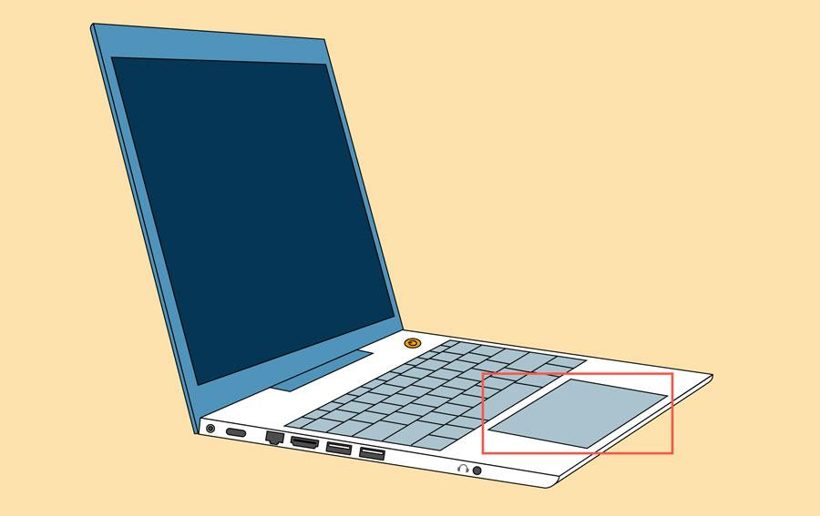
- Battery: Every laptop has a battery, which allows you to use the laptop when it's not plugged in. Whenever you plug in the laptop, the battery recharges. Another benefit of having a battery is that it can provide backup power to the laptop if the power goes out.
- AC adapter: A laptop usually has a specialized power cable called an AC adapter, which is designed to be used with that specific type of laptop.

- Ports: Most laptops have the same types of ports found on desktop computers (such as USB), although they usually have fewer ports to save space. However, some ports may be different, and you may need an adapter in order to use them.
- Price: Generally speaking, laptops tend to be more expensive than a desktop computer with the same internal components. While you may find that some basic laptops cost less than desktop computers, these are usually much less powerful machines.

KT1504 Troubleshooting common problems: battery or power supply issues, verifying connections, checking the wireless switch, and verifying software configuration
Tips to Troubleshoot Your Internet Connection
Have a full house working, gaming, streaming, and news binging, all at the same time? If you're experiencing lags, the problem might be on your end. Before you call your ISP, try these easy router tips to get back online.


With the proliferation of smart home devices, online gaming platforms, and video-streaming services, maintaining a strong internet connection is more important than ever. If you're experiencing lag while playing League of Legends, or it takes forever to download music, there's a good chance the problem is on your end and not an issue with your internet service provider (ISP). Before you schedule a service call with your cable company, check out our tips for troubleshooting your internet connection.

1. Try Another Device or Website
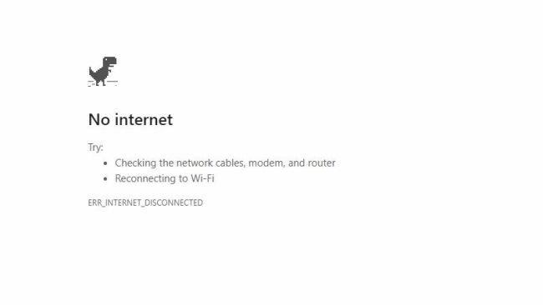
Start with the obvious: is the problem only happening on one device or all your devices? If your computer's having problems, see if your tablet or someone else's laptop can connect to the internet. If the problem only happens on one device, you can safely narrow the problem down to that particular machine.
If a specific website won't load, try another site. If you can visit other websites just fine, it's likely that the problem is with the website you're trying to visit, and you'll have to wait for them to fix things on their end. Try typing the website's address into downforeveryoneorjustme.com(Opens in a new window) or downdetector.com(Opens in a new window) to see if there's a known service outage.
If there is no known outage, it could be an issue with your browser's cache. You may want to try visiting the site in a private browsing window or from a different browser to see if that fixes the connection problem. And clear your browser's cache and cookies.

2. Check the Wi-Fi Settings
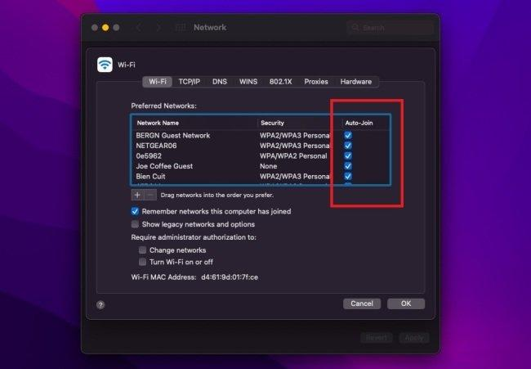
Check the Wi-Fi signal icon in the bottom-right corner of Windows and top-right corner in macOS. Click the icon and make sure you are connected to the proper SSID using the correct password. If not, you may be connecting to the wrong network by default. Windows users can change the connection priority or right-click a network and select Forget. On a Mac, open System Preferences > Network > Advanced and uncheck any unwanted networks under the Auto-Join column.
Troubleshooting
Do you know what to do if your screen goes blank? What if you can't seem to close an application, or can't hear any sound from your speakers? Whenever you have a problem with your computer, don't panic! There are many basic troubleshooting techniques you can use to fix issues like this. In this lesson, we'll show you some simple things to try when troubleshooting, as well as how to solve common problems you may encounter.
General tips to keep in mind
There are many different things that could cause a problem with your computer. No matter what's causing the issue, troubleshooting will always be a process of trial and error—in some cases, you may need to use several different approaches before you can find a solution; other problems may be easy to fix. We recommend starting by using the following tips.
- Write down your steps: Once you start troubleshooting, you may want to write down each step you take. This way, you'll be able to remember exactly what you've done and can avoid repeating the same mistakes. If you end up asking other people for help, it will be much easier if they know exactly what you've tried already.
- Take notes about error messages: If your computer gives you an error message, be sure to write down as much information as possible. You may be able to use this information later to find out if other people are having the same error.
- Always check the cables: If you're having trouble with a specific piece of computer hardware, such as your monitor or keyboard, an easy first step is to check all related cables to make sure they're properly connected.

- Restart the computer: When all else fails, restarting the computer is a good thing to try. This can solve a lot of basic issues you may experience with your computer.
Using the process of elimination
If you're having an issue with your computer, you may be able to find out what's wrong using the process of elimination. This means you'll make a list of things that could be causing the problem and then test them out one by one to eliminate them. Once you've identified the source of your computer issue, it will be easier to find a solution.
Scenario:
Let's say you're trying to print out invitations for a birthday party, but the printer won't print. You have some ideas about what could be causing this, so you go through them one by one to see if you can eliminate any possible causes.
First, you check the printer to see that it's turned on and plugged in to the surge protector. It is, so that's not the issue. Next, you check to make sure the printer's ink cartridge still has ink and that there is paper loaded in the paper tray. Things look good in both cases, so you know the issue has nothing to do with ink or paper.
Now you want to make sure the printer and computer are communicating correctly. If you recently downloaded an update to your operating system, it might interfere with the printer. But you know there haven't been any recent updates and the printer was working yesterday, so you'll have to look elsewhere.
You check the printer's USB cord and find that it's not plugged in. You must have unplugged it accidentally when you plugged something else into the computer earlier. Once you plug in the USB cord, the printer starts working again. It looks like this printer issue is solved!
This is just one example of an issue you might encounter while using a computer. In the rest of this lesson, we'll talk about other common computer problems and some ways to solve them.
Simple solutions to common problems
Most of the time, problems can be fixed using simple troubleshooting techniques, like closing and reopening the program. It's important to try these simple solutions before resorting to more extreme measures. If the problem still isn't fixed, you can try other troubleshooting techniques.
Problem: Power button will not start computer
- Solution 1: If your computer does not start, begin by checking the power cord to confirm that it is plugged securely into the back of the computer case and the power outlet.
- Solution 2: If it is plugged into an outlet, make sure it is a working outlet. To check your outlet, you can plug in another electrical device, such as a lamp.
- Solution 3: If the computer is plugged in to a surge protector, verify that it is turned on. You may have to reset the surge protector by turning it off and then back on. You can also plug a lamp or other device into the surge protector to verify that it's working correctly.
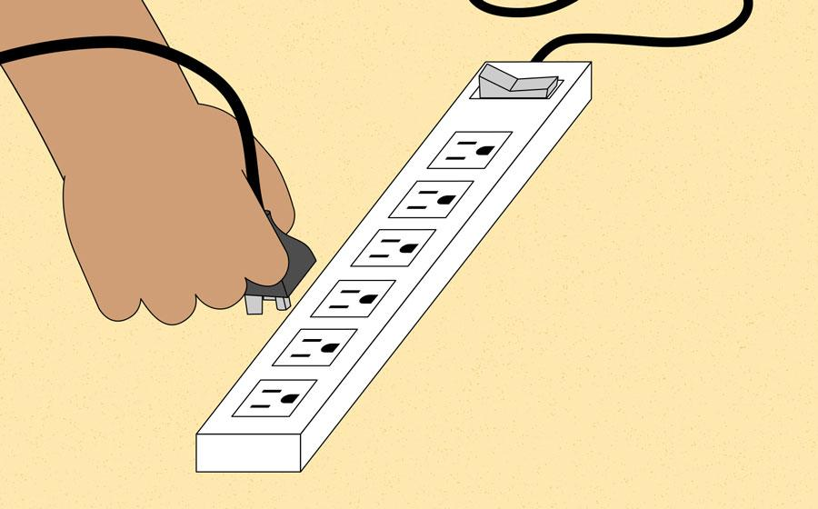
- Solution 4: If you are using a laptop, the battery may not be charged. Plug the AC adapter into the wall, then try to turn on the laptop. If it still doesn't start up, you may need to wait a few minutes and try again.

Internal Assessment Criteria and Weight

• IAC1501 The respective functions of mobile devices, multimedia, and laptop computers are identified
• IAC1502 Common problems are listed
• IAC1503 Troubleshooting procedures are explained
(Weight 2%)

KM-07-KT14: Preventative maintenance
Learning Outcome

Topic elements to be covered include:

• KT1601 Purpose of preventive maintenance
• KT1602 Benefits
• KT1603 Prevent data loss
• KT1604 Improve performance
• KT1605 Preventive tasks: e.g. Updating virus and malware detectors, backing up data, defragmenting drives, etc.

KT1601 Purpose of preventive maintenance
Preventive maintenance (PM) is the regular and routine maintenance of equipment and assets in order to keep them running and prevent any costly unplanned downtime from unexpected equipment failure.
A successful maintenance strategy requires planning and scheduling maintenance of equipment before a problem occurs. A good preventive maintenance plan also involves keeping records of past inspections and the servicing of equipment.
Because of the complexity of maintaining a preventive maintenance schedule for a large amount of equipment, many companies use preventive maintenance software to organise their required preventive maintenance tasks.
What are the Types of Preventive Maintenance?
PM is used to anticipate and prevent the breakdown of equipment and should ideally be performed on all items of equipment to prevent age-related failure. Manufacturers often provide recommendations to maintain a piece of equipment but, generally speaking, there are three main types of preventive maintenance task:
Mandatory / Non-Mandatory Tasks
Mandatory tasks are those that must be performed as soon as they are due and will often include safety-critical checks. Non-mandatory tasks are still important, but can be delayed without resulting in a critical failure or performance reduction. A preventive maintenance checklist should split tasks into mandatory or non-mandatory.
Pyramiding / Non-Pyramiding Tasks
Pyramiding tasks occur when maintenance is set for a due date but is not completed and overlaps with a later scheduled maintenance. In this instance, should a new PM task become due, the previous one is cancelled. A cancellation should include a note to explain this and the new task should include the original due date to monitor how overdue the task is. Some companies prefer a non-pyramiding structure, which removes the need to note the original missed task and just takes the new date as the baseline.
Inspection and Task Oriented Tasks
Inspection tasks require checks to be made before the results are turned into work orders for planned maintenance to fix any problems that have been discovered. Task oriented PMs allow for minor repairs and adjustments to be made at the time of inspection, reducing the amount of work that needs to be written up as work orders on the inspection sheet.
When is Preventive Maintenance Required?
The exact requirement for preventive maintenance will vary depending on the equipment and the operation it is performing. Industry uses standards to help determine schedules for maintenance so that assets do not run to failure. These guidelines will also cover the type of inspection or maintenance that is needed.
Ideally, by following guidelines set down by manufacturers or standards, a PM schedule should ensure proactive maintenance rather than having to resort to reactive maintenance when something has already begun to fail.
Following this type of predictive maintenance schedule, through tasks such as condition monitoring, requires accurate recording of inspections and servicing against an understanding of the lifespan of a particular piece of equipment. These records will help determine when preventive maintenance is required.

KT1602 Benefits
Advantages of Preventive Maintenance
- Less equipment downtime.
- Fewer interruptions to critical operations.
- Longer asset life.
- Improved efficiency (assets in good repair tend to operate better)
- Increased workplace safety and improved compliance with OSHA.

KT1603 Prevent data loss
How to prevent data loss
Nobody likes to hear the words "I told you so," especially when they're busy trying to recover from a serious data loss.
Here are some tips to help you avoid hearing them:
- Regularly schedule "fire drills" to restore information from backup. They are a necessity, not a frill. If you currently have no drill system, or it has gotten rusty, it's only fair to notify everyone involved that "no-excuse" exercises are on the way. It sounds easy, but it can be a tall order, because a lot can go wrong along the chain of events needed to perform a complete backup and restore.
- Keep computers in safe, dry and dust-free areas. Low-traffic locations are best to prevent physical damage to the computers.
- Back up data regularly. Then verify the backups by actually getting the data off the tape and back into the computers.
- Have a generator or battery back-up system. Large power surges can destroy computer equipment, but even relatively low-level bursts of energy can erase the data on hard drives. Uninterrupted power supplies give protection during lightning and electrical storms so data can be saved or backed up during an outage.
- Protect equipment from static electricity that can erase data or damage components. Today's storage media is becoming more vulnerable to extraneous static discharge.
- Use virus-detection protection programs and keep them updated. Viruses may not be as common as the news media makes them seem, but they do exist and they can be deadly to data. Use virus-detection protection programs and keep them updated.
- Use the "undo" feature. Many installation and diagnostic programs offer undo disks that can restore systems to their original configurations if things go wrong. It's good practice to take advantage of this feature.
- There are also software programs that can detect impending problems within hard drives. Using them regularly can head off problems.

KT1604 Improve performance
Tips for Improving Preventive Maintenance with EAM/CMMS Software

Any maintenance manager at a manufacturing plant or facility is likely aware of the problems caused by faulty equipment. Even if just one piece of equipment out of thousands breaks down, it could cause your entire operation to come to a halt. Preventive maintenance involves scheduling various maintenance activities to keep your equipment in peak condition and prevent breakdowns and failure. EAM/CMMS software is an essential tool for scheduling preventive maintenance and monitoring performance. The following are 5 tips to improve preventive maintenance with maintenance management software.
1. Establish standards
In order to develop an effective maintenance management plan, it’s important to outline detailed preventive maintenance procedures and schedules as well as establish standards for measuring performance and improving efficiency. Standard preventive maintenance lists and charts that your software vendor provides should only be used as a guideline to start. You must develop a preventive maintenance process that is unique to your organization.
2. Get all stakeholders involved
EAM/CMMS software alone will not improve preventive maintenance programs. In order to achieve an effective maintenance management process, you must refine the software to fit your process and get stakeholders involved to ensure that the software meets everyone’s needs.
3. Evaluate your current strengths and weaknesses
Prior to implementing new maintenance software, evaluate your current preventive maintenance plan’s strengths and weaknesses to determine what your organization’s most pressing needs are. Factors to consider include preventive maintenance and work procedures, equipment history, inventory, and maintenance costs.
4. Create a detailed preventive maintenance checklist
A preventive maintenance checklist consists of step-by-step instructions for maintenance technicians to follow when completing a preventive maintenance job. A comprehensive preventive maintenance checklist also shows what preventive maintenance work was performed on a given asset and allows maintenance technicians to provide feedback to the planner and supervisor. The feedback that maintenance technicians provide on a preventive maintenance checklist is valuable and can help improve future work orders.
5. Fine-tune your preventive maintenance schedule
EAM/CMMS software generates automated reminders and preventive maintenance work orders. However, it can be challenging for maintenance technicians to balance preventive maintenance work orders on a combination of assets that includes new equipment and old, poorly running equipment. Maintenance technicians are more likely to ignore new equipment since it’s running smoothly and focus on fixing older equipment instead.
It’s acceptable to skip preventive maintenance tasks for new equipment that’s showing no signs of problems, but maintenance technicians should continue monitoring the performance of the equipment regardless. You may eventually need to resume a more regular preventive maintenance schedule for that piece of equipment.

KT1605 Preventive tasks: e.g. Updating virus and malware detectors, backing up data, defragmenting drives, etc.
Common Causes of Data Loss
Data loss can be caused by many different factors, and each poses a unique problem for data recovery. Hard drive crashes account for the highest percentage of data loss, but human errors and issues with software follow closely behind. According to data from Kroll Ontrack:
1. Human Error

Humans are not infallible — we all make mistakes and sometimes they’re big ones. For businesses, these mistakes can result in the unintentional deletion of data files or sections of text. Without realizing it, employees can overwrite important files or delete information that is essential to your business. Human error can also play a role in many other main causes of data loss, including hard drive damage, liquid spills, software corruption and hard drive formatting.
One important measure to prevent human error in data handling is proper training. Ensure your employees understand how data processing within your company works and how your backup systems function. This can be as simple as knowing if the documents they are working with will be backed up automatically or if they must manually save files while they are working.
Mistakes from human error can also be minimized through several software means. Automation minimizes the amount of human interaction with data, which reduces the risk of deletion or overwriting. An optimized workflow will also leave little room for human error to occur while saving employees time and making mistakes easier to spot. Backup systems should also be used to preserve previous data states.
Recovering accidentally deleted or overwritten data can sometimes be as simple as searching through the computer’s Recycle Bin. Other times, you may be able to access previously saved versions of a document. When lost data is not as easy to retrieve, file recovery software can be a great tool. File recovery software scans your computer’s hard drive to identify and restore lost data.
2. Viruses and Malware
Most people think of viruses when you ask them what causes data losses. For businesses, viruses can steal and delete swaths of data or bring business operations to a crawl, destroying company functionality. A computer often gets a virus from an email-based attack or through phishing that tempts an employee to click on a corrupted link. This link then allows the virus or malware to enter the computer system to damage or steal files.
Guard against malware with appropriate anti-virus software. Keep your anti-virus systems constantly updated and regularly run scans to catch viruses before they can do any serious damage. Just in case a malicious program wrecks your data, be sure to make regular system backups as well. Often backed up data is the only way to recover lost data from malware or viruses.
3. Hard Drive Damage
The majority of data losses occur due to hardware malfunctions, with the primary perpetrator being the hard drive. Hard drives are the most fragile parts of computers, and around 140 thousand hard drives crash every week. Of these crashes, 60 percent are due to mechanical issues and 40 percent are a result of human misuse or mishandling, including dropping or jostling a computer or laptop. Hard drives can also be damaged if a computer overheats, typically caused by overuse or a build-up of dust in the computer.
However, as with any machine, a hard drive will wear out over time and will eventually stop working. Below are some signs to watch out for that indicate a hard drive may be failing:
- The hard drive frequently crashes
- The computer is unusually hot
- The hard drive experiences issues while booting up
- Processing speeds continually slow
- The computer freezes frequently
- The computer makes clicking or grinding noises
- Files will not open or become corrupted randomly
To prevent hard drive malfunctions, be sure to work with your device appropriately and keep your computer away from excessive dust. You can also ensure that a random malfunction doesn’t destroy your data by regularly backing up your hard drive on an external drive or cloud server.
SSDs or solid state drives are also emerging as an alternative to traditional HDDs or hard disk drives. SSDs do not have any moving parts, so they are more durable for handling than HDDs. SSDs are also less likely to malfunction or crash, meaning you are less likely to lose data. However, computers with solid state drives also tend to be more expensive than those with standard hard drives and may not be financially feasible for every business. Taking preventative measures to protect your computer’s data is essential regardless of the type of hard drive it has.
You may be able to recover lost data from a hard drive damage by removing the hard drive from the computer and connecting it to another computer to see if any files are not damaged. If the hard drive is entirely corrupted, you can try to retrieve data using data recovery software. However, it is often best to contact a professional to help you recover data lost from a crashed hard drive.
4. Power Outages

Power outages can interrupt business operations substantially, shutting software systems down without warning. Not only can this result in the loss of unsaved data, but it can also cause existing files to be corrupted due to improper shutdown procedures. Sometimes, entire programs may be rendered non-functional by a poorly timed power outage. If a computer shuts down while it is writing to the hard drive system, it may never start up again.
Even if you do not lose data during a power outage, the improper shutdowns can have lasting impacts on computer hard drives. If power outages or surges happen frequently, the lifespan of a hard drive will be greatly reduced and it will be more likely to crash.
The best way to protect against these problems is by making regular, automatic system backups. Backups are often the only way to recover lost data from a power outage. Your business should also use surge protectors to help prevent possible damage from power surges. Having a generator or backup battery system can also allow you to save or back up business data during a power outage.
5. Computer or Laptop Theft
In the modern workplace, more and more people are becoming mobile. This often means they are working from laptops or smartphones rather than PCs. Laptop theft is a serious risk and can happen anywhere if a laptop is left unattended. According to a study:
- 25 percent of IT theft occurs in cars or other transportation vehicles
- 23 percent takes place in the office
- 15 percent happens in airports or hotels
- 12 percent occurs in restaurants
On top of losing data, laptop theft also poses the threat of a data breach. If employees in your company store or access sensitive information on portable devices, you should have a means of remotely wiping data from those laptops or tablets. You should also ensure that crucial data stored on laptops is backed up to a safe location.
For computers in your office building, ensure that they are kept in locked rooms that only employees authorized to use them have access to. When closing your business overnight, be sure to have a secure lock-up procedure so that you do not invite thieves to steal computers or other valuables.

Internal Assessment Criteria and Weight
• IAC1601 The importance of preventative maintenance is justified
• IAC1602 The purpose and benefits of preventative maintenance is explained
• IAC1603 Preventative procedures are explained
(Weight 2%)

KM-07-KT15: Troubleshooting procedures
Learning Outcome

Topic elements to be covered include:

• KT1701 Troubleshooting process
• KT1702 Hardware tools required
• KT1703 Software tools e.g. boot disks and system rescue, etc.
KT1701 Troubleshooting process
- Identify the problem.
- Establish a theory of probable cause.
- Test the theory to determine the cause.
- Establish a plan of action to resolve the problem and implement the solution.
- Verify full system functionality and, if applicable, implement preventive measures
KT1702 Hardware tools required
Hardware Tools
For every job there is the right tool. Make sure that you are familiar with the correct use of each tool and that the correct tool is used for the current task. Skilled use of tools and software makes the job less difficult and ensures that tasks are performed properly and safely.
A toolkit should contain all the tools necessary to complete hardware repairs. As you gain experience, you learn which tools to have available for different types of jobs. Hardware tools are grouped into four categories:
- ESD tools
- Hand tools
- Cleaning tools
- Diagnostic tools
Figure shows some common tools used in computer repair.
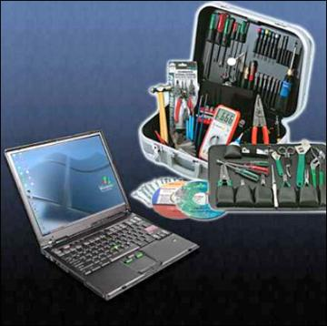
Computer Tools
ESD Tools
There are two ESD tools: the antistatic wrist strap and the antistatic mat. The antistatic wrist strap protects computer equipment when grounded to a computer chassis. The antistatic mat protects computer equipment by preventing static electricity from accumulating on the hardware or on the technician.
Hand Tools
Most tools used in the computer assembly process are small hand tools. They are available individually or as part of a computer repair toolkit. Toolkits range widely in size, quality, and price. Some common hand tools and their uses are:
- Flat-head screwdriver: Used to tighten or loosen slotted screws.
- Phillips-head screwdriver: Used to tighten or loosen cross-headed screws.
- Torx screwdriver: Used to tighten or loosen screws that have a star-like depression on the top, a feature that is mainly found on laptops.
- Hex driver: Used to tighten or loosen nuts in the same way that a screwdriver tightens or loosens screws (sometimes called a nut driver).
- Needle-nose pliers: Used to hold small parts.
- Wire cutters: Used to strip and cut wires.
- Tweezers: Used to manipulate small parts.
- Part retriever: Used to retrieve parts from locations that are too small for your hand to fit.
- Flashlight: Used to light up areas that you cannot see well.
- Wire stripper: A wire stripper is used to remove the insulation from wire so that it can be twisted to other wires or crimped to connectors to make a cable.
- Crimper: Used to attach connectors to wires.
- Punch-down tool: Used to terminate wire into termination blocks. Some cable connectors must be connected to cables using a punch down tool.
Cleaning Tools
Having the appropriate cleaning tools is essential when maintaining and repairing computers. Using the appropriate cleaning tools helps ensure that computer components are not damaged during cleaning. Cleaning tools include the following:
- Soft cloth: Used to clean different computer components without scratching or leaving debris
- Compressed air: Used to blow away dust and debris from different computer parts without touching the components
- Cable ties: Used to bundle cables neatly inside and outside of a computer
- Parts organizer: Used to hold screws, jumpers, fasteners, and other small parts and prevents them from getting mixed together
Diagnostic Tools
Diagnostic tools are used to test and diagnose equipment. Diagnostic tools include the following:
- A digital multimeter, as shown in Figure 2-3, is a device that can take many types of measurements. It tests the integrity of circuits and the quality of electricity in computer components. A digital multimeter displays the information on an LCD or LED.

Figure 2-3.Multimeter
- A loopback adapter, also called a loopback plug, tests the basic functionality of computer ports. The adapter is specific to the port that you want to test.
- The toner probe, as shown in Figure 2-4, is a two-part tool. The toner part is connected to a cable at one end using specific adapters, such as an RJ-45, coaxial, or metal clips. The toner generates a tone that travels the length of the cable. The probe part traces the cable. When the probe is in near proximity to the cable to which the toner is attached, the tone can be heard through a speaker in the probe.
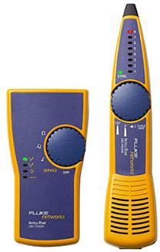
Figure 2-4.Toner Probe
Although an external hard drive enclosure is not a diagnostic tool, it is often used when diagnosing and repairing computers. The customer hard drive is placed into the external enclosure for inspection, diagnosis, and repair using a known-working computer. Backups can also be recorded to a drive in an external enclosure to prevent data corruption during a computer repair.
KT1703 Software tools e.g. boot disks and system rescue, etc.
Software Tools
Like hardware tools, there are a variety of software tools that can be used to help technicians pinpoint and troubleshoot problems. Many of these tools are free and several come with the Windows operating system.
Disk Management Tools
Software tools help diagnose computer and network problems and determine which computer device is not functioning correctly. A technician must be able to use a range of software tools to diagnose problems, maintain hardware, and protect the data stored on a computer.
You must be able to identify which software to use in different situations. Disk management tools help detect and correct disk errors, prepare a disk for data storage, and remove unwanted files.
The following are some disk management tools:
- FDISK: A command-line tool that creates and deletes partitions on a hard drive. The FDISK tool is not available in Windows XP, Vista, or 7. It has been replaced with the Disk Management tool.
- Disk Management Tool: Initializes disks, creates partitions, and formats partitions.
- Format: Prepares a hard drive to store information.
- Scandisks or CHKDSK: Checks the integrity of files and folders on a hard drive by scanning the file system. These tools might also check the disk surface for physical errors.
- Defrag: Optimizes space on a hard drive to allow faster access to programs and data.
- Disk Clean-up: Clears space on a hard drive by searching for files that can be safely deleted.
- System File Checker (SFC): A command-line tool that scans the operating system critical files and replaces files that are corrupted.
Use the Windows 7 boot disk for troubleshooting and repairing corrupted files. The Windows 7 boot disk repairs Windows system files, restores damaged or lost files, and reinstalls the operating system.
Third-party software tools are also available to assist in troubleshooting problems.
Protection Software Tools
Each year, viruses, spyware, and other types of malicious attacks infect millions of computers. These attacks can damage operating systems, applications, and data. Computers that have been infected may even have problems with hardware performance or component failure.
To protect data and the integrity of the operating system and hardware, use software designed to guard against attacks and to remove malicious programs.
Various types of software protect hardware and data:
- Windows 7 Action Centre: Checks the status of essential security settings. The Action Centre continuously checks to make sure that the software firewall and antivirus programs are running. It also ensures that automatic updates download and install automatically.
- Antivirus program: Protects against virus attacks.
- Antispyware program: Protects against software that sends information about web surfing habits to an attacker. Spyware can be installed without the knowledge or consent of the user.
- Window 7 Firewall: Runs continuously to protect against unauthorized communications to and from your computer.
Worksheet Diagnostic Software

In this worksheet, you use the Internet, a newspaper, or a local store to gather information about a hard drive diagnostic program. Be prepared to discuss the diagnostic software you researched. Refer to the worksheet in IT Essentials: PC Hardware and Software Lab Manual, Fifth Edition.
Organizational Tools
Keeping accurate records and journals during a busy workday can be challenging. Many organizational tools, such as work-order systems, can help the technician document their work.
Reference Tools
A technician must document all repairs and computer problems. The documentation can then be used as a reference for future problems or for other technicians who may not have encountered the problem before. The documents can be paper based, but electronic forms are preferred because they can be easily searched for specific problems.
It is important that a technician document all services and repairs. These documents need to be stored centrally and made available to all other technicians. The documentation can then be used as reference material for similar problems that are encountered in the future. Good customer service includes providing the customer with a detailed description of the problem and the solution.
Internal Assessment Criteria and Weight
• IAC1701 Troubleshooting procedures are explained
• IAC1702 Hardware and software tools and the respective functions are described
(Weight 2%)

KM-07-KT16: Operating systems
Learning Outcome

Topic elements to be covered include:

• KT1801 Functions of an operating system: e.g. managing hardware, resources, data, and making user interaction easy through the use of a graphical user interface (GUI)
• KT1802 Big three operating systems: Windows, Linux, and Mac
• KT1803 Control panel
• KT1804 Remote assistance
• KT1805 OS command prompt
• KT1806 OS migration
• KT1807 OS configurations

KT1801 Functions of an operating system: e.g. managing hardware, resources,
data, and making user interaction easy through the use of a graphical user interface (GUI)
An Operating System (OS) is an interface between a computer user and computer hardware. An operating system is a software which performs all the basic tasks like file management, memory management, process management, handling input and output, and controlling peripheral devices such as disk drives and printers.
Some popular Operating Systems include Linux Operating System, Windows Operating System, VMS, OS/400, AIX, z/OS, etc.
Definition
An operating system is a program that acts as an interface between the user and the computer hardware and controls the execution of all kinds of programs.
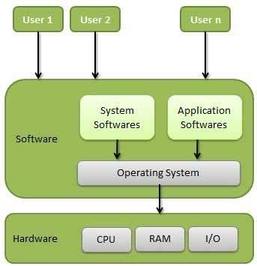
Following are some of important functions of an operating System.
- Memory Management
- Processor Management
- Device Management
- File Management
- Security
- Control over system performance
- Job accounting
- Error detecting aids
- Coordination between other software and users
Memory Management
Memory management refers to management of Primary Memory or Main Memory. Main memory is a large array of words or bytes where each word or byte has its own address.
Main memory provides a fast storage that can be accessed directly by the CPU. For a program to be executed, it must in the main memory. An Operating System does the following activities for memory management −
- Keeps tracks of primary memory, i.e., what part of it are in use by whom, what part are not in use.
- In multiprogramming, the OS decides which process will get memory when and how much.
- Allocates the memory when a process requests it to do so.
- De-allocates the memory when a process no longer needs it or has been terminated.
Processor Management
In multiprogramming environment, the OS decides which process gets the processor when and for how much time. This function is called process scheduling. An Operating System does the following activities for processor management −
- Keeps tracks of processor and status of process. The program responsible for this task is known as traffic controller.
- Allocates the processor (CPU) to a process.
- De-allocates processor when a process is no longer required.
Device Management
An Operating System manages device communication via their respective drivers. It does the following activities for device management −
- Keeps tracks of all devices. Program responsible for this task is known as the I/O controller.
- Decides which process gets the device when and for how much time.
- Allocates the device in the efficient way.
- De-allocates devices.
File Management
A file system is normally organized into directories for easy navigation and usage. These directories may contain files and other directions.
An Operating System does the following activities for file management −
- Keeps track of information, location, uses, status etc. The collective facilities are often known as file system.
- Decides who gets the resources.
- Allocates the resources.
- De-allocates the resources.
Other Important Activities
Following are some of the important activities that an Operating System performs −
- Security − By means of password and similar other techniques, it prevents unauthorized access to programs and data.
- Control over system performance − Recording delays between request for a service and response from the system.
- Job accounting − Keeping track of time and resources used by various jobs and users.
- Error detecting aids − Production of dumps, traces, error messages, and other debugging and error detecting aids.
- Coordination between other software’s and users − Coordination and assignment of compilers, interpreters, assemblers and other software to the various users of the computer systems.

KT1802 Big three operating systems: Windows, Linux, and Mac
Windows, Mac, or Linux? We compare the pros and cons of these computing platforms

- Latest computer news at CNET
By mid-2019, most people are fully entrenched with their favourite operating system choice. But, if you're upgrading from an old machine, you might want to re-evaluate your options. If you're choosing an operating system for your desktop or laptop computer, there are three main choices: Windows, MacOS, and Linux.
In this article, we're going to take a comprehensive look at the differences between these platforms for desktop use. Before we get started, let's establish a few ground rules and recognize a few realities.
We're looking at desktop and laptop use only. Choosing a server, IoT, or infrastructure operating system is a very different beast, something we don't have room to discuss in this article.
Also: Small business servers: Why and how you can say 'no' to the cloud
We are well aware of the nearly religious affinities for each of these platforms. We'll touch lightly on some of the fundamental features that drive these affinities, but we're not preaching. Each choice works for different people. We're not telling you what to do, we're just discussing some factors you might want to keep in mind when making a choice.
We will consider how these well-understood OSs differ in 2019. We've started each OS off with six key considerations, so if you want to just skim, you'll get a good feel for the pros and cons of each system merely by scanning the 18 considerations in our pro and con lists.
And, with that, let's take a deep dive into today's three leading desktop platforms.
Use and cost
Let's start with the key questions I ask when anyone comes to me for advice about computer purchasing:
- What do you want to do with it?
- How much do you want to spend?
- Which of those two (use versus spend) is more important?
Windows typically comes with new PCs. If you have an old PC, it almost certainly came with Windows. Pretty much the only time you're going to pay to buy Windows is if you're building one of your own, and we'll address that later. Macs always come with MacOS, so there's no cost there. And, of course, Linux is free. The much bigger cost for all these environments will be your ongoing maintenance expenses.
Also: Laptop vs. Chromebook: Picking the best computer for you CNET
Choosing a computer is always about making trade-off decisions. If you've got a very limited budget, then your choice is often going to be Windows or even Linux. If you're going to do heavy graphics or video production, your choice might often be Mac. The point is, before you choose your desktop platform, it's important for you to identify your needs.
I find that the trade-off between use and spend is often the deciding factor. I recently bought a new main desktop machine. In my case, I didn't want to spend all that much, but my bigger priority was getting my job done.
Because of the amount of work I have to do, I'm always finding ways to save time. If my computer choice increases productivity at the expense of cost, well, then I'm probably going to be spending more money. I need those hours back.
You may have a hard-and-fast budget, or you may have a key need. As you work your way through your choices, keep these factors (and the balance between them) in mind.
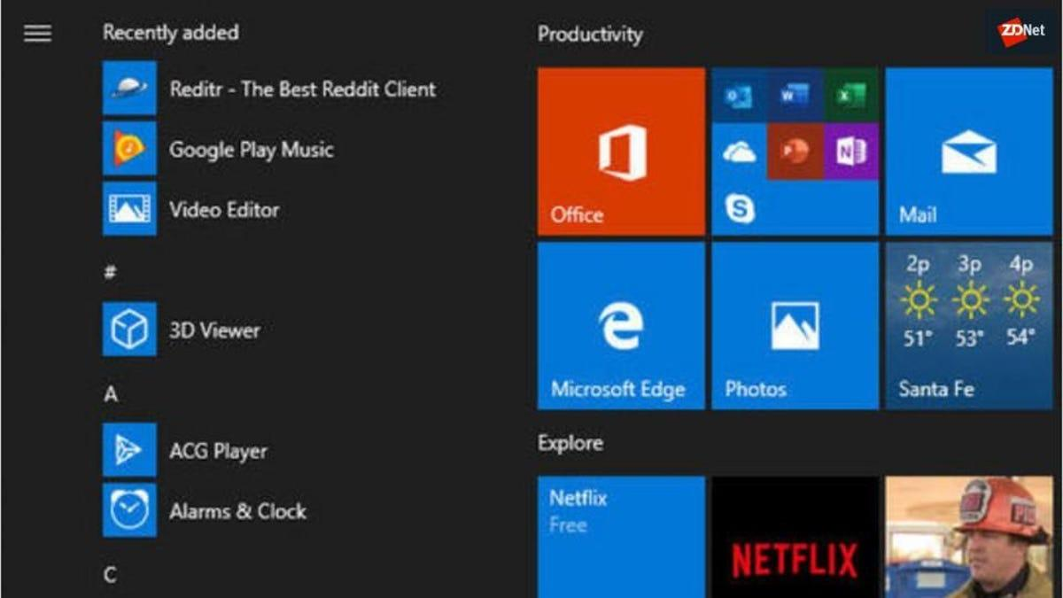
Understanding Windows
Let's talk Windows. Windows went through a rough period during its Windows 8 generation. Microsoft removed the Start menu, forcing users to rely on gestures to find features and launch applications. Microsoft also introduced a limited version of Windows called Windows RT, which only allowed Windows Store apps and didn't run on the Intel platform.
Also: Next for Windows 10: What to expect from the May 2019 Update
Three years later, in 2015, Microsoft introduced Windows 10, a substantially improved version of Windows that returned the Start menu. Microsoft improved the user interface, streamlined many of the settings, and eliminated the odd inconsistencies that had haunted Windows 8. Windows 10, which has had some substantial interim upgrades, is a truly strong Windows release.
By most accounts, Windows runs on roughly 90 percent of PCs worldwide, with desktop Linux usage accounting for a very low single digit percentage of usage and MacOS making up the rest. In developed markets like the US, the Mac percentage is considerably higher, at around 20 percent. But corporate usage, with the exception of some companies like IBM, is almost all Windows. For most people, Windows is the default choice.
Windows means choice
In fact, choice is Windows' outstanding feature. No matter what kind of computer you want, what configuration, or what form-factor, there's a Windows machine for you. Microsoft has long embraced touch-screen computing with Windows, a feature not found in Macs anywhere. Windows machines are built by hundreds of manufacturers, and users have long built their own machines from easily-available components.
That means if you want a Windows computer that's really a tablet with a detachable keyboard, an all-in-one, a super-beefy tower machine with lots of blinking coloured lights, or even a system on a USB thumb drive, along with so many more options, there's a Windows machine for you.
When it comes to customization, that choice increases exponentially. If you want to build a machine yourself, you can add nearly any configuration of cards and features you want. Do you want four beefy graphics cards working in tandem? Windows can do it. Do you want on-board instrumentation inputs? Windows can do it. Do you want to be able to run 10 drives internal to the machine? Well, of course, Windows can do it.

KT1803 Control panel
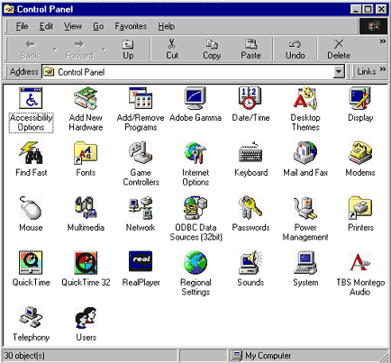
Sections of the Windows Control Panel
There are eight main areas on the Control Panel, containing different tools designed to optimize your computer.
- System and Security - A section to check your computer's status, backup and restore, and others.
- Network and Internet - View network status.
- Hardware and Sound - View which devices are on your computer and add devices.
- Programs - Uninstall programs.
- User Accounts - Change user accessibility.
- Appearance and Personalization - Change desktop options, like fonts and screen readers.
- Clock and Region - Change date and time.
- Ease of access - Optimize your display settings.

KT1804 Remote assistance
Remote Assistance
Remote assistance refers to a connection that is intended to provide technical support from a distance. In this mode, a user who is sitting at his or her computer can invite a technician to see what is happening on the screen remotely. The remote user receives an invitation from the host and cannot log in without responding to it.
If allowed within the settings of the host computer, the remote user can also share control of the host computer, opening files, accessing information and inputting data by mouse and keyboard. This is extremely helpful for an IT professional who can handle a problem from a distance by running scans or checking the registry. While this type of connection originated within the confines of a LAN, remote assistance is now possible over the internet regardless of the users’ locations.
An important distinction in remote assistance vs. remote desktop is that both the host user and the remote user are seeing the same screen. Both can take part in the process.
Remote Desktop
Remote desktop refers to the connection made when a user obtains full access to a host computer or device from a distance. For example, a user connects to their work computer from a personal computer at home.
In a typical Windows remote desktop connection, the host computer’s screen locks when the session begins. Only the remote computer will see any video output. Although viewed on a remote screen, the host computer does all the processing. The user only sends keyboard and mouse input, and the host computer only sends back video and audio output. If someone makes a remote connection and saves a file to a hard drive, it will be on the hard drive of the host computer and would have to be transferred to the remote computer when the connection has ended.
A remote desktop connection is mostly about productivity. It allows an employee to connect to his or her computer and access files from somewhere else in the workplace or, with some configuring via the internet. In short, remote desktop aims to increase efficiency whereas remote assistance facilitates technical support.
Remote Assistance Vs. Remote Desktop: Setting Up The Connection

In considering the difference between remote desktop and remote assistance, the means of connection is an important factor. Because each mode has a different function, the connections between each mode vary. One commonality is that the host computer must set up the connection. Typically, the host computer needs to give permission to accept a remote connection.
These kinds of connections were originally designed for use within a business’s LAN as opposed to connecting to computers across the country. This is especially true for remote assistance, which allows IT professionals to work on a computer without leaving their offices.
Now with the help of a remote access app, remote connections can be successfully carried out between nearly any devices that have internet connections.
How to Connect Remote Assistance
Remote assistance involves users on both ends of the connection: both at the remote station and at the host computer. Advanced software allows a technician to troubleshoot multiple computers at once, or even have a few technicians connect to the host machine at the same time if the problem is really complex.
Here is what the process for establishing a remote assistance connection will look like:
- The host user sends an invitation to the technician.
- The technician, using the remote computer, must accept this invitation in order to gain access to the host computer.
- Depending on the configuration, the host user may choose to simply share their screen or give full control over to the technician.
- The connection continues until either side ends the session.
How to Connect Remote Desktop
A Windows remote desktop connection involves a single user operating another computer at a distance, which means the connection process is going to look a little different:
- Prior to leaving the host computer, the user must navigate to the control panel and toggle the option to allow remote access.
- Once the host computer is configured to allow remote access, the user must have proper credentials at the ready.
- From the remote computer, the user is prompted to enter the IP address of the host.
- Then, the user is prompted to enter the login credentials of the host.
- At this point, the remote screen displays information from the host computer, allowing the user to interact with it like normal, even if the computer is miles away.
Remote Assistance Vs. Remote Desktop: Security Needs And Concerns
In terms of remote control security, how does remote assistance differ from remote desktop? While making remote connections is important for proper support and productivity, it also opens a computer and the business that owns it to heightened security risks. This is one of the dangers of using remote connections outside of a LAN. No matter where you land when making a remote assistance vs. remote desktop decision, the host computer is only as safe as the user who allows the connection.
Security Concerns of Remote Assistance
In looking at security threats of remote desktop vs. remote assistance, they’re both vulnerable to cyber-attacks. But when it comes to the security of remote assistance, the primary difference is the nature of the connection. Unless the host user is acting improperly, there is always someone on either side of the connection. The host user must invite the connection and monitor it throughout the session.
In addition, when someone is giving remote desktop assistance and wants to take control of functions like the keyboard and mouse, it’s important to make sure the host user actively grants those permissions.
Security Concerns of Remote Desktop
Employees often use remote desktop to connect to a work computer from home or on the road. However, this can lead to dangerous security breaches if precautions are not taken. It’s important to make sure remote workers use a VPN or something similar to keep connections encrypted–and monitor the network for unusual activity. If the remote user’s device is compromised, it could allow a malicious actor easy access to the corporate network.
If a cybercriminal can obtain the IP address of a computer that can make RDP connections, that person then only needs to obtain the login credentials. If an employee uses a weak password, a criminal can log in and potentially access information and data on the work computer–or elsewhere on the network. This is why many IT teams implement strong authentication protocols, such as multi-factor authentication, to make sure any users who try to remotely connect are actually who they say they are.
Impero Connect For Remote Connections
If you are evaluating the benefits of Windows remote assistance and remote desktop in 2022, you may want to look at an RDP alternative. Impero recognizes the need for a variety of remote connections beyond the LAN network. RDP’s most common uses come with well-known risks which is why considering all options before you select your software is important.
Impero Connect gives businesses secure remote support software that controls both the access and abilities of remote connections. Some of the features that make Impero a better choice in the remote assistance vs. remote desktop comparison include:
- End-to-end encryption: Both sides of the connection remain secure.
- Role-based access controls: Administrators limit which employees can access which computers.
- White-listed applications: Administrators can limit the applications available to a user during a remote session.
- Video logging: Impero Connect can record videos of remote sessions to help monitor issues and check for security breaches.
- Simple cross-platform access: Users can make connections between devices on multiple platforms.

KT1805 OS command prompt
What is a command prompt?
A command prompt is the input field in a text-based user interface screen for an operating system (OS) or program. The prompt is designed to elicit an action. The command prompt consists of a brief text string followed by a blinking cursor, which is where the user types command prompt commands.
Command-line interfaces (CLI) and prompts were the standard interface for computers from the early days of computing into the 1980s. Microsoft MS-DOS systems and other early consumer-based computers used CLIs. Current Windows systems offer the CLI for administrative tasks. The CLI is still an essential part of the Linux OS.
The command prompt is an executable CLI program, cmd.exe. At the command prompt, the user types a statement including a base batch file or a command name and any arguments to specify running conditions, logging and so on for the program. In Windows systems, such as Windows 10 and many previous versions of Windows, the command interpreter and executioner are referred to as the Windows Command Processor.
Command prompt interfaces can be powerful and succinct. Some tools that aren't available through the graphical user interface (GUI) can be accessed through the command prompt. It also offers superior automation through scripting, but mastering the commands can be challenging.
How to use the command prompt
Many Windows users regularly use the GUI. However, it is helpful to know how to execute system functions in the command prompt window. For example, basic functions such changing a directory or performing an examination of the system disk are easy to execute at the command level.
There are various ways to open command prompt. A common one in Windows is to use the command prompt shortcut located in the Start menu or on the Apps screen.
The basic command level might look like this:
C:\Windows\system32\>cmd.exe and <enter>
This results in the following:
C:\>
The OS is now ready for a command. Each command launches a batch file that initiates a specific function. The change directory function looks like this:
C:\>dir and <enter>
This presents a list of available directories linked to the root directory -- for example, the C drive -- in the system. To change to a different directory, the following is performed, using the example of changing to a directory called applications:
C:\>cd applications\ and <enter>
This changes the directory to:
C:\applications\>
Now the system needs a command to execute something in the applications directory. To check on the status of the elements associated with a specific directory, the user enters the following at the command prompt:
C:\applications\>chkdsk and <enter>
The OS executes the chkdsk utility for the applications directory and presents a summary of the components in that directory, such as the number of files and subdirectories, and number of bytes in use and the number available.
KT1806 OS migration
About migrating Windows operating system to SSD / HDD
What is system migration? A system migration, just as the words imply, refers to the process of transferring current operating system to another storage device such as SSD (solid state drive) or HDD (hard disk drive). The process not only migrates Windows OS, but also installed apps, system updates, drivers, custom settings and wanted personal data on the system disk. If original system disk is of MBR format, both system reserved partition and C drive will be migrated; if it is a GPT disk, the OS migration will include system drive, EFI partition, MSR partition and other specified partitions. After system migration, the destination disk will be bootable, and it can be used to replace the original system disk immediately.
When do you want to migrating system to SSD or HDD? Here are some scenarios that you can simply migrate OS instead of reinstalling Windows from scratch:
- To get faster and better performance: If you are not satisfied with the speed of current hard drive or the booting time, you can replace HDD with an SSD. After migrating OS to SSD from HDD, your computer will be much faster when booting up, reading or writing data.
- To upgrade current disk to a larger one: As time passes, your system disk is full of data and running out of free space. There is not any free space available on the disk to transfer to C drive. In this case, you can replace current disk with a larger one.
- To get a well-organized operating system: If you intend to add hard disk to computer and separate OS and personal data on different drives, you can simply move OS to a new disk without reinstalling everything; you may want to upgrade computer's build, but still want to use the old system, you can also try transferring Windows to new device without reinstalling OS and apps.
How to migrate Windows operating system to SSD or HDD? If you google similar questions, you can find the best solution is transferring OS to new disk with a free and reliable system migration tool.

Freeware to migrate Windows OS to SSD / HDD
Disk Genius Free Edition is recommended here to migrate Windows OS to new SSD or hard disk. With this free edition, you can simply select the destination disk which will be used as new system disk, and then click Start button to move OS. Once the process is done, the destination will be bootable, and your computer can boot from it directly. Features related system migration:
- Supports to migrate Windows OS to SSD or hard drive which is smaller than original system disk.
- It is able to migrate all system-related partitions and other specified data partitions.
- It allows users to set whether let computer boot from destination disk automatically after system is migrated.
- It allows users to manually set boot entries for UEFI computers.
- Supports BIOS / UEFI boot solutions as well as MBR / GPT disks.
- Provides two ways of transferring OS: migrating system in Windows without affecting any running applications; transfer OS in WinPE environment. You can choose either way based on your preference.

How to migrate Windows operating system to SSD / HDD using DiskGenius Free Edition?
Preparations for system migration:
- Uninstall software you won't use and delete unwanted files on original system disk, so that you can free up space and exclude data that you do not want to migrate to new disk.
- Connect the SSD or hard drive which is going to hold the OS and make sure the disk can be detected by Windows properly. If the disk contains data, please backup important files in advance.
- Install free system migration software – Disk Genius Free Edition. With this system cloning software, you can migrate Windows 10/8/7/Vista and Windows Server 2019/2016/2012/2008 operating system with ease.

KT1807 OS configurations
Operating system configurations
Each device can be defined to one or more operating systems. The hardware configuration contains this definition information, known as the operating system (OS) configuration. Note that you may define devices and their associated parameters to an OS configuration, even if they are not explicitly connected.
Typically, the OS configuration is associated with a processor or partition. Each processor can run different OS configurations at different times. There are two types of OS configuration: MVS and VM.
An MVS OS configuration can contain one or more EDTs. An Eligible Device Table or EDT is a list of esoteric device groups, plus the names of the generic device types which determine how devices are used (order of preference) within each esoteric. The EDT is identified by a two-digit ID; you must define at least one EDT for each MVS OS configuration.
An esoteric device group or esoteric is an installation-defined and named grouping of I/O devices under an EDT. An esoteric act as a single “virtual device” which can be allocated without using a specific device number. Devices within an esoteric are usually from the same device group, but can be of different device types.
Every device type is associated with a generic device group or generic. A generic is an MVS-defined grouping of devices with similar characteristics, which determines how devices are used in an esoteric device group. Each generic has a preference number which governs the order of allocation of devices to jobs within an esoteric. For example, if the esoteric contains the device types 3390, 3380 and 3350, and the generics associated with the device types have preference numbers 280, 290 and 300, respectively, then the preference numbers are used by the MVS allocation component to assign the devices in that order of preference.
Faster devices have lower preference numbers. You can change the preference number of a generic under an EDT (user-defined generic), but not under an OS configuration (system-defined generic).
You can mark one or more of the devices defined to an OS configuration to be your consoles. A console displays system-related information (for example, error messages) directly from MVS. For the MVS system, you can specify NIP consoles; for z/VM, you can specify primary and alternative VM consoles.

Internal Assessment Criteria and Weight
• IAC1801 An understanding of operating systems is demonstrated
(Weight 5%)

KM-07-KT17: Managing files
Learning Outcome

Topic elements to be covered include:

• KT1901 Files and directories, naming conventions, and the File Allocation Table (FAT)
• KT1902 Common executable file extensions, such as batch files, command files, and power shell scripts and purpose
• KT1903 Copying, moving, deleting and archiving (ZIP) files and folders
KT1901 Files and directories, naming conventions, and the File Allocation Table (FAT)
File Allocation Table (FAT)
What is File Allocation Table (FAT)?
File Allocation Table (FAT) is a file system that was developed by Microsoft to support small disks and simple folder structures. The file system is named File Allocation Table because it uses a table to track the clusters on a storage volume, as well as how those clusters are linked together through their associated files and directories. Because of the table's important role, the acronym FAT is sometimes used to refer to the table itself, rather than the file system, although it's not uncommon to see it used both ways in a single resource.
The FAT file system got its start with the introduction of MS-DOS, or Microsoft Disk Operating System, and is still in use today, but it has evolved over the years to accommodate growing data volumes. During that time, there have been multiple versions of the file system. The original version was FAT8, followed by FAT12, then FAT16 and finally FAT32. Several variants have also been developed based on the last three versions -- FAT12, FAT16 and FAT32 -- further extending the file system.
The number associated with each FAT version (e.g., FAT16) refers to the number of bits that are used for each entry in the allocation table. For example, an allocation table entry for a FAT16 volume is 16 bits long. However, it's not just the number of entry bits that differentiates the FAT versions. Each version also supports larger volumes and file sizes than its predecessor. Even so, FAT is still limited to small-scale storage compared with more modern file systems. The largest file size FAT32 can support is 4 gigabytes, and the largest volume size is 2 terabytes.
At one time, the FAT file system was used extensively for Windows computers. However, today, most Windows systems use the New Technology File System (NTFS) -- or, to a lesser degree, the Resilient File System (ReFS), which Microsoft introduced in 2012 promising to support greater availability, resiliency and scalability.
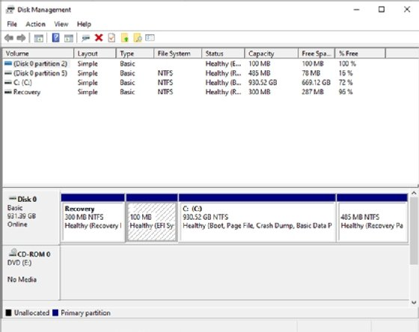
Although Windows 10 and 11 still support FAT, they use NTFS by default, and ReFS to a lesser extent.
Although the FAT system has been superseded on most Windows computers, current Windows editions still support FAT, as do macOS, Linux and Unix. In addition, FAT is still used for floppy disks, USB flash drives and storage media in smaller, portable devices such as digital cameras.
What is the function of File Allocation Table?
FAT plays a pivotal role in facilitating file and directory access on a FAT volume, and is directly integrated into the volume's layout. A FAT volume is organized into multiple sections that follow a prescribed order, starting with the boot sector:
- Boot sector. Stores the information needed by the file system to access the volume, including the volume's layout and file system structure.
- Allocation table region. Stores the primary allocation table, as well as a duplicate of the table that serves as a backup in case the primary table cannot be accessed.
- Root directory. Stores a directory table containing entries that describe the files and folders stored on the volume. Each entry includes information such as name, size, created date and last modified date. An entry also includes the starting cluster number, which corresponds to an entry in the file allocation table. For FAT12 and FAT16, the root directory exists at a specified location on the storage media -- right after the allocation tables -- and has a fixed number of maximum entries. The root directory for FAT32 is maintained in the data region and does not have a fixed number of maximum entries.
- Data region. Stores the actual file and directory data. This area is divided into clusters that make up the bulk of the volume. The clusters are numbered sequentially and correspond to the listings in the allocation table.
Clusters are the basic units of logical storage on a FAT volume. A cluster can range in size from 512 bytes to 64 kilobytes, depending on volume size and type of FAT file system. Each file written to a FAT volume is stored in one or more clusters, with each cluster available to only one file at a time. A file's clusters might be adjacent to each other in consecutive order or be scattered across the volume, resulting in a fragmented file.
The allocation table on a FAT volume tracks each cluster in that volume, mapping the allocation chains associated with the volume's directories and files. Each table entry corresponds to a cluster and is typically in one of four states:
- The cluster is unused.
- The cluster is in an allocation chain associated with a specific file or directory; the table entry references to the next cluster in the chain.
- The cluster is the last cluster in an allocation chain associated with a specific file or directory.
- The cluster is bad.
The first cluster entry in the allocation table is typically used for the volume's FAT ID, and the second entry indicates that the cluster is reserved. In a FAT32 volume, the third entry usually corresponds to the first cluster used for the root directory. The rest of the cluster entries in the allocation table are devoted to the directory and file allocation chains. Each chain begins with the cluster identified in the root directory listing for that directory or file. A chain might be made up of only one cluster, in which case it's marked as the last cluster in the chain.

KT1902 Common executable file extensions, such as batch files, command files, and power shell scripts and purpose
Executable File Formats
You must compile your program to an executable before it can be run or debugged. This topic summarizes the different types of executable file that the Micro Focus COBOL Compiler can produce. It also gives recommendations to help you choose which file format is most appropriate for your applications and summarizes how you can simply packaging by bundling intermediate and generate code files into Micro Focus library files.
.NET COBOL code
.NET COBOL compiles to Common Intermediate Language which can be executed under the Common Language Runtime (CLR) on Windows and Linux systems.
The Compiler supports the generation of procedural COBOL code to .NET assemblies and also offers object-oriented extensions to the COBOL language.
JVM COBOL code
JVM COBOL compiles to Java bytecode (.class files) which can run under the Java Virtual Machine.
The Compiler the supports generation of procedural COBOL code to Java .class files and also offers object-oriented extensions to the COBOL language.
Executable code
You produce executable code by compiling and linking in one step.
An executable file has a filename extension of .exe (Windows) or no filename extension (UNIX).
To create executable code, you need either a COBOL project or a remote COBOL project. Select Project > Properties > Micro Focus > Build Configuration and create or edit a configuration, choosing a Target types option of All Executable Files or Single Executable File.
Object code
Object code files are created when you build your project. The object code file is not executable. It requires linking with the run-time system to produce an executable file.
By default, object code files have the extension .obj (Windows) or .o (UNIX).
Object code files must be linked to create .exe or .dll files (Windows) or executable, callable shared object or shared library files (UNIX).
Intermediate code
Intermediate code files have the extension .int and are usually used for testing and debugging. The Compiler creates the intermediate code file during its first phase, when it checks the program syntax. Intermediate code files compile quickly.
.int files are dynamically loadable, and don't need to be linked into a system executable. You can ship them to your users as executable files, but we recommend that you use .exe files and .dll files for this.
Generated code
Generated code files have the extension. gnt and are created by the Compiler, on request, during its second phase. Generated code is slower to compile than intermediate code but the resulting code runs faster.
.gnt files are dynamically loadable, and don't need to be linked into a system executable. You can ship them to your users as executable files, but we recommend that you use .exe files and .dll files for this.
Dynamic Link Libraries (Windows) or Callable shared objects (UNIX)
Dynamic link libraries (Windows) or callable shared objects (UNIX) are dynamically loaded at run time when required; that is, when referenced as a main entry point (for example, by run (Windows) or cobrun (UNIX)) or by the COBOL CALL syntax. When all the entry points in a dynamic link library (Windows) or a callable shared object (UNIX) have been cancelled then the file is unloaded, releasing any memory used.
This behaviour is similar to .int and. gnt code but is different to linked shared libraries and system executables, which are always loaded at process start-up, whether they are used or not. Further, the code and memory used by shared libraries and system executables are only unloaded when the process terminates.
A dynamic link library (Windows) or a callable shared object (UNIX) can contain more than one COBOL program and can also contain other language programs, such as C and C++. Dynamic link libraries (Windows) or callable shared objects (UNIX) can also be linked with third party object files or shared libraries. This behaviour is similar to system executables and shared libraries but differs from .int and .gnt files, where each file corresponds to a single COBOL program.
A dynamic link library (Windows) has a filename extension of .dll.
A callable shared object file (UNIX) has a filename extension of .so.
Recommendations
This section contains general guidance and recommendations about when to use each of the different file formats.
.int files have the advantage of being portable across different hardware platforms. They have the disadvantage of not being optimized for any target architecture and will typically execute more slowly than code that has been generated for a specific platform.
.gnt files are optimized for a specific chipset. They typically execute faster than .int code. Micro Focus recommends the use of generated executables for best application performance.
.gnt files are not locked by the operating system while executing. This means that new files can be overlaid, but this is not considered good practice.
Standard executable formats, such as .dll or .exe, are also optimized for the target platform and can be digitally signed. These formats can also contain more than one program.
Micro Focus recommends the use of standard format executables.
Bundling intermediate or generated code files
You can bundle .int files and .gnt files in Micro Focus library files. The advantages of this are:
- It simplifies the packaging of files for users, as it reduces the number of files to be shipped.
- When your program calls a subprogram stored in a library file, the library file and all the programs loaded in it are loaded into memory. This can make program execution faster.
A library file has the file extension .lbr.
For example, given the following programs in our application:
Figure 1. Programs in application
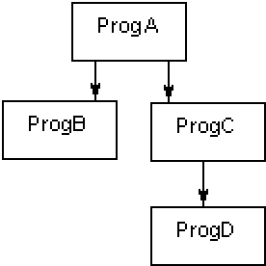
ProgC and ProgD could be compiled as generated code files, and then placed in a library file, mylib.lbr. When ProgA calls ProgC, mylib.lbr would be loaded into memory, also loading progc.gnt and progd.gnt. You would need to ship proga.gnt, progb.gnt, and mylib.lbr, as well as a trigger program.

KT1903 Copying, moving, deleting and archiving (ZIP) files and folders
Copy Files or Folders
Copy a file or folder (Windows 10)
Method 1: Right-click
- Click File Explorer icon.
- Go to the location where stores your file or folder (hard drive, USB, etc.).
- Click the name of the file or folder you wish to copy.
- Right-click the highlighted file or folder and click Copy.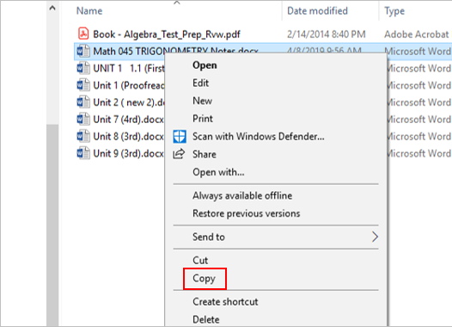
- Go to the destination folder, right-click the destination folder and click Paste.
Method 2: Ribbon toolbar commands
- Click File Explorer icon.
- Go to the location where stores your file or folder (hard drive, USB, etc.).
- Click the name of the file or folder you wish to copy.
- Click the Home tab at the top (on the ribbon).
- Click the Copy button.
- Go to the destination location, click the Home tab.
- Click the Paste button.
Move Files or Folders
Move a file or folder (Windows 10)
Method 1
- Click File Explorer icon.
- Go to the location where stores your file or folder (hard drive, USB, etc.).
- Click the name of the file or folder you wish to move.
- Click the Home tab at the top (on the ribbon).
- Click the Move to button.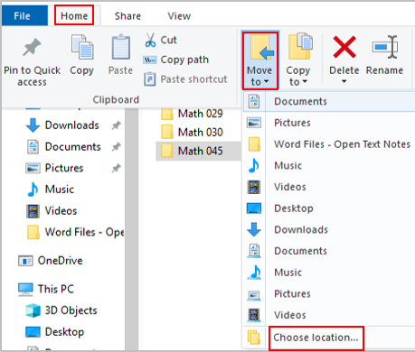
- Click Choose Location (if you don’t find the right spot on the drop-down menu).
- Go to the location you want to move for this folder.
- Click Move.
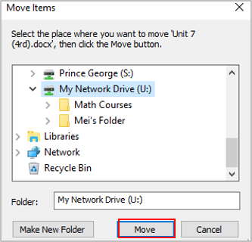
Method 2
- Click File Explorer icon.
- Go to the location where stores your file or folder.
- Click the name of the file or folder you wish to move.
- Hold down the right mouse button and drag the file or folder to the location you wish to move.
Difference between copying and moving files / folders
- Copying – make a duplicate of the selected file or folder and place it in another location.
- Moving – move the original files or folder from one place to another (change the destination).
- The move deletes the original file or folder, while copy creates a duplicate.
Delete and Rename Files or Folders
Delete a file or folder (Windows 10)
- Click File Explorer icon.
- Go to the location where stores your file or folder.
- Click the name of the file or folder you wish to delete.
- Press the delete key (on the keyboard) or right click the file or folder and click Delete.
Recover a deleted file or folder
- Go to Desktop and click the Recycle Bin.
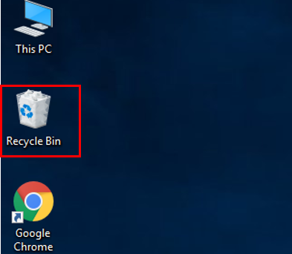
- Right-click the name of the file or folder (that you wish to recover). …
- 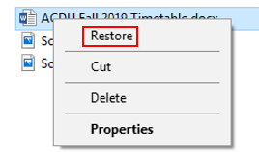Click Restore. (The file or the folder will be restored to its original location.)
Rename files or folders
- Click File Explorer icon.
- Go to the location where stores your file or folder.
- Right click the name of the file or folder you wish to rename.
- 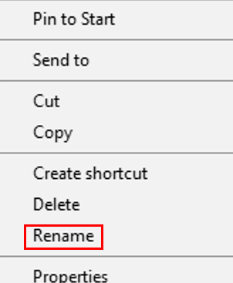Click Rename (on the menu that opens up).
- Type a new name for the file and press Enter.
Note:
- If a file is in use, Windows will not allow you to rename the file.
- Do not change the file extension of a file when renaming the file (file extensions often indicate the file type, file format, etc.).

Internal Assessment Criteria and Weight

• IAC1901 Types of files and the respective purposes are identified
(Weight 2%)

KM-07-KT18: Applications utility, troubleshooting, and optimization
Learning Outcome

Topic elements to be covered include:

• KT2001 Upgrade and remove applications from computers
• KT2002 New installs through disc or internet download
• KT2003 Common processes for downloading and removing software
• KT2004 Troubleshooting
• KT2005 Optimisation
KT2001 Upgrade and remove applications from computers
Uninstall
What Does Uninstall Mean?
Uninstall is the process of removing or deleting an application or software from electronic devices such as a personal computer, laptop, smartphone, cellphone, etc. Uninstall helps in removing applications or programs that are not functioning or working properly, are outdated or are not being used anymore. It can also help if extra disk space is needed. However, uninstall, if done improperly, can result in performance issues and problems for the electronic device.
Advertisement
Techopedia Explains Uninstall
Typically, an application includes an uninstall program that can be used to remove the application if the need arises. In fact, this is the recommended way of removing a program or application from a device, as it removes all the configurations, registry information and other files, including the files generated by the program or application to ensure that no conflicts, if any, will occur in the future. In some cases, searching for the application file by means of a file browser can help in uninstalling the application. However, an uninstaller may still be needed to remove all the files, including the orphan files that were not deleted by a manual uninstall.
For electronic devices such as smartphones and tablets, app removers are available that perform a similar functionality to that of an uninstaller. For most operating systems, commands are available at the kernel level for uninstalling applications or programs. The commands and the method of removal vary according to the operating system and, sometimes, to the type of applications. If the program is installed on a Windows operating system, the user can uninstall it from the Control Panel using the "Uninstall a program" option. If this procedure does not work, the user can use the Windows system-restore-point feature to uninstall an application, which brings the system to its state prior to the installation of the program.
KT2002 New installs through disc or internet download
Installing software on your Windows PC
Your computer allows you to do some really amazing things. Digital photo editing, sophisticated computer gaming, video streaming—all of these things are possible because of different types of software. Developers are always creating new software applications, which allow you to do even more with your computer.
Installing from a CD-ROM
From the mid-1990s through the late 2000s, the most common way to get new software was to purchase a CD-ROM. You could then insert the disc, and the computer would walk you through the installation.
Now, almost all software has moved away from this model. Many new computers no longer include a CD-ROM for this reason. However, if you do need to install software from a CD-ROM, simply insert the disc into your computer, then follow the instructions.
Installing software from the Web
Today, the most common way to get new software is to download it from the Internet. Applications like Microsoft Office and Adobe Photoshop can now be purchased and downloaded right to your computer. You can also install free software this way. For example, if you wanted to install the Google Chrome web browser, you can visit this page and click the Download button.
The installation file will be saved to your computer in .exe format. Pronounced dot e-x-e, this is the standard extension for installation files on Windows computers. You can follow the steps below to install an application from an .exe file.
- Locate and download an .exe file.

- Locate and double-click the .exe file. (It will usually be in your Downloads folder.)
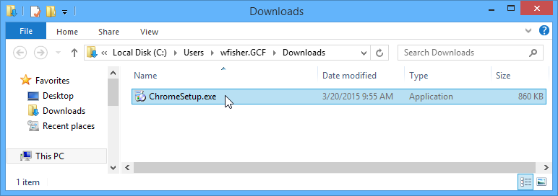
- A dialog box will appear. Follow the instructions to install the software.
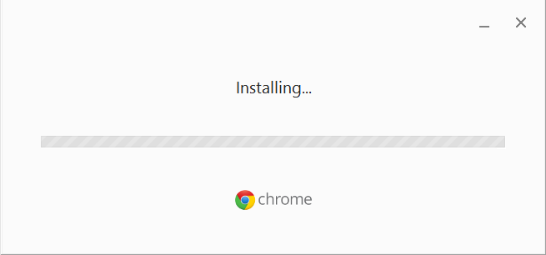
- The software will be installed. You can now open the application from the Start menu (Windows 7) or the Start Screen (Windows 8).
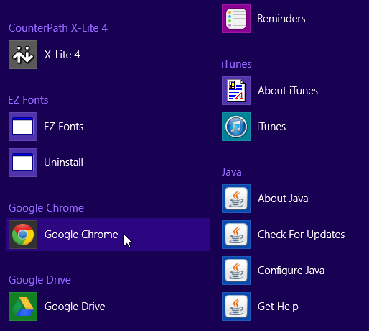
Tips for finding software
In our experience, the easiest way to find new software is to search the Web. For example, if you were looking for a way to edit some personal photos on your computer, you could run a Google search for free photo-editing software. If you're not exactly sure what kind of software you're looking for, try describing the tasks you want to complete. For example, if you wanted a way to create to-do lists and organize your appointments, you might search for something like free calendar organizer software.
The Windows Store
If you're using Windows 8, you can download and install software from the Windows Store. The Windows Store is meant to simplify the process of locating and installing software from third-party developers—when you find an app in the Windows store, you won't have to do any extra work to install it.
KT2003 Common processes for downloading and removing software
How to safely download and install software


Unless you’re planning to purchase all of your software on CDs (something you likely won’t be able to do in the near future anyway), you’re eventually going to have download new software directly from websites hosting those files. That could mean downloading software directly from the company or developers. But your downloading escapades will come with the inevitable dance around sometimes suspicious-looking websites, followed by the knot you get in your stomach that maybe, just maybe, you could be downloading a nasty piece of malware.
Is it possible to safely download and install software you find online? Of course! But sometimes it takes a little bit of common sense mixed with a touch of uncommon knowledge to get the best and safest results. Let’s lay out a few helpful tips to follow while trying to weave around sketchy websites and less-than-reputable downloads.
First, check the website address
We’ve written rather extensively on the differences between secured and unsecured websites, so we won’t rehash the whole spiel here. Simply put: before downloading software from a website, check the website address. Look either for an HTTPS at the beginning of the address, or in the situations where your browser doesn’t always display the hypertext transfer protocol, look for a lock symbol. Websites with an HTTPS or lock symbol (often both) are secured through SSL/TLS encryption and have purchased a certificate to verify this fact.
This means they are, for all intents and purposes, far more difficult to hack. The files you download from those pages are far less likely to have been hijacked and less likely to be a safety concern. Websites without SSL/TLS encryption or without the requisite certificates to prove they utilize that type of security cannot guarantee you anything, even if they say they can.
For example, one would think CNET’s Download.com would be a secure, reputable place to download some new software. After all, it’s Download.com. But wait:
There’s no lock symbol and not HTTPS.
But then, sometimes websites choose to only secure specific pages. Perhaps CNET only saves the certification for where it’s needed?
Not quite. Even an antivirus software’s download page on CNET’s website has no SSL/TLS secured certification:
Does that mean you can’t trust Download.com? Not necessarily. But it doesn’t exactly confer trust in Download.com either. Despite the mostly official source (CNET has been around for on the internet for over 2 decades), the site’s lack of obtaining SSL/TLS certification is at the least somewhat confusing, considering the data protection concerns that exist on the web. They’re not alone in this, to be frank, as the larger share of software hosting sites we’ve listed at the end of this article also lack SSL/TLS certificates.
CNET’s Download.com might have highly secure servers hosting their files. We just don’t know. They haven’t bothered to purchase the certificate to verify that for us, and we could not find any information on their website detailing what security measures they employ for hosted files. We’re left to wonder whether the site is or is not secure, among some other questionable practices they use (more on that later).
Meanwhile, a somewhat smaller, mostly unknown site, Free Software Directory, is fully secured:
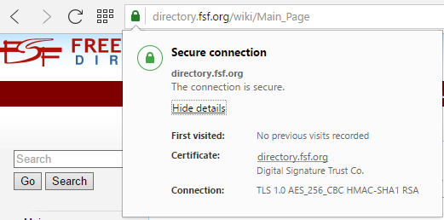
Look, we get it. SSL certificates aren’t exactly cheap to purchase. Even the lowest level SSL certificate, “Secure Site” can cost several hundred dollars a year, if not more. But if a not-for-profit website like Free Software Directory can afford to verify its security for consumers, surely a big, for-profit site like Download.com, and any other file-hosting websites for that matter can afford to do so as well.
Next, just use your eyes

This might seem a bit trite to say, but let your gut do the talking when you’ve hopped onto a website. Does it look and feel suspicious? Do you feel like your computer is catching viruses just by being connected to the web page? If so, you might want to consider moving away from that website as fast as possible. That is, of course, if your built-in web browser or antivirus software hasn’t already alerted you to the fact that the website is not safe or secure. On that end…
Use active virus and malware scanners
There’s almost no substitute for active virus and malware scanners. Not only can they scan your files before you install them, many will actually prevent you from downloading files that contain viruses and malware in them. This is a boon to you, and one of your best defenses against this kind of thing.
If you’re a Windows user, you might also want to consider turning on Windows Defender. Windows Defender is Microsoft’s built-in active malware scanner. It will actively block any attempt to download suspicious files.
If you don’t trust the site, look for the software elsewhere
Simple, right? Sometimes, it’s easier to try to locate the same program hosted on a more secure website. However, there will be times where that’s simply not possible. Some programs are so rare or uncommon that the only websites that do host them are exactly the ones you want to steer clear of. In those cases, it may still be in your best interest to use those websites but to employ a few methods to avoid getting duped into downloading the malware or files and programs you don’t actually want.
Check that the download link is really the link you’re looking for
Let’s come back to Download.com. Earlier, we mentioned that Download.com employs a few tricks we don’t particularly like. One of them is including very large advertisements on download pages that will occasionally look like download links. This is a common practice among many software hosting sites, and it’s not exactly a good one. On Download.com, that looks like this:
Instead of just giving you an obvious download link, CNET’s site places two advertisements right beside the actual download link. In CNET’s defense, you won’t see this occur with the advertisements all the time. Sometimes the ads are mostly unrelated, and it’s easy to identify which link is the correct one almost immediately.
However, the use of such ads is somewhat misleading. This method is used to build advertising revenue through more clicks, playing on the fact that the human eye tends to scan websites quickly. Many people will instinctively click the first link that looks like the right download button without thinking about it first. While you may not end up downloading unwanted software or malware if you click on such a link at Download.com, this has been known to occur with many other websites that utilize this same revenue tactic.
It’s even worse on the website FileHippo. Where would you instinctively click first on this page?

That’s right — you’d probably click the extremely large, in-your-face, official looking “START DOWNLOAD” button. FileHippo can get by with this because, well, it says “Advertisement” over the button. If you click that instead of the much less ambiguous real download link on the top right, that’s your fault.
Not every website lacking SSL/TLS certificates does this. The website TechSpot doesn’t offer misleading download links, for example:
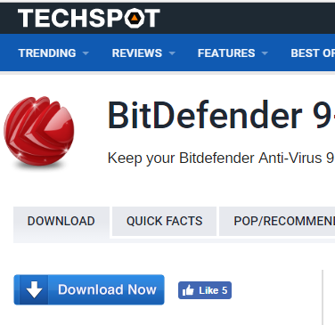
The download link you see on this website is the download link you want. You don’t get any misleading advertisements moving your eyes to other directions to trick you into hitting a link and downloading a file you don’t want.
In most cases, you can check the download link by hovering over what looks like the download, then checking the bottom of your browser. For example, when we hover over the download link on Tech Spot, this is what we get at the bottom of the screen:

Here, we are on the Bit Defender download page for Tech Spot. Positively, the download link is to Bit Defender. Some websites do not bring up the actual link when you hover, although you can still right-click the link, select “Copy Address” and paste the link into your address bar or a word processor to see what the link actually says.
Avoid download programs and installers
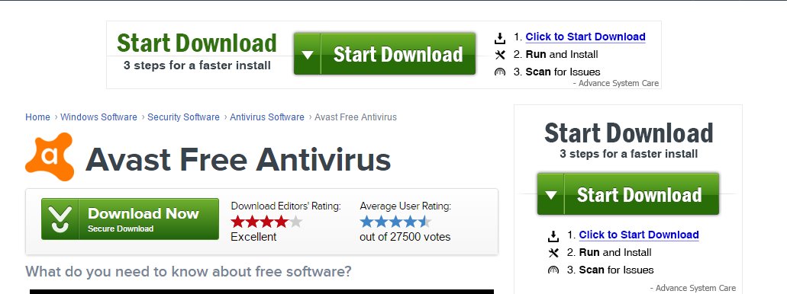
Repeat after me: I do not need a downloader or installer to install a program. Keep saying that to yourself. That way, when you run into a website that attempts to make you download a program with an installer or a download program, you’ll remember to avoid that site altogether and find that file hosted somewhere else.
These types of programs are often referred to as “potentially unwanted programs”, or PUPs. To be clear, you don’t need a download program or installer simply because every operating system you might use is designed to unpack that software file and install it, while the program itself should have installation methods built into the software. Download programs and installers are essentially extraneous pieces of software that often pair the program you want into a piece of unneeded software, commonly adware.
Know the difference between freeware, shareware, trialware, open source, and commercial software
Here are some simple definitions for you:
Freeware: any software that is completely free. You do not have to purchase it to use it.
Shareware: any software that is designed for limited, evaluation use, after which you must pay for the software to continue using it.
Trialware: a modern iteration of shareware. You can use the terms interchangeably.
Open source: any program that has openly published source code, which is available for free, and which is often continuously in development by the community.
Commercial software: any software that you must purchase in order to use.
On that end, free downloads are not the same as free software. If a website tells you that you can download a program for free, be wary. Almost all software is available to download for free. Nobody makes you pay for the action of downloading. Pay attention to that tricky wording.
Installing software safely
Once you’ve found a reputable site to download your software and you’ve hit the download button, you’re still going to have to install the program. Here are a few quick tips for when you’re at the final stage.
Make sure your active malware or virus scanner has scanned the file
If this was not done, or you lack an active scanner, some programs do let you scan the file after downloading, but before installation. Some will even allow you to single out specific programs to scan by right clicking on the file name or icon.
During installation, always choose the “Custom” installation process
Many programs will come with multiple installation options. Instead of going for the “Quick” install option, instead, choose the “Custom” option. This will let you pick and choose which features you want to be installed. Sometimes, you may find that pieces of software come packed with additional software you don’t actually want and that may actually be malware. Examine the list of options when doing a “Custom” install and uncheck anything you don’t want.
Avoid giving out your email address during installation if you can
Some programs will ask for your email address once the download is nearly complete. In some cases, this is to sign up for an account with the website or service, yet far too often it’s just so that the company behind the software can spam your email. If the software requires no account, it’s best to avoid providing your contact information.
Of course, there are exceptions to this rule. Free software which requires no registration keys to install and use certainly don’t need to have your email address. However, for paid software that requires a registration key to operate, such as the latest game or a high-quality piece of creative software, like Adobe Photoshop, it’s in your best interest to register.
The main reason is data loss. If your computer crashes, or you lose all of your data, you may be forced to reinstall the program. Some programs have one-time use registration keys that are randomly generated upon purchase. Registration can help you avoid having to repurchase an expensive piece of software.
Trusty and untrustworthy software sites
Not sure which sites you should trust the most? Here’s a list of websites that host software programs. We’ve broken them up into three categories: SSL/TLS Certified and Trustworthy, Not Certified but Trustworthy and Not Recommended.
In this case, we’ve listed a site as “trustworthy” if does not include SSL/TLS, but it avoids using sneaky and distracting ads. Any site listed as “Not Recommended” is purely based on our opinion that the site in question is not recommended due a lack of advertising its security methods through SSL/TLS certificates, or that it often uses distracting advertisements. This in no way means those sites are prone to hosting malware, nor that you will find malware on those sites.
KT2004 Troubleshooting
Unable to Install Apps or Software on Windows? Here's What to Do
If you're unable to install software on Windows 10 or Windows 11, here's how to fix common app installation problems.
Wondering why you can't install any apps on Windows 10 or Windows 11? It's frustrating when software installers won't run, throw an error code, or seem to work properly but then fail.
Below are fixes to try when software won't install correctly in Windows.
1. Reboot Your Computer
This is a common troubleshooting step, but it's important for a reason. The reason that software won't install on your computer could be due to a temporary glitch. Before you jump into more focused fixes, you should reboot to get back to a clean state.
If you still can't install software after a reboot, continue troubleshooting further with the next steps.
2. Check App Installer Settings in Windows
Windows 10 and Windows 11 allow you to install traditional desktop apps, as well as apps from the Microsoft Store. Certain settings will restrict you to only installing Store apps, so you should check those first.
To do this, head to Settings > Apps > Apps & features. At the top, you'll see a Choose where to get apps section. If the dropdown is set to The Microsoft Store only (recommended) then you won't be able to install apps from anywhere else. This prevents you from installing traditional Windows desktop software.
Change this to Anywhere (or anywhere, but let me know if there's a comparable app in the Microsoft Store if you want) and Windows won't block you from installing software anymore
If you're on an older version of Windows 10, you should also check a similar setting in Settings > Update & Security > For developers. Here, under Use developer features, make sure that you have Sideload apps selected. Picking Microsoft Store apps can prevent you from installing regular software.

On modern versions of Windows 10 and on Windows 11, you won't see these three options. Instead, you'll see a single Developer Mode slider (on Windows 11, this is under Settings > Privacy & security > Developer Mode). You don't need to enable this to install regular apps, so you can leave it disabled. It doesn't hurt to enable it while you're troubleshooting, but you can turn it back off once everything is working.
If you're trying to install an app that requires you to toggle this setting, make sure you trust it. Installing random apps from unknown sources could be dangerous.
Finally, if you're in Windows 10 S Mode or Windows 11 S Mode, you can only install apps from the Microsoft Store. Thankfully, it's easy to switch out of S Mode at no charge. To do this, open the Microsoft Store app, search for "Switch out of S mode," and proceed through the download like you would with other apps.
3. Free Up Disk Space on Your PC
If you're extremely low on disk space, you may not be able to install new software. While this is rarely an issue for small apps, installing heavy-duty tools, such as Microsoft Office or Adobe products, will require several gigabytes.
Follow our guide to freeing up space in Windows, then try installing the software again.
4. Run the Installer as an Administrator
Thanks to User Account Control (UAC) in Windows, your account only uses its admin privileges when necessary. Since most software requires admin rights to install, you'll usually see a UAC prompt when you try to install a new app.
If you're only installing an app for your current account, it might not need administrator permissions. But installing software that applies to all users will require admin approval. Make sure you don't have UAC turned off, or prompts to give admin permissions might fail to appear.
Occasionally, approving a UAC prompt won't work right. You might see an error that the installer can't write to a certain folder, or it might refuse to run at all. In these cases, you should run the installer as an admin manually.
To do this, close the installer dialog if it's open, then right-click on the installer file and choose Run as administrator. After granting admin rights, try the installer again and see if it succeeds.
In case you don't have admin rights on your current machine, ask someone who manages the computer or check our guide to getting admin rights on your computer for more help.
5. Check the App's 64-Bit Compatibility
A lot of software offers both 32-bit and 64-bit flavours. 64-bit software is only compatible with 64-bit versions of Windows. However, 32-bit apps will run on both 32-bit Windows and 64-bit Windows, since 64-bit Windows is backward-compatible.
Most of the time, the software will automatically pick the right version to install on your system, or will just install as 32-bit if that's the only option available. If you have a modern computer, it's likely 64-bit, meaning this isn't a problem. But if you're not sure, you should find out if you have 64-bit Windows.
Once you know which version of Windows you have, keep an eye out on software download pages and make sure to download the version that's compatible with your system. x86 refers to 32-bit, while x64 means 64-bit. Don't download 64-bit software on a 32-bit system, as it won't run.
6. Run Program Trouble-shooters
Windows 10 and 11 include several built-in troubleshooting tools that try to detect and fix common problems. They don't always work well, but they're worth a try when Windows won't install programs for some reason.
To access the trouble-shooter that deals with installing software on Windows 10, head to Settings > Update & Security > Troubleshoot and click Additional trouble-shooters. Here, run the Program Compatibility Trouble-shooter and see if it fixes any problems. You can also run the Windows Store Apps tool if you're having trouble installing a Store app.
On Windows 11, these utilities are under Settings > System > Troubleshoot > Other trouble-shooters.
If this doesn't work, you should try the Program Install and Uninstall trouble-shooter, available to download separately from Microsoft.
7. Uninstall Previous Software Versions
Most of the time, installing an app update (even if it's a new major version) goes smoothly. But sometimes, having an old version of a program installed can cause issues when you try to install the latest release.
KT2005 Optimisation
Optimization (computer science)
In computing, optimization is the process of modifying a system to make some features of it work more efficiently or use fewer resources. For instance, a computer program may be optimized so that it runs faster, or to run with less memory requirements or other resources (see Space-time tradeoff), or to consume less energy. This is a branch of software engineering.
The optimization can have sense at different levels, from the lowest (development of circuits, writing of machine code designed especially for the architecture) up to the highest levels of making of implementation, use or design of algorithms.
The optimization is generally recommended to leave until the end of the process of development, since the premature optimization can introduce new errors (generally more difficult to detect for being of algorithmic nature).
The optimized system may be a single computer program, a collection of computers or even an entire network such as the Internet.

Internal Assessment Criteria and Weight
• IAC2001 Procedures for installing and removing utilities are described
(Weight 2%)

KM-07-KT19: Configuring device drivers
Learning Outcome

Topic elements to be covered include:

• KT2101 Configuring device drivers
• KT2102 Changing device settings
• KT2103 Updating drivers
• KT2104 Removing device drivers
• KT2105 Plug-and-play devices
• KT2106 Device failure
• KT2107 System restore points

KT2101 Configuring device drivers
Installing and Configuring Device Drivers
Devices have changed from being single-function peripherals to complex, multifunction devices, with a large amount of local storage and the ability to run applications. They have evolved from a single type of connection, such as USB, to multi transport devices that support USB, Bluetooth, and WiFi.
Many of today's devices are often integrated and sold with services that are delivered over the Internet, Internet delivery has simplified the delivery mechanism, which means that a computer's ability to recognize and use devices has expanded to cover all possibilities. Microsoft has expanded the list of devices and peripherals that are being tested for compatibility with Windows 8.
The device experience in Windows 8 is designed on existing connectivity protocols and driver models to maximize compatibility with existing devices. The following are areas in Windows 8 that you can use to manage devices:
- The Devices and Printers control panel gives users a single location to find and manage all the devices that connect to a Windows 8-based computer, and provides quick access to device status, product information, and key functions, such as Faxing and scanning. This enhances and simplifies the customer experience with a Windows 8-connected device.
- Device Manager is used to view and update hardware settings and driver software for devices such as internal hard drives, disc drives, sound cards, video or graphics cards, memory, processors, and other internal computer components.
Seamless user experiences begin with the ability to effortlessly connect devices. Additional drivers are retrieved automatically from Windows Update, and when appropriate, users are given an option to download and install additional applications for the device. These components all help reduce support calls and increase customer satisfaction.
Device Drivers in Windows 8
A driver is a small software program that the computer uses to communicate with hardware or devices. It also is specific to an operating system. Without drivers, the hardware that you connect to the computer does not work properly.
In most cases, drivers are part of windows, or you can locate them by navigating to Windows Update, and then checking for updates. If Windows does not have the required driver, look for it on the disc that came with the hardware or device, or on the manufacturer's website.
32-bit and 64-bit Drivers
Windows 8 is available in 32-bit and 64-bit version. Drivers developed for the 32-bit versions do not work with the 64-bit versions, and vice versa. You must make sure that you obtain the appropriate device drivers before you install Windows 8.
Driver Signing
The device drivers that are part of Windows 8 have a Microsoft digital signature that indicates whether a particular driver or file has met a certain level of testing, is stable and reliable, and has not been altered since it was signed digitally. Windows 8 checks for driver's digital signature during installation, and prompts the user if no signature is available.
Note:
The signature file is stored as a .cat file in the same location as the driver file.
Driver Store and Driver Packages
The driver store is the driver repository in Windows 8. A driver package is a set of files that make up a driver. It includes the .inf file, any files that the .inf file references, and the .cat file that contains the digital signature for the device driver. You can preload the driver store with drivers for commonly used peripheral devices. The driver store is located in system root\System32\Driver Store.
Installing a driver is a two-stage process. First, you install the driver package into the driver store. You must use administrator credentials to install the driver package into the driver store. The second step is to attach the device and install the driver. A standard user can perform this second step.
During hardware installation, if the appropriate driver is not available, Windows 8 uses Windows Error Reporting to report an unknown device. This enables Original Equipment Manufacturers (OEMs) to work in conjunction with Microsoft to provide additional information to the user, such as a statement of non-support for a particular device, or a link to a website with additional support information.
In Windows 8, the Device Metadata System provides an end-to-end process for defining and distributing device metadata packages. These packages contain device experience XML documents that represent the device's properties and functions, together with applications and services that support the device.
Through these XML documents, the Devices and Printers folder and Device Stage present users with an interface that is specific to the device, which the device maker defined.
Windows Online Quality Services (Winqual) validates device-experience XML documents, and then signs device metadata packages. Windows Metadata and Internet Services (WMIS) distributes new or revised device-metadata packages that device makers submit through Winqual.
Windows 8 uses WMIS to discover, index, and match device metadata packages to specific devices that are connected to the computer. Device makers also can distribute device-metadata packages directly to the computer through their own Setup applications.

KT2102 Changing device settings
Device Manager displays a graphical view of the hardware that is installed on your computer. Use this tool when you want to view and manage hardware devices and their drivers. You must be logged on to the computer as an administrator or as a member of the Administrators group to add or remove devices or to configure device properties in Device Manager.
When you install a Plug and Play device, Windows automatically configures the device so that it works correctly with the other devices that are installed on the computer. During the configuration process, Windows assigns a unique set of system resource settings to the device. The following list describes the four types of resources that a device can use:
- Interrupt request (IRQ) line numbers
- Direct memory access (DMA) channels
- Input/output (I/O) port addresses
- Memory address ranges
Each resource that is assigned to a device is given a unique value. Occasionally, a device conflict may occur if two devices require the same resources. If this conflict occurs, you can manually configure the device to assign unique resources to each device. In some situations, depending on the device drivers and the computer, two devices can share a resource (for example, interrupts on Peripheral Component Interconnect [PCI] devices).
When you install a non-Plug and Play device, Windows doesn't automatically configure resource settings for the device. Depending on the type of device, you may have to manually configure these settings. Before you do so, either contact the hardware manufacturer, or see the documentation that is included with the device for more information.
Typically, Windows identifies devices and their resource requests, and then automatically gives the resource settings for your hardware. In most situations, you don't have to modify resource settings for your hardware. Don't change resource settings for a Plug and Play device unless it's necessary. When you manually configure a resource, the setting is fixed. So Windows can't modify resource assignments if that is required, and Windows can't assign that resource to another device.
How to configure a device in Device Manager
To configure a device in Device Manager, follow these steps.
Important
Use caution when you configure resource settings for a device. If you configure resources incorrectly, you can disable your hardware, and you can cause your computer to stop working. Change resource settings only when you are sure that the settings that you want to use are unique and don't conflict with settings for other devices, or when a hardware manufacturer has provided you with specific resource settings for a device.
- Sign in to your computer as an administrator or as a member of the Administrators group.
- Select Start, point to Administrative Tools, and then select Computer Management.
- Under System Tools in the console tree, select Device Manager.
The devices that are installed on your computer are listed in the right pane.
- Double-click the type of device that you want to configure--for example, Ports (COM & LPT).
- Right-click the device that you want to configure, and then select Properties.
- Select the Resources tab.
- Click to clear the Use automatic settings check box.
Note
The Use automatic settings check box is unavailable and appears dimmed, both on devices for which there are no other settings to configure and on devices that are controlled by Plug and Play resources and which do not require user modification.
- In the Settings based on box, select the hardware configuration that you want to modify--for example, Basic configuration 0000.
- Under Resource type in the Resource settings box, select the type of resource that you want to modify--for example, Interrupt Request.
- Select Change Setting.
- In the Edit Resource dialog box, type the value that you want for the resource, and then select OK.
- Repeat steps 8 through 11 to configure the resource settings that you want for the device.
- Quit Device Manager.
How to view resource settings in Device Manager
To view a list of resources and the devices that are using them by type or by connection, follow these steps:
- Select Start, point to Administrative Tools, and then select Computer Management.
- Under System Tools in the console tree, select Device Manager.
The devices that are installed on your computer are listed in the right pane. The default view lists devices by type.
- Use one of the following methods:
  - To view a list of resources by type, select Resources by type on the View menu.
  - To view a list of resources by connection type, select Resources by connection on the View menu.
Use Device Manager to search for device conflicts
A device conflict occurs when the same resources are given to two or more devices. Use Device Manager to search for device conflicts. To do so, follow these steps:
- Select Start, point to Administrative Tools, and then select Computer Management.
- Under System Tools in the console tree, select Device Manager.
The devices that are installed on your computer are listed in the right pane.
- Double-click the type of device that you want to test--for example, Sound, video and game controllers.
- Right-click the device that you want to test for conflicts, and then select Properties.
- Select the Resources tab.
Any conflicts that exist for the device are listed under Conflicting device list.
Windows Hardware Trouble shooter
Use the Windows Hardware trouble shooter to help you troubleshoot and resolve a hardware conflict or other hardware-related issues. To start the Hardware trouble shooter, follow these steps:
- Sign in to your computer as an administrator or as a member of the Administrators group.
- Select Start, point to Administrative Tools, and then select Computer Management.
- Under System Tools in the console tree, select Device Manager.
The devices that are installed on your computer are listed in the right pane.
- Double-click the type of device that you want to troubleshoot--for example, Modems.
- Right-click the device that you want to troubleshoot, and then select Properties.
- Select the General tab.
- Select Troubleshoot.

KT2103 Updating drivers
Update drivers manually in Windows
Before you begin
Driver updates for Windows, along with many devices, such as network adapters, monitors, printers, and video cards, are automatically downloaded and installed through Windows Update. You probably already have the most recent drivers, but if you'd like to manually update or reinstall a driver, here's how:
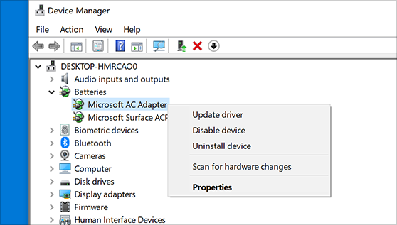
Update the device driver
- In the search box on the taskbar, enter device manager, then select Device Manager.
- Select a category to see names of devices, then right-click (or press and hold) the one you’d like to update.
- Select Search automatically for updated driver software.
- Select Update Driver.
- If Windows doesn't find a new driver, you can try looking for one on the device manufacturer's website and follow their instructions.
Reinstall the device driver
- In the search box on the taskbar, enter device manager, then select Device Manager.
- Right-click (or press and hold) the name of the device, and then select Uninstall.
- Restart your PC.
- Windows will attempt to reinstall the driver.

KT2104 Removing device drivers
How to Uninstall Drivers in Windows
Installing drivers can be a hair-raising adventure, even on today’s modern operating systems. These finicky pieces of code act as the middleman between your PC’s hardware and its operating system. Although they install with ease just like any other software, they integrate deeply into the OS, sinking their teeth into areas most other software doesn’t go near. Most of the time the driver installation process is simple, seamless, and transparent to you, as it should be.
On those occasions when things go wrong, however, they can go really wrong, and even crash your entire computer. For example, when Microsoft’s Windows Vista came out in 2007, critics lambasted it for being slow and prone to crashing; Microsoft investigated the causes and found that a majority of crashes were due to driver issues.
Thankfully, when you prepare yourself for battle with a problematic driver, you have a couple of tricks that can help. Microsoft has introduced an easy way to roll back to a previous (and, you hope, more stable) version of the driver, or remove it from the system altogether, giving you a clean slate to try again or install a different version.
Roll Back to a Previous Driver
- Click Start, type Device Manager, and press Enter.
- Find and double-click the category of device causing the issue (for instance, the graphics card would be listed under Display Adapters).
- Double-click the problematic device to bring up the Properties window.
- Click the Driver tab.
- Click the Roll Back Driver button.
- A dialog box will ask you to confirm your decision to roll back to a previous driver. Click Yes to begin the roll-back process. Use the Properties menu to uninstall your driver software or roll back to a previous version.
At this point Windows will automatically remove the current driver for the device and reinstall the previous driver. You may then receive a notification that the system settings have changed, and Windows will ask you to reboot. If you see that message, you should reboot your computer as soon as possible.
Uninstall a Driver
When you need to uninstall a driver completely, the best and safest method is to use the device’s uninstaller program (if it has one). If you added the device to your system through an installer (as is the case with most graphics card and sound card drivers, for instance), you can uninstall it just as you would any other program.
- Click Start, type Uninstall Program, and press Enter.
- In the Uninstall window that appears, go through the list and find your device or drivers. Double-click the entry to begin the uninstallation process.
Sometimes devices won’t have an uninstaller, or the uninstaller will not appear in the list. In those instances, you can use the Device Manager to remove the driver completely.
- Click Start, type Device Manager, and press Enter.
- Find and double-click the category of device whose driver you wish to uninstall (for example, the graphics card would be listed under Display Adapters).
- Right-click the device, and click Uninstall.
- Windows will prompt you to confirm the device’s removal. Click OK to remove the driver.
- After the uninstallation is complete, reboot your computer as soon as possible. In a pinch you can use the Windows Device Manager to uninstall troublesome driver software.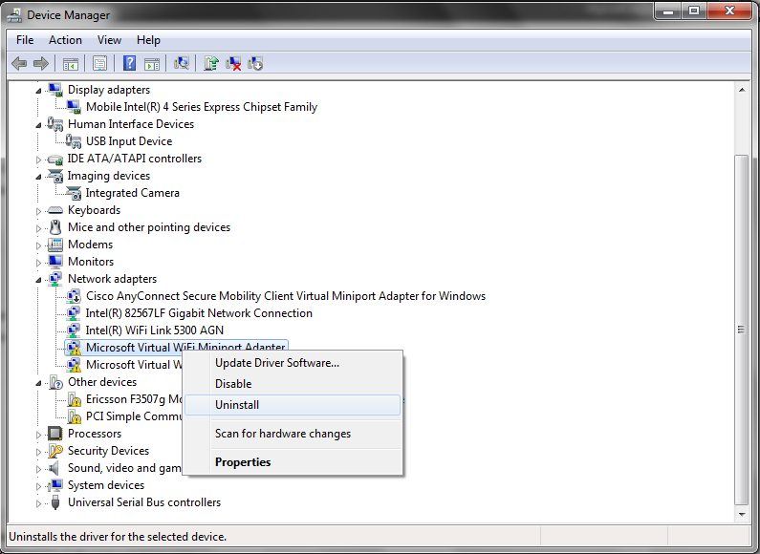
After you roll back or uninstall a problematic driver, you can try downloading and installing the latest version from the manufacturer’s website, or try a specific version that previously worked to get your computer back on its feet.

KT2105 Plug-and-play devices
Plug & Play, sometimes abbreviated to PnP, is a technology that allows peripheral devices to be connected to a computer and used almost immediately. All the user has to do is plug the device into a free computer port, with no need for manual configuration and no need to install a driver. One of the first companies to introduce this technology was Microsoft. Plug & Play was first available in Windows 95.
Plug & Play: How it works
Before Plug & Play became a standard feature of the most popular operating systems, users had to manually set up expansion cards and peripheral devices in a multi-step process and install suitable drivers for each hardware component.
With Plug & Play, the newly connected hardware component creates a unique identification code instead. The computer then uses this code to recognise the hardware and allocate the required computer resources, as well as automatically configuring parameters required for operation and loading the correct drivers. This automated process allows users to connect devices to the USB port of their computer and start working with them straight away. It also enables fast, convenient zero-touch provisioning of new hardware –an example of this cloudy
Plug & Play and security
While it is convenient, the Plug & Play technology can also introduce security risks. In principle, a malicious actor can compromise a computer by simply plugging in hardware – such as a manipulated USB stick –, thus gaining unauthorised access to data in order to manipulate this data or to install malware. This is why business computers often have the Plug & Play feature of their USB ports protected or completely deactivated.
NFON takes security very seriously. In January 2020, we introduced a new, patented technology for the secure auto provisioning of end devices. The NFON platform now requires two-factor authentication (2FA) for newly connected hardware devices. When commissioning new phones, users must enter a one-time, six-digit Phone Authentication PIN (PAP). This prevents cyber-attacks and increases the level of security for all users. Read more about it here: NFON AG introduces two-factor- authentication for hardware

Further information
Voice over Internet Protocol (VoIP)
What is VoIP?
The Voice over Internet Protocol, also called IP telephony, is a method of communication for making calls over a broadband Internet connection as an alternative to regular calls made…

KT2106 Device failure
Recovery procedure for a system failure
A system failure is a problem either with hardware (other than disk) or with operating system software that causes your system to end abnormally.
After your service representative has corrected the problem, follow the procedure to start your system after an abnormal end.

KT2107 System restore points
Restore point
What is restore point?
A system restore point is a backup copy of important Windows operating system (OS) files and settings that can be used to recover the system to an earlier point of time in the event of system failure or instability. It is a part of Windows XP, Vista, 7, 8, 10, 11 and Windows Server. They are created automatically or manually. System restore points only affect OS and application files, but not user data.
How do system restore points work?
The Windows system restore utility is responsible for making and using restore points. In old versions, Windows XP and Server 2003, the restore points were saved by the utility. Since Windows Vista, system restore points are made using the Microsoft Volume Shadow Copy Service (Microsoft VSS).
System restore points are designed to help the user recover the OS in the event an update, driver or application damages the OS. This way, copies of the files needed for operation are available and can be used to restore from. A system restore point can be called the last known good configuration.
The amount of hard drive space used by system restore points varies from 1% to 15%, depending on the size of the drive. If the reserved space for system restore points fills up, it will delete old copies to make space for new ones. System restore points also only store changed files -- also known as the difference -- and therefore use less storage than a full copy.
System restore is different than Windows Reset this PC or go back to the previous version of Windows.
What a restore point saves and recovers
A system restore point is primarily used for OS files and settings. It saves Windows system files and drivers. This will help in the event of a bad Windows update or system corruption. It also saves executable application data. This can be used in the event a program affects system performance or stability. The system registry and configurations are also saved.
The Windows Security Account Manager (SAM) and passwords are not backed up in restore points. Saved passwords may not be available after a system restore. This also means that a corporate domain-joined computer may lose its association to the domain after a restore and will need to be re-joined to the domain.
A system restore point is not a full backup. It does not affect user data or files. This means that a system restore point can be safely used by a user. A system restore will not delete personal files such as documents, pictures, music or videos. Be careful, though; because these files are not affected by a system restore, it cannot be used to recover these types of files if they are accidentally deleted. The Volume Shadow Copy may have copies of user files separate from system restore points though.
A system restore point is also only a local copy of the data. If the computer hardware is damaged a system restore cannot be used. It also cannot be used to transfer data from an old computer to a new one. A Windows system image may be used to create a full backup.
When system restore points are made and how to make a manual restore point
Windows will automatically make a restore point before doing most changes. This allows the system to easily rollback the change if something goes wrong. An automatic restore point is made before a Windows update is installed, an unsigned driver is installed, or a program is installed from an MSI. A restore point is also made every seven days if no other automatic restore point has been otherwise made.
Creating a manual system restore point is easy. In Windows 10 and Windows 11:
- Open the Settings app and go to the System
- From the system page open the About tab, then go to the right side under Related Settings.
- Click Advanced System Settings. This opens the System Properties window.
- From there, go to the System Protection This has all the system restore settings.
- To create a manual system restore point click the button labelled Create… and then give it a name that will help identify what the point is for.

Internal Assessment Criteria and Weight
• IAC2101 Considerations for configuring device drivers are reasoned
(Weight 5%)

KM-07-KT20: Networking and wireless connections
Learning Outcome

Topic elements to be covered include:

• KT1201 Peer-to-peer networks and server networks
• KT1202 Common functionality of server networks
• KT1203 Networking devices including network interface cards, repeaters, bridges, routers, gateways, hubs, and switches
KT1201 Peer-to-peer networks and server networks
Peer to peer network and client-server network are the telecommunication networks where the information is transferred from the source to the destination without any loss or only minimal loss in transmission. In both these kinds of the network, a path is used for transmission of the information. In the client-server network, the path is dedicated but the peer-to-peer network does not have a dedicated path. Let us read about these servers and the difference between peer to peer and client-server.
1) WHAT IS CLIENT SERVER NETWORK?
A client server network includes many clients or workstations that are connected to at least one central server. Most of the data and the applications get installed on the server. When the client wants access to the resources they then access it from the server. The server mostly has a private user directory as well as many public directories. The client server network has faster speed access because these are designed to support several clients. The client functions as a workstation without sharing any of the resources.
It makes it easy to upgrade the software applications and the files because these are held on a single computer only. The server software provides system-wide services. There is enhanced security in the client server network because the server handles the security. This is a network model that is broadly used. In the client server network, the clients and the servers are differentiated and specific servers and clients are present. In a client server network, the centralized server gets used to store data because it has centralized management. In this network, the server responds to the services which are requested by the client.
A client server network is a kind of online network that comprises of a single central computer that behaves like a server and that directs various computes or clients to it. When the server is accessed clients can reach the shared information and files that are saved on the computer serving it. The World Wide Web is an example of a computer application that makes use of the client server model.
The nature of the application is what decides whether in the client server model the computer is a client, a server, or acts like both of them.
2) WHAT IS PEER-TO-PEER NETWORK?
A peer-to-peer network is one that involves two or more than two computers that pool individual resources like the printers, DVD players, and disk drivers. These are the shared resources that are available in every computer in the network. Each of the computers will behave as the client as well as the server and it communicates with the other computers directly. In the peer-to-peer network like for example the printer of one of the computers can be used by any computer present in the particular network. It is inexpensive to set up a peer-to-peer network.
All that is needed is a Wi-Fi router or an Ethernet cable to set it up. The model does not differentiate between the server and the client, and here every node behaves as a server and a client. In the peer-to-peer network, every node can request as well as respond to the services.
The peer-to-peer network is a computer group or a group of computer systems that are connected through the internet. It allows direct sharing of the files between the network systems without any need for a central server. The network form is common in small offices that do not need a file server that is dedicated for use. All the MAC, Windows, and Linux client versions function as a node in the peer-to-peer network which allows sharing of the files.
3) DIFFERENCE BETWEEN CLIENT SERVER AND PEER TO PEER NETWORK
Here is the difference between peer to peer and client server.
- The servers and clients are differentiated in the client network however the client and the server do not get differentiated in the peer-to-peer network.
- The client server networks work on sharing of information while the peer-to-peer networks focuses on connectivity.
- Centralized servers get used to store data in the client server network while each peer gets its data in the peer-to-peer networks.
- In the clients’ server network, the serves respond to the client’s request where in the peer-to-peer network each node can request as well as respond to the services. It is an important peer to peer vs client server difference.
- The client server networks are much costly than the peer-to-peer networks.
- The client server network is more stable as compared to the peer-to-peer networks.
- The client server networks can be used for small and large networks but the peer-to-peer networks can be suited only for the small networks. This is another difference between client server and peer to peer network.
- The client server network does not save the information that gets transmitted so there is no option to resend the data if in case it gets lost for some reason. If the information gets lost in the peer-to-peer networks then the corresponding node can resend the information as the information is stored.
- The full bandwidth gets reserved in advance in the client server network because there are only two nodes and a dedicated submission path. In the peer-to-peer network, the entire bandwidth is not reserved in advance. It consumes the bandwidth node as per the bandwidth and they release it when it gets free.
- Client server makes use of geographical addressing whereas peer to peer network makes use of hierarchical addressing
CONCLUSION
The article solves all doubts about the difference between peer to peer and client server network.
The client server and the peer-to-peer networks connect the computers so that the resources like applications and files are shared. The peer-to-peer network connects computers so that every computer shares all or some part of the resources. The client server networks operate with one or more than one central computers or servers that manage the resources and hold the data.
KT1202 Common functionality of server networks
Using a server
A server is used to store files and run centralised applications, such as your customer database.
In the past, a server was essential. However, most businesses use cloud computing services instead.
A network server can have many roles
You can use a network server to:
- store and share your files;
- share a single internet connection between all your devices;
- manage incoming and outgoing email;
- allow staff to access files when out and about through a virtual private network (VPN);
- centralise printing, so the server manages print jobs and lets you share printers;
- run networked applications and software;
- host an intranet (a kind of private website holding important information about your business).
Businesses with many computers may need to spread the load across several servers
- Virtualisation can help you do more with a single server (see Types of system).
Some applications may dramatically slow your network if you run them on your server
They may require a separate server, used just for them. Such applications can include:
- large shared databases;
- in-house software development environments;
- complex internal email systems.
Using the cloud as a server
You can use cloud computing services (sometimes called hosted applications or Software as a Service [SaaS]) to perform many jobs that have traditionally required a server.
Cloud computing services are well suited to small or new companies with little IT expertise in-house. They are simple to set-up, cheap to operate and most come with 24/7 support if you experience problems with the service. Some businesses use a mix of server and cloud-based services.
With cloud computing, your data is held on a server located outside your business
- To access files and services, you log in through a web browser.
- Individual cloud computing services can help you with specific tasks, like backing up data or accounting.
- You can also purchase 'cloud servers' that perform all the functions of an in-house network server.
Cloud computing offers several key advantages over buying a server
- You pay monthly, allowing you to spread the cost. Overall, the total annual cost is broadly the same.
- Your cloud provider manages the administration of the server, takes backups and provides technical support.
- Cloud servers are highly flexible. You can add or remove users instantly, and you aren't usually tied into a long contract.
- Updates can take place without disrupting internal operations. Most major updates are performed outside of normal business hours, on weekends or during the night.
- Cloud servers support remote working enabling users to login from anywhere and on virtually any device.
Consider carefully before signing up to cloud services
- Make sure your cloud supplier is trustworthy, as you'll be relying on them to take good care of your data.
- You need an internet connection to use cloud services, so make sure yours is fast and reliable.
- Check what level of support you get. Are you confident your cloud provider will be there to help?
- Learn where your data is stored. You have responsibilities under GDPR to ensure that it’s safe and secure.

• KT1203 Networking devices including network interface cards, repeaters, bridges, routers, gateways, hubs, and switches
Network Devices (Hub, Repeater, Bridge, Switch, Router, Gateways and Brouter)

1. Repeater – A repeater operates at the physical layer. Its job is to regenerate the signal over the same network before the signal becomes too weak or corrupted so as to extend the length to which the signal can be transmitted over the same network. An important point to be noted about repeaters is that they do not amplify the signal. When the signal becomes weak, they copy the signal bit by bit and regenerate it at the original strength. It is a 2-port device.
2. Hub – A hub is basically a multiport repeater. A hub connects multiple wires coming from different branches, for example, the connector in star topology which connects different stations. Hubs cannot filter data, so data packets are sent to all connected devices. In other words, the collision domain of all hosts connected through Hub remains one. Also, they do not have the intelligence to find out the best path for data packets which leads to inefficiencies and wastage.

Types of Hubs
- Active Hub: - These are the hubs that have their own power supply and can clean, boost, and relay the signal along with the network. It serves both as a repeater as well as a wiring centre. These are used to extend the maximum distance between nodes.
- Passive Hub: - These are the hubs that collect wiring from nodes and power supply from the active hub. These hubs relay signals onto the network without cleaning and boosting them and can’t be used to extend the distance between nodes.
- Intelligent Hub: - It works like active hubs and includes remote management capabilities. They also provide flexible data rates to network devices. It also enables an administrator to monitor the traffic passing through the hub and to configure each port in the hub.
3. Bridge – A bridge operates at the data link layer. A bridge is a repeater, with add on the functionality of filtering content by reading the MAC addresses of source and destination. It is also used for interconnecting two LANs working on the same protocol. It has a single input and single output port, thus making it a 2-port device.
Types of Bridges
- Transparent Bridges: - These are the bridge in which the stations are completely unaware of the bridge’s existence i.e., whether or not a bridge is added or deleted from the network, reconfiguration of the stations is unnecessary. These bridges make use of two processes i.e., bridge forwarding and bridge learning.
- Source Routing Bridges:- In these bridges, routing operation is performed by the source station and the frame specifies which route to follow. The host can discover the frame by sending a special frame called the discovery frame, which spreads through the entire network using all possible paths to the destination.
4. Switch – A switch is a multiport bridge with a buffer and a design that can boost its efficiency (a large number of ports imply less traffic) and performance. A switch is a data link layer device. The switch can perform error checking before forwarding data, which makes it very efficient as it does not forward packets that have errors and forward good packets selectively to the correct port only. In other words, the switch divides the collision domain of hosts, but broadcast domain remains the same.
5. Routers – A router is a device like a switch that routes data packets based on their IP addresses. The router is mainly a Network Layer device. Routers normally connect LANs and WANs together and have a dynamically updating routing table based on which they make decisions on routing the data packets. Router divide broadcast domains of hosts connected through it.

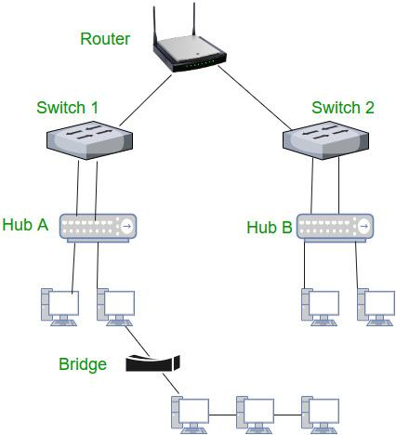

6. Gateway – A gateway, as the name suggests, is a passage to connect two networks together that may work upon different networking models. They basically work as the messenger agents that take data from one system, interpret it, and transfer it to another system. Gateways are also called protocol converters and can operate at any network layer. Gateways are generally more complex than switches or routers. Gateway is also called a protocol converter.
7. Brouter – It is also known as the bridging router is a device that combines features of both bridge and router. It can work either at the data link layer or a network layer. Working as a router, it is capable of routing packets across networks, and working as the bridge, it is capable of filtering local area network traffic.
8. NIC – NIC or network interface card is a network adapter that is used to connect the computer to the network. It is installed in the computer to establish a LAN. It has a unique id that is written on the chip, and it has a connector to connect the cable to it. The cable acts as an interface between the computer and router or modem. NIC card is a layer 2 device which means that it works on both physical and data link layer of the network model.

Internal Assessment Criteria and Weight
• IAC1201 Networking and wireless connections are discussed with reference to types and functionality
(Weight 3%)

KM-07-KT21: Recovery
Learning Outcome

Topic elements to be covered include:

• KT2201 Recovering systems and disaster recovery
• KT2202 Process for disaster recovery
• KT2203 Expecting things to go wrong
• KT2204 Using boot logs to troubleshoot problems
• KT2205 Process for booting a system into safe mode
• KT2206 Emergency repair
• KT2207 Factory repair partitions
• KT2208 Startup repair
• KT2209 System image recovery

KT2201 Recovering systems and disaster recovery
What is disaster recovery?
Disaster recovery (DR) is an organization's ability to respond to and recover from an event that negatively affects business operations. The goal of DR methods is to enable the organization to regain use of critical systems and IT infrastructure as soon as possible after a disaster occurs. To prepare for this, organizations often perform an in-depth analysis of their systems and create a formal document to follow in times of crisis. This document is known as a disaster recovery plan.
Read on to learn more about why DR is important, how it works, and the difference between disaster recovery and business continuity. You'll also discover what to include in a disaster recovery plan and the major types of DR, as well as major DR services and vendors.
What is a disaster?
The practice of DR revolves around events that are serious in nature. These events are often thought of in terms of natural disasters, but they can also be caused by systems or technical failure or by humans carrying out an intentional attack. They are significant enough to disrupt or completely stop critical business operations for a period of time. Types of disaster include:
- Cyber-attacks such as malware, DDoS and ransomware attacks
- Sabotage
- Power outages
- Equipment failure
- Epidemics or pandemics, such as COVID-19
- Terrorist attacks or threats
- Industrial accidents
- Hurricanes
- Tornadoes
- Earthquakes
- Floods
- Fires
Why is disaster recovery important?
Disasters can inflict many types of damage with varying levels of severity, depending on the scenario. A brief network outage could result in frustrated customers and some loss of business to an e-commerce system. A hurricane or tornado could destroy an entire manufacturing facility, data centre or office.
Additionally, many businesses are required to create and follow plans for disaster recovery, business continuity and data protection in order to meet compliance regulations. This is particularly important for organizations operating in financial, healthcare, manufacturing and government sectors. Failure to have DR procedures in place can result in legal or regulatory penalties, so understanding how to comply with resiliency standards is important.
Preparing for every potential disaster may seem extreme, but the COVID-19 crisis illustrated that even scenarios that seem farfetched can come to pass. Businesses that had emergency measures in place to support remote work had a clear advantage when stay-at-home orders were enacted.
Thinking about disasters before they happen and creating a plan for how to respond can provide many benefits. It raises awareness about potential disruptions and helps an organization to prioritize its mission-critical functions. It also provides a forum for discussing these topics and making careful decisions about how to best respond in a low-pressure setting.
What is the difference between disaster recovery and business continuity?
On a practical level, DR and business continuity are often combined into a single corporate initiative and even abbreviated together as BCDR, but they are not the same thing. While the two disciplines have similar goals relating to an organization's resilience, they differ greatly in scope.
BC is a proactive discipline intended to minimize risk and help ensure the business can continue to deliver its products and services no matter the circumstances. It focuses especially on how employees will continue to work and how the business will continue operations while a disaster is occurring. BC is also closely related to business resilience, crisis management and risk management, but each of these has different goals and parameters.
DR is a subset of business continuity that focuses on the IT systems that enable business functions. It addresses the specific steps an organization must take to resume technology operations following an event. DR is also a reactive process by nature. While planning for it must be done in advance, DR activity is not kicked off until a disaster actually occurs.
Elements of a disaster recovery strategy
Before an organization can determine its DR strategies, it must first analyse existing assets and priorities. Two different analyses typically factor into DR decision-making:
Risk analysis
Risk analysis or risk assessment is an evaluation of all the potential risks the business could face, as well as their outcomes. Risks can vary greatly depending on the industry the organization is in and its geographic location. The assessment should identify potential hazards, determine who or what these hazards would harm, and use the findings to create procedures that take these risks into account.
Business impact analysis
Business impact analysis (BIA) evaluates the effects of the risks identified above to business operations. A BIA can help predict and quantify costs, both financial and non-financial. It also examines the impact of different disasters on an organization's safety, finances, marketing, business reputation, legal compliance and quality assurance.
Understanding the difference between risk analysis and BIA and conducting the assessments can also help an organization define it goals when it comes to data protection and the need for backup. Organizations generally quantify these using measurements called recovery point objective (RPO) and recovery time objective (RTO).
Get started with your own analysis by reading our guide to BIA and free template.
Recovery point objective
RPO is the maximum age of files that an organization must recover from backup storage for normal operations to resume after a disaster. The RPO determines the minimum frequency of backups. For example, if an organization has an RPO of four hours, the system must back up at least every four hours.
Recovery time objective
RTO refers to the amount of time an organization estimates its systems can be down without causing significant or irreparable damage to the business. In some cases, applications can be down for several days without severe consequences. In others, seconds can do substantial harm to the business.
RPO and RTO are both important elements in disaster recovery, but the metrics have different uses. RPOs are acted on before a disruptive event takes place to ensure data will be backed up, while RTOs come into play after an event occurs.
Read more about calculating recovery objectives and the difference between RPO and RTO.
What's in a disaster recovery plan?
Once an organization has thoroughly reviewed its risk factors, recovery goals and technology environment, it can write a DR plan. The DR plan is the formal document that specifies these elements and outlines how the organization will respond when disruption or disaster occurs. The plan details recovery goals including RTO and RPO as well as the steps the organization will take to minimize the effects of the disaster.
The components of a DR plan should include:
- A DR policy statement, plan overview and main goals of the plan.
- Key personnel and DR team contact information.
- A step-by-step description of disaster response actions immediately following an incident.
- A diagram of the entire network and recovery site.
- Directions for how to reach the recovery site.
- A list of software and systems that staff will use in the recovery.
- Sample templates for a variety of technology recoveries, including technical documentation from vendors.
- A communication that includes internal and external contacts, as well as boilerplate for dealing with the media.
- Summary of insurance coverage.
- Proposed actions for dealing with financial and legal issues.
An organization should consider its DR plan a living document. Regular disaster recovery testing should be scheduled to ensure the plan is accurate and will work when a recovery is required. The plan should also be evaluated against consistent criteria whenever there are changes in the business or IT systems that could affect DR.
For more details and guidance, download a free DR plan template and planning guide.
How disaster recovery works
DR initiatives are more attainable by business of all sizes today due to widespread cloud adoption and availability of virtualization technologies that make backup and replication easier. However, much of the terminology and best practices developed for DR were based on enterprise efforts to recreate large-scale physical data centres. This involved plans to transfer, or fail over, workloads from a primary data centre to a secondary location or DR site in order to restore data and operations.
Disaster recovery sites
An organization uses a DR site to recover and restore its data, technology infrastructure and operations when its primary data centre is unavailable. DR sites can be internal, external or cloud-based.
An organization sets up and maintains an internal DR site. Organizations with large information requirements and aggressive RTOs are more likely to use an internal DR site, which is typically a second data centre. When building an internal site, the business must consider hardware configuration, supporting equipment, power maintenance, heating and cooling of the site, layout design, location and staff.
An external disaster recovery site is owned and operated by a third-party provider. External sites can be hot, warm or cold.
- Hot site: A fully functional data centre with hardware and software, personnel and customer data, which is typically staffed around the clock and operationally ready in the event of a disaster.
- Warm site: An equipped data centre that doesn't have customer data; an organization can install additional equipment and introduce customer data following a disaster.
- Cold site: Has infrastructure to support IT systems and data, but no technology until an organization activates DR plans and installs equipment; they are sometimes used to supplement hot and warm sites during a long-term disaster.
A cloud recovery site is another option. An organization should consider site proximity, internal and external resources, operational risks, service-level agreements and cost when contracting with cloud providers to host their DR assets or outsourcing additional services.
Disaster recovery tiers
In addition to choosing the most appropriate DR site, it may be helpful for organizations to consult the tiers of disaster recovery identified by the Share Technical Steering Committee and IBM in the 1980s. The tiers feature a variety of recovery options organizations can use as a blueprint to help determine the best DR approach depending on their business needs.
Another type of DR tiering involves assigning levels of importance to different types of data and applications and treating each tier differently based on the tolerance for data loss. This approach recognizes that some mission-critical functions may not be able to tolerate any data loss or downtime, while others can be offline for longer or have smaller sets of data restored.
Types of disaster recovery
In addition to choosing a DR site and considering DR tiers, IT and business leaders must evaluate the best way to put their DR plan into action. This will depend on the IT environment and the technology the business chooses to support its DR strategy.

KT2202 Process for disaster recovery
What is Disaster Recovery?
How does disaster recovery work?
Disaster recovery relies upon the replication of data and computer processing in an off-premises location not affected by the disaster. When servers go down because of a natural disaster, equipment failure or cyber-attack, a business needs to recover lost data from a second location where the data is backed up. Ideally, an organization can transfer its computer processing to that remote location as well in order to continue operations.
5 top elements of an effective disaster recovery plan
- Disaster recovery team: This assigned group of specialists will be responsible for creating, implementing and managing the disaster recovery plan. This plan should define each team member’s role and responsibilities. In the event of a disaster, the recovery team should know how to communicate with each other, employees, vendors, and customers.
- Risk evaluation: Assess potential hazards that put your organization at risk. Depending on the type of event, strategize what measures and resources will be needed to resume business. For example, in the event of a cyber-attack, what data protection measures will the recovery team have in place to respond?
- Business-critical asset identification: A good disaster recovery plan includes documentation of which systems, applications, data, and other resources are most critical for business continuity, as well as the necessary steps to recover data.
- Backups: Determine what needs backup (or to be relocated), who should perform backups, and how backups will be implemented. Include a recovery point objective (RPO) that states the frequency of backups and a recovery time objective (RTO) that defines the maximum amount of downtime allowable after a disaster. These metrics create limits to guide the choice of IT strategy, processes and procedures that make up an organization’s disaster recovery plan. The amount of downtime an organization can handle and how frequently the organization backs up its data will inform the disaster recovery strategy.
- Testing and optimization: The recovery team should continually test and update its strategy to address ever-evolving threats and business needs. By continually ensuring that a company is ready to face the worst-case scenarios in disaster situations, it can successfully navigate such challenges. In planning how to respond to a cyber-attack, for example, it’s important that organizations continually test and optimize their security and data protection strategies and have protective measures in place to detect potential security breaches.

KT2203 Expecting things to go wrong
Most Common Computer Problems
- The Computer Won't Start. A computer that suddenly shuts off or has difficulty starting up could have a failing power supply.
- The Screen is Blank.
- Abnormally Functioning Operating System or Software.
- Windows Won't Boot.
- The Screen is Frozen.
- Computer is Slow.
- Strange Noises.
- Slow Internet.

KT2204 Using boot logs to troubleshoot problems
Create a boot log for troubleshooting
Problems that you’re troubleshooting in Windows XP often originate in the boot process. As such, one of your key troubleshooting techniques should be to create a boot log. Creating such a log is a relatively easy process. Follow these steps: Restart the system. When the operating system begins to load, press [F8]. Select the Enable ...
Problems that you’re troubleshooting in
Windows XP often originate in the boot process. As such, one of
your key troubleshooting techniques should be to create a boot log.
Creating such a log is a relatively easy process.
Follow these steps:
- Restart the system.
- When the operating system begins to load,
press [F8].
- Select the Enable Boot Logging option from
the Windows Advanced menu, and press [Enter].
After the system restarts, launch Notepad, and
open the C:\Windows\Ntbtlog.txt file. This file contains a list of
all of the files that Windows XP attempted to load during
start-up.
Every line in the file will begin with either
“Loaded driver” or “Did not load driver,” which makes it easy to
determine what drivers or services could be causing the problem. In
either case, the path and filename of the driver or service will
follow.

KT2205 Process for booting a system into safe mode
The Advanced Boot Options screen lets you start Windows in advanced troubleshooting modes. You can access the menu by turning on your computer and pressing the F8 key before Windows starts.
Some options, such as safe mode, start Windows in a limited state, where only the bare essentials are started. If a problem doesn't reappear when you start in safe mode, you can eliminate the default settings and basic device drivers and services as possible causes. Other options start Windows with advanced features intended for use by system administrators and IT professionals. For more information, go to the Microsoft website for IT professionals.
Repair Your Computer
Shows a list of system recovery tools you can use to repair start-up problems, run diagnostics, or restore your system. This option is available only if the tools are installed on your computer's hard disk. If you have a Windows installation disc, the system recovery tools are located on that disc.
Safe Mode
Starts Windows with a minimal set of drivers and services.
To start in safe mode:
- Remove all floppy disks, CDs, and DVDs from your computer, and then restart your computer. Click the Start button, click the arrow next to the Shut Down button (or the arrow next to the Lock button), and then click Restart.
- Do one of the following:
  - If your computer has a single operating system installed, press and hold the F8 key as your computer restarts. You need to press F8 before the Windows logo appears. If the Windows logo appears, you'll need to try again by waiting until the Windows logon prompt appears, and then shutting down and restarting your computer.
  - If your computer has more than one operating system, use the arrow keys to highlight the operating system you want to start in safe mode, and then press F8.
- On the Advanced Boot Options screen, use the arrow keys to highlight the safe mode option you want, and then press Enter.
- Log on to your computer with a user account that has administrator rights.
- Safe Mode with Networking. Starts Windows in safe mode and includes the network drivers and services needed to access the Internet or other computers on your network.
- Safe Mode with Command Prompt. Starts Windows in safe mode with a command prompt window instead of the usual Windows interface. This option is intended for IT professionals and administrators.
- Enable Boot Logging. Creates a file, ntbtlog.txt, that lists all the drivers that are installed during start-up and that might be useful for advanced troubleshooting.
- Enable low-resolution video (640×480). Starts Windows using your current video driver and using low resolution and refresh rate settings. You can use this mode to reset your display settings. For more information, see Change your screen resolution.
- Last Known Good Configuration (advanced). Starts Windows with the last registry and driver configuration that worked successfully.
- Directory Services Restore Mode. Starts Windows domain controller running Active Directory so that the directory service can be restored. This option is intended for IT professionals and administrators.
- Debugging Mode. Starts Windows in an advanced troubleshooting mode intended for IT professionals and system administrators.
- Disable automatic restart on system failure. Prevents Windows from automatically restarting if an error causes Windows to fail. Choose this option only if Windows is stuck in a loop where Windows fails, attempts to restart, and fails again repeatedly.
- Disable Driver Signature Enforcement. Allows drivers containing improper signatures to be installed.
- Start Windows Normally. Starts Windows in its normal mode.

KT2206 Emergency repair

Short for Emergency Repair Disk, an ERD is a diskette that creates backups of system files and settings and helps troubleshoot and fix issues for Windows NT and Windows 2000 users. The ERD is used in conjunction with the Windows repair option and prompts for the diskette when needed. Note: The ERD is not to be confused with a standard boot diskette as it cannot be used alone.
ERD capabilities
- Verifying the boot sector is not corrupt.
- Repairing any start up files.
- Locate any missing or damaged system files.

KT2207 Factory repair partitions
What is a recovery partition?
Due to the inclusion on their PC by default, many users assume the recovery partition isn’t something they should mess with. In reality, though, it’s completely safe and relatively easy to format the OEM recovery partition and create a recovery partition of your own.
The recovery partition is simply a save of the system’s state when the manufacturer first set up the PC. It usually takes the form of a .wim file that can be accessed through the usual recovery interface. You can create a recovery partition in Windows yourself to replace those files, but it’s usually not a good idea to simply delete the OEM partition without replacing it.
To create a recovery drive in Windows 10, you must first create a Windows recovery image, before preparing the partition and adding it to your boot menu for easy access. If you want to create a full Windows 10 System Image Backup, there is an easier way to do it which does not work to update the recovery partition.
How to Capture a Windows Recovery Image as a WIM file
There’s some preparation required before you create your windows recovery image, though this is reduced if you already keep your OS maintained and up-to-date. First, make sure your PC is fully updated, has the user accounts and software you want to be included, and has the themes/settings you’d prefer. Once complete, boot from Windows installation media by following this guide.
- Open Command Prompt via Windows Installation Media
Once your PC boots, ignore the setup screen and press “Shift + F10” to open the command-line interface.
- (Optional) Initialize networking services
You only need to do this if you want to save your Windows 10 recovery image on a network drive. To do so, type wpeinit and press “Enter”.
- (Optional) Map a network drive for network drive storage
In Command Prompt, enter the following command, replacing ‘Z:’ with your mapped drive, ‘storage server’ with the server name, and ‘images’ with the name of your shared folder:
net use Z: \\storageserver\images
- Confirm your Windows 10 recovery drive with disk part
Before you create your Windows recovery image, it’s worth double-checking that you know the correct letter for your Windows drive and to save your image to. In Command prompt, verify this by typing disk part, then list vol.
You’ll be faced with an output similar to below. In our case, we can look at the size and use our previous knowledge to determine that ‘C’ is our OS/source drive and ‘D’ is the destination we want to save our recovery image to. Be sure to type “exit” to leave disk part before you continue.

KT2208 Start up repair
BIOS phase
To determine whether the system has passed the BIOS phase, follow these steps:
- If there are any external peripherals connected to the computer, disconnect them.
- Check whether the hard disk drive light on the physical computer is working. If it's not working, this dysfunction indicates that the start-up process is stuck at the BIOS phase.
- Press the NumLock key to see whether the indicator light toggles on and off. If it doesn't toggle, this dysfunction indicates that the start-up process is stuck at BIOS.
If the system is stuck at the BIOS phase, there may be a hardware problem.
Boot loader phase
If the screen is black except for a blinking cursor, or if you receive one of the following error codes, this status indicates that the boot process is stuck in the Boot Loader phase:
- Boot Configuration Data (BCD) missing or corrupted
- Boot file or MBR corrupted
- Operating system Missing
- Boot sector missing or corrupted
- Bootmgr missing or corrupted
- Unable to boot due to system hive missing or corrupted
To troubleshoot this problem, use Windows installation media to start the computer, press Shift + F10 for a command prompt, and then use any of the following methods.
Method 1: Start-up Repair tool
The Start-up Repair tool automatically fixes many common problems. The tool also lets you quickly diagnose and repair more complex start-up problems. When the computer detects a start-up problem, the computer starts the Start-up Repair tool. When the tool starts, it performs diagnostics. These diagnostics include analysing start-up log files to determine the cause of the problem. When the Start-up Repair tool determines the cause, the tool tries to fix the problem automatically.
To do this task of invoking the Start-up Repair tool, follow these steps.
Note
For additional methods to start WinRE, see Windows Recovery Environment (Windows RE).
- Start the system to the installation media for the installed version of Windows. For more information, see Create installation media for Windows.
- On the Install Windows screen, select Next > Repair your computer.
- On the Choose an option screen, select Troubleshoot.
- On the Advanced options screen, select Start-up Repair.
- After Start-up Repair, select Shutdown, then turn on your PC to see if Windows can boot properly.

KT2209 System image recovery
System Image Backup and Recovery
What Is System Image Backup?
System image backup is a backup technique that allows to copy all drives of the computer and the state of its operating system at a given point in time and allows it to recover that computer to this state.
System image backup works as follows:
- Backup software creates a copy of selected drives.
- If the drive contains several partitions, each partition is then saved as a single file, an image.
- The software adds a copy of a boot sector and drive configuration data to images.
While Microsoft generally calls that backup technique system image backup, many backup vendors (including MSP360) and users tend to name it image-based backup.
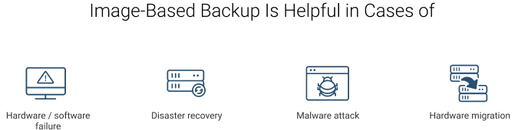
System image backup solutions can be helpful in cases of hardware or software failure, disaster recovery, or any malware attack. Speaking of less disastrous situations, you may need system image backup if you would like to switch to different hardware keeping the same system settings and configuration.
The greatest advantage of system image backup is a faster recovery of entire systems. The faster you restore your data, the sooner you can get back to business operations. (Check out our article to learn more about common backup recovery mistakes.)
System Image-based backup is actively used to backup and recover the production servers to enhance the recovery time and recovery point objectives.
FREE WHITEPAPER
Full System Backup and Recovery
Check out our comprehensive guide covering system image, system state, and application-aware backup and recovery, as well as bare-metal recovery:
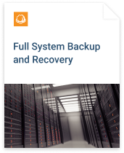
System Image Recovery Options
There are three options to recover a system from an image-based backup:
- File-level restore, when you recover the selected files
- Recovery of the selected partitions to the drive
- System recovery with the ISO file.
Below we will overview each of the options in detail.
File-Level Restore
The recovery of individual files and folders from the system image backup is called file-level or granular restore. It often saves the day when you need to recover only one file without downloading the whole image from the failed machine. That’s not a standard recovery technique and is available in 3-rd party backup solutions, such as Cloud Berry Backup.
How to Recover Individual File from Image-Based Backup
Recovery to the Drive
Sometimes you boot your machine and one or several partitions are missing or do not work. There are two possible reasons for that: HDD/SSD failure and file system failure. In these situations, you can recover only the selected partitions from system image without recreating their structure, or reinstalling the OS.
Recovery with ISO File

ISO file is basically an archive with the .iso, .img or .ima file extension. Nowadays, it’s an industry standard and files with mentioned extensions are used to distribute large programs. The idea behind the ISO image file in system image backup is that you can store and recreate, when needed, an exact digital copy of a disc or a selected partition.
ISO files typically contain everything you need to run and install a given program. That is why, for the full system recoveries, ISO-images in Cloud Berry Backup contain not only copies of partitions, configuration, and a boot sector, but also a Windows PE (PE stands for Preinstalled Environment). This makes images bootable - you don’t need any installed OS on the machine to boot it and recover your data.
Further reading Creating a Bootable ISO Image with MSP360 Backup
Bare-Metal Recovery
A computer without an operating system installed is called a bare-metal machine. Bootable ISO images help to recover the system to these machines fast and without additional configuration. This method works best whenever the hardware is upgraded, or under maintenance, for instance.
System Image Recovery Destinations
The system image recovery process is different for different types of IT-architecture. There are three common destinations for a recovery:
- Physical machine
- Virtual machine
- Virtual cloud machine

Internal Assessment Criteria and Weight
• IAC2201 Recovery processes are identified and application is described
(Weight 5%)

KM-07-KT22: Cloud computing
Learning Outcome

Topic elements to be covered include:

• KT2301 Network or internet connection
• KT2302 Manipulate, collate, configure, and access applications online
• KT2303 Providing support infrastructure, applications, and data storage
• KT2304 Benefits and risks to cloud computing as well as cloud characteristics
• KT2305 Cloud storage
KT2301 Network or internet connection
What is the relationship between internet and network (Network vs. Internet)?
There are numerous technical terminologies present which confuse people a lot. Internet and network are two terminologies that are pegged by non-technical people the same. But, they are two opposite terms with different uses. So, in this post, explain what is the Network and the Internet and what are the difference between the internet and network (Network vs. Internet) in a constructive way.
What is a Computer Network?
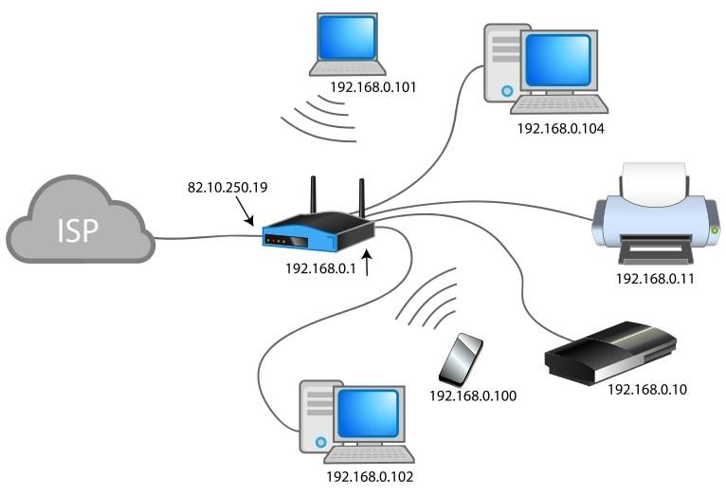
The network is a connection between two computer devices to share resources like internet connection, printer, apps, etc., It is a collection of computers or other devices that are connected with wireless technology or transmission media. The network provides connectivity between two devices present within the restricted range where one person is only authorized to manage the entire system. The network can be distinguished into different types such as –
- Local Area Network aka LAN is the network that connects the small number of devices present in the close geographical location such as nearby buildings or a floor up/down.
- Metropolitan Area Network aka MAN is a communication network that is available in large cities.
- Wide Area Network aka WAN is a network that connects two local area networks over a long distance. The operational area of WAN is vast like across countries or states.
What is the Internet?

The internet (short for inter-network) is a global system that uses TCP/IP protocol suite to connect various electronic devices. It is a huge collection of interconnecting devices with speed around the globe. Internet is the network of the network which is compressed of different networks like public, private, academic, government and others. It is a type of network which connects different devices.
What is the difference between a network and the Internet?
In simple words, the network is a collection of devices that can communicate with each other on the other hand the Internet is a collection of networks that can communicate with each other.

- The network is a structure when two or more than two computers are connected to exchange data and information. On the other hand, the internet is a type of network and networks of the network, that can connect.
- The working range of the network is limited whereas the area of operation for the internet is the whole world.
- A network connecting with the three of four devices can be very affordable, but with the internet internetworking is required which can be pretty costly.
- The network is interactive over are face to face connections. The internet won’t always allow the face-to-face interaction.
- There are different types of networks available such as – LAN, MAN, WAN, Campus Area Network and Home Area Network. However, there’s only one type of internet presence that is the world wide web.
- The network aims to connect and complete work at a fast pace. On the contrary, the internet has sole purpose to get access to the latest news and information.
 | Network | Internet
Definition | A group of two or more computer systems are linked together. | Several networks of working that are linked together.
Location | Present within a restricted geographical area such as an institute or home. | It ranges from one country to another.
Connection | Get to interact with each other from face to face. | Do not always get to interact with each other face to face.
Types | Local Area Network, Wide Area Network, Campus Area Network and Home Area Network. | World Wide Web.
Aim | To get connected and complete work at fast rates. | To get access to news and information.
 | A computer network can have 100% private IP addresses. | The Internet requires public IP addresses
 | A computer network can exist entirely within a host and be 100% virtual. | The Internet cannot exist with only virtual devices, it includes the host.
 | A computer network can exist in a single location. | The Internet is geographically diverse

KT2302 Manipulate, collate, configure, and access applications online
Data Manipulation: Definition, Importance
Data manipulation means to organize or arrange the kind of structured data that is read by computer programs so that it’s easier to interpret. Performing this process effectively can improve the quality of your data and analysis.
How is data manipulation performed?
Data manipulation typically requires the use of data manipulation language (DML). DML is a coding language that allows you to reorganize data by modifying it within its database program.
What is structured query language (SQL)?
Communicating with the database program to make these adjustments may require the use of structured query language (SQL) to ensure none of the data gets lost in the database when it's being organized.
Here are some common SQL commands used in the data manipulation process:
- Select: This command allows you to select the data you want to manipulate from the database. Specifically, it tells the database what data to select and where to find the data.
- Update: This command allows you to update existing data within the database. Specifically, it can communicate with the database to tell it what data needs to be updated, where the new data should be input and whether it should add the data records one at a time or together.
- Insert: This command allows you to relocate data within the database. Specifically, it tells the database where the data is currently located and where the data needs to be moved.
- Delete: This command allows you to remove data from the database. Specifically, it tells the database what data to delete and where it can find the data.
Related: What Is a Data Scientist?
Why is data manipulation important?
Data manipulation is important because it allows you to easily access the information that’s critical to your specific business and goals. This process can be tailored to identify different data sets as your company grows or makes adjustments due to market demand. Data manipulation is also a valuable tool in identifying and correcting data redundancies in reporting.

Reasons why companies use data manipulation
Companies may manipulate data to transform it into useful insights that they can use for stakeholder presentations, project or financial decisions and trend or success measurements. Here are four reasons companies may choose to implement data manipulation:
1. Consistent and organized data
Companies may manipulate their data because it can provide them with well-organized databases. Categorization can allow companies to group similar data, which may make it easier to search for information. For example, a company may choose to alphabetize data. Depending on their needs, businesses can categorize data in a variety of different ways.
2. Insightful project data access
Another reason companies might manipulate their data is that it can allow them to archive project data and access it later if they want to use it as a reference while working on a new project or setting business goals. Businesses may also reference their previous data when examining finances and whether profits are increasing.
3. More valuable data
Companies that choose to manipulate their data can tailor their results to provide specific insights. For example, if a business were interested in learning more about its website traffic and wanted to track the number of visitors over a certain period of time, they might manipulate their website traffic data to provide those results. Then, they can use this data to help make informed decisions about when to post new content.
4. Reduces unnecessary data points
Companies that choose to manipulate their data might also avoid generating unnecessary data. Sometimes, the data received might not provide useful insights or may be inaccurate. With data manipulation, companies can remove non-useful data insights and clean inaccurate data to provide accurate results.
How to use data manipulation effectively
Strategies for effectively using data manipulation can incorporate the use of multiple steps. Here are some common strategic steps you may use when manipulating data:
1. Create a database with information from different sources
A common initial strategic step is to create a database with information and data from different sources. This might be a database you create or an automated software you choose to use. If you choose to create a database yourself, you may use tools like Microsoft Excel or Google Analytics and Data Studio.
Related: Advanced Excel Skills: Definition and Examples
2. Restructure and cleanse data content
Another common strategic step is restructuring and cleansing data content to ensure it's accurate and organized. If you use automated software, it may complete this process for you. This can include making sure you properly link all data and analytics in organized patterns.
3. Combine information and remove redundancies
Once you've organized your data in the database, the next strategic step usually includes combining your information to check for redundancies. This can help you remove overlapping data and further organize your database. This might also include the combination of data in formulas to provide extensive niche data to meet business needs.
4. Analyse the data to find useful information
Typically, the final strategic step is to analyse the comprehensive data results to find useful information. This useful information may include consumer purchasing trends, profit insights or digital brand engagement. Depending on an individual company's needs, the useful information they find and analyse can vary.

Top job searches near you
Part time jobs
Full time jobs
Work from home jobs
Hiring immediately jobs
View more jobs on Indeed
Tips for using data manipulation
Here are some helpful tips for using data manipulation:
- Understand your needs and focuses before beginning this process.
- Determine the specific data you need for your specific business focuses.
- Research different manipulation tools.
- Use resources to help guide you through this process.
- Consider taking advantage of automation tools.
- Understand mathematical functions and how they can help you combine data.
- Use different formulas to help you gain more niche results to meet your needs.
- Filter your data to find specific results.
- Implement autofill functions for commonly used formulas or equations.
- Update your manipulation as needed to address your business focuses.
- Use visualization data tools to present or represent your manipulated data.

KT2303 Providing support infrastructure, applications, and data storage
Storage infrastructure in IT refers to the overall set of hardware and software components needed to facilitate storage for a system. This is often applied to cloud computing, where cloud storage infrastructure is composed of hardware elements like servers, as well as software elements like operating systems and proprietary delivery applications.
They are majorly hardware and software framework that supports the computing requirements of a private or public cloud storage service. Both public and private cloud storage infrastructures are known for their elasticity, scalability and flexibility.
The three major areas of management are capacity, performance, and availability. These three areas can be easily summarized as good storage management, which is about making sure that the storage is always available, always has enough space, and is fast in terms of performance. Good storage management requires solid processes, policies, and tools.
Traditional storage infrastructure management is component specific. The management tools only enable monitoring and management of specific components. This may cause management complexity and system interoperability issues in a large environment that includes many multi-vendor components residing in world-wide locations.
In the cloud environment, more value is given to the software-defined infrastructure management over the traditional physical component-specific management. Management functions are increasingly becoming decoupled from the physical infrastructure and moving to external software controller. As a result of this shift, the infrastructure components are managed through the software controller. The controller usually has a native management tool for configuring components and creating services. Administrators may also use independent management tools for managing the storage infrastructure. Management tools interact with the controller commonly through the application programming interfaces (APIs).
The key storage infrastructure components are Servers, storage systems, and storage area networks (SANs). These components could be physical or virtual and are used to provide services to the users. The storage infrastructure management includes all the storage infrastructure-related functions that are necessary for the management of the infrastructure components and services, and for the maintenance of data throughout its lifecycle. These functions help IT organizations to align their storage operations and services to their strategic business goal and service level requirements. They ensure that the storage infrastructure is operated optimally by using as few resources as needed. They also ensure better utilization of existing components, thereby limiting the need for excessive ongoing investment on infrastructure.

KT2304 Benefits and risks to cloud computing as well as cloud characteristics
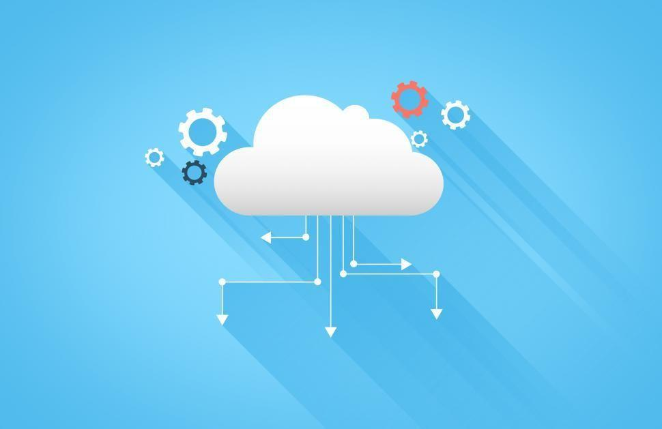
Benefits And Risks Of Cloud Computing
Various aspects of Cloud Computing, its major characteristics, and a comparative analysis between different cloud computing platforms were discussed in the articles Major Characteristics of Cloud Computing and Comparative Analysis of Cloud Platforms respectively. In this article, we’ll learn about the plethora of benefits cloud computing provides as well as the risk aspects of its usage. Each of the pros and cons is described in detail.

Benefits
- Cost Saving and Reduced Investment
- Increase in Scalability
- High Availability and Reliability
- Efficient Collaboration
- Automatic Updates
Cost Saving and Reduced Investment
Cloud Computing has significant hands-on reducing the costs proportionally to the usage of the services and reducing the initial investment for the computing resources. Cloud computing often has a pay-as-you-go model which costs a fraction of the charges and limits the possible excessive cost. The automated cloud capacity is extremely elastic in terms of wisely allocating resources as per the growth or decrease in the customer demand without ever wasting the capacity nor ever having a crisis of insufficient resources. Moreover, the automated cloud capacity will always meet the demand of the customers without wasting the capacity thus providing cost savings. This cost reduction regarded as one of the primary benefits of cloud computing has driven business prospects for this technology adopted by uncountable business enterprises and personal userbases parallelly. Also, not having to invest a huge chuck on servers and computing resources in the initial phase supports the growth for companies that would stay as fixed assets that cannot be dispensed elsewhere for years. Reducing this initial investment is a significant benefit cloud computing has provided in the most accessible way.

Increase in Scalability
The increase in scalability is one of the important benefits of cloud computing. This can be easily illustrated with the ever-changing as elastic customer demand being met by cloud computing technology. The rapid elasticity and automatic triggers that are provided by cloud computing have enabled consumers on assuring that the cloud capacity exceeds the customer demands by a respectable margin in a way it neither leads to the occurrence of hefty billing at the end of the month nor ever slack to meet the consumer demand with resources supply.

When Instagram was bought by Facebook for $1B with only 13 people building and running the company, the world was shaken to witness the value that had been created by such a small group of people. If we dive deeper, the automated features of cloud computing have played a huge role to achieve that feat. Meeting the customer demand for the ever-changing resources need, and with the minimized wasting of capacity and also reducing the need for the expenditure of company resources to predict the customer demand, capacity planning for the business was a monumental feat. This has saved huge charges that would have incurred on the company for unused resources and instead benefitted the increased scalability which has been the driving force for businesses adopting cloud computing.
High Availability and Reliability
As we have discussed Business Continuity in the previous article, Business Continuity and Disaster Recovery, availability and reliability are critical for businesses. Henceforth, the increase in availability and reliability offered by cloud computing has driven its adoption by organizations. We know that availability and reliability can also be offered by the traditional approach to infrastructures. But with Cloud computing, comes in a package with all other characteristics of cloud computing as we’ve discussed in the last article, Major Characteristics of Cloud Computing. Moreover, cloud providers guarantee the associated availability and reliability of the services in the service level agreement (SLA). Companies can adapt and evolve to better respond to the changes of the customer demand as well as mitigate risk for precarious situations that may arise in the future through the availability and reliability provided by cloud computing.

Efficient Collaboration
Beyond the approach of traditional methods, with cloud computing and cloud environment businesses will have the ability to collaborate, communicate and share more easily. With the world becoming a global village with every passing year, the office has become an ideology. With numerous employees working from across the borders, when projects are being worked on employees, contractors and third parties will have the capability to share and access the files required through cloud computing. The possibility of efficient collaboration has become a reality today, a major contribution of cloud computing.

Automatic Updates
In legacy systems working on traditional infrastructures, companies were responsible to take care of the hardware as well as software. On contrary with cloud computing, the frequent updates in software aren’t a hassle anymore with the cloud computing service provider taking care of it easily. While installing an operating system, one only has to choose the image of the latest software and the system will do it all by itself. The tedious tasks of updating each and every new update have become history. This is one amazing advantage that cloud computing provides.

Risks and Challenges
- Security Vulnerabilities
- Minimized Governance Control
- Portability in between cloud providers
- Compliance and Legal Issues
Security Vulnerabilities
The cases of Data Breaches, DDOS Attacks, Data Losses, hijacking of accounts are front-line news today. While the cloud service utilizes resource pooling as discussed in the previous article, Major characteristics of cloud computing, there are chances the consumer is accessing it through shared cloud resources rather than the physically isolated resource. This can lead to huge security vulnerabilities with cloud computing if measures are not taken. In comparison to the traditional infrastructure which would have a direct connection to the on-premise infrastructure with the isolated resources, it is not the same with various functionalities of cloud computing. Thus, however, Cloud Computing can be adjusted to mitigate such risks with careless administration of resource allocation and usage, it can also become equally vulnerable. Thus, skilled manpower is of extreme importance while handling critical data and resources in cloud computing.

Minimized Governance Control
Cloud Computing comes with the risk of minimized operational control of governance. Since the cloud providers operate the infrastructures and external connections are essential for the communication between the customers and the provider, there is a lack of control. For an instance, a corrupt cloud provider might guarantee SLA but would fail to honour those agreements making the consumer ever more vulnerable and susceptible to risks without even their recognition. Also, the physical location for these servers and data centers might be located further away from the customer thus increasing the probabilities of high latency and bandwidth issues. Hence, it is consequential that only respected and trustworthy cloud providers be used to handle such important data.

Portability in between cloud providers
Each of the cloud providers is discrete and can be observed to be shielded from each other. This increases the chances of limited portability between the cloud providers. Since there is no such industry standard that would allow the diffuse of customer dependency, each of these cloud providers is more of a vault. Similar to the Photo Stream provided by Apple, anyone outside of the ecosystem isn’t that welcome to share their photos. Thus, though not impossible to move between these cloud providers, it becomes extremely difficult to switch in between then down the path. Some features might be provided by one provider and the other doesn’t and vice versa.

KT2305 Cloud storage
Cloud storage delivers a cost-effective, scalable alternative to storing files to on-premise hard drives or storage networks. Cloud service providers allow you to save data and files in an off-site location that you access through the public internet or a dedicated private network connection. The provider hosts, secures, manages, and maintains the servers and associated infrastructure and ensures you have access to the data whenever you need it.
Hybrid cloud storage
Hybrid cloud storage combines private and public cloud elements. With hybrid cloud storage, organizations can choose which cloud to store data. For instance, highly regulated data subject to strict archiving and replication requirements is usually more suited to a private cloud environment. Whereas less sensitive data can be stored in the public cloud. Some organizations use hybrid clouds to supplement their internal storage networks with public cloud storage.

Internal Assessment Criteria and Weight
• IAC2301 Cloud computing functionality, benefits and risks are identified and described
(Weight 5%)

KM-07-KT23: Security fundamentals
Learning Outcome

Topic elements to be covered include:

• KT2401 Business continuity
• KT2402 Disaster recovery planning
• KT2403 Application development security
• KT2404 Access control
• KT2405 Information security governance
• KT2406 Risk management
• KT2407 Operation security
• KT2408 Physical security
• KT2409 Network security

KT2401 Business continuity
What is Business Continuity?
Business continuity involves a higher-level set of plans than those related to disaster recovery and seeks to ensure that your business can continue to function even as it recovers from a disaster safely. Business continuity is a process that looks to build resilience rather than solving immediate issues.
Because of this, the best business continuity plans tend to take a holistic approach, one that defines how your business will react to difficulties in its dealings with multiple groups. Ensuring business continuity entails clear communication with customers, staff, and contractors.
It means working collaboratively with your business partners and your cloud provider in particular.
Business continuity planning is often confused with several similar processes, which is why so many companies overlook its importance. There is a distinction between business continuity planning and disaster recovery planning.
Do you need end-to-end security? Download our Alert Logic Security & Compliance Suite Datasheet now.
What is Disaster Recovery (DR) Planning?
Disaster recovery planning covers how you react to natural and man-made disasters, ranging from insider threats to the fallout from a massive data breach. Because of this, disaster recovery plans generally define many acute problems and spell out how they can be solved.
Moving to the Cloud
Moving to cloud systems can make your business more efficient, more adaptive, and ultimately more profitable. Taking this step requires careful planning, especially when it comes to thinking about business continuity in the cloud.
In many ways, SaaS and IaaS (Infrastructure-as-a-Service) models have become victims of their own success because they are simply too easy for businesses not to take advantage of their services. The marketplace for cloud providers is a highly crowded one. As a result, providers typically offer to take care of every aspect of system and data management, all at a low price.
Understandably, this can lead to businesses forgetting about critical aspects of their business continuity planning and assuming their cloud provider will be handling them.
This is a real concern for security analysts, who are increasingly worried that massive amounts of public data are concentrated in one or two clouds – 63% of people use Google Chrome, for instance, which means that one company has responsibility for protecting a good proportion of the world’s data. If these clouds were to suffer a catastrophic failure, this could mean that hundreds (or perhaps hundreds of thousands) of businesses would be rendered mute.
In reality, moving your business to cloud systems necessitates that you assess whether your chosen provider can contribute to your company’s resilience. It’s important to recognize that cloud providers vary significantly when it comes to the level of support they offer. Some merely supervise the execution of your business continuity and disaster recovery plans, while others may be able to execute the plan on your behalf.
That’s why 68% of companies cited cloud misconfiguration as the top concern for keeping their data and infrastructure safe. A whopping 52% of organizations found insecure interfaces another top concern for their cloud, which is why you need the best security practices for cloud systems.

Four Considerations for Maintaining Business Continuity
When it comes to maintaining business continuity during (and after) a move to cloud infrastructure, there are four key considerations:
- Ensure that your provider can give you the level of access to data that you need. The service agreement should spell out this information and acknowledge that you are unlikely to be the only company your cloud provider does business with.
- Ensure you know how to access your data in an emergency that affects either you or your cloud provider. For most organizations, this means making regular, local backups of critical data.
- Check the level of support offered by your cloud provider. You should be clear on how much support they provide and through which hours they do so.
- Have a plan for what happens if your cloud provider experiences a disaster. Business continuity plans should include contingencies for a total (and potentially permanent) loss of all the data you have stored in the cloud. If you don’t know how you would keep your business running in that circumstance, more continuity planning is required.
What To Look For in a Cloud Host
As we’ve seen, your business continuity planning strength and your business’s resilience are dependent on your cloud provider. Coupled with recognizing the range of cloud services that are now available, this indicates that choosing the right cloud provider is one of the most crucial business decisions that most firms will make.
It’s therefore essential to perform due diligence on your cloud provider. Here are some key questions to ask in your search:
- Are they guiding you through the process?
- Do they validate what you actually need?
- Do they show restraint but plan for growth?
- Are they providing a positive return on investment?
- Do they support your business and users alike?
The best cloud providers offer 24/7 customer support and precisely spell out their responsibilities during and after a disaster. The best may even ask to share business resilience plans so that you can both determine how to support each other.

• KT2402 Disaster recovery planning
Disaster Recovery Plans for Your Business and Computers
Like clockwork, once a high publicity disaster befalls a community, all the newspapers, media and business journals go on at length about the destruction of vital records and the loss of the priceless asset that is the information stored in the typical company’s computers. Everything from vendor and customers lists to years of correspondences, plans and specs, employee and tax information and, increasingly vital, e mail exchanges are often lost forever.
Most medium and small businesses save most of their records now either on desktop computers or a local server (a larger storage and distribution computer) located on the premises. A few wiser companies also use backup provided by a local company that routinely stores the company files on a much larger server at another location.
But a surprising number of companies do not take the time or trouble to truly analyse the safety of such methods. Most companies do not know where the off-site server is located or if it is subject to the same threat of disaster or loss of electricity for prolonged periods. (It’s eight o’clock…do you know where your backup server is?)
One client felt relaxed about having not only a very good local server in the office but a backup server provided by his computer maintenance people-until he discovered that they were located in the same building and the flood that destroyed his system…destroyed theirs. Another client knew that his backup outside server had a battery to maintain its functioning and memory if there was a power outage…but never investigated to discover that the batteries useful life, when new, was six hours, woefully inadequate.
The wise business understands that taking time to plan for such disasters is not only wise but vital in today’s electronic information age. This article shall briefly discuss some basic steps to take to implement your disaster recovery plan for your own data.

THE BASIC PLAN:

1. Consider the Risks And Prepare Defensive Steps To Minimize Them.

- IN OFFICE DISASTERS: Most people readily consider the danger of fire and flood within the office but few realize that having an actual fire in the premises may not be necessary for destruction of electronic memory. Smoke travels where the air travels and smoke is actually particulates (soot) on air currents. Most computers have fans that bring cool air into the computer. Most buildings have heating and air condition systems that move air around. Put simply, a fire on a floor five hundred feet below you could result in soot ruining your server on your floor. Indeed, fire sprinkler systems are often the cause of “local flooding” that destroys data. Most buildings have extremely sensitive systems that release water even if the fire is not on the in office premises. The fire may be putting soot in your server while the fire protection system simultaneously drowns it…all due to a fire not even in your premises. Waterproof casings on the computer and isolated ventilation systems are recommended-but seldom practically available. Back up systems are, realistically, your only solution to this in office risk.
- IN OFFICE VANDALISM/THEFT. Disgruntled employees or vendors can easily gain access to most servers in most offices and pushing a few buttons or pulling a plug can wreak havoc. Most battery backup systems do not have alarms sounding when they come on and only last a few hours. It is remarkable that few companies bother to lock their server away in truly secure locations, with power chords locked into plugs. If a separate room is not available, secure and locked computer cabinets can be purchased that enclose the entire server and power supply and, of course, if battery power comes on there should be warning alert on every computer screen and an audible alarm. The battery backup should be a minimum of twelve hours. This is not expensive to create and should be the part of every system in every business.
- VIRUSES AND INTERNET SECURITY ATTACKS. Although most people are aware in a vague manner that viruses are out there and purchase some anti virus programs, few realize that it is only a matter of time until a virus will truly disrupt the internet and all computers on it for hours or weeks. We are engaged in a race between defensive measures and brilliant hostile minds seeking to demonstrate their prowess or harm the global economy. When suicide bombers cheerfully commit suicide to wreck havoc in a store or bus station, it is apparent that the technologically sophisticated enemies of this nation will sooner or later break through with a system attack that could, in microseconds, cause more economic harm than a thousand suicide bombings. No one expected the Twin Towers, All should expect the internet attack. One easy solution is to disconnect from the internet when not actually using it. The problem with that is most businesses are now global and require twenty four hour a day access. Further, the most likely time for an attack would be during regular business hours. The only real protection is the best virus protection software one can find and a backup system described below. Your system will sooner or later be a victim of attack. Plan on storing data off the internet linked computers now and keep the older technology available since sooner or later you will need it. Yes, cell phones, not just Trios, yes fax and Xerox machines, not just scanning and e mail. And print out information and place the key information in file cabinets. Someday, when all are bewailing the loss, you will still be in business.
- GENERAL DISASTER PLAN FOR YOUR PERSONNEL. Too many companies protect the machinery and do not think about the fact that the people with the expertise to utilize same may not be available to use it. If you have expert personnel who are essential to the retrieving of the data, have you considered how to make sure they are available and reachable in an emergency to actually do the work? Find out what expertise is needed and either learn it yourself or have at least two persons capable of working on the data with one always local and available. Create a plan for how to get that person to your office. This should form part of a personnel disaster plan that is not the topic of this article but should be a part of your office overall business plan.
- UPDATE YOUR NEEDS. Most businesses upgrade their computers at least annually, often more. A disaster plan good for last year may be useless for this year. One client after a fire discovered to his horror that the operating system he needed to retrieve his older data storage system was no longer in production. Each year, every year, review the entire methodology and technology of what you are using and update it.
- MAKE SURE YOUR CONTRACTS GIVE YOU TIME TO REPAIR. Each obligation your company undertakes should have a clause giving you extra time to perform should you face computer data loss. These are called Force Majeure clauses and your attorney should review your agreements to make sure they exist. Check the Contracts article on our web site for a fuller discussion of this clause.

THE PLAN IN WRITING.
Using the criteria above, management should create a written plan which is also stored off site but which all top management can gain access to when needed. DO NOT STORE IT ON COMPUTER…PRINT IT OUT AND KEEP IT IN A FIRE PROOF SAFE OFF SITE.

- A disaster recovery plan needs to include documentation of the computer configuration, backup copies of the application software and most importantly, backup copies of your data. It also should specifically identify for various levels of interruption what needs to be done and who has the responsibility to do it. The plan must be tested periodically to assure that it’s working correctly. An essential element: get the data off site in a secure location and update that process weekly or more often.
- The very small business with one computer has two options depending on the amount of data that needs to be backed up. One is the DOS/Windows backup utility that comes with the computer. This is an inexpensive, yet effective solution. But as the number of required disks for the database increases, the more time- consuming this project becomes for the person whose job it is to sit and feed the disks.
- In the case where several megabytes need to be backed up, a tape backup drive is a better solution. This is available from 250 MB and costs less than $300. Tape backup drives come with software that allow regular, unattended backups - including program files. This allows for the quickest recovery in case the hard disk drive fatally crashes. For a relatively small cost, this solution is convenient and frees up the computer during business hours.
- It is important to maintain and rotate several tapes (two weeks’ worth, for example) and periodically take one out and save it. This enables data to be restored from any point in time (as long as there is a backup) without having to make up lost data manually. Periodically test backup tapes by restoring some files to a temporary directory to make sure the backups are working. Keep backups in a fireproof safe or cabinet and take the most recent copy offsite in case the office is destroyed.
- There are companies with multiple computer sites operating duplicate equipment and data for the sole purpose of an emergency backup system. These hot sites ensure a business’s critical operations can continue to function in the event the primary location becomes unusable.
- If a disaster occurs, the action plan must address all variables. Where will the business function if the principal location is not usable? How and where will the necessary equipment be obtained (computers, copiers, telephones, etc.)? A disaster recovery plan should be updated on a regular basis to ensure appropriate timely measures will be implemented in a crisis.
- The plan, and a complete listing of all equipment and software, should be made available to your insurance carrier.
- Finally, make certain key individuals are aware of the disaster recovery plan and able to implement it if necessary. Develop practice drills to prepare staff if such a crisis occurs.
KT2403 Application development security
Application security definition
Application security is the process of developing, adding, and testing security features within applications to prevent security vulnerabilities against threats such as unauthorized access and modification.
Why application security is important
Application security is important because today’s applications are often available over various networks and connected to the cloud, increasing vulnerabilities to security threats and breaches. There is increasing pressure and incentive to not only ensure security at the network level but also within applications themselves. One reason for this is because hackers are going after apps with their attacks more today than in the past. Application security testing can reveal weaknesses at the application level, helping to prevent these attacks.

Types of application security
Different types of application security features include authentication, authorization, encryption, logging, and application security testing. Developers can also code applications to reduce security vulnerabilities.
- Authentication: When software developers build procedures into an application to ensure that only authorized users gain access to it. Authentication procedures ensure that a user is who they say they are. This can be accomplished by requiring the user to provide a user name and password when logging in to an application. Multi-factor authentication requires more than one form of authentication—the factors might include something you know (a password), something you have (a mobile device), and something you are (a thumb print or facial recognition).
- Authorization: After a user has been authenticated, the user may be authorized to access and use the application. The system can validate that a user has permission to access the application by comparing the user’s identity with a list of authorized users. Authentication must happen before authorization so that the application matches only validated user credentials to the authorized user list.
- Encryption: After a user has been authenticated and is using the application, other security measures can protect sensitive data from being seen or even used by a cybercriminal. In cloud-based applications, where traffic containing sensitive data travels between the end user and the cloud, that traffic can be encrypted to keep the data safe.
- Logging: If there is a security breach in an application, logging can help identify who got access to the data and how. Application log files provide a time-stamped record of which aspects of the application were accessed and by whom.
- Application security testing: A necessary process to ensure that all of these security controls work properly.

Application security in the cloud
Application security in the cloud poses some extra challenges. Because cloud environments provide shared resources, special care must be taken to ensure that users only have access to the data they are authorized to view in their cloud-based applications. Sensitive data is also more vulnerable in cloud-based applications because that data is transmitted across the Internet from the user to the application and back.

Mobile application security
Mobile devices also transmit and receive information across the Internet, as opposed to a private network, making them vulnerable to attack. Enterprises can use virtual private networks (VPNs) to add a layer of mobile application security for employees who log in to applications remotely. IT departments may also decide to vet mobile apps and make sure they conform to company security policies before allowing employees to use them on mobile devices that connect to the corporate network.

Web application security
Web application security applies to web applications—apps or services that users access through a browser interface over the Internet. Because web applications live on remote servers, not locally on user machines, information must be transmitted to and from the user over the Internet. Web application security is of special concern to businesses that host web applications or provide web services. These businesses often choose to protect their network from intrusion with a web application firewall. A web application firewall works by inspecting and, if necessary, blocking data packets that are considered harmful.
What are application security controls?
Application security controls are techniques to enhance the security of an application at the coding level, making it less vulnerable to threats. Many of these controls deal with how the application responds to unexpected inputs that a cybercriminal might use to exploit a weakness. A programmer can write code for an application in such a way that the programmer has more control over the outcome of these unexpected inputs. Fuzzing is a type of application security testing where developers test the results of unexpected values or inputs to discover which ones cause the application to act in an unexpected way that might open a security hole.
What is application security testing?
Application developers perform application security testing as part of the software development process to ensure there are no security vulnerabilities in a new or updated version of a software application. A security audit can make sure the application is in compliance with a specific set of security criteria. After the application passes the audit, developers must ensure that only authorized users can access it. In penetration testing, a developer thinks like a cybercriminal and looks for ways to break into the application. Penetration testing may include social engineering or trying to fool users into allowing unauthorized access. Testers commonly administer both unauthenticated security scans and authenticated security scans (as logged-in users) to detect security vulnerabilities that may not show up in both states.
KT2404 Access control
What is access control?
Access control is a fundamental component of data security that dictates who’s allowed to access and use company information and resources. Through authentication and authorization, access control policies make sure users are who they say they are and that they have appropriate access to company data. Access control can also be applied to limit physical access to campuses, buildings, rooms, and datacentres.
Explore additional data security topics:
- How does access control work?
- Why is access control important?
- Citrix solutions for access control
How does access control work?
Access control identifies users by verifying various login credentials, which can include usernames and passwords, PINs, biometric scans, and security tokens. Many access control systems also include multifactor authentication (MFA), a method that requires multiple authentication methods to verify a user’s identity.
Once a user is authenticated, access control then authorizes the appropriate level of access and allowed actions associated with that user’s credentials and IP address.
There are four main types of access control. Organizations typically choose the method that makes the most sense based on their unique security and compliance requirements. The four access control models are:
- Discretionary access control (DAC): In this method, the owner or administrator of the protected system, data, or resource sets the policies for who is allowed access.
- Mandatory access control (MAC): In this nondiscretionary model, people are granted access based on an information clearance. A central authority regulates access rights based on different security levels. This model is common in government and military environments.
- Role-based access control (RBAC): RBAC grants access based on defined business functions rather than the individual user’s identity. The goal is to provide users with access only to data that’s been deemed necessary for their roles within the organization. This widely used method is based on a complex combination of role assignments, authorizations, and permissions.
- Attribute-based access control (ABAC): In this dynamic method, access is based on a set of attributes and environmental conditions, such as time of day and location, assigned to both users and resources.
Why is access control important?
Access control keeps confidential information such as customer data, personally identifiable information, and intellectual property from falling into the wrong hands. It’s a key component of the modern zero trust security framework, which uses various mechanisms to continuously verify access to the company network. Without robust access control policies, organizations risk data leakage from both internal and external sources.
Access control is particularly important for organizations with hybrid cloud and multi-cloud cloud environments, where resources, apps, and data reside both on premises and in the cloud. Access control can provide these environments with more robust access security beyond single sign-on (SSO), and prevent unauthorized access from unmanaged and BYO devices.
KT2405 Information security governance
What is Information Security Governance and What it is Not
IT security governance is the system by which an organization directs and controls IT security (adapted from ISO 38500). IT security governance should not be confused with IT security management. IT security management is concerned with making decisions to mitigate risks; governance determines who is authorized to make decisions. Governance specifies the accountability framework and provides oversight to ensure that risks are adequately mitigated, while management ensures that controls are implemented to mitigate risks. Management recommends security strategies. Governance ensures that security strategies are aligned with business objectives and consistent with regulations.
NIST describes IT governance as the process of establishing and maintaining a framework to provide assurance that information security strategies are aligned with and support business objectives, are consistent with applicable laws and regulations through adherence to policies and internal controls, and provide assignment of responsibility, all in an effort to manage risk.
Enterprise security governance results from the duty of care owed by leadership towards fiduciary requirements. This position is based on judicial rationale and reasonable standards of care [1]. The five general governance areas are:
- Govern the operations of the organization and protect its critical assets
- Protect the organization's market share and stock price (perhaps not appropriate for education)
- Govern the conduct of employees (educational AUP and other policies that may apply to use of technology resources, data handling, etc.)
- Protect the reputation of the organization
- Ensure compliance requirements are met
"Governing for enterprise security means viewing adequate security as a non-negotiable requirement of being in business."
Governance: doing the right thing.
Management: doing things right.
KT2406 Risk management
What Is a Computer Security Risk?
A computer security risk is really anything on your computer that may damage or steal your data or allow someone else to access your computer, without your knowledge or consent. There are a lot of different things that can create a computer risk, including malware, a general term used to describe many types of bad software. We commonly think of computer viruses, but, there are several types of bad software that can create a computer security risk, including viruses, worms, ransomware, spyware, and Trojan horses. Misconfiguration of computer products as well as unsafe computing habits also pose risks. Let's look at these in more detail.
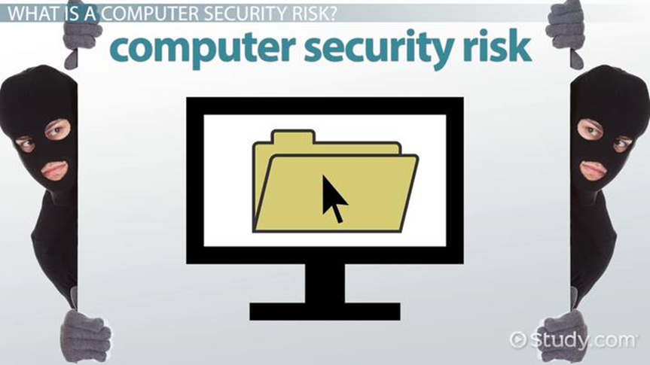
Viruses, Worms, & Ransomware
Viruses are malware that are attached to other files in your system and may be used to destroy your data. Viruses have many capabilities, but, unlike worms, they usually require human interaction to spread from system to system, even if the user is unaware, they are spreading it.
Worms are like viruses, but they have the ability to spread themselves from computer to computer, all on their own. They know how to attach themselves to portable storage devices, like USB drives or removable hard drives, or to move through the network by automatically moving to connected machines.
Ransomware is a relatively new term for malware that, when installed on your system, makes all of your files unreadable, holding your data hostage until you pay the hacker the ransom. Ransomware may be delivered by a virus or by a worm and there is no guarantee that, even if you pay the ransom, you'll get your data restored.
KT2407 Operation security
Security refers to providing a protection system to computer system resources such as CPU, memory, disk, software programs and most importantly data/information stored in the computer system. If a computer program is run by an unauthorized user, then he/she may cause severe damage to computer or data stored in it. So a computer system must be protected against unauthorized access, malicious access to system memory, viruses, worms etc. We're going to discuss following topics in this chapter.
- Authentication
- One Time passwords
- Program Threats
- System Threats
- Computer Security Classifications
Authentication
Authentication refers to identifying each user of the system and associating the executing programs with those users. It is the responsibility of the Operating System to create a protection system which ensures that a user who is running a particular program is authentic. Operating Systems generally identifies/authenticates users using following three ways −
- Username / Password − User need to enter a registered username and password with Operating system to login into the system.
- User card/key − User need to punch card in card slot, or enter key generated by key generator in option provided by operating system to login into the system.
- User attribute - fingerprint/ eye retina pattern/ signature − User need to pass his/her attribute via designated input device used by operating system to login into the system.
One Time passwords
One-time passwords provide additional security along with normal authentication. In One-Time Password system, a unique password is required every time user tries to login into the system. Once a one-time password is used, then it cannot be used again. One-time password are implemented in various ways.
- Random numbers − Users are provided cards having numbers printed along with corresponding alphabets. System asks for numbers corresponding to few alphabets randomly chosen.
- Secret key − User are provided a hardware device which can create a secret id mapped with user id. System asks for such secret id which is to be generated every time prior to login.
- Network password − Some commercial applications send one-time passwords to user on registered mobile/ email which is required to be entered prior to login.
Program Threats
Operating system's processes and kernel do the designated task as instructed. If a user program made these process do malicious tasks, then it is known as Program Threats. One of the common example of program threat is a program installed in a computer which can store and send user credentials via network to some hacker. Following is the list of some well-known program threats.
- Trojan Horse − Such program traps user login credentials and stores them to send to malicious user who can later on login to computer and can access system resources.
- Trap Door − If a program which is designed to work as required, have a security hole in its code and perform illegal action without knowledge of user then it is called to have a trap door.
- Logic Bomb − Logic bomb is a situation when a program misbehaves only when certain conditions met otherwise it works as a genuine program. It is harder to detect.
- Virus − Virus as name suggest can replicate themselves on computer system. They are highly dangerous and can modify/delete user files, crash systems. A virus is generally a small code embedded in a program. As user accesses the program, the virus starts getting embedded in other files/ programs and can make system unusable for user
System Threats
System threats refers to misuse of system services and network connections to put user in trouble. System threats can be used to launch program threats on a complete network called as program attack. System threats creates such an environment that operating system resources/ user files are misused. Following is the list of some well-known system threats.
- Worm − Worm is a process which can choked down a system performance by using system resources to extreme levels. A Worm process generates its multiple copies where each copy uses system resources, prevents all other processes to get required resources. Worms’ processes can even shut down an entire network.
- Port Scanning − Port scanning is a mechanism or means by which a hacker can detects system vulnerabilities to make an attack on the system.
- Denial of Service − Denial of service attacks normally prevent user to make legitimate use of the system. For example, a user may not be able to use internet if denial of service attacks browser's content settings.
Computer Security Classifications
As per the U.S. Department of Defense Trusted Computer System's Evaluation Criteria there are four security classifications in computer systems: A, B, C, and D. This is widely used specifications to determine and model the security of systems and of security solutions. Following is the brief description of each classification.
S.N. | Classification Type & Description
1 | Type A  Highest Level. Uses formal design specifications and verification techniques. Grants a high degree of assurance of process security.
2 | Type B  Provides mandatory protection system. Have all the properties of a class C2 system. Attaches a sensitivity label to each object. It is of three types.  - B1 − Maintains the security label of each object in the system. Label is used for making decisions to access control.  - B2 − Extends the sensitivity labels to each system resource, such as storage objects, supports covert channels and auditing of events.  - B3 − Allows creating lists or user groups for access-control to grant access or revoke access to a given named object.
3 | Type C  Provides protection and user accountability using audit capabilities. It is of two types.  - C1 − Incorporates controls so that users can protect their private information and keep other users from accidentally reading / deleting their data. UNIX versions are mostly Cl class.  - C2 − Adds an individual-level access control to the capabilities of a Cl level system.
4 | Type D  Lowest level. Minimum protection. MS-DOS, Window 3.1 fall in this category.

KT2408 Physical security
Keep your computer physically secure.
Enabling firewalls and keeping your operating system patched are very effective methods of protecting your data from threats on the Internet, but do not prevent someone from sitting down in front of your keyboard and gaining access to sensitive information. If you're walking away from your machine, use a screen saver with a password lock or simply log out of your operating system. Be suspicious of anyone you don't know attempting to gain access to a computer in your area.
Never assume physical safety, even in a swipe-access location. There is almost always a way for someone to get to a restricted area. Keep very sensitive data on monitored central servers and not on machines that can be carried away.
KT2409 Network security
What is Network Security?
Network Security protects your network and data from breaches, intrusions and other threats. This is a vast and overarching term that describes hardware and software solutions as well as processes or rules and configurations relating to network use, accessibility, and overall threat protection.
Network Security involves access control, virus and antivirus software, application security, network analytics, types of network-related security (endpoint, web, wireless), firewalls, VPN encryption and more.


Benefits of Network Security
Network Security is vital in protecting client data and information, keeping shared data secure and ensuring reliable access and network performance as well as protection from cyber threats. A well-designed network security solution reduces overhead expenses and safeguards organizations from costly losses that occur from a data breach or other security incident. Ensuring legitimate access to systems, applications and data enables business operations and delivery of services and products to customers.
Types of Network Security Protections
Firewall
Firewalls control incoming and outgoing traffic on networks, with predetermined security rules. Firewalls keep out unfriendly traffic and is a necessary part of daily computing. Network Security relies heavily on Firewalls, and especially Next Generation Firewalls, which focus on blocking malware and application-layer attacks.

Network Segmentation
Network segmentation defines boundaries between network segments where assets within the group have a common function, risk or role within an organization. For instance, the perimeter gateway segments a company network from the Internet. Potential threats outside the network are prevented, ensuring that an organization’s sensitive data remains inside. Organizations can go further by defining additional internal boundaries within their network, which can provide improved security and access control.

What is Access Control?
Access control defines the people or groups and the devices that have access to network applications and systems thereby denying unsanctioned access, and maybe threats. Integrations with Identity and Access Management (IAM) products can strongly identify the user and Role-based Access Control (RBAC) policies ensure the person and device are authorized access to the asset.
Zero Trust
Remote Access VPN
Remote access VPN provides remote and secure access to a company network to individual hosts or clients, such as telecommuters, mobile users, and extranet consumers. Each host typically has VPN client software loaded or uses a web-based client. Privacy and integrity of sensitive information is ensured through multi-factor authentication, endpoint compliance scanning, and encryption of all transmitted data.

Zero Trust Network Access (ZTNA)
The zero trust security model states that a user should only have the access and permissions that they require to fulfil their role. This is a very different approach from that provided by traditional security solutions, like VPNs, that grant a user full access to the target network. Zero trust network access (ZTNA) also known as software-defined perimeter (SDP) solutions permits granular access to an organization’s applications from users who require that access to perform their duties.

Email Security
Email security refers to any processes, products, and services designed to protect your email accounts and email content safe from external threats. Most email service providers have built-in email security features designed to keep you secure, but these may not be enough to stop cybercriminals from accessing your information.

Data Loss Prevention (DLP)
Data loss prevention (DLP) is a cybersecurity methodology that combines technology and best practices to prevent the exposure of sensitive information outside of an organization, especially regulated data such as personally identifiable information (PII) and compliance related data: HIPAA, SOX, PCI DSS, etc.

Intrusion Prevention Systems (IPS)
IPS technologies can detect or prevent network security attacks such as brute force attacks, Denial of Service (DoS) attacks and exploits of known vulnerabilities. A vulnerability is a weakness for instance in a software system and an exploit is an attack that leverages that vulnerability to gain control of that system. When an exploit is announced, there is often a window of opportunity for attackers to exploit that vulnerability before the security patch is applied. An Intrusion Prevention System can be used in these cases to quickly block these attacks.

Sandboxing
Sandboxing is a cybersecurity practice where you run code or open files in a safe, isolated environment on a host machine that mimics end-user operating environments. Sandboxing observes the files or code as they are opened and looks for malicious behaviour to prevent threats from getting on the network. For example, malware in files such as PDF, Microsoft Word, Excel and PowerPoint can be safely detected and blocked before the files reach an unsuspecting end user.

Hyperscale Network Security
Hyperscale is the ability of an architecture to scale appropriately, as increased demand is added to the system. This solution includes rapid deployment and scaling up or down to meet changes in network security demands. By tightly integrating networking and compute resources in a software-defined system, it is possible to fully utilize all hardware resources available in a clustering solution.

Cloud Network Security
Applications and workloads are no longer exclusively hosted on-premises in a local data center. Protecting the modern data center requires greater flexibility and innovation to keep pace with the migration of application workloads to the cloud. Software-defined Networking (SDN) and Software-defined Wide Area Network (SD-WAN) solutions enable network security solutions in private, public, hybrid and cloud-hosted Firewall-as-a-Service (FWaaS) deployments.
Robust Network Security Will Protect Against
- Virus: A virus is a malicious, downloadable file that can lay dormant that replicates itself by changing other computer programs with its own code. Once it spreads those files are infected and can spread from one computer to another, and/or corrupt or destroy network data.
- Worms: Can slow down computer networks by eating up bandwidth as well as the slow the efficiency of your computer to process data. A worm is a standalone malware that can propagate and work independently of other files, where a virus needs a host program to spread.
- Trojan: A trojan is a backdoor program that creates an entryway for malicious users to access the computer system by using what looks like a real program, but quickly turns out to be harmful. A trojan virus can delete files, activate other malware hidden on your computer network, such as a virus and steal valuable data.
- Spyware: Much like its name, spyware is a computer virus that gathers information about a person or organization without their express knowledge and may send the information gathered to a third party without the consumer’s consent.
- Adware: Can redirect your search requests to advertising websites and collect marketing data about you in the process so that customized advertisements will be displayed based on your search and buying history.
- Ransomware: This is a type of trojan cyberware that is designed to gain money from the person or organization’s computer on which it is installed by encrypting data so that it is unusable, blocking access to the user’s system.

Internal Assessment Criteria and Weight
• IAC2401 Typical security risks are listed
• IAC2402 The importance of counter measures is justified
(Weight 5%)

KM-07-KT24: Introduction to applications
Learning Outcome

Topic elements to be covered include:

• KT2501 Software development
• KT2502 Game development
• KT2503 Software tools
• KT2504 Mobile Apps
• KT2505 Internet of things

KT2501 Software development

What is software development?
Software development refers to a set of computer science activities dedicated to the process of creating, designing, deploying and supporting software.
Software itself is the set of instructions or programs that tell a computer what to do. It is independent of hardware and makes computers programmable. There are three basic types:
System software to provide core functions such as operating systems, disk management, utilities, hardware management and other operational necessities.
Programming software to give programmers tools such as text editors, compilers, linkers, debuggers and other tools to create code.
Application software (applications or apps) to help users perform tasks. Office productivity suites, data management software, media players and security programs are examples. Applications also refers to web and mobile applications like those used to shop on Amazon.com, socialize with Facebook or post pictures to Instagram.
A possible fourth type is embedded software. Embedded systems software is used to control machines and devices not typically considered computers — telecommunications networks, cars, industrial robots and more. These devices, and their software, can be connected as part of the Internet of Things (IoT).
Software development is primarily conducted by programmers, software engineers and software developers. These roles interact and overlap, and the dynamics between them vary greatly across development departments and communities.
Programmers, or coders, write source code to program computers for specific tasks like merging databases, processing online orders, routing communications, conducting searches or displaying text and graphics. Programmers typically interpret instructions from software developers and engineers and use programming languages like C++ or Java to carry them out.
Software engineers apply engineering principles to build software and systems to solve problems. They use modelling language and other tools to devise solutions that can often be applied to problems in a general way, as opposed to merely solving for a specific instance or client. Software engineering solutions adhere to the scientific method and must work in the real world, as with bridges or elevators. Their responsibility has grown as products have become increasingly more intelligent with the addition of microprocessors, sensors and software. Not only are more products relying on software for market differentiation, but their software development must be coordinated with the product’s mechanical and electrical development work.
Software developers have a less formal role than engineers and can be closely involved with specific project areas — including writing code. At the same time, they drive the overall software development lifecycle — including working across functional teams to transform requirements into features, managing development teams and processes, and conducting software testing and maintenance.
The work of software development isn’t confined to coders or development teams. Professionals such as scientists, device fabricators and hardware makers also create software code even though they are not primarily software developers. Nor is it confined to traditional information technology industries such as software or semiconductor businesses. In fact, according to the Brookings Institute (link resides outside of ibm.com), those businesses “account for less than half of the companies performing software development.”
An important distinction is custom software development as opposed to commercial software development. Custom software development is the process of designing, creating, deploying and maintaining software for a specific set of users, functions or organizations. In contrast, commercial off-the-shelf software (COTS) is designed for a broad set of requirements, allowing it to be packaged and commercially marketed and distributed.

Steps in the software development process
Developing software typically involves the following steps:
- Selecting a methodology to establish a framework in which the steps of software development are applied. It describes an overall work process or roadmap for the project. Methodologies can include Agile development, DevOps, Rapid Application Development (RAD), Scaled Agile Framework (SAFe), Waterfall and others.
- Gathering requirements to understand and document what is required by users and other stakeholders.
- Choosing or building an architecture as the underlying structure within which the software will operate.
- Developing a design around solutions to the problems presented by requirements, often involving process models and storyboards.
- Building a model with a modelling tool that uses a modelling language like SysML or UML to conduct early validation, prototyping and simulation of the design.
- Constructing code in the appropriate programming language. Involves peer and team review to eliminate problems early and produce quality software faster.
- Testing with pre-planned scenarios as part of software design and coding — and conducting performance testing to simulate load testing on the application.
- Managing configuration and defects to understand all the software artifacts (requirements, design, code, test) and build distinct versions of the software. Establish quality assurance priorities and release criteria to address and track defects.
- Deploying the software for use and responding to and resolving user problems.
- Migrating data to the new or updated software from existing applications or data sources if necessary.
- Managing and measuring the project to maintain quality and delivery over the application lifecycle, and to evaluate the development process with models such as the Capability Maturity Model (CMM).
The steps of the software development process fit into application lifecycle management (ALM). The IBM Engineering Management solution is a superset of ALM that enables the management of parallel mechanical, electrical and software development.
- Requirements analysis and specification
- Design and development
- Testing
- Deployment
- Maintenance and support
Software development process steps can be grouped into the phases of the lifecycle, but the importance of the lifecycle is that it recycles to enable continuous improvement. For example, user issues that surface in the maintenance and support phase can become requirements at the beginning of the next cycle.

KT2502 Game development

Game development, like any other project, starts with an idea. The hard part is to materialize this idea into a shippable product. To achieve this, we follow specific steps.
1. DISCOVERY
It is the very first step where the idea turns into a game. Initially, the discovery stage identifies a game’s scope and what’s required to bring it to a release date.
The discovery stage usually lasts for a month or two, depending on the project scope, resources needed, and available budget. At this point, the team consists of a few members – the Core Team. The Core Team usually consists of a Solution Architect, Game Designer, and Art Director.
The discovery stage is a vital starting point of the game creation and usually implies a wide range of activities displayed in detail below:
Game Design Document Creation. Designers create a single document that has all the rules and descriptions of the game, namely:
- Game mechanics description
- User flow UX charts
- Customization design
- Metagame design
Art-Style Definition. In collaboration with Game Designers and Stakeholders, Art Director, and the teamwork on the visual style for the product, developing the aesthetics, look, and feel.
- Game visual style
  - Concepts (background/environment, characters, some iconography)
  - 3D models (characters, maybe some props like weapons)
  - 3D animations (if we have time)
  - VFX concepts/prototypes (how particle effects might look like)
- Requirements for graphics
  - Polygon budget (based on target devices)
  - Texture resolution
  - Animation requirements (animation skeleton requirements like number of bones, naming convention, folder structure)
Technology Stack Definition. At this point, Solution Architect or Tech Lead identifies the technologies needed for the development process.
- Define if the team can use an existing solution
  - Usually, it’s faster to develop a product with an available game engine
  - In some instances, it makes sense to build a custom engine or platform
- Pick among various available engines
  - Decide what engine suits best to express your idea
- Define the project architecture
  - Make sure the product is built with expansion and future support in mind
Planning. When the team is ready with the procedures mentioned above, we provide the information on:
- The team needed to develop the game
- How long it takes to develop a game
- Deliverables produced along the way
- Budget breakdown

2. PRODUCTION: THE MOST LABOR-INTENSIVE STAGE OF THE GAME DEVELOPMENT PROCESS
This is when the actual development begins. Team members polish the story, define game mechanics, its balance, pacing, and gameplay. Plus, they create all assets (characters, creatures, props, and environments), set the rules of play, build levels and scenes, and write the code.
Each component of the game has to be designed thoughtfully, the fun and gameplay, and then characters, environment, objects, the level of difficulty, scenes, and more. Because the initial ideas don’t always render well in reality, the game testing and improvement continue even when the game is released.
Let’s look at the fundamentals of game production, and some of the critical video game development jobs, bearing in mind that small teams undertake multiple roles. In contrast, a larger studio with more team players who specialize in a particular aspect of production.
Production Milestones
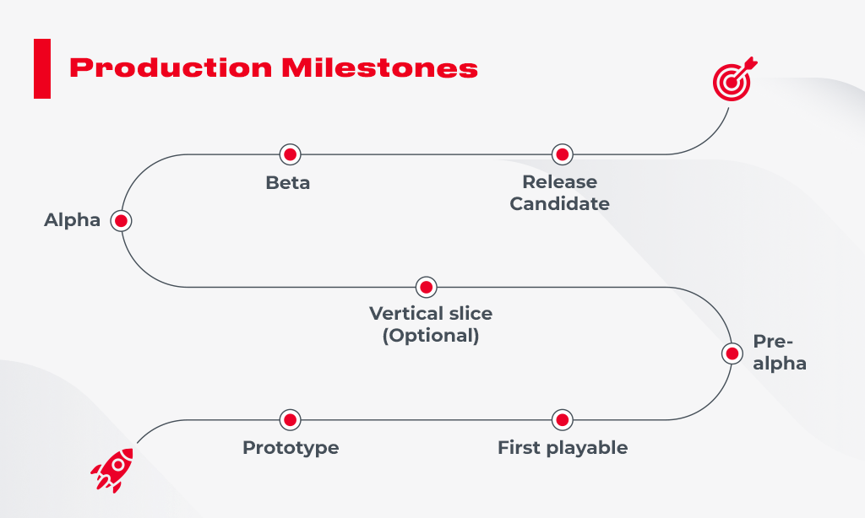
Prototype: A video game prototype is a raw test that examines functionality, user experience, gameplay, mechanics, and art style. Prototyping happens as the first phase of production to test whether the game idea will work and is worth pursuing. Many ideas fail at this stage.
First playable: The first playable allows us to get a better idea of the game’s look. While it is still far from the final version, placeholders are starting to be replaced with higher quality elements, and art is added.
Pre-alpha: Most of the content is designed in the pre-alpha stage. At this point in the game development process, some critical decisions take place. The content may get cut, or new assets are incorporated to improve gameplay.
Vertical slice (optional): A vertical slice is a fully playable version that can be used to manifest your game to clients, studios, or investors. A vertical slice gives a first-hand experience of the game, ranging from a couple of minutes to half an hour.

Alpha: The game is packed with all features, meaning that it is entirely playable from start to end. Some elements, such as art details, may still need to be added, but controls and functions should be working accurately.
Beta: Here, all the content and assets are aligned, and the team should focus on improvement rather than adding new functions or features. The QA testers ensure everything is running seamlessly and report bugs back to the side.
Release Candidate: The game is ready-to-use and can be sent to the publishing outlet and launched to the public.
The 10 Key Roles In The Game Development Process
Delivery Managers / Producers manage the business aspect of the project, particularly the expenses and schedules. Producers typically handle the budget and develop marketing strategies to sell the product.
Development Managers ensure game development runs smoothly, milestones are aligned, risks are mitigated, and teammates are doing what they’re supposed to. A project manager is often in the center of communication between the dev and design teams and executives.
Game Developers build games by turning design concepts into fully playable games. Game developers have a solid programming background. Plus, devs should have a combination of creativity, math skills, and patience to code ideas into interactive visuals and sounds.
Game Designers are the creative drivers of the game, and bridge between writers and artists, with some knowledge of programming. The game design production includes creating attention-grabbing stories, characters, goals, rules, and challenges that drive interactions between game elements.
Level Designers are responsible for creating exciting and fun levels. The challenge a level designer has to cope with is to keep a player’s focus and achieve the goal while reducing the potential of confusion. Level designers are also responsible for identifying player’s bottlenecks when going through the game, such as falling out of borders or getting stuck and not being able to get out.

Game Artists encompass concept artists, animators, 3D modelers, and FX artists. They usually create concept art, 2D elements, give colour, action, and life to the play.
While concept artists are active during designing of the first look, they may be involved later in the game development process to add new elements into the game.
3D Artists create models of characters, objects, props, and environments that can then be textured and animated. Modelers need to know how to get and use high-quality reference materials, primarily if they’re replicating real objects like, for instance, Kalashnikov rifle.
Animators make characters and objects lifelike by adding movement to them. They create storyboards and outline key animation scenes that match the game’s storyline. Animators often conduct lots of research on the objects they need to bring to life.
Audio Engineers / Sound Designers make natural sound effects, record voice dialogues between characters, create soundtracks to set the mood for players, i.e., opening music, menu pause music, marking a victory.
QA Testers are vital in the game development process. These people check games for bugs and make sure the game runs seamlessly, and guides are clear for players. They report errors to the developers in what’s sometimes known as a bug sheet.
3. TESTING
Every feature and mechanic in the game requires testing for quality control. A game without thorough testing is a game that’s not even ready for an Alpha launch. Here are some questions a QA tester may check during this stage:
- Are there error-areas or levels?
- Is everything rendering on the screen?
- Can my character walk through a particular wall?
- Does my character get forever stuck at this point?
- Is the character dialogue boring?
There are even various types of play testers. Some of them conduct stress tests by running into walls hundreds of times to crash the game. Other play-testers check “fun factor” to see if the game is too complicated or too easy and comfortable enough.
After countless iterations of testing, the game should be ready for Alpha or Beta release, depending on how refined the in-game features are. At this phase, the players, for the first time, get hands-on the game.
4. RELEASE
The release day is coming, and one can see the light is at the end of the tunnel. The months leading up to an awaited date is typically spent in errors debugging found in the testing stage.
In addition to bug squashing, developers hone in on the game as much as possible before it launches. Maybe that rock can have more depth. Perhaps the character’s outfit can be more texture, or those trees may finally sway in the wind. These slight changes can be significant for making a video game more immersive.

KT2503 Software tools
Most useful software development tools

A software development tool is a program that can be leveraged to develop, maintain, or test other applications. Today there are both paid and free software development tools available to choose from. There are a wide range of software development tools, and each of them perform a specific role better than the others.
Software development tools are in huge demand. The software industry has been experiencing phenomenal growth in recent years. In 2020, the IT industry was worth $ 5.2 trillion and it is obvious why so many people want to be a part of such a rewarding industry. Even with over 21 million developers out there, the industry still faces a shortage due to a lack of skilled professionals. Here we have discussed the most useful software development tools that are available today.
1. Github
This is the most popular one out there. It is a web-based Git repository hosting solution that serves as a place where developers can search for codes. The platform allows developers to upload private/public projects and helps to keep them safe. Github has a large community and an impressive repository of projects. It is the perfect solution for professionals who seek to collaborate.
2. Gleek
It is similar to Github as it is a data modelling tool and not just a typical software tool. It is free to use and can be leveraged without signing up for an account. It does not provide any drag and drop functionality and it can be accessed using a keyboard.
3. Codepen
It is a powerful tool especially helpful for front-end developers. The tool is a great place to find ideas for your next project. It allows web developers to share CSS, HTML related issues to find a quick solution from other developers.
4. Buddy
Another web development tool that leverages delivery pipelines to develop, deploy and test software. It is easy to use due to the action system that allows developers to arrange it in the required way. It is perfect for deployment-related tasks. It takes as low as only 15minutes to configure. The tool works flawlessly with WordPress, Google, AWS, etc.
5. Cloud9 IDE
It is an online integrated environment where you can find answers to your app development-related problems. The tool offers support for a vast range of languages such as Python, Ruby, PHP, C, and JavaScript. It can be leveraged to set breakpoints as it saves time and it is quite user-friendly. Tool’s code completion section offers useful suggestions which help in writing codes faster.

KT2504 Mobile Apps
What Does Mobile Application (Mobile App) Mean?
A mobile application, most commonly referred to as an app, is a type of application software designed to run on a mobile device, such as a smartphone or tablet computer. Mobile applications frequently serve to provide users with similar services to those accessed on PCs. Apps are generally small, individual software units with limited function. This use of app software was originally popularized by Apple Inc. and its App Store, which offers thousands of applications for the iPhone, iPad and iPod Touch.
A mobile application also may be known as an app, web app, online app, iPhone app or smartphone app.
Advertisement
Mobile Application (Mobile App)
Mobile applications are a move away from the integrated software systems generally found on PCs. Instead, each app provides limited and isolated functionality such as a game, calculator or mobile web browsing. Although applications may have avoided multitasking because of the limited hardware resources of the early mobile devices, their specificity is now part of their desirability because they allow consumers to hand-pick what their devices are able to do.
The simplest mobile apps take PC-based applications and port them to a mobile device. As mobile apps become more robust, this technique is somewhat lacking. A more sophisticated approach involves developing specifically for the mobile environment, taking advantage of both its limitations and advantages. For example, apps that use location-based features are inherently built from the ground up with an eye to mobile given that the user is not tied to a location, as on PC.
Apps are divided into two broad categories: native apps and web apps. Native apps are built for a specific mobile operating system, usually iOS or Android. Native apps enjoy better performance and a more finely-tuned user interface (UI), and usually need to pass a much stricter development and quality assurance process before they are released.
Web apps are used in HTML5 or CSS and require minimum device memory since they’re run through a browser. The user is redirected on a specific web page, and all information is saved on a server-based database. Web apps require a stable connection to be used.
There are several types of apps currently available.
- Gaming apps: The equivalent of computer video games, they are among the most popular types of apps. They account for one-third of all app downloads and three-fourths of all consumer spending.
- Productivity apps: These focus on improving business efficiency by easing various tasks such as sending emails, tracking work progress, booking hotels, and much more.
- Lifestyle and entertainment apps: Increasingly popular, these encompass many aspects of personal lifestyle and socialization such as dating, communicating on social media, as well as sharing (and watching) videos. Some of the most widely known apps such as Netflix, Facebook or TikTok fall into this category.
Other app types include mobile commerce (M-commerce) apps used to purchase goods online such as Amazon or eBay, travel apps that help a traveller in many ways (booking tours and tickets, finding their way through maps and geolocation, travel diaries, etc.), and utility apps such as health apps and barcode scanners.

KT2505 Internet of things
The internet of things is a technology that allows us to add a device to an inert object (for example: vehicles, plant electronic systems, roofs, lighting, etc.) that can measure environmental parameters, generate associated data and transmit them through a communications network.
What Is It?
The internet of things (IoT) is a set of technologies that uses sensors and actuators to inform us about the status of everyday items such as vehicles, tools and even living beings. It allows us to interact with them, enabling connectivity with platforms in the cloud that receive and process information for posterior analysis. This analysed data is then used to make decisions.
Applications for Use
Here at Ferrovial, we mainly use IoT technology with connected cars, wearables, collaborative robotics, sensors in industrial plants (industry 4.0) and to efficiently manage energy.
We have developed a wide variety of projects in areas such as mobility, construction, highways, airports and industry. Some examples of initiatives carried out by our Digital Hub include:
- Monitoring the Zity vehicle fleet, acquiring real-time telemetry and positioning data, carrying out bidirectional communication with drivers, and creating accident and harsh driving alerts — all to reduce the occurrence of accidents.
- Using sensors in lineal construction machinery, which identify work events and optimize the production cycle.
- Implementing markers on national highways and roads to analyse vehicle transit and users, characterizing and quantifying trip profiles to learn more about our end users and to better understand their behaviour.
- Designing and using push-button terminals at airports where users can express their levels of satisfaction and record voice messages with their opinions about our service. Analysing this information is used to improve passenger satisfaction levels.
- Acquiring information about water treatment plants via integration with SCADAs (Supervisory Control and Data Acquisition) to facilitate the ability to analyse and optimize production aspects.
Our Digital Hub technology specialists support businesses by identifying which technology solutions (IoT devices) are best for each case, analysing its technical viability within the correct context, providing support during economic analysis and, if needed, executing the entire project (from device installation and management, field testing, sending information and posterior analysis).
In addition, our Digital Hub started an IoT platform that assists different Ferro vial companies and serves as the central piece of all applications and use cases of this type. It integrates different field elements and is the base over which vertical solutions are developed, which add value to businesses via data analysis techniques and automatic learning.
The main advantage of this platform is that, as new sensors are added, data integration capacities can be re-used by other departments and business lines for other use cases that install the same type of sensor, therefore accelerating the implantation process for these types of solutions.

Internal Assessment Criteria and Weight
• IAC2501 Various software developments are listed
(Weight 5%)

References
https://codered.eccouncil.org › course › network-defens..
https://www.checkpoint.com › Secure The Network
https://www.sciencedirect.com › topics › computer-science
https://www.forcepoint.com › cyber-edu › defense-depth
https://www.cisco.com › Products & Services › Security
https://www.techtarget.com › searchsecurity › definition
https://www.itgovernance.co.uk › what-is-cybersecurity
https://www.gartner.com › topics › cybersecurity
https://www.ibm.com › za-en › topics › mobile-security
https://www.archonsecure.com › mobile-device-guide
https://preyproject.com › blog › what-are-cyber-threats-h..
https://emeritus.org › learn › different-types-of-cyber-s
https://www.simplilearn.com › cyber-security-tutorial

